Les Phillips Cup Final: After falling short in last season’s final, Shepton Mallet made amends on Sunday afternoon, beating Barnstaple Town 3-1 to secure their first ever Les Phillips Cup. Playing at the same venue in Tiverton as they had done 12 months previously, Mallet pulled after in the second half to claim victory. On a beautiful sunny afternoon, the game started at breakneck speed, with Shepton’s Cam Allen opening the scoring in the second minute putting the finishing touches on his sides opening attacking foray. Town weren’t here to make up the numbers however, and they got back on level terms after only minutes, with Billy Tucker’s pin-point cross converted by teammate Matty Andrew. An entertaining opening half continued with Shepton pushing to go back ahead, and after going close on a couple occasions, they were handed a penalty on the half hour. Barnstaple keeper Liam Kingston was not to be beaten however, diving to his left to keep out Jacob Sloggett’s spot kick and keeping the game locked at one apiece as the players headed off for half time.
#42
Season 2023/24

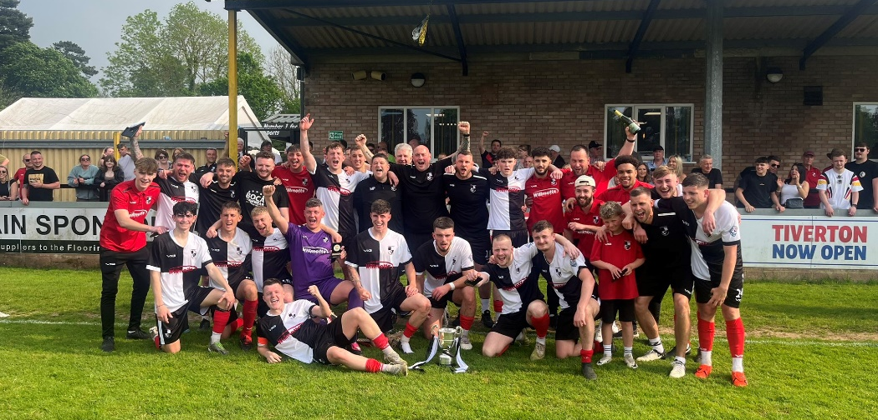
In a mirror image of the first half, both sides came out flying in the second period, and Sloggett was quick to atone for his earlier penalty miss, putting his side 2-1 ahead following an excellent solo effort. The Devon side looked to hit back again, and came within inches of doing so, only to see the ball cannon back into safety off the foot of the post. The benches started to empty on both sides, with coaches looking for fresh legs, and it was Shepton’s Charlie Bateson who made the desired impact, scoring ten minutes after coming on to make it 3-1 midway through the second half. Cheered on by a strong following, Mallet maintained their two-goal advantage for the remainder of the game, managing to finally get the upper hand over Barnstaple this term at the third time of asking.

In a playoff winners special, the latest podcast firstly catches up with Falmouth boss Andrew Westgarth, who gives his take on a historic season for the Cornish club. Ian then chats with Brislington manager, Lee Perks, who looks ahead to their Premier Division return following their dramatic playoff final victory.
http://toolstationleague.com/season-2023-24-podcast-episode-40/

Final League Tables
 | PREMIER DIVISION | Played | Won | Drawn | Lost | GD | Points
C | Helston Athletic | 34 | 25 | 5 | 4 | 74 | 80
PO | Falmouth Town | 34 | 24 | 4 | 6 | 55 | 76
3 | Bridgwater United | 34 | 23 | 3 | 8 | 51 | 72
4 | Clevedon Town | 34 | 21 | 7 | 6 | 44 | 70
5 | Barnstaple Town | 34 | 19 | 10 | 5 | 40 | 67
6 | Buckland Athletic | 34 | 18 | 7 | 9 | 35 | 61
7 | Shepton Mallet | 34 | 18 | 6 | 10 | 17 | 60
8 | Brixham AFC | 34 | 15 | 10 | 9 | 33 | 55
9 | Nailsea & Tickenham | 34 | 14 | 4 | 16 | 5 | 46
10 | Torpoint Athletic | 34 | 13 | 6 | 15 | -8 | 45
11 | Ilfracombe Town | 34 | 10 | 10 | 14 | -9 | 40
12 | St Blazey | 34 | 11 | 6 | 17 | -13 | 39
13 | Saltash United | 34 | 10 | 6 | 18 | -9 | 36
14 | Street | 34 | 9 | 7 | 18 | -22 | 34
15 | Wellington | 34 | 8 | 8 | 18 | -38 | 32
16 | Oldland Abbotonians | 33 | 7 | 2 | 25 | -48 | 23
17 | Welton Rovers | 34 | 4 | 8 | 22 | -63 | 17*
18 | Millbrook | 34 | 2 | 1 | 31 | -144 | 7
 | FIRST DIVISION | Played | Won | Drawn | Lost | GD | Points
C | Portishead Town | 42 | 31 | 6 | 5 | 93 | 99
2 | Radstock Town | 42 | 28 | 7 | 7 | 55 | 91
3 | Bitton | 42 | 27 | 8 | 7 | 51 | 89
4 | Wincanton Town | 42 | 27 | 4 | 11 | 28 | 85
5 | Wells City | 42 | 27 | 3 | 12 | 41 | 84
6 | Cribbs Reserves | 42 | 27 | 3 | 12 | 45 | 83*
PO | Brislington | 42 | 25 | 5 | 12 | 71 | 80
8 | Bradford Town | 42 | 19 | 11 | 12 | 25 | 68
9 | Hallen | 42 | 20 | 8 | 14 | 16 | 68
10 | AEK Boco | 42 | 19 | 8 | 15 | 17 | 65
11 | Bristol Telephones | 42 | 19 | 6 | 17 | -12 | 63
12 | Longwell Green Sports | 42 | 18 | 5 | 19 | -3 | 59
13 | Middlezoy Rovers | 42 | 18 | 2 | 22 | -12 | 56
14 | Cadbury Heath | 42 | 17 | 4 | 21 | 14 | 55
15 | Hengrove Athletic | 42 | 13 | 7 | 22 | -21 | 46
16 | Odd Down | 42 | 13 | 7 | 22 | -41 | 46
17 | Shirehampton | 42 | 12 | 7 | 23 | -13 | 43
18 | Keynsham Town | 42 | 13 | 4 | 25 | -27 | 43
19 | Warminster Town | 42 | 10 | 7 | 25 | -42 | 37
20 | Gillingham Town | 42 | 10 | 4 | 28 | -59 | 34
21 | Cheddar | 42 | 8 | 1 | 33 | -62 | 25
22 | Bishop Sutton | 42 | 0 | 3 | 39 | -164 | 3

