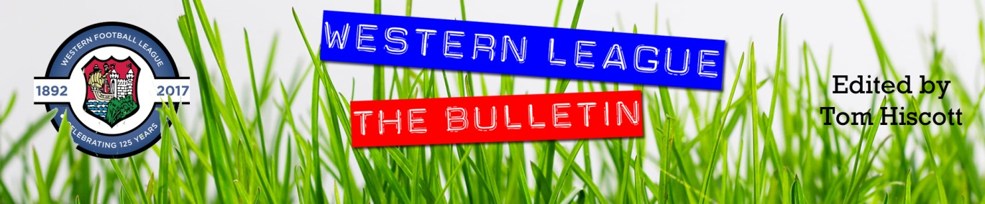
Latest Round-ups:
#37
Season 2023/24

Premier Division: Falmouth’s continued progression up the table reached new heights on Saturday after a 4-0 win over Clevedon helped them move up into second spot. The highly-anticipated contest ended in disappointing circumstances following an injury to Caleb Selway, but the Cornish side were in control for much of the afternoon. Two first half goals put the hosts ahead at the break, with a 17th minute header from Rubin Wilson followed on the cusp of half-time by an Oscar Massey penalty. The score remained 2-0 up until Selway’s late injury, with Massey then scoring twice during the extended added time period to complete a match-winning hat-trick. 4-0 was also the winning margin for the current league leaders, with Helston seeing off Saltash at Coach Road in Newton Abbott. Having taken a one-goal lead to the interval courtesy of Rikki Sheppard, a second-half brace from Tom Payne lit up Helston’s temporary home. Payne’s first came shortly after the break, with a late free-kick then wrapping up the victory following a further goal from teammate Jacob Smith. To complete a hat-trick of 4-0 winners, Barnstaple eased past Street to pick up their fourth win in a row. A dominant first half helped steer Town to victory, with Harvey Dorothy scoring twice in quick succession to add to Tommy Rogers’ opener. Myles Perkins then scored a fourth for the visitors from the edge of the area, with the Cobblers now having been defeated in their past six home games. Bridgwater United held off a late charge from Ilfracombe to eventually prevail by five goals to three at Fairfax Park. The full-time result would have been scarcely believable for much of the afternoon, with Jay Murray’s second minute effort followed by a Josiah McKayle as Bridgy took complete control. Substitute Jack Taylor then extended the lead to four shortly after half-time, before Ilfracombe staged a remarkable late fightback. Harry Stevens scored twice, and Jack Magarotto once in a wild five minute spell which suddenly saw Town trail 4-3 with ten left on the clock. Fortunately for the home side, they expelled any chance of more late drama, with a wind-assisted corner from Jake Llewellyn nestling in the back of the visitors net to put them two goals clear. Nailsea & Tickenham were the day’s other winner, with Oscar Collins scoring late on to help them beat Brixham 2-1. Having taken an 11th minute lead through Luke Osgood, the Swags saw their lead disappear when the in-form Josh Parry levelled for the away side. Then with five minutes left on the clock, Collins was able to turn the ball home to help Nailsea secure all three points.
On the latest podcast, Barnstaple Town manager, Ben Watson, reflects on his sides path to the Les Phillips Cup, while also touching on how the weather disruption has impacted their progress this season. Ian also catches up with Hallen boss Karl Baggaley, who explains why his side have benefited from a mix of youth and experience, before discussing why Exmouth Town have a lot to be thankful for in their bid for Southern League revival.
http://toolstationleague.com/season-2023-24-podcast-episode-35/

First Division: On a weekend where home sides dominated, Radstock Town got the ball rolling on Friday night, putting three past Keynsham to become the first side to reach 80 points this term. The Miners enjoyed a dream start under the lights, going ahead inside the opening three minutes thanks to Jack Pearson. A Jacob Reader goal midway through the second half doubled the hosts advantage, but they were then soon pegged back with Joe Davis scoring for the K’s. That was as close as the away side came however, and shortly after the Davis goal, Radstock restored their two-goal lead courtesy of Jack Farion.
Saturday saw eight of the nine fixtures won by home sides, with only Middlezoy’s shock victory at Wincanton stopping it from being a perfect record. The Wasps have been in outstanding form since the turn of the year, winning 11 from 13 prior to now suffering back-to-back defeats. The hosts would have been looking for revenge following the 5-2 loss they suffered at Middlezoy in December, but they were second best for much of the afternoon, and only an injury-time consolation goal from Jamie Irwin stopped them from being shut out on home soil. Second-placed Portishead took out some of their recent frustration on Warminster, scoring seven unanswered goals to increase their huge advantage in the goal difference standings. Calum Townsend was the main man during the opening stages, and after heading Portishead into an early lead, he then turned provider for Callum Eastwood had converted his cross for 2-0 inside 20 minutes. It then became the Ethan Feltham show, starting with his opening goal of the afternoon which took him to 46 for the season, breaking a club record. He wasn’t finished there however, and after scoring again late in the first half, he bagged another shortly after the restart to complete yet another hat-trick. The game was done and dusted at that stage, but the hosts kept pushing for more goals, with James Crossley-John and Jack Ball completing the scoring. Cribbs Reserves are the other side fully ensconced in the title race, and they held on to beat Cadbury Heath 2-1 at The Lawns. Goals either side of the interval from Andrew Forward & Tom Burns helped Cribbs go two clear, but they were forced to battle hard until the finale following a late penalty from Heath forward Tom Withers. 2-1 was also the final score at Trowbridge Road, where Bradford Town defeated Shirehampton thanks to first half efforts from Ben Wickens and Owen Pearce. Things were slightly more one-sided at Brislington meanwhile, where three players grabbed goalscoring braces in a 7-1 victory over Gillingham Town. Jordan Scadding scored the only goal of the game during a relatively quiet opening half before he then struck again at the beginning of the second to set the ball rolling for a frantic 45 minutes of action. Oaklan Buck edged the lead out to three, with Gillingham reducing the deficit from the spot midway through the second half. That was the away side’s only moment of cheer however, with Neikell Plummer and Jordan Ricketts both scoring twice during a rampant finale from the Bristolians. Elliot Garnder struck in either half of Hallen’s 3-1 win over AEK Boco, while Joe Beardwell’s early penalty helped kickstart Bitton’s 4-1 defeat of Bristol Telephones. In Bath, Alfie Andrews and Curtis Dunn both scored inside the opening 15 minutes to help Odd Down ease to a 3-0 win over basement boys Bishop Sutton. The most impressive team performance of the day probably belonged to Longwell Green Sports who ended Wells City’s eight-match winning streak with a relatively comfortable 4-2 victory. Doubles from both Liam Oswin and Fin Burnell did the business for Longwell Green, who led for almost the entirety of the 90 minutes, with Fin Wilkinson scoring twice in defeat for sixth-placed Wells.

Toolstation to end their sponsorship of the Western League – Read More.

Latest Results
Friday 5th April 2024
First Division
Radstock Town 3-1 Keynsham Town 150

Saturday 6th April 2024
Premier Division
Bridgwater United 5-3 Ilfracombe Town 231
Buckland Athletic P-P Shepton Mallet
Falmouth Town 4-0 Clevedon Town 531
Helston Athletic 4-0 Saltash United
Millbrook P-P Oldland Abbotonians
Nailsea & Tickenham 2-1 Brixham AFC 131
St Blazey P-P Welton Rovers
Street 0-4 Barnstaple Town

First Division
Bitton 4-1 Bristol Telephones 72
Bradford Town 2-1 Shirehampton 130
Brislington 7-1 Gillingham Town 101
Cheddar P-P Hengrove Athletic
Cribbs Reserves 2-1 Cadbury Heath 39
Hallen 3-1 AEK Boco 52
Longwell Green Sports 4-2 Wells City 165
Odd Down 3-0 Bishop Sutton 55
Portishead Town 7-0 Warminster Town 108
Wincanton Town 1-2 Middlezoy Rovers 60

Leading Goalscorers (Stats courtesy of FA Fulltime Website)
Premier Division
Jared Lewington (Buckland) – 29
Ryan Richards (Torpoint) – 22
Jack Thorne (Bridgwater) – 21
Oscar Massey (Falmouth) – 20
Rubin Wilson (Falmouth) – 19
Phil Ormrod (Street) - 17
Rikki Sheppard (Helston) – 17

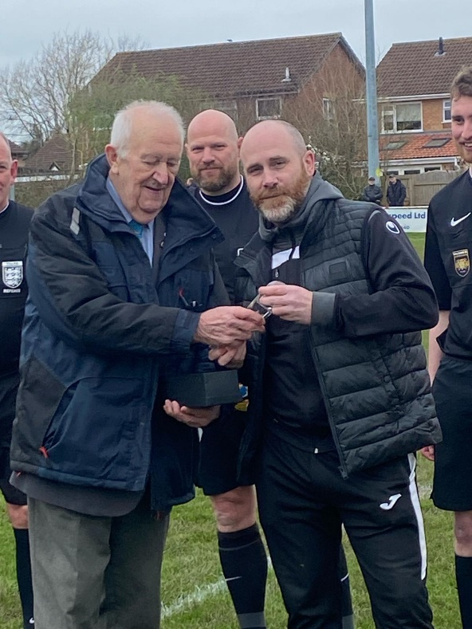
Western League President Brian Beer recently attended Cadbury Heath to award Matt Huxley with a special award for scoring his 500th league goal.

All Competitions
Ethan Feltham (Portishead) – 45
Jared Lewington (Buckland) – 34
Matt Garner (Wincanton) – 33
Jack Thorne (Bridgwater) – 27
Harry Warwick (Wells) - 25
Louis Snailham (Shirehampton) – 25
Ryan Richards (Torpoint) – 24
Liam Winter (Middlezoy) – 23
Liam Clayton (Cribbs Reserves) - 23
First Division
Ethan Feltham (Portishead) – 42
Matt Garner (Wincanton) – 31
Liam Winter (Middlezoy) - 23
Louis Snailham (Shirehampton) – 21
Liam Clayton (Cribbs Reserves) – 20
Harry Warwick (Wells) - 20
Joe Beardwell (Bitton) - 18

Upcoming Fixtures
Tuesday 9th April 2024
Premier Division
Barnstaple Town vs Clevedon Town 19:45KO
Buckland Athletic vs Brixham 19:30KO
Ilfracombe Town vs Millbrook 19:45KO
Shepton Mallet vs Oldland Abbotonians 19:30KO
Torpoint Athletic vs Saltash United 19:30KO
Wellington vs Falmouth Town 19:45KO
Welton Rovers vs Nailsea & Tickenham 19:30KO
First Division
Bitton vs Wincanton Town 19:30KO
Bradford Town vs Warminster Town 19:30KO
Bristol Telephones vs Brislington 19:30KO
Cheddar vs Shirehampton 19:45KO
Hengrove Athletic vs Portishead Town 19:30KO
Middlezoy Rovers vs Keynsham Town 19:30KO
Wells City vs Gillingham Town 19:30KO

Thursday 11th April 2024
Premier Division
Ilfracombe Town vs Barnstaple Town 19:45KO
Oldland Abbotonians vs Welton Rovers 19:45KO
First Division
Bishop Sutton vs Cheddar 19:30KO
Bitton vs Cadbury Heath 19:30KO
Portishead Town vs Brislington 19:30KO

Saturday 13th April 2024 (3pm Kick-off unless noted otherwise)
Premier Division
Barnstaple Town vs Nailsea & Tickenham
Bridgwater United vs Saltash United
Clevedon Town vs Ilfracombe Town
Millbrook vs Brixham
Oldland Abbotonians vs Falmouth Town
Torpoint Athletic vs Shepton Mallet
Wellington vs Helston Athletic
Welton Rovers vs Buckland Athletic
First Division
AEK Boco vs Radstock Town
Bishop Sutton vs Wells City
Cadbury Heath vs Cribbs Reserves
Cheddar vs Brislington
Gillingham Town vs Hallen
Hengrove Athletic vs Bradford Town
Keynsham Town vs Middlezoy Rovers
Shirehampton vs Odd Down
Warminster Town vs Longwell Green Sports
Wincanton Town vs Bristol Telephones

League Tables
 | PREMIER DIVISION | Played | Won | Drawn | Lost | GD | Points
1 | Helston Athletic | 28 | 22 | 3 | 3 | 72 | 69
2 | Falmouth Town | 28 | 21 | 3 | 4 | 52 | 66
3 | Clevedon Town | 30 | 20 | 5 | 5 | 42 | 65
4 | Bridgwater United | 29 | 19 | 2 | 8 | 38 | 59
5 | Barnstaple Town | 27 | 16 | 8 | 3 | 38 | 56
6 | Buckland Athletic | 29 | 15 | 6 | 8 | 33 | 51
7 | Shepton Mallet | 28 | 14 | 6 | 8 | 11 | 48
8 | Brixham AFC | 30 | 13 | 8 | 9 | 31 | 47
9 | Torpoint Athletic | 27 | 12 | 4 | 11 | 1 | 40
10 | Nailsea & Tickenham | 29 | 12 | 2 | 15 | 3 | 38
11 | Street | 31 | 9 | 7 | 15 | -12 | 34
12 | St Blazey | 28 | 9 | 5 | 14 | -15 | 32
13 | Ilfracombe Town | 25 | 6 | 8 | 11 | -10 | 26
14 | Wellington | 28 | 5 | 8 | 15 | -38 | 23
15 | Saltash United | 27 | 6 | 4 | 17 | -22 | 22
16 | Oldland Abbotonians | 26 | 5 | 0 | 21 | -49 | 15
17 | Welton Rovers | 27 | 3 | 5 | 19 | -53 | 11*
18 | Millbrook | 25 | 2 | 0 | 23 | -122 | 6
 | FIRST DIVISION | Played | Won | Drawn | Lost | GD | Points
1 | Radstock Town | 38 | 25 | 6 | 7 | 49 | 81
2 | Portishead Town | 34 | 24 | 6 | 4 | 73 | 78
3 | Cribbs Reserves | 37 | 24 | 5 | 8 | 39 | 77
4 | Wincanton Town | 37 | 24 | 4 | 9 | 28 | 76
5 | Bitton | 35 | 21 | 8 | 6 | 36 | 71
6 | Wells City | 35 | 23 | 2 | 10 | 30 | 71
7 | Brislington | 33 | 22 | 4 | 7 | 72 | 70
8 | AEK Boco | 37 | 18 | 6 | 13 | 17 | 60
9 | Longwell Green Sports | 40 | 18 | 5 | 17 | 1 | 59
10 | Bradford Town | 37 | 16 | 9 | 12 | 19 | 57
11 | Middlezoy Rovers | 37 | 18 | 2 | 17 | 3 | 56
12 | Bristol Telephones | 37 | 16 | 5 | 16 | -17 | 53
13 | Hallen | 36 | 15 | 7 | 14 | -1 | 52
14 | Cadbury Heath | 37 | 15 | 4 | 18 | 8 | 49
15 | Odd Down | 39 | 12 | 6 | 21 | -41 | 42
16 | Shirehampton | 36 | 10 | 7 | 19 | -11 | 37
17 | Hengrove Athletic | 36 | 10 | 6 | 20 | -25 | 36
18 | Warminster Town | 37 | 9 | 7 | 21 | -32 | 34
19 | Gillingham Town | 35 | 10 | 3 | 22 | -34 | 33
20 | Keynsham Town | 36 | 9 | 4 | 23 | -33 | 31
21 | Cheddar | 31 | 5 | 1 | 25 | -39 | 16
22 | Bishop Sutton | 38 | 0 | 3 | 35 | -142 | 3

