Latest Round-ups:
#35
Season 2023/24

Midweek Action: With teams in catch-up mode following the vast amount of recent postponements, there was a busy midweek period, where away sides went unbeaten in the seven completed fixtures. Starting on Tuesday, both Premier Division contests ended level, with leaders Helston letting a two-goal lead slip in their 2-2 draw at Bridgwater. With a big crowd in attendance for the top-four clash, the visitors made a dream start, going ahead inside the opening minute through Aaron Bentley. It then became 2-0 to Helston after 27 minutes when Bentley struck again, but Bridgwater grabbed a lifeline on the stroke of half-time, with an own goal halving the deficit. The score then remained the same for the majority of the second half, but with five minutes left on the clock, Bridgwater’s Dave Thorne managed to find the back of the net to secure a late point. The other game that night finished goalless, with Saltash holding Barnstaple to a rare blank at the Kimberley Stadium. 24 hours later, Ryan Richards made it six goals in two games, bouncing back from an early penalty miss to fire Torpoint to a 3-0 win away at Oldland Abbotonians. Having starred in his sides’ late victory on Saturday, Richards looked to pick up where he left off on Wednesday, only to miss the target with a third minute spot kick which he had earned after being fouled in the box. Fortunately for the visitors, Richards managed to make amends, slotting home four minutes into the second half to break the deadlock at the Aitchison Playing Field. The game remained tight for much of the night, but with both sides reduced to ten men, Torpoint ended the game strongly, with James Rowe and Richards scoring in the final minutes to secure the three-goal victory. Elsewhere that evening, the match between Street and Wellington was abandoned during the first half following a bad injury to visiting forward Ryan Brereton.
In the First Division, there was a clean sweep of away wins, with Middlezoy overturning a half-time deficit to topple AEK Boco 2-1 to complete the set on Wednesday night. 24 hours earlier, Wincanton won a seven-goal thriller away at Gillingham to take local bragging rights. With the sides meeting again on Good Friday, the Gills will get a shot at revenge, but this loss will have hit them hard after clawing their way back from three goals down. For Wincanton, everything looked rosy when they led 2-0 at the interval courtesy of goals from Gary Chapman and Jamie Thompson. A further goal at the beginning of the second half from Connor Williams stretched the lead out further, before the home side got back into the contest thanks to a quickfire brace from Harrison Foster. The comeback was then complete 15 minutes from time, but that left the title chasers a chance to push for a fourth goal, and a thunderbolt in added time from Wincanton’s Jamie Jordan brought the curtain down on a terrific night of action in North Dorset. Tuesday also saw Chris Pile’s second half strike edge Wells City past Bristol Telephones, while Longwell Green Sports romped to victory at Bishop Sutton, where six different goalscorers helped the Green run out 6-2 winners.

Premier Division: Helston have opened up a five point lead atop the division following their come-from-behind 2-1 win at Welton Rovers. After dropping a couple of points in midweek, the league leaders were struggling in the early stages at West Clewes, falling behind to a 16th minute effort from Joe Cattermole. It took the away side half an hour to get their first shot on target, but they certainly made it count, with Jordan Copp finding the back of the net to make it one apiece. Copp was then on hand to fire home the winner, scoring from the spot midway through the second half after Rikki Sheppard had been fouled in the area. Falmouth maintained their push for a top spot, beating Nailsea & Tickenham 1-0 to register their seventh consecutive home victory. A Jared Sims strike was all it took for Town to take home all three points, with the victors now facing a run of five away games in 15 days. Bridgwater got back to winning ways at Shepton Mallet, with a 2-0 victory helping to establish them in the top four. A couple of usual suspects did the damage for the away side, with leading scorer Jack Thorne breaking the deadlock, which was followed up on the stroke of half time by strike partner Jack Taylor. Barnstaple were another away side to take home maximum points, with the Devonians easing to a 4-0 victory at bottom-side Millbrook. Billy Tucker played a prominent role in the win, and after putting his side ahead in the 16th minute, he then turned provider for Harvey Dorothy who doubled Town’s advantage. A sweet left-footed strike just prior to half time from Matty Andrew put the game out of sight, before Brodie Montague wrapped up the scoring during a quiet second half period. Brixham were another side to make short work of their fixture, with Josh Parry’s brace sandwiching a Tom Mortimore effort during their 3-0 win at home to Ilfracombe. The other game on Saturday went the way of Wellington, with their 2-1 comeback win at home to Oldland Abbotonians giving them back-to-back league victories for the first time all season. It was Tom Blake’s second minute strike which stunned the hosts, putting the Abbots ahead early on as they looked to arrest a four-match losing streak of their own. The hosts eventually fought their way back into the contest, and after levelling through Mark Cornish, they then snatched victory late on, with Sam Towler converting an 87th minute penalty after Rohan Poulsom had been brought down inside the area.
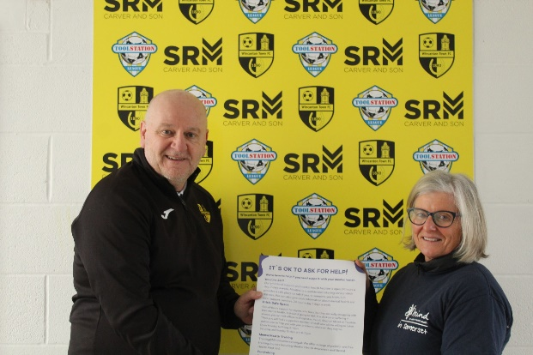
WASPS SUPPORT MIND IN SOMERSET
Wincanton Town played host to the latest leg of Toolstation Western League’s partnership with Mind in Somerset.
Ian Nockolds was joined at the Wincanton Sports Ground by Alison Baker, Corporate Partnership Co-Ordinator at Mind in Somerset, with the duo meeting people at the club to discuss the league’s campaign to promote positive mental wellbeing. Click here to read more.
On the latest episode of the podcast, Torpoint Athletic boss Dean Cardew explains why he’s targeting a good run of form to finish the season to give them a boost heading into 2024/25. Ian then catches up with Wells City Chairman, Steve Loxton, who reflects on his time at the club, the reality of running a Western League side, and the ambition that he hopes will continue after he steps away from the boardroom.
http://toolstationleague.com/season-2023-24-podcast-episode-33/

First Division: In a title race which seems to be changing by the minute, Wincanton Town currently sit top of the pile after beating Warminster 4-2 on Saturday afternoon. Wasps forward Matt Garner has been on a hot-streak in front of goal recently, and that trend continued against Warminster, with his ability to get on the end of set pieces spearheading their victory. Having already headed the home side into a two-goal advantage, Garner then completed his hat-trick just prior to half time when he met Jamie Thompson’s in-swinging corner. Warminster threatened a fightback, scoring twice to heavily reduce the arrears, before Winky returned to their tried and trusted method with Garner heading home a fourth corner ten minutes from time to complete the scoring. A log-jam behind Wincanton sees three sides level on 74 points including Cribbs Reserves who won 3-1 away at Middlezoy thanks to goals from Andrew Forward, Gerlando Parrinello and Tom Headford. The other two sides met at Portishead, where the home side squeezed past Radstock by a goal to nil. Having not played each other since early August, little separated the sides then, and it was similar second time around, with only a 20th minute goal from Kyle Egan, rebounding after his own penalty miss giving Portishead the crucial three points.
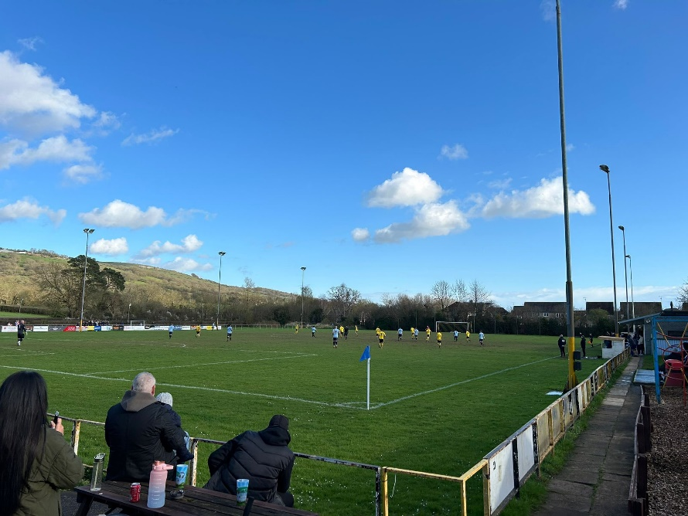
It was a day of comebacks elsewhere in the division, including at Hallen where visitors Wells City struck twice in the final quarter to complete their 3-1 victory. A 20th minute penalty from Cory Thomas-Baker saw Hallen go ahead, only for Wells to hit back on the brink of half-time courtesy of Tom Ovigne. Wells had won five on the bounce heading into this game, and that winning run was extended with leading scorer Harry Warwick coming off the bench to score goals two and three in an impressive road win. Shirehampton were another side who trailed in the opening few minutes before finishing the game strongly to defeat AEK Boco 4-2 at The Creek. For Boco, goals from Ollie Williams and Mickey Parsons put them in front at the beginning of either half, only for the home side to draw level on each occasion thanks to frontman Ryan Radford. The second of Radford’s equalisers came with just 17 minutes left on the clock, but that left Shirehampton plenty of time to push for victory, and they did just that with Louis Snailham’s long ranger making it 3-2, before he then struck again in added time to round out the win. Fifth-placed Bitton secured another win, with Lewis Russell, Harry Haughton and Joe Garland each netting in their 3-1 defeat of Longwell Green, while Hengrove overturned a half-time deficit on their way to a 2-1 victory over Odd Down. Bottom-side Bishop Sutton picked up their first point in a while following a goalless draw away at Gillingham, and it would have been the same outcome at Cheddar (pictured), only for Dean Chrisostomou to score in the 88th minute to hand the hosts a last-gasp 1-0 win over Bristol Telephones. Points were shared in the other contests, with Keynsham recovering from an early deficit to draw 1-1 with Bradford, while Cadbury Heath denied Brislington a crucial victory during their 1-1 draw in Bristol.
Latest Results
Tuesday 19th March 2024
Premier Division
Bridgwater United 2-2 Helston Athletic 238
Saltash United 0-0 Barnstaple Town 114
First Division
Bishop Sutton 2-6 Longwell Green Sports 48
Bristol Telephones 0-1 Wells City 53
Gillingham Town 3-4 Wincanton Town 102

Wednesday 20th March 2024
Premier Division
Oldland Abbotonians 0-3 Torpoint Athletic 70
Street A-A Wellington
First Division
AEK Boco 1-2 Middlezoy Rovers 62

Saturday 23rd March 2024
Premier Division
Brixham 3-0 Ilfracombe Town 142
Falmouth Town 1-0 Nailsea & Tickenham 455
Millbrook 0-4 Barnstaple Town 79
Shepton Mallet 0-2 Bridgwater United
St Blazey P-P Torpoint Athletic
Wellington 2-1 Oldland Abbotonians 87
Welton Rovers 1-2 Helston Athletic 80
First Division
Brislington 1-1 Cadbury Heath 115
Cheddar 1-0 Bristol Telephones 88
Gillingham Town 0-0 Bishop Sutton 37
Hallen 1-3 Wells City 52
Hengrove Athletic 2-1 Odd Down 74
Keynsham Town 1-1 Bradford Town 135
Longwell Green Sports 1-3 Bitton
Middlezoy Rovers 1-3 Cribbs Reserves 80
Portishead Town 1-0 Radstock Town 362
Shirehampton 4-2 AEK Boco 76
Wincanton Town 4-2 Warminster Town 72
Leading Goalscorers (Stats courtesy of FA Fulltime Website)
Premier Division
Jared Lewington (Buckland) – 29
Ryan Richards (Torpoint) – 22
Jack Thorne (Bridgwater) – 21
Phil Ormrod (Street) - 17
Rikki Sheppard (Helston) – 17
Rubin Wilson (Falmouth) – 17
Oscar Massey (Falmouth) – 17

First Division
Ethan Feltham (Portishead) – 42
Matt Garner (Wincanton) – 31
Liam Winter (Middlezoy) - 23
Louis Snailham (Shirehampton) – 21
Liam Clayton (Cribbs Reserves) – 20
Joe Beardwell (Bitton) - 18

All Competitions
Ethan Feltham (Portishead) – 45
Jared Lewington (Buckland) – 34
Matt Garner (Wincanton) – 33
Jack Thorne (Bridgwater) – 27
Louis Snailham (Shirehampton) – 25
Ryan Richards (Torpoint) - 24
Liam Winter (Middlezoy) – 23
Liam Clayton (Cribbs Reserves) - 23

Upcoming Fixtures
Tuesday 26th March 2024
Premier Division
Barnstaple Town vs Welton Rovers 19:45KO
Street vs Falmouth Town 19:45KO
Wellington vs Saltash United 19:30KO
First Division
Bradford Town vs Gillingham Town 19:30KO
Brislington vs Portishead Town 19:30KO
Hallen vs Radstock Town 19:30KO
Warminster Town vs Cheddar 19:45KO
Wells City vs Bristol Telephones 19:30KO

Thursday 28th March 2024
First Division
Bitton vs Cadbury Heath 19:30KO

Friday 29th March 2024 (3pm Kick-off unless noted otherwise)
Premier Division
Bridgwater United vs Wellington 13:00KO
Buckland Athletic vs Brixham 13:00KO
Helston Athletic vs Falmouth Town
Ilfracombe Town vs Barnstaple Town
Millbrook vs Torpoint Athletic 11:00KO
Nailsea & Tickenham vs Clevedon Town
Oldland Abbotonians vs Welton Rovers
St Blazey vs Saltash United 11:00KO
Street vs Shepton Mallet 13:00KO

First Division
AEK Boco vs Longwell Green Sports
Bishop Sutton vs Cheddar
Bradford Town vs Warminster Town
Brislington vs Keynsham Town
Bristol Telephones vs Hengrove Athletic
Cribbs Reserves vs Portishead Town
Odd Down vs Radstock Town 12:30KO
Middlezoy Rovers vs Wells City 13:00KO
Shirehampton vs Hallen
Wincanton Town vs Gillingham Town 13:00KO

League Tables
 | PREMIER DIVISION | Played | Won | Drawn | Lost | GD | Points
1 | Helston Athletic | 27 | 21 | 3 | 3 | 68 | 66
2 | Clevedon Town | 27 | 19 | 4 | 4 | 45 | 61
3 | Falmouth Town | 25 | 18 | 3 | 4 | 40 | 57
4 | Bridgwater United | 27 | 18 | 2 | 7 | 37 | 56
5 | Buckland Athletic | 29 | 15 | 6 | 8 | 33 | 51
6 | Barnstaple Town | 25 | 14 | 8 | 3 | 30 | 50
7 | Shepton Mallet | 27 | 13 | 6 | 8 | 10 | 45
8 | Brixham AFC | 28 | 12 | 8 | 8 | 26 | 44
9 | Torpoint Athletic | 27 | 12 | 4 | 11 | 1 | 40
10 | Nailsea & Tickenham | 27 | 11 | 1 | 15 | 2 | 34
11 | Street | 27 | 9 | 7 | 11 | -3 | 34
12 | St Blazey | 27 | 9 | 5 | 13 | -9 | 32
13 | Ilfracombe Town | 24 | 6 | 8 | 10 | -8 | 26
14 | Wellington | 26 | 4 | 8 | 14 | -39 | 20
15 | Saltash United | 25 | 5 | 4 | 16 | -19 | 19
16 | Oldland Abbotonians | 26 | 5 | 0 | 21 | -49 | 15
17 | Welton Rovers | 25 | 3 | 5 | 17 | -43 | 14
18 | Millbrook | 25 | 2 | 0 | 23 | -122 | 6
 | FIRST DIVISION | Played | Won | Drawn | Lost | GD | Points
1 | Wincanton Town | 35 | 24 | 4 | 7 | 30 | 76
2 | Portishead Town | 31 | 23 | 5 | 3 | 67 | 74
3 | Radstock Town | 35 | 23 | 5 | 7 | 44 | 74
4 | Cribbs Reserves | 36 | 23 | 5 | 8 | 38 | 74
5 | Bitton | 33 | 19 | 8 | 6 | 31 | 65
6 | Wells City | 32 | 21 | 2 | 9 | 29 | 65
7 | Brislington | 30 | 20 | 4 | 6 | 67 | 64
8 | AEK Boco | 34 | 17 | 6 | 11 | 20 | 57
9 | Middlezoy Rovers | 35 | 17 | 2 | 16 | 3 | 53
10 | Longwell Green Sports | 37 | 16 | 5 | 16 | -1 | 53
11 | Bristol Telephones | 34 | 16 | 4 | 14 | -12 | 52
12 | Bradford Town | 35 | 14 | 9 | 12 | 16 | 51
13 | Cadbury Heath | 35 | 15 | 4 | 16 | 10 | 49
14 | Hallen | 33 | 13 | 7 | 13 | -2 | 46
15 | Odd Down | 36 | 11 | 5 | 20 | -43 | 38
16 | Shirehampton | 34 | 10 | 6 | 18 | -10 | 36
17 | Hengrove Athletic | 35 | 9 | 6 | 20 | -28 | 33
18 | Gillingham Town | 32 | 9 | 3 | 20 | -27 | 30
19 | Keynsham Town | 34 | 9 | 3 | 22 | -31 | 30
20 | Warminster Town | 34 | 7 | 7 | 20 | -30 | 28
21 | Cheddar | 30 | 5 | 1 | 24 | -35 | 16
22 | Bishop Sutton | 36 | 0 | 3 | 33 | -136 | 3

