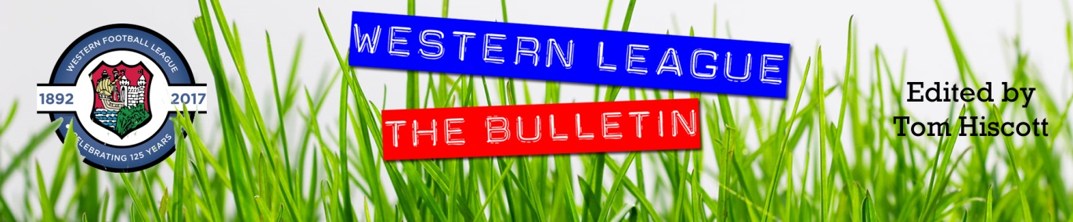
Latest Round-ups:
#34
Season 2023/24

Midweek Action: Despite more treacherous conditions across the South West, three First Division matches took place on Wednesday evening, bringing wins for Cadbury Heath, AEK Boco and Brislington. For the Heath, George Boon’s audacious chip at the end of the first half helped lead them to a 2-0 victory over Warminster. Boon’s effort was then followed up by a Josh Williams strike later in the piece to hand the Springfield club their third successive home win. The other two fixtures both went the way of the visitors, with Brislington winning by two goals to nil against Shirehampton and Oaklands Park. Goals in either half from Jay Malpas and Neikell Plummer proved to be enough for Bris, with both scorers also having notched in their big weekend victory over Bradford. At the Lawns, Cribbs Reserves recent struggles continued, as they relinquished an early advantage in their 2-1 loss against Boco. Having suffered a heavy defeat four days previously, Cribbs looked to have responded well after taking an early lead through Aubrey Raymond-Barker. The visitors didn’t let that early goal deter them, and after drawing level through Luke Bryan, the same man then scored again shortly after to give Boco back-to-back wins.
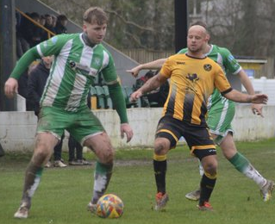
Premier Division: With a little bit of respite on the weather front, a strong set of fixtures saw plenty of goalscoring action with the top sides flexing their muscles on Saturday afternoon. League leaders Helston maintained their one-point advantage thanks to a 2-0 win at home to Brixham. It took the hosts 31 minutes to break the deadlock, with Rikki Sheppard heading home Jordan Copp’s corner, and then in the early stages of the second half, they added to their lead with Jacob Smith stroking the ball home. Clevedon remain hot on Helston’s tails, beating Welton 5-0 to add some impetus to their title charge. After opening the scoring in the seventh minute, Syd Camper was on hand again on the half-hour, heading home to make it 2-0 to the hosts. A goal early in the second half from Sam Beresford extended the lead further, before late efforts from Harlee Vozza and Alex Camm completed the scoring. There was incredible drama at The Mill, where Ryan Richards (pictured, right) scored all four of Torpoint’s goals in their 4-2 victory over Street. With the game level at one apiece heading into the final ten minutes, Eli Collins fired the Cobblers in front as they looked to pinch all three points. That goal seemed to fire up the home side, and Richards in particular, with his second goal of the afternoon making it two apiece with three minutes left on the lock. Richards wasn’t finished there however, and after completing his hat-trick in the 90th minute, he then added a fourth in stoppage time to put the finishing touches on an outstanding individual performance. 4-2 was also the full-time score at Barnstaple, where the hosts held off an attempted comeback from Oldland Abbotonians to move up into sixth spot. Town were untouchable during the opening half hour of the contest, storming into a four-goal lead thanks to four different goalscorers, with Harvey Dorothy, Matty Andrew, Brodie Montague and Charlie Prentice all finding the back of the net. Tom Blake then scored what looked to be a consolation at the end of the first half, but to give Oldland credit, they continued to put a scare in their hosts, with Harrison Kyte trimming the deficit in what ended up being a losing battle.
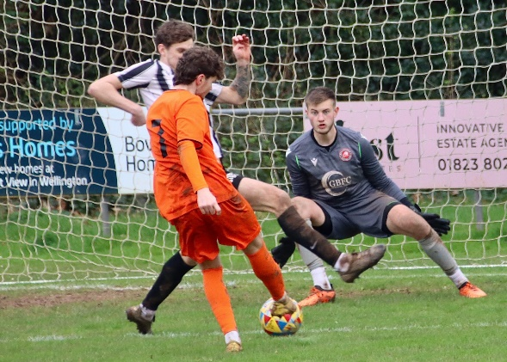
Falmouth’s winning run shows no signs of slowing, with Cornish outfit easing to a 4-1 win away at Bridgwater. Town made a dream start to the contest, and led within a minute of the game kicking off thanks to their in-form frontman Oscar Massey. Another goal inside the opening ten minutes from Luke Barner extended Falmouth’s lead further, with the game then coming to life again in the early stages of the second half. Bridgwater looked to have earned a way back into the game, only to see Adam Wright’s spot kick saved, and then moments later, Wright’s strike partner Jack Taylor had a goal ruled out thanks to the linesman’s flag. Things went from bad to worse for the hosts when Jared Sims made it 3-0, with another goal shortly after from Rubin Wilson ending any hopes of a late fightback. Ilfracombe twice came from behind to draw 2-2 in their home clash against Buckland, with Jack Magarotto netting 13 minutes from time to grab a share of the spoils. Wellington were the day’s biggest risers, moving up 15th after Sully McKenna goals in either half saw the Tangerines beat Millbrook 3-1 (pictured, left)
First Division: Four points now cover the top four sides in the First Division, after table-topping Radstock stumbled in their home clash with Bristol Telephones. Falling to a 2-0 defeat, the Miners have now only collected four points from a possible nine since the beginning of March and have allowed the chasing pack to close in on them. One side to capitalise on Saturday afternoon was Cribbs Reserves, with Liam Clayton scoring twice in their 4-2 win away at Longwell Green Sports. Clayton’s opener made it 1-0 to the away side after only nine minutes, before an own goal shortly after got Longwell Green back level. Cribbs gradually began to pull away, with James Capon handing them a 2-1 lead at the interval, before Clayton struck again to extend their advantage. A goal 12 minutes from time threatened to add some late spice, but Cribbs had enough in the tank, restoring their two-goal advantage with a stabbed finish from Tom Headford. Coming up on the rails in fourth spot are Wincanton Town, with a ninth win from ten helping them surge into the title race. Their latest three points came thanks to a 4-0 home win over Bishop Sutton, with first half efforts from Jamie Thompson and Tom Jarvis, followed up after half-time by Connor Williams and Lewis Townsend. Shirehampton enjoyed one of their biggest league wins of the season, putting four past a struggling Warminster outfit to register their ninth victory of campaign. Rich Brightwell’s double was the catalyst for Shirehampton, with further goals from Tom Duffin, and leading scorer Louis Snailham helping them win their first league game since early December. Will Stead was also able to grab a double, scoring both of Bradford’s goals in their 2-0 win at Cadbury Heath, while Hengrove thumped Keynsham 4-0 to leapfrog their visitors up into 17th spot. The other game saw Wells come out on top in a five-goal thriller at home to Odd Down, finally holding onto their third lead of the afternoon to claim maximum points. Goals from Harry Warwick and Steve Murray had twice put City in front, but after conceding on both occasions, a late Joe Morgan finally proved to be enough as Wells extended their winning run to four matches.
On the podcast this week, we hear from Clevedon Town boss, Alex White, who explains how important it is for the modern manager to understand players mental wellbeing. Gillingham Town manager, Olly Feltham, also joins the show to talk about his sides climb away from the relegation places, before then touching on the footballing apprenticeship he has undertaken which has led him to the dugout.
http://toolstationleague.com/season-2023-24-podcast-episode-32/

Latest Results
Wednesday 13th March 2024
First Division
Cadbury Heath 2-0 Warminster Town 44
Cribbs Reserves 1-2 AEK Boco
Shirehampton 0-2 Brislington 97

Saturday 16th March 2024
Premier Division
Barnstaple Town 4-2 Oldland Abbotonians 148
Bridgwater United 1-4 Falmouth Town 334
Clevedon Town 5-0 Welton Rovers 170
Helston Athletic 2-0 Brixham 198
Ilfracombe Town 2-2 Buckland Athletic 55
Nailsea & Tickenham P-P St Blazey
Saltash United P-P Shepton Mallet
Torpoint Athletic 4-2 Street 122
Wellington 3-1 Millbrook 91
First Division
AEK Boco P-P Middlezoy Rovers
Cadbury Heath 0-2 Bradford Town
Cheddar P-P Hallen
Gillingham Town P-P Bitton
Hengrove Athletic 4-0 Keynsham Town
Longwell Green Sports 2-4 Cribbs Reserves 171
Portishead Town P-P Brislington
Radstock Town 0-2 Bristol Telephones 56
Warminster Town 1-4 Shirehampton 119
Wells City 3-2 Odd Down
Wincanton Town 4-0 Bishop Sutton 72

Leading Goalscorers (Stats courtesy of FA Fulltime Website)
Premier Division
Jared Lewington (Buckland) – 29
Ryan Richards (Torpoint) – 20
Jack Thorne (Bridgwater) – 20
Phil Ormrod (Street) - 17
Rikki Sheppard (Helston) – 17
Rubin Wilson (Falmouth) – 17
Oscar Massey (Falmouth) – 17

First Division
Ethan Feltham (Portishead) – 42
Matt Garner (Wincanton) – 27
Liam Winter (Middlezoy) - 23
Liam Clayton (Cribbs Reserves) – 20
Louis Snailham (Shirehampton) – 19
Joe Beardwell (Bitton) - 18

All Competitions
Ethan Feltham (Portishead) – 45
Jared Lewington (Buckland) – 34
Matt Garner (Wincanton) – 29
Jack Thorne (Bridgwater) – 26
Liam Winter (Middlezoy) – 23
Louis Snailham (Shirehampton) – 23
Liam Clayton (Cribbs Reserves) - 23
Harry Warwick (Wells) – 22

Upcoming Fixtures
Tuesday 19th March 2024
Premier Division
Bridgwater United vs Helston Athletic 19:45KO
Saltash United vs Barnstaple Town 19:30KO
First Division
Bishop Sutton vs Longwell Green Sports 19:30KO
Brislington vs Hallen 19:30KO
Bristol Telephones vs Wells City 19:45KO
Cheddar vs Portishead Town 19:45KO
Gillingham Town vs Wincanton Town 19:30KO

Wednesday 20th March 2024
Premier Division
Millbrook vs Ilfracombe Town 19:45KO
Oldland Abbotonians vs Torpoint Athletic 19:45KO
Street vs Wellington 19:30KO
First Division
AEK Boco vs Middlezoy Rovers 19:30KO

Saturday 23rd March 2024 (3pm Kick-off unless noted otherwise)
Premier Division
Brixham vs Ilfracombe Town
Falmouth Town vs Nailsea & Tickenham
Millbrook vs Barnstaple Town
Shepton Mallet vs Bridgwater United
St Blazey vs Torpoint Athletic
Wellington vs Oldland Abbotonians
Welton Rovers vs Helston Athletic
First Division
Brislington vs Cadbury Heath
Cheddar vs Bristol Telephones
Gillingham Town vs Bishop Sutton
Hallen vs Wells City
Hengrove Athletic vs Odd Down
Keynsham Town vs Bradford Town
Longwell Green Sports vs Bitton
Middlezoy Rovers vs Cribbs Reserves
Portishead Town vs Radstock Town
Shirehampton vs AEK Boco
Wincanton Town vs Warminster Town

League Tables
 | PREMIER DIVISION | Played | Won | Drawn | Lost | GD | Points
1 | Helston Athletic | 25 | 20 | 2 | 3 | 67 | 62
2 | Clevedon Town | 27 | 19 | 4 | 4 | 45 | 61
3 | Falmouth Town | 24 | 17 | 3 | 4 | 39 | 54
4 | Bridgwater United | 25 | 17 | 1 | 7 | 35 | 52
5 | Buckland Athletic | 29 | 15 | 6 | 8 | 33 | 51
6 | Barnstaple Town | 23 | 13 | 7 | 3 | 26 | 46
7 | Shepton Mallet | 26 | 13 | 6 | 7 | 12 | 45
8 | Brixham AFC | 27 | 11 | 8 | 8 | 23 | 41
9 | Torpoint Athletic | 26 | 11 | 4 | 11 | -2 | 37
10 | Nailsea & Tickenham | 26 | 11 | 1 | 14 | 3 | 34
11 | Street | 27 | 9 | 7 | 11 | -3 | 34
12 | St Blazey | 27 | 9 | 5 | 13 | -9 | 32
13 | Ilfracombe Town | 23 | 6 | 8 | 9 | -5 | 26
14 | Saltash United | 24 | 5 | 3 | 16 | -19 | 18
15 | Wellington | 25 | 3 | 8 | 14 | -40 | 17
16 | Oldland Abbotonians | 24 | 5 | 0 | 19 | -45 | 15
17 | Welton Rovers | 24 | 3 | 5 | 16 | -42 | 14
18 | Millbrook | 24 | 2 | 0 | 22 | -118 | 6
 | FIRST DIVISION | Played | Won | Drawn | Lost | GD | Points
1 | Radstock Town | 34 | 23 | 5 | 6 | 45 | 74
2 | Portishead Town | 30 | 22 | 5 | 3 | 66 | 71
3 | Cribbs Reserves | 35 | 22 | 5 | 8 | 36 | 71
4 | Wincanton Town | 33 | 22 | 4 | 7 | 27 | 70
5 | Brislington | 29 | 20 | 3 | 6 | 67 | 63
6 | Bitton | 32 | 18 | 8 | 6 | 29 | 62
7 | Wells City | 30 | 19 | 2 | 9 | 26 | 59
8 | AEK Boco | 32 | 17 | 6 | 9 | 23 | 57
9 | Bristol Telephones | 32 | 16 | 4 | 12 | -10 | 52
10 | Bradford Town | 34 | 14 | 8 | 12 | 16 | 50
11 | Middlezoy Rovers | 33 | 16 | 2 | 15 | 4 | 50
12 | Longwell Green Sports | 35 | 15 | 5 | 15 | -3 | 50
13 | Cadbury Heath | 34 | 15 | 3 | 16 | 10 | 48
14 | Hallen | 32 | 13 | 7 | 12 | 0 | 46
15 | Odd Down | 35 | 11 | 5 | 19 | -42 | 38
16 | Shirehampton | 33 | 9 | 6 | 18 | -12 | 33
17 | Hengrove Athletic | 34 | 8 | 6 | 20 | -29 | 30
18 | Gillingham Town | 30 | 9 | 2 | 19 | -26 | 29
19 | Keynsham Town | 33 | 9 | 2 | 22 | -31 | 29
20 | Warminster Town | 33 | 7 | 7 | 19 | -28 | 28
21 | Cheddar | 29 | 4 | 1 | 24 | -36 | 13
22 | Bishop Sutton | 34 | 0 | 2 | 32 | -132 | 2

