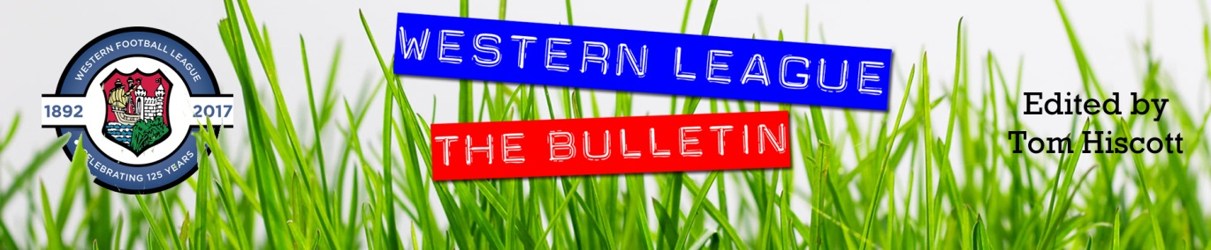
Latest Round-ups:
#33
Season 2023/24

Midweek Action: Cribbs Reserves made a big move in the First Division title race on Wednesday evening, beating Odd Down 2-0 to cut the gap at the top. Goals from Jack Guthrie and Andrew Forward proved to be enough for the Bristol side who capitalised on Radstock’s slip-up the night before, with the Miners dropping two points in their 1-1 draw with Warminster. Having taken the lead through Jacob Reader, Radstock were pegged back just prior to half-time by Reece Collyer and were then unable to find a further breakthrough during the second half. In Tuesday’s other fixture, Hallen secured a tight 1-0 victory over Hengrove, with Luke Banfield’s 26th minute strike separating the sides.
The Premier Division action on Wednesday saw a pair of away wins, with Brixham finishing strongly to prevail by three goals to one at St Blazey. In a clash between the two South West Peninsula Champions from last season, it was the West Division winners Brixham who went ahead in the early stages thanks to Charlie Johansen. The East champs managed to get back on level terms right at the beginning of the second half courtesy of Luke Cloke, but things then derailed for hosts after they were reduced to ten men, with Josh Parry and Tom Mortimore scoring in the final 20 minutes to help Brixham take home all three points from Blaise Park. The other away victors were Nailsea & Tickenham, with a pair of goals late in the first half from Lucas Vowles and Hamish Hurst leading them to a 2-0 win over Oldland Abbotonians.
Premier Division: Helston overcame a tough trip to Street, prevailing by three goals to nil to maintain their slender lead atop the league table. A tight opening half saw the game remain goalless for 43 minutes, until the away side were awarded a penalty which was duly converted by Jordan Copp. Helston then added to their advantage early in the second period through Tom Payne, before Copp struck again in the closing stages to complete the victory. Second-placed Clevedon mirrored Helston’s 3-0 victory, scoring twice in the final ten minutes to see off Barnstaple at the Hand Stadium. Goals in either half from Freddie King proved pivotal for the hosts, with Harley Vozza also getting on the scoresheet with a smart finish during the final ten minutes. Another player to score twice on Saturday afternoon was Buckland’s Jared Lewington, with the division’s leading marksman helping fire his side to a 3-1 win over Nailsea & Tickenham. A close range strike from Lewington got the ball rolling for the Bucks early on, with Josh Grant then making it 2-0 inside 15 minutes. Lewington managed to strike again at the end of the first half to all-but end the contest, with Nailsea’s Luke Osgood reducing the deficit slightly after the interval. 3-1 was a very popular scoreline all afternoon, with both Shepton Mallet and Brixham grabbing victories by the same margin. For Brixham, three goals in the space of ten second half minutes from Scott Robinson, Tom Mortimore and Charlie Johansen did all the damage in their away win over Oldland Abbotonians.
In Somerset, Shepton followed up their Les Phillips semi-final triumph with another impressive home victory over St Blazey. First half efforts from Charlie Bateson and Joel Sisson put Mallet in position to push for victory, with Paul Braithwaite extending the lead out further prior to a late consolation for the Cornish outfit courtesy of George Newton. Bridgwater were the afternoon’s other winners, with goals either side of the interval from Ben Griffith and Jack Taylor helping them defeat Welton by two goals to nil. Elsewhere, Falmouth’s epic run in the FA Vase was ended in Essex, with a pair of second half goals from Harry Talbot leading Great Wakering Rovers to a 2-0 win.
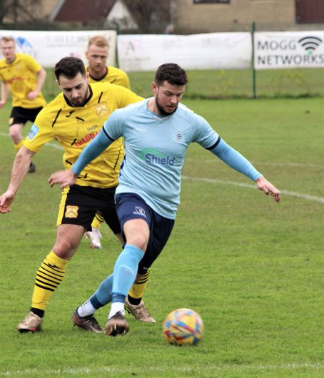
First Division: It was another huge day in the title race, with most of the top sides securing maximum points on Saturday afternoon. The only team to end the day in the top ten who didn’t win this weekend were Cribbs Reserves who suffered a chastening 4-0 defeat at home to Wells City. There was only one goal separating the sides at half-time, with a Joe Morgan header in the tenth minute putting Wells in front. Morgan then struck again midway through the second half to extend Wells’ advantage, before a couple of powerful finishes in the closing stages from Fin Wilkinson and Tom Ovigne completed the one-sided victory. Top beat bottom at the Southfields Rec, where a hat-trick from Martin Johnson and a cross-come-shot from Jack Farion saw Radstock ease to a 4-0 victory over Bishop Sutton. Second-placed Portishead did their goal difference no harm whatsoever on their trip to Bath, putting nine past a mismatched Odd Down side. Ethan Feltham’s prolific campaign shows no signs of slowing down, and he grabbed yet another hat-trick during the demolition job, with new signing Ben Bament making an instant impact thanks to an early brace. Another debutant, Jack Ball also struck twice for Town, with Callum Eastwood and Toby Lawrence each scoring during the second half. Wincanton remain very much ensconced in the title race, beating Hengrove 2-0 courtesy of goals from Jamie Irwin and Matt Garner, while Brislington ran out 4-0 winners over Bradford Town to maintain their chances of catching the top four. With the game deadlocked at the break, Bris came out firing in the second period with Jack Fillingham putting them one-up within two minutes of the restart. Another goal from Jay Malpas shortly after edged Brislington into a two-goal advantage which was doubled during the final minutes thanks to Neikell Plummer and Ali Sen. The late drama came at Bitton, where star-man Joe Beardwell struck at the death to help the home side beat Keynsham 2-1. Earlier in the contest, Beardwell had converted an early penalty to make it 1-0, only for Jack Weaver to draw the K’s level from with a smart finish from outside the area. Elliot Gardner scored a double of his own, grabbing two second half goals in Hallen’s 2-1 come-from-behind victory over Cadbury Heath. Elsewhere, a Sam Thomas header in the 20th minute saw Boco beat Cheddar 1-0 (pictured, right), while Middlezoy reached the 50-point mark thanks to a 3-1 win at home to Warminster. The other two matches both ended in away wins, with Kris Hastings scoring the only goal in Gillingham’s defeat of Shirehampton, and Longwell Green romping to a 4-1 victory at Bristol Telephones where Matt Brown scored in either half.

Latest Results
Tuesday 5th March 2024
Hallen 1-0 Hengrove Athletic
Radstock Town 1-1 Warminster Town 74

Wednesday 6th March 2024
Premier Division
Oldland Abbotonians 0-2 Nailsea & Tickenham 80
St Blazey 1-3 Brixham AFC 102
First Division
Cribbs Reserves 2-0 Odd Down 31

Saturday 9th March 2024
FA Vase Quarter-Final
Great Wakering Rovers 2-0 Falmouth Town
Premier Division
Buckland Athletic 3-1 Nailsea & Tickenham 263
Clevedon Town 3-0 Barnstaple Town
Millbrook A-A Ilfracombe Town
Oldland Abbotonians 1-3 Brixham
Shepton Mallet 3-1 St Blazey 177
Street 0-3 Helston Athletic 80
Torpoint Athletic P-P Saltash United
Welton Rovers 0-2 Bridgwater United 92
First Division
AEK Boco 1-0 Cheddar
Bitton 2-1 Keynsham Town 77
Brislington 4-0 Bradford Town 109
Bristol Telephones 1-4 Longwell Green Sports 53
Cribbs Reserves 0-4 Wells City 30
Hallen 2-1 Cadbury Heath 52
Middlezoy Rovers 3-1 Warminster Town 200
Odd Down 0-9 Portishead Town
Radstock Town 4-0 Bishop Sutton 72
Shirehampton 0-1 Gillingham Town 41
Wincanton Town 2-0 Hengrove Athletic 72
Leading Goalscorers (Stats courtesy of FA Fulltime Website)
Premier Division
Jared Lewington (Buckland) – 27
Jack Thorne (Bridgwater) – 20
Phil Ormrod (Street) - 17
Ryan Richards (Torpoint) – 16
Rikki Sheppard (Helston) – 16
Rubin Wilson (Falmouth) – 16
Oscar Massey (Falmouth) – 16
Sam Beresford (Clevedon) – 15

First Division
Ethan Feltham (Portishead) – 39
Matt Garner (Wincanton) – 26
Liam Winter (Middlezoy) - 21
Liam Clayton (Cribbs Reserves) – 18
Louis Snailham (Shirehampton) – 18
Milo Murgatroyd (Odd Down) – 16
Harry Warwick (Wells) – 16
Joe Beardwell (Bitton) - 16

All Competitions
Ethan Feltham (Portishead) – 42
Jared Lewington (Buckland) – 32
Matt Garner (Wincanton) – 28
Jack Thorne (Bridgwater) – 26
Louis Snailham (Shirehampton) – 22
Liam Clayton (Cribbs Reserves) - 21
Liam Winter (Middlezoy) – 21
Harry Warwick (Wells) – 21

Upcoming Fixtures
Tuesday 12th March 2024
Premier Division
Barnstaple Town vs Helston Athletic 19:45KO
First Division
Bitton vs Wincanton Town 19:30KO
Bristol Telephones vs Keynsham Town 19:45KO
Odd Down vs Hengrove Athletic 19:45KO
Wells City vs Portishead Town 19:30KO

Wednesday 13th March 2024
Premier Division
Millbrook vs St Blazey 19:30KO
Oldland Abbotonians vs Shepton Mallet 19:45KO
First Division
Cadbury Heath vs Warminster Town 19:30KO
Cribbs Reserves vs AEK Boco 19:30KO
Shirehampton vs Brislington 19:30KO

Saturday 16th March 2024 (3pm kick-off unless noted)
Premier Division
Barnstaple Town vs Oldland Abbotonians
Bridgwater United vs Falmouth Town
Clevedon Town vs Welton Rovers
Helston Athletic vs Brixham
Ilfracombe Town vs Buckland Athletic
Nailsea & Tickenham vs St Blazey
Saltash United vs Shepton Mallet
Torpoint Athletic vs Street
Wellington vs Millbrook
First Division
AEK Boco vs Middlezoy Rovers
Cadbury Heath vs Bradford Town
Cheddar vs Hallen
Gillingham Town vs Bitton
Hengrove Athletic vs Keynsham Town
Longwell Green Sports vs Cribbs Reserves
Portishead Town vs Brislington
Radstock Town vs Bristol Telephones
Warminster Town vs Shirehampton
Wells City vs Odd Down
Wincanton Town vs Bishop Sutton

League Tables
 | PREMIER DIVISION | Played | Won | Drawn | Lost | GD | Points
1 | Helston Athletic | 24 | 19 | 2 | 3 | 65 | 59
2 | Clevedon Town | 26 | 18 | 4 | 4 | 40 | 58
3 | Bridgwater United | 24 | 17 | 1 | 6 | 38 | 52
4 | Falmouth Town | 23 | 16 | 3 | 4 | 36 | 51
5 | Buckland Athletic | 28 | 15 | 5 | 8 | 33 | 50
6 | Shepton Mallet | 26 | 13 | 6 | 7 | 12 | 45
7 | Barnstaple Town | 22 | 12 | 7 | 3 | 24 | 43
8 | Brixham AFC | 26 | 11 | 8 | 7 | 25 | 41
9 | Nailsea & Tickenham | 26 | 11 | 1 | 14 | 3 | 34
10 | Street | 26 | 9 | 7 | 19 | -1 | 34
11 | Torpoint Athletic | 25 | 10 | 4 | 11 | -4 | 34
12 | St Blazey | 27 | 9 | 5 | 13 | -9 | 32
13 | Ilfracombe Town | 22 | 6 | 7 | 9 | -5 | 25
14 | Saltash United | 24 | 5 | 3 | 16 | -19 | 18
15 | Oldland Abbotonians | 23 | 5 | 0 | 18 | -43 | 15
16 | Welton Rovers | 23 | 3 | 5 | 15 | -37 | 14
17 | Wellington | 24 | 2 | 8 | 14 | -42 | 14
18 | Millbrook | 23 | 2 | 0 | 21 | -116 | 6
 | FIRST DIVISION | Played | Won | Drawn | Lost | GD | Points
1 | Radstock Town | 33 | 23 | 5 | 5 | 47 | 74
2 | Portishead Town | 30 | 22 | 5 | 3 | 66 | 71
3 | Cribbs Reserves | 33 | 21 | 5 | 7 | 35 | 68
4 | Wincanton Town | 32 | 21 | 4 | 7 | 23 | 67
5 | Bitton | 32 | 18 | 8 | 6 | 29 | 62
6 | Brislington | 28 | 19 | 3 | 6 | 65 | 60
7 | Wells City | 29 | 18 | 2 | 9 | 25 | 56
8 | AEK Boco | 31 | 16 | 6 | 9 | 22 | 54
9 | Middlezoy Rovers | 33 | 16 | 2 | 15 | 4 | 50
10 | Longwell Green Sports | 34 | 15 | 5 | 14 | -1 | 50
11 | Bristol Telephones | 31 | 15 | 4 | 12 | -12 | 49
12 | Bradford Town | 33 | 13 | 8 | 12 | 14 | 47
13 | Hallen | 32 | 13 | 7 | 12 | 0 | 46
14 | Cadbury Heath | 32 | 14 | 3 | 15 | 10 | 45
15 | Odd Down | 34 | 11 | 5 | 18 | -41 | 38
16 | Shirehampton | 31 | 8 | 6 | 17 | -13 | 30
17 | Gillingham Town | 30 | 9 | 2 | 19 | -26 | 29
18 | Keynsham Town | 32 | 9 | 2 | 21 | -27 | 29
19 | Warminster Town | 31 | 7 | 7 | 17 | -23 | 28
20 | Hengrove Athletic | 33 | 7 | 6 | 20 | -33 | 27
21 | Cheddar | 29 | 4 | 1 | 24 | -36 | 13
22 | Bishop Sutton | 33 | 0 | 2 | 31 | -128 | 2

