Latest Round-ups:
#30
Season 2023/24

FA Vase: Bridgwater were unable to join Falmouth in the quarter-finals of the Vase after falling to a penalty shootout defeat against Deal Town. United made the worst possible start, falling behind inside the opening minute when Tom Chapman scored from well outside the area to put the visitors in front. The Kent side then doubled their advantage in the 20th minute when Chapman turned provider for teammate Rory Smith who finished well for 2-0. Bridgy used the half-time break to regroup, and came out strongly at the beginning of the second period with Ben Griffiths halving the deficit. Deal were then reduced to ten men on the hour mark, and Bridgwater didn’t take long to utilise that advantage with Jack Thorne drawing the hosts level. It looked like the turnaround was complete when Jack Taylor made it 3-2 shortly after the leveller, but the linesman had spotted an offside and the goal was ruled out. That sent the game to penalties, with Deal winning a dramatic shootout 6-5 and booking their spot in the last eight.
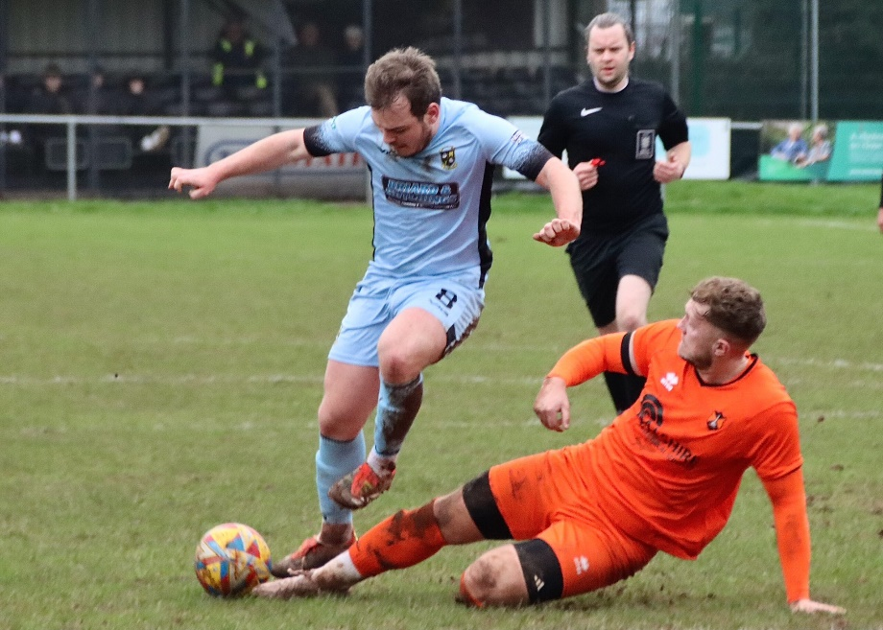
Premier Division: With game falling by the wayside once again, just three went ahead on Saturday afternoon, and they produced a trio of away wins. One of those were secured by the league’s bottom side Millbrook who grabbed just their second three points of the season thanks to a late 3-2 victory at Street. The Cobblers had been in relatively good form coming into the game, but they trailed at the interval courtesy of an own goal. The hosts were much stronger after the interval, but they came unstuck in the final ten minutes, with both Will Sullivan and substitute Adam Beardsmore firing home to lead Millbrook to a memorable win. At the opposite end of the table, Buckland gained ground on the top two thanks to a comeback win away at Wellington (pictured, right). Having fallen behind to Josh Lukins early long-ranger, the Bucks hit back shortly after through Rob Farkins. It was the away side who then pushed on after the break, with leading scorer Jared Lewington adding another goal to his tally to make it 2-1, before Teigan Rosenquest pushed the lead out further in the closing moments thanks to a calm finish from just inside the box.
To complete the set of away victories, Shepton Mallet extended their strong run of results with a 3-0 win at Welton Rovers. The sides were level for the majority of the first half, before Mallet took control of the contest with a pair of quickfire strikes from Cam Allen and Will Banks. A tough afternoon got tougher for Welton who found themselves reduced to nine men on the hour mark, with Mallet finally making the man advantage count in stoppage time when Matt Morris scored at the far post to complete the scoring.
First Division: Earlier in the week, Bitton claimed a 3-2 win away at Keynsham thanks to a star performance from Toby Cole. After falling behind to an early Brandon Oputeri goal, Bitton stormed back behind Cole’s strong showing which saw him score twice, while also laying on the assist for Jacob Saunders who scored the visitor’s third. Joe Davis then struck 20 minutes from time to give Keynsham hope of a late comeback, but Bitton managed to hold on to end their six-match winless run.
Saturday saw five games avoid postponement, with Cadbury Heath among the winners following their 3-1 triumph at home to Middlezoy. The hosts made a fast start with Harry Goldspink breaking the deadlock after only 56 seconds, before Josh Haynes made it 2-0 inside quarter of an hour thanks to a long-range rocket. Rovers got themselves back into the game early in the second half, but the Heath finally wrapped things up five minutes from time courtesy of Zac Cheetham. In the day’s early kickoff, league leaders Portishead clawed back a point in their home clash with Longwell Green Sports. Following a goalless opening half, Longwell Green forged ahead shortly after the restart with Sonny Passco finding the back of the net. Having suffered defeat in their previous outing, Portishead were under pressure not to repeat the trick, and managed to grab a share of the spoils when Callum Eastwood headed home Kyle Egan’s pin-point cross. Cribbs Reserves capitalised on Town’s slip-up, moving within four points of top spot following a 3-0 win at home to Warminster. Having beaten the same opponent 3-1 earlier in the campaign, Cribbs completed the double thanks to goals from Tom Headford, Aaron Coleman and Jack Guthrie. Wells became the eighth side to reach the 50-point mark this season, after goals from Joe Morgan and Harry Warwick led them to a 2-0 win at home to Hengrove. 2-0 was also the result at Lakeview, where bottom side Bishop Sutton fell to defeat at home to Odd Down. In an even contest, two goals at the end of the first half proved to be the difference, with Alfie Andrews and Raphael Waugh both finishing well.

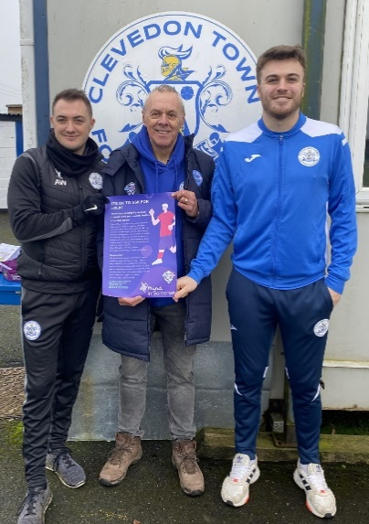
Seasiders Support Mind in Somerset
Clevedon Town was the destination for the latest leg of the Toolstation Western League partnership with Mind in Somerset.
Ian Nockolds was joined at the Everyone Active Stadium by Alison Baker, Corporate Partnership Co-Ordinator at Mind in Somerset. The duo met with fans and club officials to discuss the League’s campaign to promote mental wellbeing which has seen 18 clubs visited to date.
The matchday programme carried an advertisement promoting the support services, and a bucket collection was carried out around the ground to raise money for Mind.

Latest Results
Tuesday 13th February 2024
First Division
Keynsham Town 2-3 Bitton 78

Saturday 17th February 2024
FA Vase
Bridgwater United 2-2 (5-6 Pens) Deal Town
Premier Division
Falmouth Town P-P Ilfracombe Town
Oldland Abbotonians P-P Torpoint Athletic
Saltash United P-P Barnstaple Town
St Blazey P-P Brixham
Street 2-3 Millbrook 84
Wellington 1-3 Buckland Athletic 151
Welton Rovers 0-3 Shepton Mallet 170
First Division
AEK Boco P-P Radstock Town
Bishop Sutton 0-2 Odd Down 39
Bristol Telephones P-P Keynsham Town
Cadbury Heath 3-1 Middlezoy Rovers 42
Cheddar P-P Shirehampton
Cribbs Reserves 3-0 Warminster Town 29
Gillingham Town P-P Wincanton Town
Portishead Town 1-1 Longwell Green Sports
Wells City 2-0 Hengrove Athletic
On the podcast this week, we have a Press Box special, where Ian and Tom are joined by Ross Reid from South West Sports News, and Josh Thomas, formerly a sports reporter for the Weston Mercury and North Somerset Times.
The group discuss Falmouth’s success in the Vase, as well as reflecting on the title and play off races in both the Premier and First Division’s.
http://toolstationleague.com/season-2023-24-podcast-episode-28/

Leading Goalscorers (Stats courtesy of FA Fulltime Website)
Premier Division
Jared Lewington (Buckland) – 27
Jack Thorne (Bridgwater) – 20
Phil Ormrod (Street) - 16
Ryan Richards (Torpoint) – 16
Rikki Sheppard (Helston) – 16
Sam Beresford (Clevedon) – 15
First Division
Ethan Feltham (Portishead) – 39
Matt Garner (Wincanton) – 25
Liam Winter (Middlezoy) - 21
Liam Clayton (Cribbs Reserves) – 18
Louis Snailham (Shirehampton) – 17
Milo Murgatroyd (Odd Down) – 16

All Competitions
Ethan Feltham (Portishead) – 42
Jared Lewington (Buckland) – 31
Matt Garner (Wincanton) – 27
Jack Thorne (Bridgwater) – 27
Liam Clayton (Cribbs Reserves) - 21
Louis Snailham (Shirehampton) – 21
Liam Winter (Middlezoy) - 21

Upcoming Fixtures
Tuesday 20th February 2024
Premier Division
Bridgwater United vs Barnstaple Town 19:45KO
Nailsea & Tickenham vs Welton Rovers 19:30KO
Torpoint Athletic vs Falmouth Town 19:30KO
First Division
Bishop Sutton vs Hengrove Athletic 19:30KO
Bitton vs AEK Boco 19:30KO
Brislington vs Shirehampton 19:30KO
Hallen vs Cheddar 19:30KO
Radstock Town vs Gillingham Town 19:45KO
Wells City vs Warminster Town 19:30KO

Wednesday 21st February 2024
Premier Division
Wellington vs Oldland Abbotonians 19:45KO
First Division
Cadbury Heath vs Cribbs Reserves 19:30KO

Saturday 24th February 2024 (3pm kick-off unless noted)
Premier Division
Bridgwater United vs Millbrook
Helston Athletic vs Clevedon Town
Ilfracombe Town vs Street
Nailsea & Tickenham vs Torpoint Athletic
Oldland Abbotonians vs Brixham
Saltash United vs Welton Rovers
Shepton Mallet vs Barnstaple Town
Wellington vs Falmouth Town
First Division
AEK Boco vs Wells City
Bishop Sutton vs Longwell Green Sports
Brislington vs Warminster Town
Bristol Telephones vs Bradford Town
Cheddar vs Cadbury Heath
Gillingham Town vs Cribbs Reserves
Middlezoy Rovers vs Keynsham Town
Odd Down vs Bitton
Portishead Town vs Hallen
Radstock Town vs Hengrove Athletic
Wincanton Town vs Shirehampton

League Tables
 | PREMIER DIVISION | Played | Won | Drawn | Lost | GD | Points
1 | Helston Athletic | 23 | 18 | 2 | 3 | 62 | 56
2 | Clevedon Town | 25 | 17 | 4 | 4 | 37 | 55
3 | Buckland Athletic | 26 | 14 | 5 | 7 | 33 | 47
4 | Bridgwater United | 22 | 15 | 1 | 6 | 35 | 46
5 | Falmouth Town | 21 | 14 | 3 | 4 | 32 | 45
6 | Shepton Mallet | 24 | 12 | 6 | 6 | 11 | 42
7 | Barnstaple Town | 20 | 11 | 7 | 2 | 26 | 40
8 | Brixham AFC | 23 | 9 | 8 | 6 | 22 | 35
9 | Street | 25 | 9 | 7 | 9 | 2 | 34
10 | Torpoint Athletic | 24 | 10 | 4 | 10 | -2 | 34
11 | St Blazey | 25 | 9 | 5 | 11 | -5 | 32
12 | Nailsea & Tickenham | 23 | 9 | 1 | 13 | 0 | 28
13 | Ilfracombe Town | 22 | 6 | 7 | 9 | -5 | 25
14 | Saltash United | 23 | 4 | 3 | 16 | -22 | 15
15 | Oldland Abbotonians | 21 | 5 | 0 | 16 | -39 | 15
16 | Welton Rovers | 21 | 3 | 5 | 13 | -32 | 14
17 | Wellington | 24 | 2 | 8 | 14 | -42 | 14
18 | Millbrook | 22 | 2 | 0 | 20 | -113 | 6
 | FIRST DIVISION | Played | Won | Drawn | Lost | GD | Points
1 | Portishead Town | 29 | 21 | 5 | 3 | 57 | 68
2 | Radstock Town | 29 | 20 | 4 | 5 | 40 | 64
3 | Cribbs Reserves | 30 | 20 | 4 | 6 | 37 | 64
4 | Wincanton Town | 30 | 19 | 4 | 7 | 20 | 61
5 | Brislington | 27 | 18 | 3 | 6 | 61 | 57
6 | Bitton | 29 | 16 | 7 | 6 | 27 | 55
7 | AEK Boco | 28 | 15 | 5 | 8 | 22 | 50
8 | Wells City | 27 | 16 | 2 | 9 | 17 | 50
9 | Middlezoy Rovers | 32 | 15 | 2 | 15 | 2 | 47
10 | Longwell Green Sports | 33 | 14 | 5 | 14 | -4 | 47
11 | Bradford Town | 30 | 13 | 7 | 10 | 19 | 46
12 | Bristol Telephones | 29 | 14 | 4 | 11 | -10 | 46
13 | Cadbury Heath | 30 | 13 | 3 | 14 | 8 | 42
14 | Hallen | 28 | 10 | 7 | 11 | 0 | 37
15 | Odd Down | 31 | 11 | 4 | 16 | -30 | 37
16 | Shirehampton | 29 | 8 | 6 | 15 | -11 | 30
17 | Keynsham Town | 31 | 9 | 2 | 20 | -26 | 29
18 | Warminster Town | 28 | 7 | 6 | 15 | -17 | 27
19 | Gillingham Town | 28 | 8 | 2 | 18 | -25 | 26
20 | Hengrove Athletic | 28 | 6 | 5 | 17 | -30 | 23
21 | Cheddar | 27 | 4 | 1 | 22 | -34 | 13
22 | Bishop Sutton | 31 | 0 | 2 | 29 | -123 | 2

