Latest Round-ups:
#28
Season 2023/24

Midweek Action: After several midweek postponements to start 2024, the weather finally abated to allow for some entertaining evening fixtures. In the Les Phillips Cup, Shepton Mallet and Shirehampton have both qualified for the semi-finals after coming through their last eight ties. Mallet secured local bragging rights in their quarter-final victory over Wells City, defeating the in-form First Division outfit 2-0 thanks to a strong first-half showing. Having also knocked out Wells in the same competition last season, Mallet made a dream start at the Playing Fields with skipper Jacob Sloggett producing an excellent finish to put them one-up. Charlie Bateson was then on hand to add a second ten minutes before the break, with a strong defensive showing from the hosts helping to shut out a Wells side who were chasing their fifth successive win in all competitions. The following evening, Shirehampton held off a ferocious fightback from Cribbs Reserves to move through to the last four. The early stages belonged exclusively to the visitors, and after a third minute own goal put them ahead, they then doubled their advantage shortly after through leading scorer Louis Snailham. It got even better for Shirehampton when Steve Fitzpatrick headed home to extend the lead, with the game then seemingly done early in the second half when Scott Bamford put them four goals to the good. Substitute Ryan Cainey offered Cribbs a glimmer of hope when he pulled a goal back on the hour mark, but that soon looked immaterial when Nathan Goodwin-Worrell was dismissed while conceding a penalty. Home keeper Kyreese Johnson managed to keep out the resulting spot kick, and that seemed to spark the ten-men into life with Cainey scoring ten minutes from time to cut the gap to two. Incredibly the home side managed to grab another goal in stoppage time courtesy of Jack Guthrie, but their remarkable comeback attempt fell just short on a dramatic night at The Lawns.
In league matters, Seb Scott’s 15th and final goal of the season helped AEK Boco secure a 1-0 victory over Cadbury Heath in their mid-table First Division clash. Then on Wednesday, St Blazey extended their brilliant run of results at Blaise Park with a 4-1 win over fellow Cornish outfit Falmouth. Sitting fourth in the Premier Division, Falmouth would have fancied their chances against bottom-half opposition, but they struggled from the off, falling behind in the third minute to a Jayden Gilbert goal. James Ward managed to get the visitors level on the cusp of half-time, but they were then blown away during the opening 20 minutes of the second half with Luke Cloke striking twice. Ryan Downing then tapped home from close range in the final quarter to extend St Blazey’s lead further, giving them their sixth home league win on the bounce.
On the latest podcast, Shepton Mallet boss, Aaron Seviour, joins Ian to explain how their next man up mentality has helped the rebuilding job they are undertaking to be ahead of schedule. Bradford Town manager, Chris Carr, also joins the show to applaud the link between his players and Bobcats fans. Carr explains why he and his coaches have worked hard to instil the Bradford spirit and how that has translated into improved performances on the pitch.
http://toolstationleague.com/season-2023-24-podcast-episode-26/

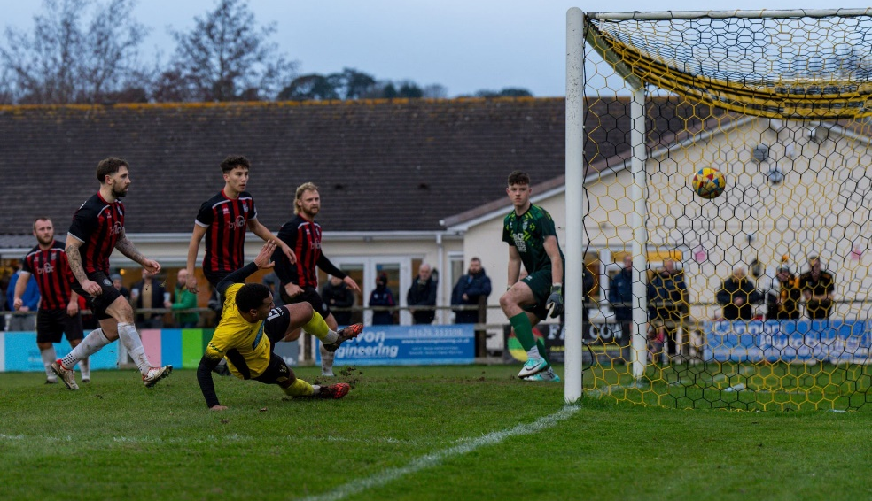
Premier Division: In a seven-goal thriller at Homers Heath, Buckland Athletic stormed back to beat Bridgwater 4-3 to deal a huge blow the visitors title hopes. Things were looking rosy for United at the break after goals from Jack Taylor and Jake Llewellyn put them two goals to the good. Buckland then made a dream start to the second half, halving the deficit courtesy of Myles James, before drawing level on the hour mark thanks to the ever-dependable Jared Lewington. With the game now in the balance, James tipped it in the hosts favour after slotting home for the second time (pictured, left) to make it 3-2 with 17 minutes left on the clock. A further goal from Josh Grant increased Buckland’s lead further, with the stunned away side grabbing a late consolation courtesy of Josiah McKayle. Table-topping Helston overcame a potentially tricky encounter away at Nailsea & Tickenham, winning by two goals to nil to maintain their four point lead atop the division. An early own goal, forced by Steve Colwell’s set-piece, gave the Cornishmen a strong footing in the contest, before Curtis Damerell put the tie to bed with a strong headed finish early in the second half. Second-placed Clevedon brought an abrupt end to their four-match winless run by easing to an 8-0 victory over bottom-side Millbrook. The visitors have been having troubles of their own, and an early own goal was the worst possible start they could have hoped for. Further first half goals from Harlee Vozza and Syd Camper made it 3-0 at the interval, with Sam Beresford then adding a fourth in the opening minute of the second period. Substitute Kieran Ireland got in on the act to increase the lead further, before an Owen Punselie double and a late Alex Camm strike completed the rout. Falmouth Town rebounded from their heavy midweek defeat with an impressive 2-0 win at home to Brixham. Following a goalless hour, Town finally made their pressure tell with Oscar Massey tucking home, and the same player then struck again ten minutes from time to wrap up an outstanding individual and team performance. Another side who left it late before confirming victory was Barnstaple, with a spot kick in the closing stages proving pivotal in their 2-1 win over Torpoint. Having gone ahead midway through the first half thanks to impressive debutant Aidan Whitefield, Barnstaple were pegged back five minutes from time courtesy of a James Rowe equaliser. That didn’t deter Town however, and following their next attack, they were awarded a penalty which was converted by Stu Bowker to secure maximum points. Another side to prevail on Saturday were Shepton Mallet, with a slender 1-0 win over Ilfracombe making it three on the bounce. Following on from their midweek derby victory in the cup, Shepton snuck past their visitors from Devon when Harry Rutty rose highest to head home 15 minutes from time. Oldland Abbotonians battled back from a couple of difficult results over recent weeks, overturning an early deficit to win by three goals to one away at Saltash United. A tough opening for the Abbots saw Kieran O’Melia hand the hosts an early advantage, with the Ashes themselves hoping to rebound from a home defeat last time out. Oldland’s way back into the game came via the penalty spot, and after being felled in the home box, Tom Blake stepped up to level affairs in the 35th minute. Blake was then on target again on the stroke of half-time to affect the quickfire turnaround, with another penalty converted by the same man five minutes into the second half completing a remarkable hat-trick.
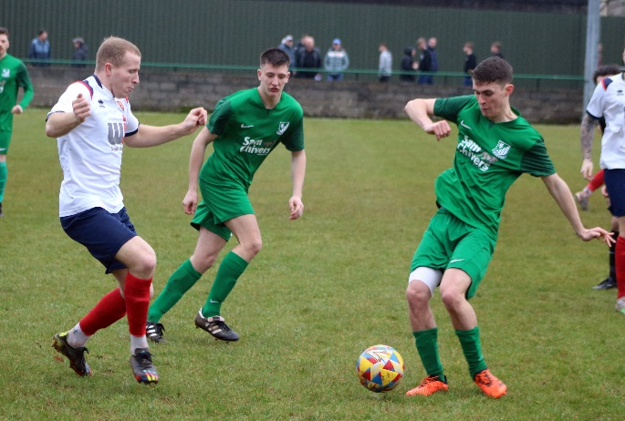
Wellington pulled off a fightback of their own, grabbing a point away at Welton (pictured, right) despite being second best for much of the contest. A fifth-minute spot kick saw Rovers move ahead, before Connor Linham doubled their advantage within 20 seconds of the second half restart. A late penalty from Sam Towler looked like it would be nothing more than a consolation, but the Tangerines had other ideas and made it 2-2 in the 86th minute when Miles Quick levelled from close range. In another entertaining encounter, Street battled back on three occasions to win 3-2 away at St Blazey. With the game locked at one apiece, St Blazey went ahead for the second time with 12 minutes left on the clock when George Newton converted a pressure penalty following a foul on teammate Scott Piper. The Cobblers weren’t ready to bow down however, and after scoring their second equaliser of the afternoon, they then went one better in stoppage time, snatching all three points following an incredible goal from Kyle Strange.
First Division: The weekend action got underway with a pulsating Friday night encounter which saw Hallen hold off a spirited fightback from Keynsham to prevail by three goals to two. Two goals towards the end of the first half from Cory Thomas-Barker and Tom Smallman put Hallen in control, with Jordan Greenwood then striking from the spot to make it 3-0 to the hosts after 63 minutes. Brandon Oputeri scored what looked like a consolation 15 minutes from time for the K’s, before visiting skipper Jake Wilson then trimmed the deficit further with a 90th minute effort. Smallman’s red card gave Keynsham even more impetus to attack, and they came mightily close to securing a dramatic late point, only to see a golden opportunity in the tenth minute of stoppage time fall just wide. The drama then continued on Saturday, with league leaders Portishead conceding two stoppage time goals on their way to a 3-2 loss at home to Wincanton. After skipper Mitch Osmond keeper to make it 2-0 in the 35th minute. A Matt Garner strike in first half stoppage time got Wincanton back into the contest, but they then had to wait until the 90th minute before drawing level with Connor Williams bending home an exquisite goal from 25 yards. It then got even better for the Wasps in the seventh minute of added time with Tom Jarvis rolling home a penalty to secure the most dramatic of victories. Second-place Radstock cut the gap atop the division to three points after surviving a scare away at Longwell Green. Taking on a side with an excellent home record, Radstock were up against it from the early stages after being reduced to ten men after only six minutes. That didn’t deter the Miners however, and goals from Kyle Thomas, Corey Rawlings and Harley Prior helped them secure their 20th league victory of the season. Boco were another side to win on their travels, with a 52nd minute effort from Luke Bryan leading them to a 1-0 triumph over Warminster, while goals at the end of the first, and beginning of the second half saw Cribbs Reserves defeat Bradford 2-0 at Trowbridge Road.
Brislington were the other member of the top five to secure three points after a strong finish helped them beat Wells City 4-1. Having gone ahead inside the opening ten minutes through skipper Asa White, Brislington were pegged back by a bullet header from Joe Morgan midway through the first half. The hosts then retook the lead 20 minutes from time through Neikell Plummer, with the same man then scoring again shortly after to put Bris out of sight. There was still time for Ben Withey to add a late fourth, with Wells’ chances dented following a red card to goalkeeper Harley Wilkinson. Five-goal Bristol Telephones were the latest side to hand bottom-side Bishop Sutton a heavy defeat, with Isaac Flynn’s brace helping lead the Phones to their first away win since late October.
Elsewhere, Middlezoy overturned a half-time deficit to beat struggling Cheddar 2-1 thanks to goals from Acey Mead and Liam Winter, while Brad Skidmore’s goal late in the first half saw Hengrove defeat Gillingham 1-0. The remaining games both finished one apiece, with Shirehampton’s Eddie Polaine producing a stunning strike to help his side secure an impressive point away at Bitton, while Odd Down’s Alfie Andrews scored on the hour mark to salvage a share of the spoils away at Cadbury Heath.

Latest Results
Tuesday 30th January 2024
First Division
AEK Boco 1-0 Cadbury Heath 86
Les Phillips Cup Quarter-Final
Shepton Mallet 2-0 Wells City

Wednesday 31st January 2024
Premier Division
St Blazey 4-1 Falmouth Town 330
Les Phillips Cup Quarter-Final
Cribbs Reserves 3-4 Shirehampton

Friday 2nd February 2024
First Division
Hallen 3-2 Keynsham Town 72

Saturday 3rd February 2024
Premier Division
Barnstaple Town 2-1 Torpoint Athletic 141
Buckland Athletic 4-3 Bridgwater United 326
Clevedon Town 8-0 Millbrook 110
Falmouth Town 2-0 Brixham AFC 402
Nailsea & Tickenham 0-2 Helston Athletic 46
Saltash United 1-3 Oldland Abbotonians 100
Shepton Mallet 1-0 Ilfracombe Town 178
St Blazey 2-3 Street 167
Welton Rovers 2-2 Wellington 120
First Division
Bishop Sutton 0-5 Bristol Telephones 38
Bitton 1-1 Shirehampton 50
Bradford Town 0-2 Cribbs Reserves 101
Brislington 4-1 Wells City 107
Cadbury Heath 1-1 Odd Down 48
Cheddar 1-2 Middlezoy Rovers 48
Hengrove Athletic 1-0 Gillingham Town 52
Longwell Green Sports 1-3 Radstock Town 95
Portishead Town 2-3 Wincanton Town
Warminster Town 0-1 AEK Boco 156

Upcoming Fixtures
Tuesday 6th February 2024
Premier Division
Falmouth Town vs Millbrook 19:45KO
Nailsea & Tickenham vs Welton Rovers 19:30KO
First Division
Brislington vs Hallen 19:30KO
Bristol Telephones vs Wells City 19:45KO
Hengrove Athletic vs Cribbs Reserves 19:30KO
Radstock Town vs Gillingham Town 19:45KO
Wincanton Town vs AEK Boco 19:30KO
Les Phillips Cup Quarter-Final
Bridgwater United vs Barnstaple Town 19:45KO
Helston Athletic vs Buckland Athletic 19:45KO

Wednesday 7th February 2024
First Division
Shirehampton vs Portishead Town 19:30KO
Warminster Town vs Keynsham Town 19:45KO

Saturday 10th February 2024 (3pm kick-off unless noted)
FA Vase Fifth Round
Bridgwater United vs Deal Town
Jersey Bulls vs Falmouth Town
Premier Division
Barnstaple Town vs Welton Rovers
Helston Athletic vs Saltash United
Ilfracombe Town vs Clevedon Town
Millbrook vs St Blazey
Oldland Abbotonians vs Nailsea & Tickenham
Street vs Buckland Athletic
Wellington vs Shepton Mallet
First Division
AEK Boco vs Gillingham Town
Bitton vs Cheddar
Bradford Town vs Middlezoy Rovers
Bristol Telephones vs Brislington
Cadbury Heath vs Warminster Town
Hallen vs Hengrove Athletic
Keynsham Town vs Bishop Sutton
Shirehampton vs Odd Down
Wells City vs Portishead Town
Wincanton Town vs Longwell Green Sports
Leading Goalscorers (Stats courtesy of FA Fulltime Website)
Premier Division
Jared Lewington (Buckland) – 24
Jack Thorne (Bridgwater) – 20
Phil Ormrod (Street) - 16
Ryan Richards (Torpoint) – 16
Rikki Sheppard (Helston) – 16
Sam Beresford (Clevedon) – 15
All Competitions
Ethan Feltham (Portishead) – 41
Jared Lewington (Buckland) – 28
Matt Garner (Wincanton) – 27
Jack Thorne (Bridgwater) – 26
Liam Clayton (Cribbs Reserves) - 21
Louis Snailham (Shirehampton) – 20

First Division
Ethan Feltham (Portishead) – 39
Matt Garner (Wincanton) – 25
Liam Winter (Middlezoy) - 21
Liam Clayton (Cribbs Reserves) – 18
Louis Snailham (Shirehampton) – 17
Milo Murgatroyd (Odd Down) – 16

League Tables
 | PREMIER DIVISION | Played | Won | Drawn | Lost | GD | Points
1 | Helston Athletic | 23 | 18 | 2 | 3 | 62 | 56
2 | Clevedon Town | 24 | 16 | 4 | 4 | 34 | 52
3 | Bridgwater United | 22 | 15 | 1 | 6 | 35 | 46
4 | Falmouth Town | 20 | 13 | 3 | 4 | 28 | 42
5 | Buckland Athletic | 24 | 12 | 5 | 7 | 30 | 41
6 | Barnstaple Town | 20 | 11 | 7 | 2 | 26 | 40
7 | Shepton Mallet | 22 | 11 | 5 | 6 | 8 | 38
8 | Brixham AFC | 23 | 9 | 8 | 6 | 22 | 35
9 | Street | 23 | 9 | 7 | 7 | 4 | 34
10 | Torpoint Athletic | 24 | 10 | 4 | 10 | -2 | 34
11 | St Blazey | 25 | 9 | 5 | 11 | -5 | 32
12 | Nailsea & Tickenham | 23 | 9 | 1 | 13 | 0 | 28
13 | Ilfracombe Town | 21 | 6 | 7 | 8 | -2 | 25
14 | Saltash United | 23 | 4 | 3 | 16 | -22 | 15
15 | Oldland Abbotonians | 21 | 5 | 0 | 16 | -39 | 15
16 | Welton Rovers | 20 | 3 | 5 | 12 | -29 | 14
17 | Wellington | 22 | 2 | 7 | 13 | -40 | 13
18 | Millbrook | 20 | 1 | 0 | 19 | -110 | 3
 | FIRST DIVISION | Played | Won | Drawn | Lost | GD | Points
1 | Portishead Town | 28 | 21 | 4 | 3 | 57 | 67
2 | Radstock Town | 29 | 20 | 4 | 5 | 40 | 64
3 | Cribbs Reserves | 29 | 19 | 4 | 6 | 34 | 61
4 | Wincanton Town | 28 | 18 | 4 | 6 | 20 | 58
5 | Brislington | 27 | 18 | 3 | 6 | 61 | 57
6 | Bitton | 28 | 15 | 7 | 6 | 26 | 52
7 | AEK Boco | 27 | 15 | 5 | 7 | 23 | 50
8 | Wells City | 26 | 15 | 2 | 9 | 15 | 47
9 | Middlezoy Rovers | 31 | 15 | 2 | 14 | 4 | 47
10 | Bradford Town | 30 | 13 | 7 | 10 | 19 | 46
11 | Bristol Telephones | 29 | 14 | 4 | 11 | -10 | 46
12 | Longwell Green Sports | 31 | 13 | 4 | 14 | -5 | 43
13 | Cadbury Heath | 29 | 12 | 3 | 14 | 6 | 39
14 | Hallen | 28 | 10 | 7 | 11 | 0 | 37
15 | Odd Down | 30 | 10 | 4 | 16 | -32 | 34
16 | Shirehampton | 29 | 8 | 6 | 15 | -11 | 30
17 | Warminster Town | 26 | 7 | 6 | 13 | -12 | 27
18 | Gillingham Town | 28 | 8 | 2 | 18 | -25 | 26
19 | Hengrove Athletic | 27 | 6 | 5 | 16 | -28 | 23
20 | Keynsham Town | 28 | 7 | 2 | 19 | -34 | 23
21 | Cheddar | 27 | 4 | 1 | 22 | -34 | 13
22 | Bishop Sutton | 29 | 0 | 2 | 27 | -114 | 2

