Latest Round-ups:
Season 2023/24

#26
Premier Division: It was a day of shocks on Saturday towards the top of the Western League, with three sides who started the day in the top six falling to defeat. That included the previously table-topping Clevedon who were shocked by Saltash on their trip to South Cornwall. It has been a thoroughly disappointing season for the Ashes, but they picked up a morale-boosting victory over the Seasiders, with Joe Preece’s goal three minutes into the second half securing all three points. That result allowed Helston to jump into top spot, and they took full advantage, beating Shepton Mallet by two goals to nil. A wind-assisted opener from Steve Colwell put the hosts in front after 20 minutes, before Dave Barker also utilised the conditions to lob the visiting keeper from long range in a result which saw Helston become the first side to reach a half-century of points this term. Barnstaple were another side to suffer a rare defeat, with their 2-1 loss at St Blazey just the second time they had ended up on the wrong end of the scoreline in their 18th match. The in-form George Newton fired St Blazey ahead after only six minutes, with a close-range finish from Jed Smale then putting the home side two goals to the good midway through the first half. Town pushed hard during the remainder of the contest, but only managed to force home a stoppage time consolation courtesy of Stu Bowker.
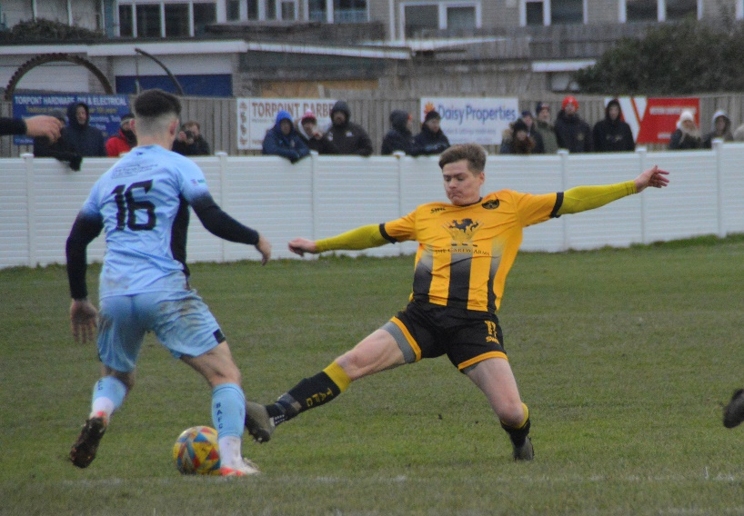
Fourth-placed Buckland were also defeated on Saturday afternoon, conceding twice in the final 15 minutes during a 2-0 loss at Torpoint (pictured, left). In what turned out to be a tight contest, Torpoint took the lead in slightly fortunate circumstances in the 76th minute with a cross-come-shot from James Rowe fooled the visiting the keeper and nestled in the back of the net. That goal was followed shortly after by a second from Ryan Richards who beat the offside trap before slotting home his 16th league goal of the campaign. Elsewhere, Luke Osgood and Harry Pruett both struck twice during Nailsea & Tickenham’s thumping 9-0 win over bottom-side Millbrook, while Brixham staged a late fightback to draw 2-2 with Street. After the Cobblers struck twice in quick succession midway through the second half, Brixham halved the deficit late on through Ben Aldous, before securing a share of the spoils thanks to Kieran Parkin’s stoppage time equaliser.

First Division: During the week, there was a triumvirate of hard-fought contests, with very little separating the sides. That included table-topping Portishead, who visited high-flying Bitton and left with a goalless draw. It was only the second time in which Town had drawn a blank this term, with the lack of goals mainly due to a string of fine saves from keepers Tom Creed and Ryan Thacker. It was also tight in Bristol, where an excellent goal in the final ten minutes from Jack Gore helped AEK Boco pip basement boys Bishop Sutton to a 1-0 win. Tuesday’s highest scoring encounter saw Longwell Green come from two-down to secure a 2-2 draw in their home clash with Brislington. An early screamer from Jay Malpas was followed shortly after by another goal from Oaklan Buck as Bris took a commanding lead just 23 minutes into the contest. The home side responded excellently however, and for the third consecutive game, both Matt Brown and Sonny Passco got themselves on the scoresheet, helping Longwell Green secure a share of the spoils.
Five days later, Brown and Passco were at it again for Longwell Green, with both getting their name on the scoresheet during a 4-1 defeat of Bristol Telephones. Only four games beat the weather on Saturday afternoon, and it was Brown who produced the best individual performance, plundering a hat-trick during the one-sided victory. Passco was also on target for Longwell Green who have now risen into the top half following a dominant second half against the Phones. In the day’s early kick-off, Boco downed Middlezoy by two goals to nil thanks to a pair of inspired substitutions. With a stalemate looking likely, Mickey Parsons was thrust into action for the away side and made an instant impact, heading home less than a minute after coming on to put Boco ahead. It was then left to another sub to add to Boco’s tally with Mitch Tippins making it 2-0 in the closing stages, handing Middlezoy a rare home defeat.
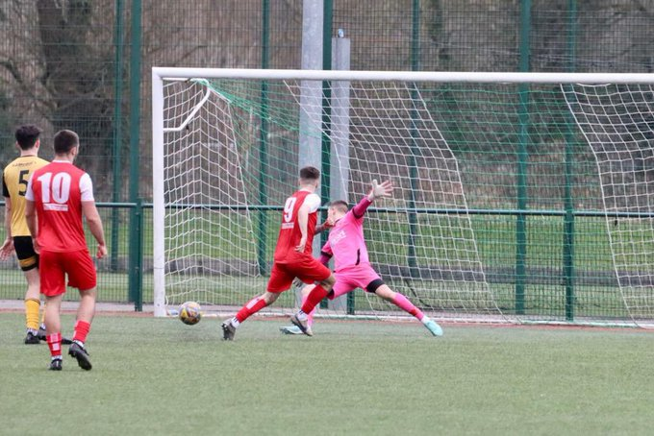
The other side to win on their travels were Cadbury Heath, with two goals in either half leading them to a 4-0 victory at Keynsham. The opening 45 minutes belonged to Heath frontman Zac Cheetham, and having broken the deadlock in the 30th minute, he then struck again just prior to half-time to put the visitors two-up. A long-ranger from Dan Winstone made it 3-0, before star man Josh Haynes followed up his two assists with a late goal of his own to complete the scoring five minutes from time. Elsewhere, Wells City defeated Bitton 2-1 to follow up their recent Les Phillips Cup victory over the same opponent. The hosts struggled during the opening stages and fell behind after quarter of an hour following a strong finish from George Lloyd. That goal seemed to kick Wells into action, and after Charlie Moon curled home for one apiece, recent addition Steve Murray then headed home in the 32nd minute to score what turned out to be the winner.
Zac Cheetham opens the scoring for Cadbury Heath at Keynsham

Latest Results
Tuesday 16th January 2024
First Division
AEK Boco 1-0 Bishop Sutton 35
Bitton 0-0 Portishead Town 68
Longwell Green Sports 2-2 Brislington 94

Saturday 20th January 2024
Premier Division
Bridgwater United P-P Ilfracombe Town
Brixham AFC 2-2 Street
Helston Athletic 2-0 Shepton Mallet 135
Nailsea & Tickenham 9-0 Millbrook 47
Saltash United 1-0 Clevedon Town
St Blazey 2-1 Barnstaple Town 150
Torpoint Athletic 2-0 Buckland Athletic 165
Wellington P-P Oldland Abbotonians
Welton Rovers P-P Falmouth Town
First Division
Cheddar P-P Portishead Town
Gillingham Town P-P Hallen
Keynsham Town 0-4 Cadbury Heath 95
Longwell Green Sports 4-1 Bristol Telephones 178
Middlezoy Rovers 0-2 AEK Boco 75
Odd Down P-P Hengrove Athletic
Radstock Town P-P Brislington
Wells City 2-1 Bitton 105
Wincanton Town P-P Bishop Sutton

Leading Goalscorers (Stats courtesy of FA Fulltime Website)
First Division
Ethan Feltham (Portishead) – 37
Matt Garner (Wincanton) – 21
Liam Clayton (Cribbs Reserves) – 18
Liam Winter (Middlezoy) - 18
Louis Snailham (Shirehampton) – 17
Milo Murgatroyd (Odd Down) – 16

Premier Division
Jared Lewington (Buckland) – 23
Jack Thorne (Bridgwater) – 18
Ryan Richards (Torpoint) – 16
Rikki Sheppard (Helston) – 15
Phil Ormrod (Street) - 15
Sam Beresford (Clevedon) – 14

All Competitions
Ethan Feltham (Portishead) – 40
Jared Lewington (Buckland) – 27
Jack Thorne (Bridgwater) – 24
Matt Garner (Wincanton) – 23
Louis Snailham (Shirehampton) – 20

Upcoming Fixtures
Tuesday 23rd January 2024
Premier Division
Street vs Wellington 19:30KO
First Division
Bishop Sutton vs Wells City 19:30KO
Brislington vs Portishead Town 19:30KO
Les Phillips Cup
Bridgwater United vs Barnstaple Town 19:45KO

Wednesday 24th January 2024
Premier Division
Oldland Abbotonians vs Shepton Mallet 19:45KO
First Division
Warminster Town vs Gillingham Town 19:45KO
Les Phillips Cup
Cribbs Reserves vs Odd Down 19:30KO

Saturday 27th January 2024 (3pm kick-off unless noted)
Premier Division
Buckland Athletic vs Helston Athletic
Falmouth Town vs Welton Rovers
Ilfracombe Town vs St Blazey
Nailsea & Tickenham vs Shepton Mallet
Oldland Abbotonians vs Bridgwater United
Saltash United vs Brixham AFC
Torpoint Athletic vs Barnstaple Town
Wellington vs Clevedon Town
First Division
Bishop Sutton vs Brislington
Bitton vs Radstock Town
Bristol Telephones vs Portishead Town 14:00KO
Gillingham Town vs Cheddar
Hengrove Athletic vs Middlezoy Rovers
Keynsham Town vs Warminster Town
Odd Down vs Wincanton Town
Shirehampton vs Bradford Town
Wells City vs Cadbury Heath
On the latest podcast, we hear from Bridgwater boss, Andy Llewellyn, who recaps his sides dramatic FA Vase victory over Farnham Town.
Ian then catches up with Warminster Town manager, Rob Nash, who talks about the development of his young side, and why his focus is on consistency during the second half of the campaign.
http://toolstationleague.com/season-2023-24-podcast-episode-24/

League Tables
 | PREMIER DIVISION | Played | Won | Drawn | Lost | GD | Points
1 | Helston Athletic | 21 | 16 | 2 | 3 | 58 | 50
2 | Clevedon Town | 22 | 15 | 3 | 4 | 26 | 48
3 | Bridgwater United | 20 | 14 | 1 | 5 | 30 | 43
4 | Buckland Athletic | 22 | 11 | 5 | 6 | 31 | 38
5 | Falmouth Town | 17 | 11 | 3 | 3 | 23 | 36
6 | Barnstaple Town | 18 | 9 | 7 | 2 | 23 | 34
7 | Torpoint Athletic | 22 | 10 | 4 | 8 | 1 | 34
8 | Brixham AFC | 21 | 8 | 8 | 5 | 22 | 32
9 | Shepton Mallet | 20 | 9 | 5 | 6 | 5 | 32
10 | Street | 22 | 8 | 7 | 7 | 3 | 31
11 | St Blazey | 22 | 8 | 5 | 9 | -6 | 29
12 | Nailsea & Tickenham | 21 | 9 | 1 | 11 | 4 | 28
13 | Ilfracombe Town | 19 | 5 | 7 | 7 | -2 | 22
14 | Saltash United | 21 | 4 | 3 | 14 | -18 | 15
15 | Welton Rovers | 18 | 3 | 4 | 11 | -23 | 13
16 | Oldland Abbotonians | 19 | 4 | 0 | 15 | -35 | 12
17 | Wellington | 20 | 2 | 5 | 13 | -40 | 11
18 | Millbrook | 19 | 1 | 0 | 18 | -102 | 3
 | FIRST DIVISION | Played | Won | Drawn | Lost | GD | Points
1 | Portishead Town | 26 | 20 | 4 | 2 | 54 | 64
2 | Radstock Town | 27 | 19 | 3 | 5 | 38 | 60
3 | Cribbs Reserves | 28 | 18 | 4 | 6 | 32 | 58
4 | Wincanton Town | 26 | 16 | 4 | 6 | 14 | 52
5 | Brislington | 25 | 16 | 3 | 6 | 51 | 51
6 | Bitton | 26 | 15 | 5 | 6 | 26 | 50
7 | AEK Boco | 25 | 13 | 5 | 7 | 21 | 44
8 | Wells City | 24 | 14 | 2 | 8 | 15 | 44
9 | Bradford Town | 28 | 12 | 7 | 9 | 20 | 43
10 | Longwell Green Sports | 30 | 13 | 4 | 13 | -3 | 43
11 | Bristol Telephones | 27 | 13 | 4 | 10 | -11 | 43
12 | Middlezoy Rovers | 29 | 13 | 2 | 14 | 0 | 41
13 | Cadbury Heath | 26 | 12 | 2 | 12 | 10 | 38
14 | Hallen | 27 | 9 | 7 | 11 | -1 | 34
15 | Odd Down | 28 | 10 | 3 | 15 | -27 | 33
16 | Shirehampton | 27 | 8 | 5 | 14 | -10 | 29
17 | Warminster Town | 23 | 7 | 4 | 12 | -11 | 25
18 | Gillingham Town | 25 | 7 | 1 | 17 | -25 | 22
19 | Keynsham Town | 26 | 7 | 1 | 18 | -33 | 22
20 | Hengrove Athletic | 25 | 5 | 5 | 15 | -26 | 20
21 | Cheddar | 25 | 4 | 1 | 20 | -32 | 13
22 | Bishop Sutton | 27 | 0 | 2 | 25 | -102 | 2

