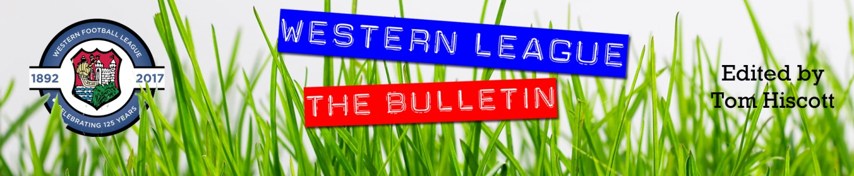
Latest Round-ups:
Season 2023/24

#25
Midweek Action: On a busy Tuesday evening of action, Keynsham stormed to a 5-2 win over Hallen in the First Division. The K’s hadn’t taken to the field since their Boxing Day triumph over Brislington making this rare back-to-back wins, and it came thanks in part to a first-half brace from Jemar Thomas. Joe Davis then added a third for the home side at the beginning of the second half, with Brandon Oputeri and Theo Jeremy completing the scoring late on. Radstock Town were also well on their way to securing three points, but unfortunately their home clash with Warminster was abandoned due a frozen pitch with the hosts leading 4-1 midway through the second half. In the Premier Division, Oldland Abbotonians grabbed their fourth win of the season, with Harrison Kyte’s double leading them to an away victory at Welton Rovers.
Turning attention to cup action, and in the Les Phillips’ there was a pair of surprise results with high-ranked First Division sides suffering home defeats. Bitton’s two-month unbeaten run was brought to an end by Wells City, with Joe Morgan and Harry Warwick striking for the away side who face the same opponents in the league a week on Saturday. Wells will be joined in the next round by Shirehampton, after Will Gallagher struck twice for the Bristolians in their 4-1 win away at Bradford Town. In local knockout competitions, Falmouth warmed up for their huge Vase tie with a 3-1 win over St Blazey in the Cornwall Senior Cup, while Brislington progressed in the Somerset County Cup following a 4-0 defeat of Bishop Sutton.
FA Vase: It was a strong showing from all three Western League sides, with both Falmouth and Bridgwater progressing to the fifth round of the National competition. Falmouth toppled Hartpury College at Bickland Park, with a strong all-round performance which saw them win by two goals to nil. The hosts were given a dream opportunity to go ahead in the opening minutes, and Jared Sims took full advantage, tucking home from the spot for 1-0. The back-five keeping their clean sheet intact proved crucial during a tight contest, and Falmouth finally surged clear 20 minutes from time with Jacob Grange doubling their advantage. Bridgwater’s victory away at Farnham Town came in much more dramatic circumstances, with a late winner from George King securing a 2-1 win. In another tie decided by fine margins, it took over an hour for the deadlock to be broken, and it was worth waiting for, with Tom Llewellyn executing a pin-point set piece. Just as thought it looked like Bridgy would clinch the slender 1-0 victory, they were denied in the 87th minute when Ryan Kinnane headed home for Farnham. That goal could have ruined United’s day, but they responded expertly, scoring with their next attack thanks to a strong finish from the edge of the box by matchwinner King. Unfortunately, Brixham couldn’t quite make it three-from-three, falling to a penalty shootout defeat at the hands of North Greenford United. Having fallen behind early in the second half, Brixham rebounded brilliantly, scoring twice in quick succession through Scott Andrews and Aaron Wellington to complete a quickfire turnaround. The home side then drew level 20 minutes from time, before prevailing 5-3 on spot kicks.
Premier Division: In the big game at the top, second placed Helston are now just one point behind league leaders Clevedon following a dramatic 2-1 win at the Hand Stadium. The highly-anticipated meeting was a tight tussle during the early stages, with Helston grabbing a half-time lead thanks to Tom Payne’s 43rd minute opener. Clevedon came out firing at the beginning of the second period, and levelled the game back up thanks to a smart finish from Freddie King. The home side were then reduced to ten men, and it proved costly in the dying moments, with Callum Martindale striking in the fourth minute of stoppage time to claim the last-gasp victory. Another side to claim all three points were Barnstaple, with Tor Swann scoring two second half goals in their win over Saltash, while Nailsea & Tickenham beat Millbrook by the same scoreline thanks to goals from Miles Hardidge and Luke Osgood. The highest scoring game of the afternoon took place in Cornwall, where goalscoring doubles from George Newton and Luke Cloke led St Blazey to a 4-2 win over Oldland. In a reverse of the result when these sides met earlier in the campaign, Newton and Cloke both struck for the home side to help them build a two-goal lead after just 25 minutes. Oldland got a goal back on the half-hour, but were soon two behind once again with Newton striking just before the interval for a 3-1 advantage. Cloke then joined his teammate, scoring his second of the afternoon to stretch the lead out further, with Zac Tucker’s consolation strike all the Abbots had to show for their second half efforts. The day’s other winners were Street, with three unanswered goals helping them see off Welton Rovers at the Tannery. Shepton Mallet pulled off a late comeback away at Ilfracombe, scoring twice in the final half hour to secure a 2-2 draw. Town utilised a strong period of play either side of the interval to take control of the game, with goals from Tyler Evans-Loude and Dan Wilson putting the hosts two-up early in the second. A rifled finish from Callum Gould got Mallet back into the game in the 63rd minute, and they then completed the comeback shortly after with Josh Jenkins grabbing the equalising goal.
First Division: Ethan Feltham continues to add to his stellar goalscoring season on a weekly basis, adding two more to his tally in Portishead’s 2-0 win over AEK Boco. Having headed Town in front after only seven minutes, Feltham then scored a goal of the season contender to move to 40 this season, firing home from long range to end Boco’s hopes of grabbing a late point. Second placed Cribbs Reserves eased to a 3-0 win at home to Cheddar, with Liam Clayton, Nathan Goodwin-Worrell and Jack Guthrie all scoring during a one-sided opening half. Wincanton overturned a half-time deficit to see off Brislington in the battle for fourth, extending their winning run to three to blast through the 50-point mark. After falling behind late in the first half, Town hit back in the 59th minute when Jamie Thompson danced his way through the visiting defence before slotting the ball into the back of the net. It remained one apiece until the dying embers of the contest, when Connor Williams was hacked down, allowing Wasp teammate Tom Jarvis to step up from the spot to fire his side ahead. It was then left to Jakob Seviour to add the finishing touches for Wincanton, firing home their third in stoppage time to hand Brislington back-to-back league defeats. The only other home side to taste victory on Saturday were Hallen, with their late show seeing off the challenge of Gillingham. Nearly 90 goalless minutes had passed before Hallen finally edged in front through Jordan Greenwood, with the home side then adding their second through Elliot Gardner during the stoppage time period.

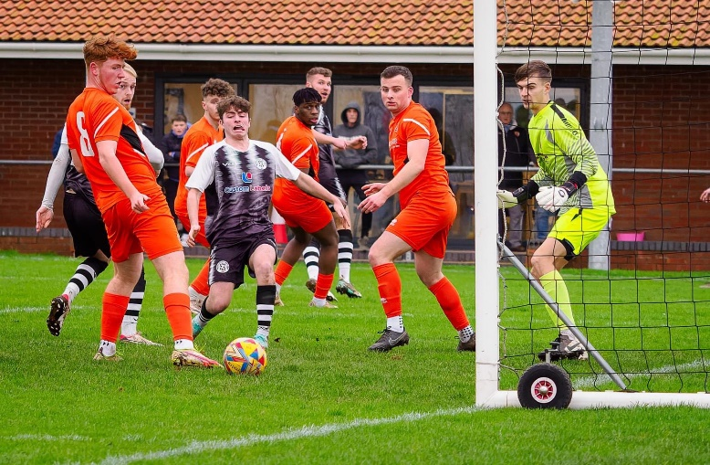
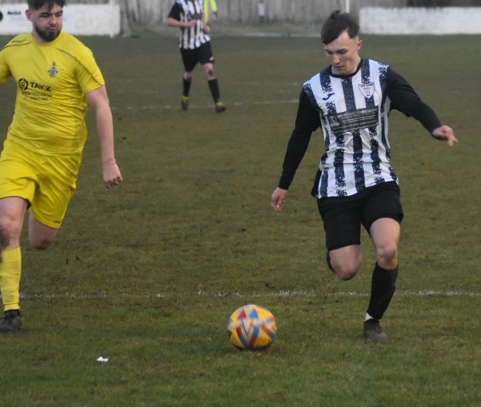
The points were shared in Bath, where Odd Down came back to draw 1-1 with Cadbury Heath (pictured, right), while the clash between Shirehampton and Warminster ended in a goalless stalemate. Elsewhere, a trio of mid-table sides continued their ascendancies up the table thanks to impressive away victories. One of those is Longwell Green Sports, who have racked up back-to-back wins to start 2024 thanks to a one-sided 6-2 thumping of Hengrove. Having also both scored in last week’s victory, both Matt Brown and Sonny Passco bagged goalscoring doubles in their huge away win, with Liam Oswin also getting his name on the scoresheet against the struggling Hengrove. Goals from Liam Winter, Acey Mead and Owen Sellick helped Middlezoy (pictured, below) pull away from bottom side Bishop Sutton in their 3-0 triumph, while Wells City’s Harry Warwick wrapped things up late on in the Somerset sides 3-1 defeat of Bradford Town. A Craig Herrod effort put City one-up at the interval, before Michael Duffy made it 2-0 early in the second half with a rocket of a finish. Jordan Pinder then struck to get the Bobcats back into the contest, only for Warwick to round things out with Wells’ third and final goal of an impressive victory.

Leading Goalscorers (Stats courtesy of FA Fulltime Website)
Premier Division
Jared Lewington (Buckland) – 23
Jack Thorne (Bridgwater) – 18
Rikki Sheppard (Helston) – 15
Ryan Richards (Torpoint) – 15
Sam Beresford (Clevedon) – 14
Curtis Damerell (Helston) – 13
Phil Ormrod (Street) – 12
Rubin Wilson (Falmouth) - 12
First Division
Ethan Feltham (Portishead) – 37
Matt Garner (Wincanton) – 21
Liam Clayton (Cribbs Reserves) – 18
Louis Snailham (Shirehampton) – 17
Liam Winter (Middlezoy) - 17
Milo Murgatroyd (Odd Down) – 16
Joe Beardwell (Bitton) – 15

All Competitions
Ethan Feltham (Portishead) – 40
Jared Lewington (Buckland) – 27
Jack Thorne (Bridgwater) – 24
Matt Garner (Wincanton) – 23
Louis Snailham (Shirehampton) – 20

Latest Results
Tuesday 9th January 2024
Premier Division
Welton Rovers 0-2 Oldland Abbotonians 75
First Division
Keynsham Town 5-2 Hallen 73
Radstock Town A-A Warminster Town 74
Les Phillips Cup
Bitton 0-2 Wells City
Bradford Town 1-4 Shirehampton

Saturday 13th January 2024
FA Vase Fourth Round
Falmouth Town 2-0 Hartpury College
Farnham Town 1-2 Bridgwater United
North Greenford United 2-2 (5-3 pens) Brixham AFC
Premier Division
Barnstaple Town 2-0 Saltash United 151
Clevedon Town 1-2 Helston Athletic 215
Ilfracombe Town 2-2 Shepton Mallet 70
Millbrook 0-2 Nailsea & Tickenham
St Blazey 4-2 Oldland Abbotonians 140
Street 3-0 Welton Rovers 80
First Division
Bishop Sutton 0-3 Middlezoy Rovers 37
Bradford Town 1-3 Wells City 103
Cribbs Reserves 3-0 Cheddar 36
Hallen 2-0 Gillingham Town 42
Hengrove Athletic 2-6 Longwell Green Sports 88
Keynsham Town A-A Bitton
Odd Down 1-1 Cadbury Heath 60
Portishead Town 2-0 AEK Boco 160
Shirehampton 0-0 Warminster Town 41
Wincanton Town 3-1 Brislington

Upcoming Fixtures
Tuesday 16th January 2024
First Division
AEK Boco vs Bishop Sutton 19:30KO
Bitton vs Portishead Town 19:30KO
Longwell Green Sports vs Brislington 19:30KO
Les Phillips Cup
Cribbs Reserves vs Odd Down 19:30KO

Wednesday 17th January 2024
First Division
Cadbury Heath vs Hallen 19:30KO
Warminster Town vs Wells City 19:45KO

Saturday 20th January 2024 (3pm kick-off unless noted)
Premier Division
Bridgwater United vs Ilfracombe Town
Brixham AFC vs Street
Helston Athletic vs Shepton Mallet
Nailsea & Tickenham vs Millbrook
Saltash United vs Clevedon Town
St Blazey vs Barnstaple Town
Torpoint Athletic vs Buckland Athletic
Wellington vs Oldland Abbotonians
Welton Rovers vs Falmouth Town
First Division
Cheddar vs Portishead Town
Gillingham Town vs Hallen
Keynsham Town vs Cadbury Heath
Longwell Green Sports vs Bristol Telephones
Middlezoy Rovers vs AEK Boco 14:00KO
Odd Down vs Hengrove Athletic
Radstock Town vs Brislington
Wells City vs Bitton
Wincanton Town vs Bishop Sutton
On the podcast this week, we hear from Western League Fixtures Secretary, George McCaffery, who explains how postponements are impacting the fixture schedule, and the state of promotion and relegation this term. There is also a conversation with St Blazey’s joint boss Andrew Moon, who discusses their recent win over leaders Clevedon, and touches on how the Green and Whites are continuing to evolve. Ian also catches up with Bristol Telephones manager, Josh Bruton, who explains why he wants his side to continue to go under the radar and why every game in the First Division is always competitive.
http://toolstationleague.com/season-2023-24-podcast-episode-23/

League Tables
 | PREMIER DIVISION | Played | Won | Drawn | Lost | GD | Points
1 | Clevedon Town | 21 | 15 | 3 | 3 | 27 | 48
2 | Helston Athletic | 20 | 15 | 2 | 3 | 56 | 47
3 | Bridgwater United | 20 | 14 | 1 | 5 | 30 | 43
4 | Buckland Athletic | 21 | 11 | 5 | 5 | 33 | 38
5 | Falmouth Town | 17 | 11 | 3 | 3 | 23 | 36
6 | Barnstaple Town | 17 | 9 | 7 | 1 | 24 | 34
7 | Shepton Mallet | 19 | 9 | 5 | 5 | 7 | 32
8 | Brixham AFC | 20 | 8 | 7 | 5 | 22 | 31
9 | Torpoint Athletic | 21 | 9 | 4 | 8 | -1 | 31
10 | Street | 21 | 8 | 6 | 7 | 3 | 30
11 | St Blazey | 21 | 7 | 5 | 9 | -7 | 26
12 | Nailsea & Tickenham | 20 | 8 | 1 | 11 | -5 | 25
13 | Ilfracombe Town | 19 | 5 | 7 | 7 | -2 | 22
14 | Welton Rovers | 18 | 3 | 4 | 11 | -23 | 13
15 | Saltash United | 20 | 3 | 3 | 14 | -19 | 12
16 | Oldland Abbotonians | 19 | 4 | 0 | 15 | -35 | 12
17 | Wellington | 20 | 2 | 5 | 13 | -40 | 11
18 | Millbrook | 18 | 1 | 0 | 17 | -93 | 3
 | FIRST DIVISION | Played | Won | Drawn | Lost | GD | Points
1 | Portishead Town | 25 | 20 | 3 | 2 | 54 | 63
2 | Radstock Town | 27 | 19 | 3 | 5 | 38 | 60
3 | Cribbs Reserves | 28 | 18 | 4 | 6 | 32 | 58
4 | Wincanton Town | 26 | 16 | 4 | 6 | 14 | 52
5 | Brislington | 24 | 16 | 2 | 6 | 51 | 50
6 | Bitton | 24 | 15 | 4 | 5 | 27 | 49
7 | Bradford Town | 28 | 12 | 7 | 9 | 20 | 43
8 | Bristol Telephones | 26 | 13 | 4 | 9 | -8 | 43
9 | Wells City | 23 | 13 | 2 | 8 | 14 | 41
10 | Middlezoy Rovers | 28 | 13 | 2 | 13 | 2 | 41
11 | Longwell Green Sports | 28 | 12 | 3 | 13 | -6 | 39
12 | AEK Boco | 23 | 11 | 5 | 7 | 18 | 38
13 | Cadbury Heath | 25 | 11 | 2 | 12 | 6 | 35
14 | Hallen | 27 | 9 | 7 | 11 | -1 | 34
15 | Odd Down | 28 | 10 | 3 | 15 | -27 | 33
16 | Shirehampton | 27 | 8 | 5 | 14 | -10 | 29
17 | Warminster Town | 23 | 7 | 4 | 12 | -11 | 25
18 | Gillingham Town | 25 | 7 | 1 | 17 | -25 | 22
19 | Keynsham Town | 25 | 7 | 1 | 17 | -29 | 22
20 | Hengrove Athletic | 25 | 5 | 5 | 15 | -26 | 20
21 | Cheddar | 25 | 4 | 1 | 20 | -32 | 13
22 | Bishop Sutton | 26 | 0 | 2 | 24 | -101 | 2

