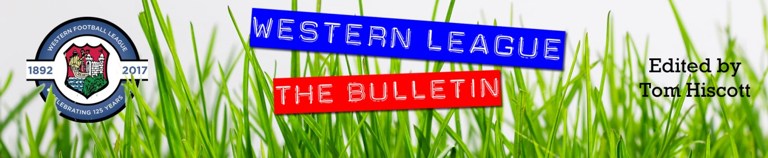
Latest Round-ups:
#21
Season 2023/24

Premier Division: Bridgwater United kickstarted the weekend with a 2-0 derby day victory over Street, helping them to complete a season double over the Cobblers. The game was decided in a three-minute spell at the end of the first half, with the league’s top goal-getter Jack Thorne ending a quiet run for himself with a huge goal in front of the large Friday night crowd in attendance at Fairfax Park.
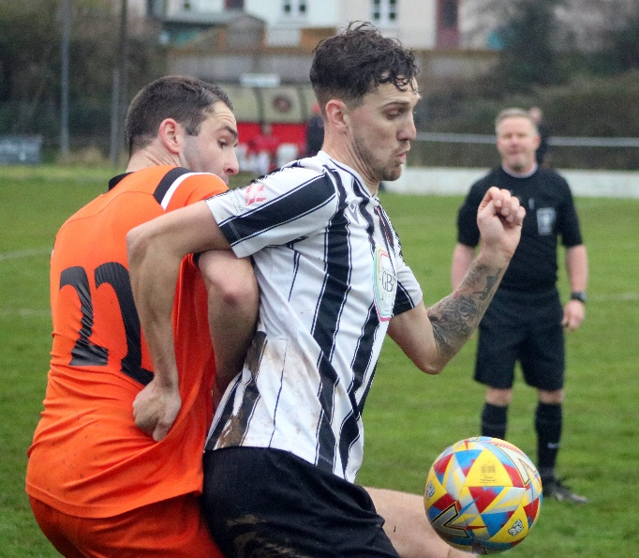
On Saturday afternoon, Helston strengthened their position atop the ladder with a thumping 9-1 win at home to Welton. The home side made a storming start to the contest, going two up inside the opening ten minutes through Rikki Sheppard and Curtis Damerell. Quickfire goals from Jacob Smith and Tom Payne strengthened the hosts dominance, making it 4-0 after 29 minutes, before Welton struck early in the second half. Any chances of a fightback were brought to an abrupt halt by Sheppard, with Helston’s leading marksman finishing off back-to-back attacks to complete his hat-trick and make it 6-1. The home side didn’t let up, continuing to add to their tally in the closing stages, with Kai Cornish’s brace and a Dave Barker effort wrapping up the scoring. Clevedon Town gained revenge from their recent defeat at the hands of Shepton Mallet, scoring in stoppage time to take home a 1-0 victory from their visit to Old Wells Road. Having suffered their only league defeat so far this season against the same opponent ten days previously, the Seasiders pinched all three points in the return fixture with Syd Camper heading home Freddie King’s free kick to bring up his half century of goals for the club. The other away side to take home three points were Wellington, with Josh Baker’s brace at the end of the first half leading them to a 2-0 win at Millbrook (pictured, right). The game of the day took place at Fryth Way, where Nailsea & Tickenham shared six goals with their Devonian visitors from Ilfracombe. A Lloyd Mills’ goal midway through the first half put the Swags two to the good following on from Luke Osgood’s fourth minute effort. Ilfracombe finished the opening period on top however, and after getting back into the game through Dan Wilson, they then grabbed a share of the spoils courtesy of Blake Shapland. A further goal from Jack Magarotto gave Town an opportunity to leave with all three points, but Mills managed to score his second of the contest to hand Nailsea their first draw of the entire season. The points were also shared between top-half rivals Barnstaple and Brixham, with Aaron Wellington levelling for the visitors to cancel out Brodie Montague’s excellent headed effort on the half hour mark.
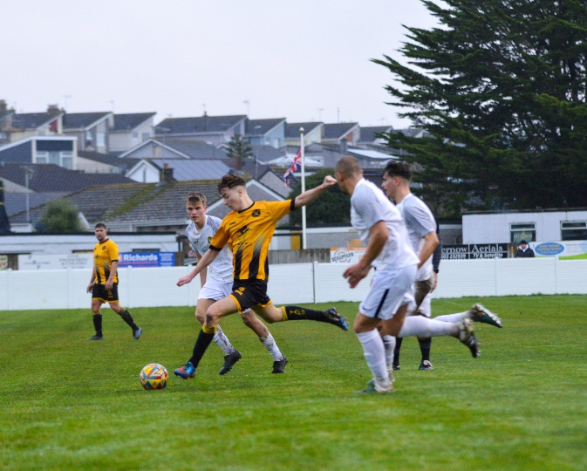
Torpoint returned to winning ways in their home clash with St Blazey, scoring twice before the break to claim their eighth victory of the campaign (in action, pictured, right). A fifth minute header from Ryan Smith gave Torpoint the dream start, with the same man then adding his second from long range to wrap up the victory at the Mill. Elsewhere in Cornwall, two recent additions helped Falmouth claim a 2-1 win over Saltash. Having also notched in their previous league win, Rubin Wilson opened the scoring for Falmouth, only for the Ashes to draw level in the opening minute of the second half through Jake Curtis. It was then left to another new signing, Oscar Massey, to secure victory for the home side, with the debutant making it 2-1 less than 48 hours after joining the club following a recent spell at Barnstaple. Over in Devon, Buckland Athletic reached the 30-point mark for the season thanks to a 3-1 win over Oldland Abbotonians. Top scorer Jared Lewington broke the deadlock inside quarter of an hour before Ryan Bush then tucked home a penalty after he had been felled inside the area. Despite being reduced to ten men, the Abbots hit back midway through the second half, only for Lewington to respond instantly, scoring his second of the afternoon to wrap up victory for the Bucks.

First Division: Radstock Town came out on top in the big game at the top, edging a tight contest at home to Cribbs Reserves to prevail by four goals to three. An early own goal put the away side in front before the Miners stormed back to move into a 2-1 lead. Liam Clayton then got Cribbs back on level terms, scoring 15 minutes from time to set up a thrilling finale in the battle for second spot. It was the home side who finished the stronger, scoring twice more to move 4-2 up, with Clayton’s injury time penalty not quite enough to complete another Cribbs fightback. Portishead now lead by seven points atop the division after sneaking past Hengrove by a single goal. With Ethan Feltham missing the game through suspension, it was left to Calum Townsend to become Posset’s latest game winner, with his exemplary turn and finish after half an hour doing the business for the home side. Brislington became the fourth side to reach the 50-point mark, adding some late gloss to the scoreline in their 4-0 win at home to Odd Down. Dean Griffiths’ eighth minute effort was all that separated the sides for much of the afternoon, before Brislington came home with a wet sail, adding three further goals in the final quarter hour courtesy of Jordan Williams, Lewis Dunn and Jordan Scadding. Another side to hit four on Saturday afternoon were Hallen, with Jordan Greenwood’s double helping to lead them past Bishop Sutton. After teammate Pete Majek-Oduyoye had headed the hosts in front, Greenwood then had a free header of his own which he converted to make it 2-0 in just the 17th minute. Liam Atwell then slammed home Hallen’s third before the interval, with Greenwood striking again midway through the second half to wrap up the 4-1 win. Home victories were very much the theme of the day, with Joe Beardwell and Lewis Russell on target for Bitton in their 2-1 triumph over Longwell Green, while Sammy Jordan’s late header helped Bradford Town complete their comeback win over Cadbury Heath by the same scoreline. The day’s early kickoff also went in the hosts favour, with Scott Saunders, Harry Walker and Craig Wilson scoring in Bristol Telephones 3-1 defeat of Cheddar.
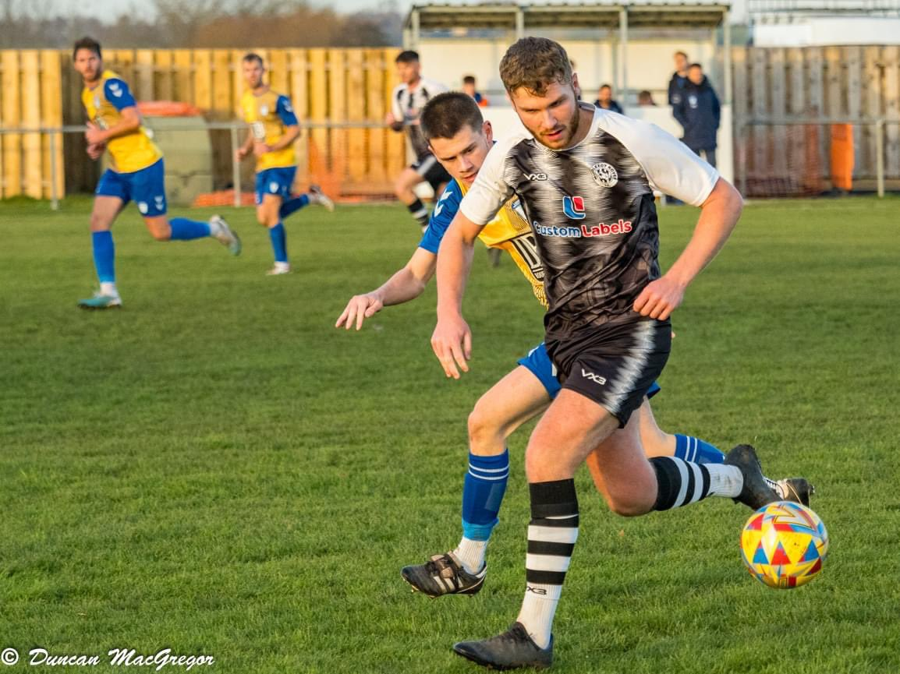
The in-form AEK Boco were another side to secure all three points, with a strong second half helping lead them to a 3-1 win over Shirehampton. Having gone in front after four minutes through Luke Bryan’s bundle, Boco were pegged back by their visitors when Louis Snailham scored his 20th goal of an increasingly impressive individual season. That was as good as it got for Shirehampton however, and the home side scored at either end of the second half through Sam Thomas and Seb Scott to give them their fifth win from six. Gillingham Town are another side hitting their staps at this moment in time, winning five from six themselves after overturning an early deficit to beat Keynsham 5-2 at the AJN Stadium. Despite suffering an early setback, the away side eventually ran out comfortable winners, with Aaron Lane-Leney playing a starting role thanks to his hat-trick, adding to further goals from Josh Haskett and Jack Bareham. 5-2 was also the winning margin for Middlezoy, with a strong performance helping them hold off the challenge of Wincanton in Somerset (pictured, left). After Acey Mead scored the only goal during a quiet opening half, Rovers made a dream start to the second period, with Liam Winter doubling their advantage. A left-footed piledriver from Connor Williams and direct corner from Tom Jarvis kept Wincanton in the game during the second half, but Middlezoy eventually pulled away with Charlie Lintell, James Millard and Noah Brown all scoring during a frantic final 15 minutes.
In FA Vase matters, Wells City finally played their third round tie with Hamworthy Recreation, falling to a 2-1 loss at the Athletic Ground. Goals in either half from Lewis McMurdo and Brian Foulger put the visitors two-up, with a late Harry Warwick effort proving to be too little, too late for City.
The latest podcast includes an interview with Barnstaple’s Ben Watson, who discusses what led him to the Barum job, and talks about his football philosophy and the importance of performance both on and off the pitch. Cribbs Reserves boss Alec Mills then joins Ian to reflect on their bright start to the campaign, and looks ahead to the upcoming Boxing Day trip to table-topping Portishead.
http://toolstationleague.com/season-2023-24-podcast-episode-20/

Latest Results
Friday 15th December 2023
Premier Division
Bridgwater United 2-0 Street 414

Saturday 16th December 2023
FA Vase Third Round
Wells City 1-2 Hamworthy Recreation
Premier Division
Barnstaple Town 1-1 Brixham AFC 134
Buckland Athletic 3-1 Oldland Abbotonians
Falmouth Town 2-1 Saltash United
Helston Athletic 9-1 Welton Rovers
Millbrook 0-2 Wellington 38
Nailsea & Tickenham 3-3 Ilfracombe Town 51
Shepton Mallet 0-1 Clevedon Town 154
Torpoint Athletic 2-0 St Blazey 161
First Division
AEK Boco 3-1 Shirehampton 52
Bitton 2-1 Longwell Green Sports 114
Bradford Town 2-1 Cadbury Heath 114
Brislington 4-0 Odd Down 75
Bristol Telephones 3-1 Cheddar 22
Hallen 4-1 Bishop Sutton 48
Keynsham Town 2-5 Gillingham Town 76
Middlezoy Rovers 5-2 Wincanton Town 76
Portishead Town 1-0 Hengrove Athletic 128
Radstock Town 4-3 Cribbs Reserves 72
Leading Goalscorers (Stats courtesy of FA Fulltime Website)
Premier Division
Jack Thorne (Bridgwater) – 17
Rikki Sheppard (Helston) – 16
Jared Lewington (Buckland) – 15
Curtis Damerell (Helston) – 12
Phil Ormrod (Street) – 12
Ryan Richards (Torpoint) – 11
Lucas Vowles (Nailsea/Tickenham) - 10
First Division
Ethan Feltham (Portishead) – 32
Matt Garner (Wincanton) – 19
Milo Murgatroyd (Odd Down) – 16
Louis Snailham (Shirehampton) – 16
Ben Millett (Odd Down) – 14
Scott Bamford (Shirehampton) – 13
Joe Beardwell (Bitton) – 13
Liam Clayton (Cribbs Reserves) - 13

All Competitions
Ethan Feltham (Portishead) – 35
Jack Thorne (Bridgwater) – 23
Matt Garner (Wincanton) – 21
Louis Snailham (Shirehampton) – 19
Jared Lewington (Buckland) – 19
Milo Murgatroyd (Odd Down) – 18

Upcoming Fixtures
Wednesday 20th December 2023
Les Phillips Cup
Shirehampton vs Bradford Town 19:30KO

Friday 22nd December 2023
Premier Division
Millbrook vs Saltash United 19:30KO
Street vs Clevedon Town 19:45KO
First Division
Gillingham Town vs Wells City 19:30KO

Saturday 23rd December 2023 (3pm kick-off unless noted)
Premier Division
Bridgwater United vs Buckland Athletic
Oldland Abbotonians vs Barnstaple Town
First Division
Cadbury Heath vs Bitton
Hengrove Athletic vs Bristol Telephones
Shirehampton vs Wincanton Town

Tuesday 26th December 2023
Premier Division
Barnstaple Town vs Ilfracombe Town 15:00KO
Brixham vs Buckland Athletic 11:00KO
Clevedon Town vs Nailsea & Tickenham 13:30KO
Falmouth Town vs Helston Athletic 15:00KO
Saltash United vs St Blazey 11:00KO
Shepton Mallet vs Street 13:00KO
Torpoint Athletic vs Millbrook 11:00KO
Wellington vs Bridgwater United 13:00KO
Welton Rovers vs Oldland Abbotonians 13:00KO
First Division
Cheddar vs Bishop Sutton 15:00KO
Gillingham Town vs Wincanton Town 13:00KO
Hallen vs Shirehampton 13:00KO
Keynsham Town vs Brislington 15:00KO
Longwell Green Sports vs AEK Boco 13:30KO
Portishead Town vs Cribbs Reserves 15:00KO
Radstock Town vs Odd Down 13:00KO
Warminster Town vs Bradford Town 15:00KO
Wells City vs Middlezoy Rovers 13:00KO

League Tables
 | PREMIER DIVISION | Played | Won | Drawn | Lost | GD | Points
1 | Helston Athletic | 17 | 13 | 2 | 2 | 52 | 41
2 | Clevedon Town | 16 | 12 | 3 | 1 | 24 | 39
3 | Bridgwater United | 16 | 12 | 1 | 3 | 30 | 37
4 | Buckland Athletic | 17 | 9 | 4 | 4 | 28 | 31
5 | Falmouth Town | 14 | 9 | 3 | 2 | 19 | 30
6 | Brixham AFC | 18 | 8 | 5 | 5 | 22 | 29
7 | Torpoint Athletic | 18 | 8 | 4 | 6 | 1 | 28
8 | Street | 17 | 7 | 5 | 5 | 3 | 26
9 | Shepton Mallet | 16 | 7 | 4 | 5 | 4 | 25
10 | Barnstaple Town | 13 | 6 | 6 | 1 | 15 | 24
11 | St Blazey | 18 | 5 | 5 | 8 | -7 | 20
12 | Ilfracombe Town | 16 | 5 | 4 | 7 | -2 | 19
13 | Nailsea & Tickenham | 17 | 6 | 1 | 10 | -9 | 19
14 | Welton Rovers | 15 | 3 | 4 | 8 | -13 | 13
15 | Wellington | 18 | 2 | 5 | 11 | -35 | 11
16 | Oldland Abbotonians | 16 | 3 | 0 | 13 | -29 | 9
17 | Saltash United | 16 | 2 | 2 | 12 | -19 | 8
18 | Millbrook | 14 | 0 | 0 | 14 | -84 | 0
 | FIRST DIVISION | Played | Won | Drawn | Lost | GD | Points
1 | Portishead Town | 23 | 19 | 3 | 1 | 53 | 60
2 | Radstock Town | 24 | 17 | 2 | 5 | 30 | 53
3 | Cribbs Reserves | 26 | 16 | 4 | 6 | 28 | 52
4 | Brislington | 22 | 16 | 2 | 4 | 55 | 50
5 | Bitton | 23 | 14 | 4 | 5 | 23 | 46
6 | Wincanton Town | 23 | 13 | 4 | 6 | 10 | 43
7 | Bradford Town | 25 | 12 | 6 | 7 | 23 | 42
8 | Bristol Telephones | 24 | 12 | 3 | 9 | -9 | 39
9 | AEK Boco | 21 | 10 | 5 | 6 | 18 | 35
10 | Middlezoy Rovers | 24 | 11 | 2 | 11 | 0 | 35
11 | Longwell Green Sports | 24 | 10 | 3 | 11 | -8 | 33
12 | Wells City | 18 | 10 | 2 | 6 | 10 | 32
13 | Cadbury Heath | 22 | 10 | 1 | 11 | 8 | 31
14 | Hallen | 24 | 8 | 6 | 10 | 0 | 30
15 | Odd Down | 25 | 9 | 2 | 14 | -24 | 29
16 | Shirehampton | 24 | 8 | 3 | 13 | -9 | 27
17 | Gillingham Town | 21 | 7 | 1 | 13 | -16 | 22
18 | Warminster Town | 20 | 6 | 3 | 11 | -9 | 21
19 | Hengrove Athletic | 23 | 5 | 4 | 14 | -22 | 19
20 | Keynsham Town | 23 | 5 | 1 | 17 | -34 | 16
21 | Cheddar | 23 | 3 | 1 | 19 | -36 | 10
22 | Bishop Sutton | 24 | 0 | 2 | 22 | -91 | 2

