Latest Round-ups:
#20
Season 2023/24

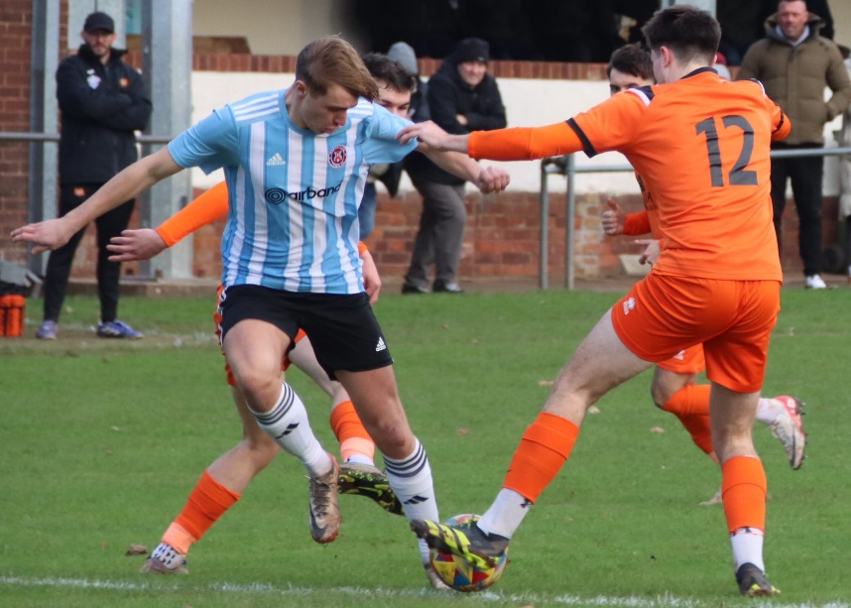
Premier Division: Friday evening’s wet weather put paid to several games in the division, with only four pitches deemed fit for play. Of the games to avoid postponement, away sides enjoyed the best of the action, taking home maximum points in three instances. One of the visiting teams to secure victory were Helston, with a late goal helping them see off Ilfracombe in a tight affair. The league leaders went ahead thanks to a comical own goal at the end of the first half, before being pegged back shortly after the interval courtesy of a penalty for the hosts. The crucial strike 12 minutes from time came from Declan Cornish, with his goal from outside the area helping Helston land the impressive win. Second place Clevedon remain hot on Helston’s tail after rebounding from their midweek defeat with a 2-1 win away at Brixham. A fast start from the Seasiders saw them go ahead in the tenth minute, with Freddie King firing home from the edge of the box. Brixham have been performing well over recent weeks, and they managed to get back on level terms in the 33rd minute when Sean Adderley headed home a Scott Robinson free kick. Clevedon kept battling until the very last moment, and inched ahead three minutes from time when substitute Harlee Vozza saw his deflected effort nestle in the back of the Brixham net. Barnstaple also took home a win after overturning an early deficit to beat Wellington 3-2 (pictured, right). Tom Burt’s close range effort put the hosts in front after only six minutes, with Barnstaple then scoring twice in added time at the end of the opening half through Tor Swann and Harvey Dorothy to take a lead to the interval. Matt Bye then added to Town’s advantage at the beginning of the second half, and they managed to hold on despite conceding to Kieran Ireland late on. At the Tannery, two second half goals helped Street defeat Torpoint, leapfrogging their opponents up into seventh spot.
Earlier in the week, Clevedon’s unbeaten start to the league season came to an end after they were defeated 1-0 by Shepton Mallet. In the first of two games scheduled between the sides in the space of ten days, Shepton got the upper hand in North Somerset thanks to a late goal from Josh Jenkins. After being played in by Jacob Sloggett, Jenkins’ driven strike nestled in the back of the home goal to extend Mallet’s impressive away form which has seen them win four from five on their travels.
First Division: Before the Saturday games took place, two of the big hitters met on Wednesday evening with second place up for grabs. As it turned out, nothing could separate Cribbs Reserves and Radstock with each side scoring early in the second half during the 1-1 draw. After Seb Hounsell had broken the deadlock in the 48th minute for the Miners, Liam Clayton then struck his 14th goal of the campaign to hand Cribbs a share of the spoils.
Clayton also played an influential role in Cribbs’ come from behind victory on Saturday afternoon, scoring the first of their late goals in a 2-1 defeat of Keynsham. In a game which remained goalless for 80 minutes, Cribbs looked like they were about to suffer a shock defeat when Jemar South-Thomas fired the K’s in front. The home side came to life after that, and following Clayton’s 87th minute leveller, they then managed to claim a dramatic late winner with Tom Headford scoring in stoppage time. The one team who remain above Cribbs in the table are Portishead, with the unstoppable Ethan Feltham dominating once again in their 5-1 win away at Middlezoy. Feltham scored a first half treble for the visitors, adding to an early goal from George Fowler which preceded a 20th minute red card for the home side. Star man Feltham then scored again at the beginning of the second half to take his season tally to 33, with Middlezoy grabbing a late consolation through George Turner. Longwell Green made a considerable jump up the table into ninth spot after Alfie Clarke’s effort led them to a 1-0 win in Bath away at Odd Down.

Latest Results
Wednesday 6th December 2023
Premier Division
Clevedon Town 0-1 Shepton Mallet 101
First Division
Cribbs Reserves 1-1 Radstock Town 56

Saturday 9th December 2023
Premier Division
Brixham AFC 1-2 Clevedon Town 138
Ilfracombe Town 1-2 Helston Athletic
Street 2-0 Torpoint Athletic 117
Wellington 2-3 Barnstaple Town
First Division
Cribbs Reserves 2-1 Keynsham Town
Middlezoy Rovers 1-5 Portishead Town
Odd Down 0-1 Longwell Green Sports 50
On the podcast this week, Brixham boss Jason Couch joins Ian to discuss why his sides run in the Vase this season is a bonus and why he’s looking forward to a competitive festive fixture schedule. There is also a conversation with AEK Boco manager Joe Pople, who explains how the early season break at the end of September benefited his side after they suffered some inconsistency during the early weeks of the campaign.
http://toolstationleague.com/season-2023-24-podcast-episode-19/

Upcoming Fixtures

Wednesday 13th December 2023
Les Phillips Cup
Cribbs Reserves vs Odd Down 19:30KO
Shirehampton vs Bradford Town 19:30KO

Friday 15th December 2023
Premier Division
Bridgwater United vs Street 19:45KO

Saturday 16th December 2023 (3pm kick-off unless noted)
FA Vase Third Round
Wells City vs Hamworthy Recreation
Premier Division
Barnstaple Town vs Brixham AFC
Buckland Athletic vs Oldland Abbotonians
Falmouth Town vs Saltash United
Helston Athletic vs Welton Rovers
Millbrook vs Wellington
Nailsea & Tickenham vs Ilfracombe Town
Shepton Mallet vs Clevedon Town
Torpoint Athletic vs St Blazey
First Division
AEK Boco vs Shirehampton
Bitton vs Longwell Green Sports
Bradford Town vs Cadbury Heath
Brislington vs Odd Down
Bristol Telephones vs Cheddar 14:00KO
Hallen vs Bishop Sutton
Keynsham Town vs Gillingham Town
Middlezoy Rovers vs Wincanton Town
Portishead Town vs Hengrove Athletic
Radstock Town vs Cribbs Reserves
Leading Goalscorers (Stats courtesy of FA Fulltime Website)
First Division
Ethan Feltham (Portishead) – 33
Matt Garner (Wincanton) – 19
Milo Murgatroyd (Odd Down) – 16
Ben Millett (Odd Down) – 14
Louis Snailham (Shirehampton) – 13
Scott Bamford (Shirehampton) - 13

Premier Division
Jack Thorne (Bridgwater) – 16
Jared Lewington (Buckland) – 13
Rikki Sheppard (Helston) – 13
Phil Ormrod (Street) – 11
Ryan Richards (Torpoint) – 11
Curtis Damerell (Helston) – 11

League Tables
 | PREMIER DIVISION | Played | Won | Drawn | Lost | GD | Points
1 | Helston Athletic | 16 | 12 | 2 | 2 | 44 | 38
2 | Clevedon Town | 15 | 11 | 3 | 1 | 23 | 36
3 | Bridgwater United | 15 | 11 | 1 | 3 | 28 | 34
4 | Buckland Athletic | 16 | 8 | 4 | 4 | 23 | 28
5 | Brixham AFC | 17 | 8 | 4 | 5 | 22 | 28
6 | Falmouth Town | 13 | 8 | 3 | 2 | 18 | 27
7 | Street | 16 | 7 | 5 | 4 | 5 | 26
8 | Shepton Mallet | 15 | 7 | 4 | 4 | 5 | 25
9 | Torpoint Athletic | 17 | 7 | 4 | 6 | -1 | 25
10 | Barnstaple Town | 12 | 6 | 5 | 1 | 15 | 23
11 | St Blazey | 17 | 5 | 5 | 7 | -5 | 20
12 | Ilfracombe Town | 15 | 5 | 3 | 7 | -2 | 18
13 | Nailsea & Tickenham | 16 | 6 | 0 | 10 | -9 | 18
14 | Welton Rovers | 14 | 3 | 4 | 7 | -5 | 13
15 | Oldland Abbotonians | 15 | 3 | 0 | 12 | -27 | 9
16 | Saltash United | 15 | 2 | 2 | 11 | -18 | 8
17 | Wellington | 17 | 1 | 5 | 11 | -37 | 8
18 | Millbrook | 13 | 0 | 0 | 13 | -82 | 0
 | FIRST DIVISION | Played | Won | Drawn | Lost | GD | Points
1 | Portishead Town | 22 | 18 | 3 | 1 | 52 | 57
2 | Cribbs Reserves | 25 | 16 | 4 | 5 | 29 | 52
3 | Radstock Town | 23 | 16 | 2 | 5 | 29 | 50
4 | Brislington | 21 | 15 | 2 | 4 | 51 | 47
5 | Bitton | 22 | 13 | 4 | 5 | 22 | 43
6 | Wincanton Town | 22 | 13 | 4 | 5 | 13 | 43
7 | Bradford Town | 24 | 11 | 6 | 7 | 22 | 39
8 | Bristol Telephones | 23 | 11 | 3 | 9 | -11 | 36
9 | Longwell Green Sports | 23 | 10 | 3 | 10 | -7 | 33
10 | AEK Boco | 20 | 9 | 5 | 6 | 16 | 32
11 | Wells City | 18 | 10 | 2 | 6 | 10 | 32
12 | Middlezoy Rovers | 23 | 10 | 2 | 11 | -3 | 32
13 | Cadbury Heath | 21 | 10 | 1 | 10 | 9 | 31
14 | Odd Down | 24 | 9 | 2 | 13 | -20 | 29
15 | Hallen | 23 | 7 | 6 | 10 | -3 | 27
16 | Shirehampton | 23 | 8 | 3 | 12 | -7 | 27
17 | Warminster Town | 20 | 6 | 3 | 11 | -9 | 21
18 | Gillingham Town | 20 | 6 | 1 | 13 | -19 | 19
19 | Hengrove Athletic | 22 | 5 | 4 | 13 | -19 | 19
20 | Keynsham Town | 22 | 5 | 1 | 16 | -31 | 16
21 | Cheddar | 22 | 3 | 1 | 18 | -34 | 10
22 | Bishop Sutton | 23 | 0 | 2 | 21 | -88 | 2

