Latest Round-ups:
#18
Season 2023/24

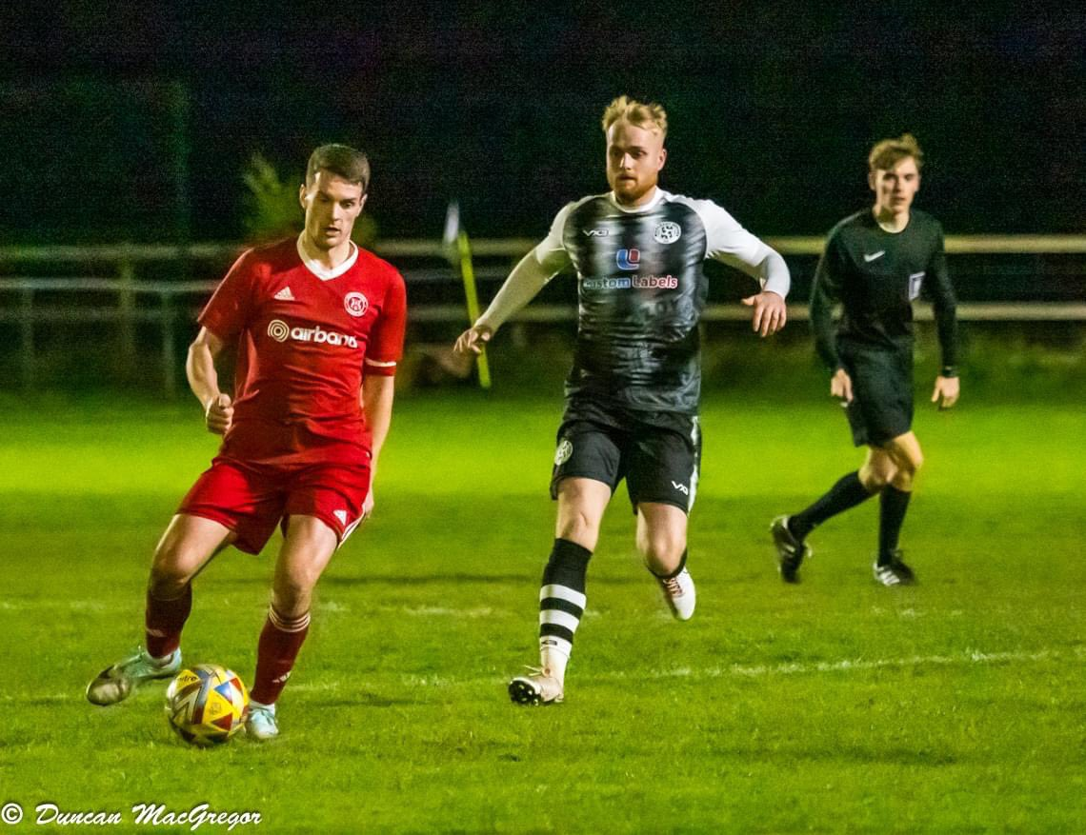
Midweek Action: On a busy Tuesday night, there was action across a number of competitions, with league and cup fixtures providing plenty of goals and plenty of drama. The Les Phillips Cup is now reaching the closing stages, and Helston are now the only Cornish side remaining in the competition after a come-from-behind victory at Saltash. The Ashes flew out of the blocks, leading after just four minutes through Joe Preece to put Helston’s defence of the trophy under threat. They were soon back on level terms however thanks to a thunderous finish from Jacob Smith, with Rikki Sheppard then scoring on the hour mark to give the visitors a 2-1 win. Another side reaching the quarter-final stage are Shepton Mallet following their 6-0 victory away at Wincanton. Charlie Bateson was the standout performer for the away side, grabbing a hat-trick of goals, with substitutes Cam Allen and Alessandro Costanza adding to Mallet’s tally during the closing stages. The other two last 16 ties were tight affairs, with penalties required to separate the sides. Barnstaple produced a strong fightback away at Middlezoy, before coming out on top of a dramatic shootout to prevail (pictured, left). Two goals from Dan Lismore looked to have put the Rovers in position to qualify, before Town struck twice in the final 15 minutes to make it 2-2 at the end of 90 minutes. Then, with the shootout locked at seven apiece, Barnstaple keeper Jack Arthur pulled off a save, which was followed up by a successful penalty from Joe Grigg to send Town through. Their opponents in the next round will be Bridgwater United after they won 4-2 on penalties following a 1-1 draw at the end of normal time at home to Ilfracombe.
In league matters, Street completed the season double over Premier Division rivals Nailsea & Tickenham thanks to a 5-0 victory in North Somerset. Phil Ormrod’s excellent season for the Cobblers continued, with his double helping the visitors secure maximum points, alongside further goals from Jake Mawford, Kyle Sampson and Freddie Frazer. In the First Division, Longwell Green Sports held off a late challenge from Keynsham to maintain their strong home form. Having fallen behind to Joe Davis’ 20th minute opener, Longwell Green stormed back to lead at the interval thanks to goals from Sam Bainbridge and Nathan Hall. A second Hall goal pushed the lead out further, with Sonny Passco then scoring 20 minutes from time to seemingly put the game to bed. Keynsham produced a late burst, scoring twice in added time through Davis and substitute Brandon Oputeri, but it was too little too late, and the home side took home the points.
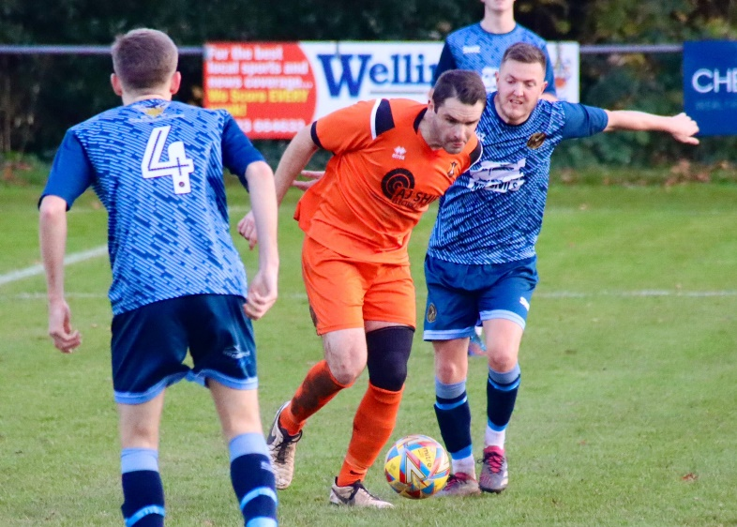
Premier Division: A tight, tense tussle on Friday evening saw Bridgwater sneak past Nailsea & Tickenham by a goal to nil, momentarily moving back into top spot. In front of a healthy crowd under the lights, Ross Edwards scored the only goal of the game, with his back-post header in the 57th minute proving to be enough for United. Saturday then saw Helston storm back to the top of the pile, with their 5-0 win over St Blazey handing them their 11th league victory of the campaign. The destination of the points was never really in doubt, with goals from Jacob Smith, Dave Barker and Aaron Bentley putting Helston three-up inside 25 minutes. Bentley then struck again late on, with Curtis Damerell rounding out the scoring with Helston’s last meaningful attack of the afternoon. Clevedon are very much keeping pace with the top two, with the Seasiders securing maximum points again following their 2-1 win over Street. It was a story of penalties down in Somerset, with Alex Camm breaking the deadlock from the spot ten minutes before half-time. Shortly after, Street were then penalised once more inside their own penalty area, and Camm added the finishing touches once more to double the hosts advantage. The Cobblers did manage to set up a nervy finale when they converted a penalty of their own through top scorer Phil Ormrod, but they couldn’t find a late equaliser and suffered their first defeat since early October. In another tight contest, Dan Wilson scored the solitary goal in Ilfracombe’s win over Oldland, while two goals inside the opening 20 minutes from Ben Carter and Cieran Bridger led Buckland to a 2-0 win away at Saltash. At Bickland Park, Falmouth Town overturned an early deficit to beat Barnstaple by three goals to one. After these sides had played out a goalless draw last month, the fans didn’t have to wait long for the deadlock to be broken in the reverse fixture with debutant Chris Sheppard firing the away side into an early lead. Brad Leivers then drew Falmouth level, before the side who sit sixth in the table moved ahead for the first time through Jake Grange. A debut goal from Rubin Wilson wrapped up the victory, with these sides set to meet once again next weekend in the third round of the FA Vase. Brixham will also take some momentum into their cup tie next Saturday after they claimed a last minute equaliser at home to Welton. After kick-off had been delayed for around 20 minutes, Welton reacted better and went ahead inside the opening quarter-hour through Josiah McKayle. It remained one-nil for the remainder of the game, all the way up until the 88th minute, when Sean Adderley tucked home to secure a share of the spoils. In similar circumstances, Torpoint also grabbed a late point, with their stoppage time leveller denying Wellington at the death. After Ryan Smith’s dipping effort had put the visitors ahead, Wellington hit back through Sully McKenna just prior to half-time. Ryan Brereton’s cool finish then edged the Somerset side in front 13 minutes from time, but they were unable to hang on, with Gary Hird sweeping home with Torpoint’s last forward foray. Bottom side Millbrook remain winless after suffering a 6-0 loss at the hands of Shepton Mallet. Jacob Sloggett set the ball rolling with a pair of first half goals, before Alessandro Costanza took over in the closing stages, adding goals five and six to round out Mallet’s second 6-0 triumph in the space of four days.

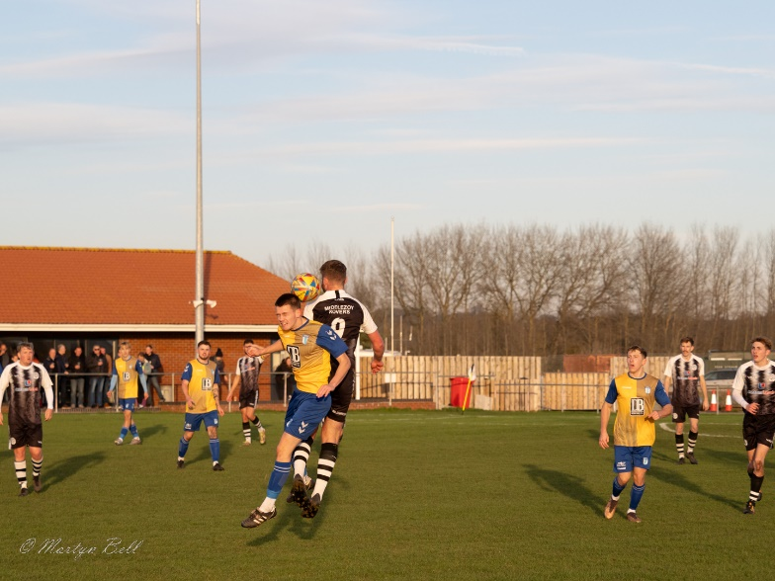
First Division: Portishead have now stretched their lead atop the division to eight points after overcoming Cheddar by a slender one-goal margin on the final Saturday of November. Following a goalless opening 45 minutes, Town turned to their most reliable goal-getter, with Ethan Feltham extending his lead atop the scoring charts to 28 in the league this term to hand Portishead a 1-0 win. Second-placed Radstock slipped to a surprise 2-1 defeat at home to Cadbury Heath, only saving face with a late consolation from the spot. A 12th minute effort from Josh Haynes put the Heath ahead, with Callum Whooley’s close range finish on the hour mark then putting the away side out of reach despite Radstock striking back with a late penalty. In the standout individual performance of the day, Joe Beardwell plundered five goals in Bitton’s huge win over bottom side Bishop Sutton. The home side were dominant throughout the match, extending their opponents winless start, and it was Beardwell who took home many of the plaudits following his five-star outing during the 8-0 triumph. Wincanton Town were the other big winners, putting six past Hengrove to end a long winless run away from home. From the moment they broke the deadlock in the 20th minute through top scorer Matt Garner, Wincanton were irresistible for the remainder of the opening half, with Connor Williams’ pinpoint free kick extending the lead to two. Gary Chapman’s header then made it 3-0, before Jamie Thompson rounded out the first period with a pair of exquisite finishes. Hengrove stemmed the tide slightly with a penalty right at the beginning of the second half, but Thompson made sure he would lead the post-match headlines after completing his hat-trick with a headed effort ten minutes from time. It was a strong goalscoring day throughout the division, with several other teams notching four in big wins, including Middlezoy who scored three times after the interval to hand Longwell Green a 4-0 loss (pictured, left). Brislington were triumphant by the same scoreline at home to Bristol Telephones, with two Jordan Ricketts spot kicks making it 2-0 within half an hour. Jack Fillingham then took centre stage, extending the lead to three at the end of the first half, before wrapping things up with his second after the interval. Ben Millett was another man to score in either half, helping Odd Down win 4-2 away at Gillingham Town, while Wells City took advantage of an early red card to defeat Keynsham. City were given an early boost, with a home defender sent off for the foul which saw Michael Duffy open the scoring from the spot. Incredibly, the ten men of Keynsham pushed forward themselves, and after equalising almost instantly, they then added another shortly after to take a surprise 2-1 lead. Wells grabbed a crucial leveller just prior to half time through Harry Warwick, with Duffy then turning the game back in the away side’s favour when he made it 3-2 shortly after the break. The extra man paid off eventually for Wells, and Duffy turned provider for their fourth, laying the ball off for Warwick who completed a goalscoring double of his own to put the game to bed. Hallen haven’t had the best of it at home this season, but enjoyed a strong all-round performance against Bradford Town, keeping a clean sheet on their way to a 1-0 win courtesy of Luke Banfield’s goal early in the second half.
A pair of First Division sides also met in the Les Phillips Cup on Saturday afternoon, with Cribbs Reserves progressing to the next round after knocking out AEK Boco on penalties.
Latest Results
Tuesday 21st November 2023
Premier Division
Nailsea & Tickenham 0-5 Street 62
First Division
Longwell Green Sports 4-3 Keynsham Town 158
Les Phillips Cup
Bridgwater United 1-1 (4-2 pens) Ilfracombe Town
Middlezoy Rovers 2-2 (7-8 pens) Barnstaple Town
Saltash United 1-2 Helston Athletic
Wincanton Town 0-6 Shepton Mallet

Friday 24th November 2023
Premier Division
Nailsea & Tickenham 0-1 Bridgwater United 252

Saturday 25th November 2023
Premier Division
Brixham 1-1 Welton Rovers 136
Clevedon Town 2-1 Street 127
Falmouth Town 3-1 Barnstaple Town 399
Helston Athletic 5-0 St Blazey 120
Ilfracombe Town 1-0 Oldland Abbotonians 70
Saltash United 0-2 Buckland Athletic 154
Shepton Mallet 6-0 Millbrook 170
Wellington 2-2 Torpoint Athletic 103
First Division
Bitton 8-0 Bishop Sutton 60
Brislington 4-0 Bristol Telephones 126
Gillingham Town 2-4 Odd Down 31
Hallen 1-0 Bradford Town 58
Hengrove Athletic 2-6 Wincanton Town 35
Keynsham Town 2-4 Wells City 75
Middlezoy Rovers 4-0 Longwell Green Sports 70
Portishead Town 1-0 Cheddar
Radstock Town 1-2 Cadbury Heath 83
Les Phillips Cup
Cribbs Reserves 0-0 (4-3 pens) AEK Boco
On the podcast this week, we hear from Ilfracombe manager, Clem Bennellick, who reflects on their recent penalty defeat to Bridgwater and a lack of football over recent weeks. Shirehampton boss Liam Greening also catches up with Ian to give an impassioned analysis on his sides current defensive woes, following on from a pair of wild goal-filled matches against Keynsham over the past week.
http://toolstationleague.com/season-2023-24-podcast-episode-17/

Upcoming Fixtures
Tuesday 28th November 2023
First Division
Keynsham Town vs AEK Boco 19:45KO
Wells City vs Brislington 19:30KO
Wednesday 29th November 2023
First Division
Shirehampton vs Radstock Town 19:30KO

Saturday 2nd December 2023 (3pm kick-off unless noted)
FA Vase Third Round
Barnstaple Town vs Falmouth Town
Brixham vs Downton
Hamworthy United vs Wells City
Hartpury College vs Clevedon Town
Royal Wootton Bassett vs Bridgwater United
Premier Division
Buckland Athletic vs Wellington
Ilfracombe Town vs Millbrook
St Blazey vs Nailsea & Tickenham
Street vs Welton Rovers
Torpoint Athletic vs Shepton Mallet
First Division
AEK Boco vs Odd Down
Bitton vs Hallen
Bradford Town vs Bishop Sutton
Brislington vs Portishead Town
Cadbury Heath vs Shirehampton
Keynsham Town vs Middlezoy Rovers
Longwell Green Sports vs Cheddar
Radstock Town vs Gillingham Town
Warminster Town vs Cribbs Reserves
Wincanton Town vs Bristol Telephones

Leading Goalscorers (Stats courtesy of FA Fulltime Website)
First Division
Ethan Feltham (Portishead) – 28
Matt Garner (Wincanton) – 19
Milo Murgatroyd (Odd Down) – 16
Ben Millett (Odd Down) – 14
Louis Snailham (Shirehampton) – 13
Scott Bamford (Shirehampton) - 13
Craig Wilson (Bristol Telephones) – 12
Premier Division
Jack Thorne (Bridgwater) – 16
Jared Lewington (Buckland) – 13
Rikki Sheppard (Helston) – 13
Phil Ormrod (Street) – 11
Ryan Richards (Torpoint) – 11
Curtis Damerell (Helston) – 11
Lucas Vowles (Nailsea&Tickenham) – 10

League Tables
 | PREMIER DIVISION | Played | Won | Drawn | Lost | GD | Points
1 | Helston Athletic | 15 | 11 | 2 | 2 | 43 | 35
2 | Bridgwater United | 15 | 11 | 1 | 3 | 28 | 34
3 | Clevedon Town | 13 | 10 | 3 | 0 | 23 | 33
4 | Brixham AFC | 16 | 8 | 4 | 4 | 23 | 28
5 | Buckland Athletic | 15 | 8 | 3 | 4 | 26 | 27
6 | Falmouth Town | 13 | 8 | 3 | 2 | 18 | 27
7 | Torpoint Athletic | 16 | 7 | 4 | 5 | 1 | 25
8 | Street | 15 | 6 | 5 | 4 | 3 | 23
9 | Shepton Mallet | 14 | 6 | 4 | 4 | 4 | 22
10 | Barnstaple Town | 11 | 5 | 5 | 1 | 14 | 20
11 | Ilfracombe Town | 14 | 5 | 3 | 6 | -1 | 18
12 | Nailsea & Tickenham | 15 | 6 | 0 | 9 | -8 | 18
13 | St Blazey | 16 | 4 | 5 | 7 | -6 | 17
14 | Welton Rovers | 14 | 3 | 4 | 7 | -5 | 13
15 | Oldland Abbotonians | 15 | 3 | 0 | 12 | -27 | 9
16 | Saltash United | 15 | 2 | 2 | 11 | -18 | 8
17 | Wellington | 15 | 1 | 4 | 10 | -36 | 7
18 | Millbrook | 13 | 0 | 0 | 13 | -82 | 0
 | FIRST DIVISION | Played | Won | Drawn | Lost | GD | Points
1 | Portishead Town | 21 | 17 | 3 | 1 | 48 | 54
2 | Radstock Town | 21 | 15 | 1 | 5 | 28 | 46
3 | Cribbs Reserves | 22 | 14 | 3 | 5 | 26 | 45
4 | Brislington | 20 | 14 | 2 | 4 | 48 | 44
5 | Wincanton Town | 22 | 13 | 4 | 5 | 13 | 43
6 | Bitton | 21 | 12 | 4 | 5 | 20 | 40
7 | Bradford Town | 23 | 10 | 6 | 7 | 14 | 36
8 | Bristol Telephones | 23 | 11 | 3 | 9 | -11 | 36
9 | Wells City | 17 | 10 | 2 | 5 | 13 | 32
10 | Middlezoy Rovers | 22 | 10 | 2 | 10 | 1 | 32
11 | Cadbury Heath | 20 | 10 | 1 | 9 | 10 | 31
12 | Odd Down | 22 | 9 | 2 | 11 | -18 | 29
13 | Hallen | 22 | 7 | 6 | 9 | -1 | 27
14 | Longwell Green Sports | 21 | 8 | 3 | 10 | -10 | 27
15 | AEK Boco | 18 | 7 | 5 | 6 | 7 | 26
16 | Shirehampton | 21 | 7 | 3 | 11 | -7 | 24
17 | Warminster Town | 19 | 6 | 3 | 10 | -7 | 21
18 | Gillingham Town | 20 | 6 | 1 | 13 | -19 | 19
19 | Hengrove Athletic | 22 | 5 | 4 | 13 | -19 | 19
20 | Keynsham Town | 20 | 5 | 1 | 14 | -22 | 16
21 | Cheddar | 21 | 3 | 1 | 17 | -32 | 10
22 | Bishop Sutton | 22 | 0 | 2 | 20 | -80 | 2

