Latest Round-ups:
#17
Season 2023/24

Cup Action: In a scarcely believable midweek Les Phillips Cup tie, Shirehampton overturned a three-goal half-time deficit to beat Keynsham 9-4! At the end of 45 minutes it seemed the K’s were destined to book their spot in the next round after goals from Joe Davis, Brandon Oputeri and Tom Ovigne put them 3-0 up. Unfortunately for the hosts, they absolutely capitulated after the interval with Scott Bamford plundering a hat-trick in the remarkable comeback. Louis Snailham and Kye Simpson both bagged doubles for the visitors, with Joe Cox also finding the back of the net for the victorious Bristolians. In the other Les Phillips clash on Tuesday, penalties were required to decide the outcome, with Buckland nailing their spot kicks to knock out Brixham. Both sides scored just once during the opening 90 minutes, with Jared Lewington’s early opener cancelled out shortly after by a strong finish from Brixham’s Scott Robinson. It remained one apiece for the remainder of normal time, and with the home side then missing three of their five penalties, their run in the competition came to an abrupt end. On Saturday afternoon, Nailsea & Tickenham were knocked out of the FA Vase following a high-scoring affair at home to Hartpury College. Locked level at one apiece after 45 minutes, the visitors stormed home, scoring four second half goals to end the Swags run in the competition.
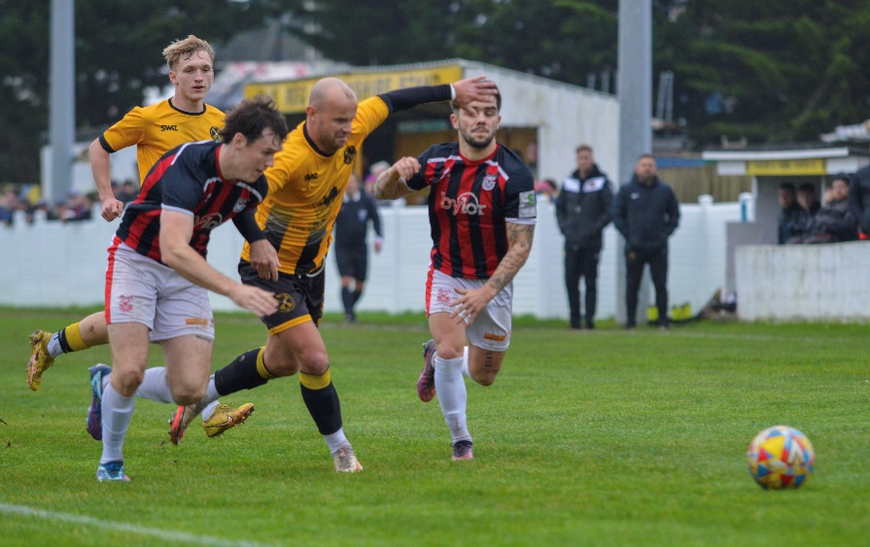
League Action: Only three games survived in the Premier Division on Saturday, with Helston moving into top spot thanks to a 2-0 win at home to Oldland Abbotonians. An eighth minute header from Jordan Bentley was all that separated the sides for much of the afternoon, with Helston only locking up the victory as the game reached the final quarter with Jamie Simmonds firing home to double their advantage. Previous league leaders Bridgwater were unable to maintain their perch atop the division after falling to a 2-1 defeat at Torpoint (pictured, right). United were second best for much of the contest, and only got on the scoresheet with the final kick of the game when Jay Murray converted a 98th minute penalty. For the home side, they continue to impress against the top sides, breaking the deadlock after only five minutes through Gary Hird. The game was then all-but decided midway through the second half, with Ryan Smith cutting in from the right before curling home to put Torpoint two goals clear.

At Homers Heath, Buckland romped to a 12-0 win over basement side Millbrook, with usual suspects Jared Lewington and Ryan Bush enjoying themselves in front of goal. Bush struck twice in either half to take his personal tally for the afternoon to four, with Lewington scoring three times inside the opening 35 minutes during the heavily one-sided affair.
In the First Division, Keynsham and Shirehampton followed up their 13-goal midweek epic in the cup with a slightly lower-scoring ten goal thriller on Saturday afternoon. Fortunately for the K’s, they didn’t have to wait long to gain revenge over their visitors, however things didn’t start well with Shirehampton forward Scott Bamford breaking the deadlock after only seven minutes. Town responded expertly, and after skipper Jake Wilson had drawn them level, they then moved ahead shortly after with Joe Davis making it 2-1. Another Bamford effort made the game level after half an hour, before a hectic end to the opening period saw Davis score twice in quick succession to complete his hat-trick and put the hosts 4-2 up at the interval. Incredibly, Bamford was first to score during the second half, following up his midweek treble with another three goal performance against the very same opponents. That was as good as it got for the away side however, and after Jemar Thomas scored a quickfire brace of his own to push the lead out to a scarcely believable 6-3, Keynsham then added another late goal to register their fifth league victory of the campaign. On a day of high-scoring, it should come as no surprise to anyone that the Western League’s leading marksman was heavily involved in Portishead’s 3-1 win away at Cadbury Heath. Ethan Feltham has been a little bit quiet over recent weeks, but he was back to his best at Springfield, firing the First Division leaders in front after only two minutes. Another Feltham effort, again assisted by Calum Townsend made it 2-0, only for the Heath to hit back instantly courtesy of Zac Cheetham to half the deficit. The home side didn’t stay in touch for long however, and six minutes after Cheetham’s effort, Town’s star man Feltham was to the fore once again, completing yet another hat-trick to help his side smash through the 50-point barrier. In the day’s early kick-off, goals in either half from Scott Saunders and Craig Wilson proved to be enough for Bristol Telephones to hand Hallen a 2-1 defeat. Elsewhere, Bishop Sutton are still without a victory after falling to a 3-0 defeat at home to Cribbs Reserves, while Bitton and Bradford remain in sixth and seventh, respectively, after battling out an entertaining 3-3 draw. Having trailed 2-1 early in the second half, Bradford turned the game on its head shortly after thanks to two goals in two minutes from Jack Witcombe and Matt Richards, but were denied victory 15 minutes from time as Bitton brought an end to their two-match losing run thanks to a late leveller.
On the podcast this week, Street boss Paddy Behan reflects on why his side have proved so tough to beat despite the rebuilding job he is currently undertaking with the Cobblers. There is also a conversation with Wincanton manager, Chris Wise, who explains why a bad day at the races spurred his side to a recent win over Radstock, and touches on the current injury crisis they are experiencing.
http://toolstationleague.com/season-2023-24-podcast-episode-16/

Latest Results
Tuesday 14th November 2023
Les Phillips Cup
Brixham 1-1 (2-3 pens) Buckland Athletic
Keynsham Town 4-9 Shirehampton

Saturday 18th November 2023
FA Vase Second Round
Nailsea & Tickenham 3-5 Hartpury College
Premier Division
Buckland Athletic 12-0 Millbrook
Helston Athletic 2-0 Oldland Abbotonians 98
Ilfracombe Town P-P St Blazey
Saltash United P-P Brixham
Street P-P Falmouth Town
Torpoint Athletic 2-1 Bridgwater United 202
Wellington P-P Clevedon Town
Welton Rovers P-P Shepton Mallet
First Division
AEK Boco P-P Radstock Town
Bishop Sutton 0-3 Cribbs Reserves 48
Bradford Town 3-3 Bitton 132
Bristol Telephones 2-1 Hallen 46
Cadbury Heath 1-3 Portishead Town 96
Cheddar P-P Brislington
Hengrove Athletic P-P Middlezoy Rovers
Keynsham Town 7-3 Shirehampton 114
Odd Down P-P Wincanton Town
Warminster Town P-P Longwell Green Sports
Wells City P-P Gillingham Town
Leading Goalscorers (Stats courtesy of FA Fulltime Website)
First Division
Ethan Feltham (Portishead) – 27
Matt Garner (Wincanton) – 18
Milo Murgatroyd (Odd Down) – 16
Louis Snailham (Shirehampton) – 13
Craig Wilson (Bristol Telephones) – 12
Ben Millett (Odd Down) – 12
Liam Clayton (Cribbs Reserves) – 11
Jack Guthrie (Cribbs Reserves) – 11
Josh Haynes (Cadbury Heath) – 11
Liam Winter (Middlezoy) -11
Premier Division
Jack Thorne (Bridgwater) – 16
Jared Lewington (Buckland) – 13
Rikki Sheppard (Helston) – 13
Ryan Richards (Torpoint) – 11
Curtis Damerell (Helston) – 10
Lucas Vowles (Nailsea&Tickenham) – 10
Phil Ormrod (Street) – 8
Jack Taylor (Bridgwater) – 8
Rubin Wilson (Helston) – 8
Sam Beresford (Clevedon) - 8

All Competitions
Ethan Feltham (Portishead) – 30
Jack Thorne (Bridgwater) – 22
Matt Garner (Wincanton) – 20
Milo Murgatroyd (Odd Down) - 18
Louis Snailham (Shirehampton) – 16
Rikki Sheppard (Helston) – 14

Upcoming Fixtures
Tuesday 21st November 2023
Premier Division
Nailsea & Tickenham vs Street 19:30KO First Division
Longwell Green Sports vs Keynsham Town 19:30KO
Les Phillips Cup
Bridgwater United vs Ilfracombe Town 19:45KO
Middlezoy Rovers vs Barnstaple Town 19:30KO
Saltash United vs Helston Athletic 19:45KO
Wincanton Town vs Shepton Mallet 19:30KO

Friday 24th November 2023
Premier Division
Nailsea & Tickenham vs Bridgwater United 19:30KO

Saturday 25th November 2023 (3pm kick-off unless noted)
Premier Division
Brixham vs Welton Rovers
Clevedon Town vs Street
Falmouth Town vs Barnstaple Town
Helston Athletic vs St Blazey
Ilfracombe Town vs Oldland Abbotonians
Saltash United vs Buckland Athletic
Shepton Mallet vs Millbrook
Wellington vs Torpoint Athletic
First Division
Bitton vs Bishop Sutton
Brislington vs Bristol Telephones
Gillingham Town vs Odd Down
Hallen vs Bradford Town
Hengrove Athletic vs Wincanton Town
Keynsham Town vs Wells City
Middlezoy Rovers vs Longwell Green Sports
Portishead Town vs Cheddar
Radstock Town vs Cadbury Heath
Les Phillips Cup
Cribbs Reserves vs AEK Boco

League Tables
 | PREMIER DIVISION | Played | Won | Drawn | Lost | GD | Points
1 | Helston Athletic | 14 | 10 | 2 | 2 | 38 | 32
2 | Bridgwater United | 14 | 10 | 1 | 3 | 27 | 31
3 | Clevedon Town | 12 | 9 | 3 | 0 | 22 | 30
4 | Brixham AFC | 15 | 8 | 3 | 4 | 23 | 27
5 | Buckland Athletic | 14 | 7 | 3 | 4 | 24 | 24
6 | Falmouth Town | 12 | 7 | 3 | 2 | 16 | 24
7 | Torpoint Athletic | 15 | 7 | 3 | 5 | 1 | 24
8 | Barnstaple Town | 10 | 5 | 5 | 0 | 16 | 20
9 | Street | 13 | 5 | 5 | 3 | -1 | 20
10 | Shepton Mallet | 13 | 5 | 4 | 4 | -2 | 19
11 | Nailsea & Tickenham | 13 | 6 | 0 | 7 | -2 | 18
12 | St Blazey | 15 | 4 | 5 | 6 | -1 | 17
13 | Ilfracombe Town | 13 | 4 | 3 | 6 | -2 | 15
14 | Welton Rovers | 13 | 3 | 3 | 7 | -5 | 12
15 | Oldland Abbotonians | 14 | 3 | 0 | 11 | -26 | 9
16 | Saltash United | 14 | 2 | 2 | 10 | -16 | 8
17 | Wellington | 14 | 1 | 3 | 10 | -36 | 6
18 | Millbrook | 12 | 0 | 0 | 12 | -76 | 0
 | FIRST DIVISION | Played | Won | Drawn | Lost | GD | Points
1 | Portishead Town | 20 | 16 | 3 | 1 | 47 | 51
2 | Radstock Town | 20 | 15 | 1 | 4 | 29 | 46
3 | Cribbs Reserves | 22 | 14 | 3 | 5 | 26 | 45
4 | Brislington | 19 | 13 | 2 | 4 | 44 | 41
5 | Wincanton Town | 21 | 12 | 4 | 5 | 9 | 40
6 | Bitton | 20 | 11 | 4 | 5 | 12 | 37
7 | Bradford Town | 22 | 10 | 6 | 6 | 15 | 36
8 | Bristol Telephones | 22 | 11 | 3 | 8 | -7 | 36
9 | Cadbury Heath | 19 | 10 | 1 | 8 | 13 | 31
10 | Wells City | 16 | 9 | 2 | 5 | 11 | 29
11 | Middlezoy Rovers | 21 | 9 | 2 | 10 | -3 | 29
12 | AEK Boco | 18 | 7 | 5 | 6 | 7 | 26
13 | Odd Down | 21 | 8 | 2 | 11 | -20 | 26
14 | Hallen | 21 | 6 | 6 | 9 | -2 | 24
15 | Shirehampton | 21 | 7 | 3 | 11 | -7 | 24
16 | Longwell Green Sports | 19 | 7 | 3 | 9 | -7 | 24
17 | Warminster Town | 19 | 6 | 3 | 10 | -7 | 21
18 | Hengrove Athletic | 21 | 5 | 4 | 12 | -17 | 19
19 | Gillingham Town | 19 | 6 | 1 | 12 | -17 | 19
20 | Keynsham Town | 18 | 5 | 1 | 12 | -19 | 16
21 | Cheddar | 20 | 3 | 1 | 16 | -31 | 10
22 | Bishop Sutton | 21 | 0 | 2 | 19 | -72 | 2

