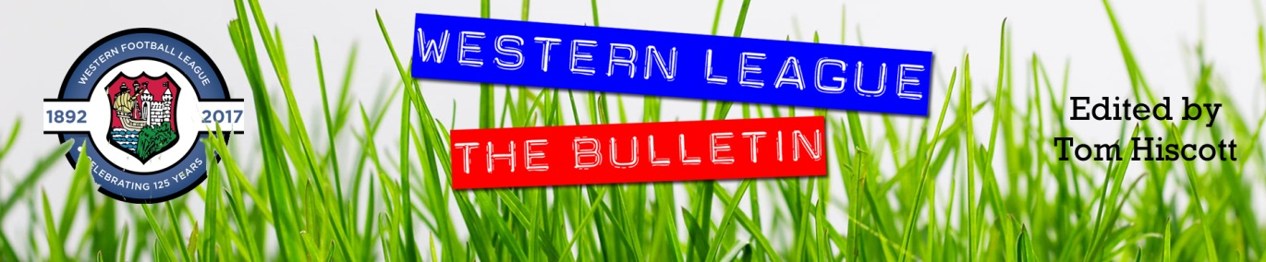
Latest Round-ups:
#17
Season 2023/24

Cup Action: It was a busy midweek of local knockout competition, with county cup’s taking precedence in the second week of November. Ilfracombe and Buckland both progressed in the Devon St Lukes Bowl, sneaking past Teignmouth and Crediton in 1-0 wins thanks to goals from Jack Magarotto and Sam Stayt, respectively. Cornwall Senior Cup holders Helston made a dream start to their defence of the competition, running out 6-1 winners away at Dobwalls thanks to a hat-trick from Sam Carter. St Blazey also progressed in that competition following a 4-0 win away at Camelford, while second half strikes from Alex Wharton and Luke Barner led Falmouth to a 2-0 victory over Torpoint. In the Gloucestershire FA Challenge Trophy, Bristol Telephones came from behind to beat Shirehampton 2-1, and in the Somerset Premier Cup, Street and Hengrove were knocked out by Taunton and Weston-Super-Mare, respectively. There was also a Les Phillips Cup tie on Tuesday evening, with a goalscoring double from Jacob Saunders helping Bitton secure a 3-2 win at home to Gillingham Town.
The FA Vase then took much of the attention on Saturday afternoon, with a host of Western League sides impressing in second round action. One side to progress was Clevedon Town who stormed to a one-sided 5-0 victory at home to Brockenhurst. The Seasiders only led by one at the interval, with leading scorer Sam Beresford outmuscling the visiting keeper before slotting home. Alex Camm then doubled the lead on the hour with a well-taken spin and finish, with his penalty putting the result beyond doubt in the 79th minute. That still left time for Town to add a couple more to their tally, with Freddie King and Beresford completing a five-star performance in the closing stages. Joining them in the third round will be the in-form Brixham who secured a 1-0 win on the Isle of Wight against Cowes Sports. Despite losing last weekend, Brixham have been producing some exquisite performances over the past month, and they collected their fifth consecutive away win thanks to a 17th minute strike from Kieran Parkin. Another Devonian outfit to move on to round three are Barnstaple Town, with Oscar Massey starring in their 2-1 win over Brimscombe & Thrupp. Massey started the game in red-hot form, and after poking home inside two minutes to break the deadlock, he then rounded the keeper and rolled the ball into an empty midway through the first half to put Town two-up. The visitors did manage to trim the deficit before half-time, but Barnstaple managed to stay ahead for the entirety of the second period to continue their progress in the Vase.

The all-Western League tie went as expected, with Premier Division leaders Bridgwater toppling Division One mid-table side Longwell Green Sports behind the scoring expertise of Jack Thorne and Jack Taylor. Thorne laid the groundwork for the 5-2 triumph with an incredible 20 minute hat-trick which saw United go three-up after only a quarter of the contest had passed. Longwell Green pulled a goal back at the beginning of the second half, but that seemed to kick Bridgwater back into life, and Taylor then struck twice to put plenty of distance between the two sides. One First Division side who did secure victory were Wells City who knocked out Portland United following a penalty shootout. Having fallen behind, Wells pegged back their visitors 15 minutes from time through Harry Warwick to send the game to spot kicks. City were then successful with four of their five penalties, and that proved to be enough to create history, taking them further than they have ever been in the history of this competition. The other success came from Falmouth Town, with Alex Wharton, Brad Leivers and Luke Brabyn all on target during their 3-0 win at home to Moneyfields. Unfortunately, they won’t be joined in the next round by Buckland and Saltash after they fell to tight home defeats against St Austell and Downton, respectively.
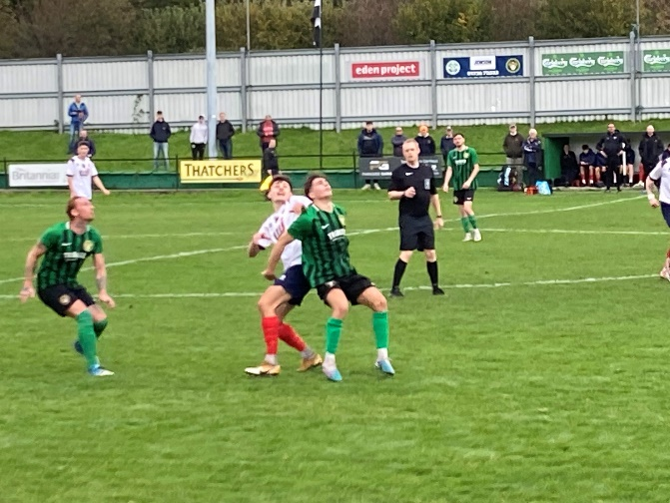
League Action: A combination of Vase entrances and poor weather saw a much reduced league schedule, with only two Premier Division contests taking place on Saturday afternoon. The biggest winners were St Blazey who beat fellow bottom-half side Wellington 5-3 to register their fourth league victory of the campaign (pictured, left). It was the Somerset side who started strongest and they forged ahead in the 16th minute with a driven effort from Jordan Hayman. The remainder of the first half belonged to the hosts, and after drawing level through Ryan Downing, they then struck twice more through Owen Pritchard and Luke Cloke to move into a 3-1 lead. After an impasse during the second half, the game then came to life over the final 15 minutes, with the sides sharing four goals. Sam Clifton and Cloke twice extended Blazey’s lead to three, but they were quickly cancelled out on each occasion by goals from Ryan Brereton and Sully McKenna for a Wellington side who refused to bow down on their trip to Cornwall. Further South, Helston suffered a late setback, conceding in stoppage time to draw two apiece with Street. Having trailed at the interval following a close-range effort from Aaron Bentley, the Cobblers got back on level terms ten minutes into the second half thanks to a Josh Goodwin effort. Helston then moved back in front through Jordan Copp, but once again they couldn’t maintain their advantage and saw Jake Horsey pop up in injury time to secure a well-earned Street point.

In the big game towards the top of the First Division, Cribbs Reserves saw their eight-match winning streak brought to an end courtesy of an excellent performance from Bradford Town. Having swept all before them over recent weeks, Cribbs’ found themselves behind early on Saturday afternoon with Jordan Pinder slamming home a tenth minute penalty. The hosts battled back and drew level just before half-time, but were then denied 15 minutes from time with Corey Gardner scoring the Bobcats winning goal. In the most dramatic encounter of the day, Wincanton scored twice in the final ten minutes to claw back a 3-2 victory at home to nine-man Radstock. After Martin Johnson headed Radstock ahead at the end of the first half, the Wasps got back on level terms soon after the interval via a Jamie Jordan effort. The major flash point then took place 15 minutes from time, with Wincanton’s Jake Seviour dismissed for a poor tackle, which saw a pair of Radstock also given their marching orders following their reaction to their challenge. Incredibly, it was then the nine man visitors who retook the lead, but they were unable to maintain that advantage for long with Charlie Berrington scoring from close range to set up a grandstand finish. It felt like a game which was always going to see a winning goal in the closing stages, and that was exactly what played out, with Wincanton’s Matt Garner getting his head on the end of a cross to secure the dramatic 3-2 victory.
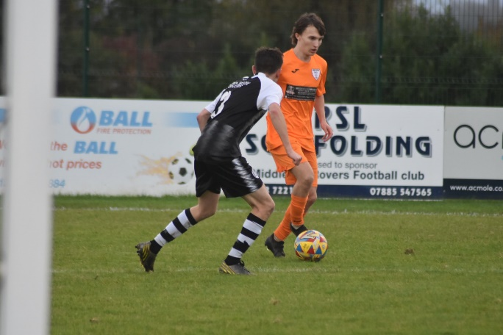
In another game decided at the death, Warminster were denied a third consecutive win after conceding a 90th minute equaliser to Hallen. Town made a horrendous start, falling behind in less than 100 seconds to Elliot Gardner, before hitting back through Sam Wright, who had also struck in their previous two victories. Having then completed the turnaround 15 minutes from time, it looked like Warminster would make it nine points from nine, however a mad scramble in the box saw Peter Majek-Oduyoye level affairs to grab a point for the Bristolians. In another game which finished two apiece, Shirehampton recovered from a poor first half to claim a share of the spoils away at Bristol Telephones. The Phones had won the cup tie between these sides five days previously, and it looked as though they would complete a short-term double when they moved two goals ahead after 45 minutes. Kye Simpson took it upon himself to make sure that wasn’t the case however, and after giving Shirehampton a lifeline on the hour mark, he then scored an excellent solo goal in the 76th minute to make sure his side took something home from the BTRA Sports Ground. There was also a tight affair in Dorset, where a solitary goal from Aaron Laney proved to be enough for Gillingham to overcome Hengrove 1-0. The other two fixtures to beat the conditions ended up being one-sided affairs, with Keynsham claiming their first win since early September, scoring four unanswered goals after the interval to thump Cheddar 4-0. It was also four goals to nil at the Ethan Berry Pavilion where Middlezoy dominated Odd Down to complete the season double over the Bath side (pictured, right).
Latest Results
Tuesday 7th November 2023
Les Phillips Cup
Bitton 3-2 Gillingham Town

Saturday 11th November 2023
FA Vase Second Round
Barnstaple Town 2-1 Brimscombe & Thrupp
Bridgwater United 5-2 Longwell Green Sports
Buckland Athletic 1-3 St Austell 194
Clevedon Town 5-0 Brockenhurst
Cowes Sports 0-1 Brixham AFC
Falmouth Town 3-0 Moneyfields
Nailsea & Tickenham P-P Hartpury College
Saltash United 0-1 Downton
Wells City 1-1 (4-3 pens) Portland United
Premier Division
Helston Athletic 2-2 Street
Oldland Abbotonians P-P Torpoint Athletic
St Blazey 5-3 Wellington 172
Welton Rovers P-P Ilfracombe Town
First Division
AEK Boco P-P Bishop Sutton
Bitton P-P Portishead Town
Bristol Telephones 2-2 Shirehampton 36
Cribbs Reserves 1-2 Bradford Town 58
Gillingham Town 1-0 Hengrove Athletic
Keynsham Town 4-0 Cheddar 103
Middlezoy Rovers 4-0 Odd Down 55
Warminster Town 2-2 Hallen
Wincanton Town 3-2 Radstock Town

Despite the bevy of postponements, we still caught up with a pair of managers in the latest episode of the podcast. As well as Tom and Ian looking back on the recent action, there is a conversation with Wellington boss Richard Cherry, who reflects on his side’s difficult start, while also explaining how the Somerset side have been rebuilding their squad. Marvin Brown of Keynsham also joins the show, to detail how the K’s want to remain competitive in games at the same time as developing the young talent in their squad.
http://toolstationleague.com/season-2023-24-podcast-episode-15/

Upcoming Fixtures
Tuesday 14th November 2023
Les Phillips Cup
Brixham vs Buckland Athletic 19:30KO
Keynsham Town vs Shirehampton 19:45KO

Saturday 18th November 2023 (3pm kick-off unless noted)
FA Vase Second Round
Nailsea & Tickenham vs Hartpury College
Premier Division
Buckland Athletic vs Millbrook
Helston Athletic vs Oldland Abbotonians
Ilfracombe Town vs St Blazey
Saltash United vs Brixham
Street vs Falmouth Town
Torpoint Athletic vs Bridgwater United
Wellington vs Clevedon Town
Welton Rovers vs Shepton Mallet
First Division
AEK Boco vs Radstock Town
Bishop Sutton vs Cribbs Reserves
Bradford Town vs Bitton
Bristol Telephones vs Hallen
Cadbury Heath vs Portishead Town
Cheddar vs Brislington
Hengrove Athletic vs Middlezoy Rovers
Keynsham Town vs Shirehampton
Odd Down vs Wincanton Town
Warminster Town vs Longwell Green Sports
Wells City vs Gillingham Town
Leading Goalscorers (Stats courtesy of FA Fulltime Website)
First Division
Ethan Feltham (Portishead) – 24
Matt Garner (Wincanton) – 18
Milo Murgatroyd (Odd Down) – 16
Louis Snailham (Shirehampton) – 13
Ben Millett (Odd Down) – 12
Liam Clayton (Cribbs Reserves) – 11
Jack Guthrie (Cribbs Reserves) – 11
Josh Haynes (Cadbury Heath) – 11
Craig Wilson (Bristol Telephones) – 11
Liam Winter (Middlezoy) -11
Premier Division
Jack Thorne (Bridgwater) – 16
Rikki Sheppard (Helston) – 13
Ryan Richards (Torpoint) – 11
Curtis Damerell (Helston) – 10
Jared Lewington (Buckland) – 10
Lucas Vowles (Nailsea&Tickenham) – 10
Phil Ormrod (Street) – 8
Jack Taylor (Bridgwater) – 8
Rubin Wilson (Helston) – 8
Sam Beresford (Clevedon) - 8

All Competitions
Ethan Feltham (Portishead) – 27
Jack Thorne (Bridgwater) – 22
Matt Garner (Wincanton) – 20
Milo Murgatroyd (Odd Down) - 18
Rikki Sheppard (Helston) – 14
Louis Snailham (Shirehampton) – 14

League Tables
 | PREMIER DIVISION | Played | Won | Drawn | Lost | GD | Points
1 | Bridgwater United | 13 | 10 | 1 | 2 | 28 | 31
2 | Clevedon Town | 12 | 9 | 3 | 0 | 22 | 30
3 | Helston Athletic | 13 | 9 | 2 | 2 | 36 | 29
4 | Brixham AFC | 15 | 8 | 3 | 4 | 23 | 27
5 | Falmouth Town | 12 | 7 | 3 | 2 | 16 | 24
6 | Buckland Athletic | 13 | 6 | 3 | 4 | 12 | 21
7 | Torpoint Athletic | 14 | 6 | 3 | 5 | 0 | 21
8 | Barnstaple Town | 10 | 5 | 5 | 0 | 16 | 20
9 | Street | 13 | 5 | 5 | 3 | -1 | 20
10 | Shepton Mallet | 13 | 5 | 4 | 4 | -2 | 19
11 | Nailsea & Tickenham | 13 | 6 | 0 | 7 | -2 | 18
12 | St Blazey | 15 | 4 | 5 | 6 | -1 | 17
13 | Ilfracombe Town | 13 | 4 | 3 | 6 | -2 | 15
14 | Welton Rovers | 13 | 3 | 3 | 7 | -5 | 12
15 | Oldland Abbotonians | 13 | 3 | 0 | 10 | -24 | 9
16 | Saltash United | 14 | 2 | 2 | 10 | -16 | 8
17 | Wellington | 14 | 1 | 3 | 10 | -36 | 6
18 | Millbrook | 11 | 0 | 0 | 11 | -64 | 0
 | FIRST DIVISION | Played | Won | Drawn | Lost | GD | Points
1 | Portishead Town | 19 | 15 | 3 | 1 | 45 | 48
2 | Radstock Town | 20 | 15 | 1 | 4 | 29 | 46
3 | Cribbs Reserves | 21 | 13 | 3 | 5 | 23 | 42
4 | Brislington | 19 | 13 | 2 | 4 | 44 | 41
5 | Wincanton Town | 21 | 12 | 4 | 5 | 9 | 40
6 | Bitton | 19 | 11 | 3 | 5 | 12 | 36
7 | Bradford Town | 21 | 10 | 5 | 6 | 15 | 35
8 | Bristol Telephones | 21 | 10 | 3 | 8 | -8 | 33
9 | Wells City | 16 | 9 | 2 | 5 | 11 | 29
10 | Middlezoy Rovers | 21 | 9 | 2 | 10 | -3 | 29
11 | Cadbury Heath | 18 | 9 | 1 | 8 | 11 | 28
12 | AEK Boco | 18 | 7 | 5 | 6 | 7 | 26
13 | Odd Down | 21 | 8 | 2 | 11 | -20 | 26
14 | Hallen | 20 | 6 | 6 | 8 | -1 | 24
15 | Shirehampton | 20 | 7 | 3 | 10 | -3 | 24
16 | Longwell Green Sports | 19 | 7 | 3 | 9 | -7 | 24
17 | Warminster Town | 19 | 6 | 3 | 10 | -7 | 21
18 | Hengrove Athletic | 21 | 5 | 4 | 12 | -17 | 19
19 | Gillingham Town | 19 | 6 | 1 | 12 | -17 | 19
20 | Keynsham Town | 17 | 4 | 1 | 12 | -23 | 13
21 | Cheddar | 20 | 3 | 1 | 16 | -31 | 10
22 | Bishop Sutton | 20 | 0 | 2 | 18 | -69 | 2

