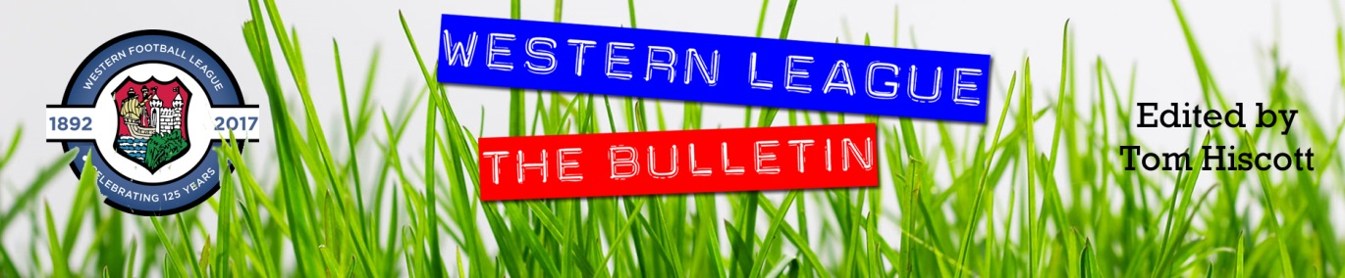
Latest Round-ups:
#13
Season 2023/24

Midweek Action: The standout result during a wet and windy week saw Bridgwater storm to a 7-2 win at home to Nailsea & Tickenham. With the original Premier Division clash having been postponed on Friday evening, the teams returned four days later to play in front of another healthy crowd of over 300. Many of those in attendance will have thoroughly enjoyed United’s performance, with Jack Taylor producing an outstanding display of finishing which saw him bag a 30-minute hat-trick to put his side in complete command. A further goal from Harry Horton made it 4-1 at the interval, with Jack Thorne then adding Bridgy’s fifth on the hour mark just moments after the visitors had struck from the spot. Man of the Match Taylor found time to add his fourth of the evening, with his replacement Adam Wright then finding the back of the net to round out the high-scoring encounter.
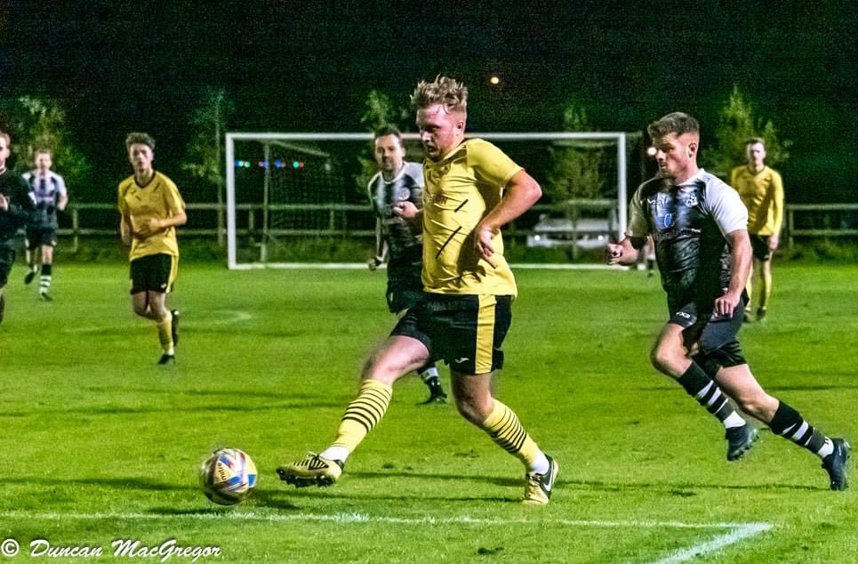
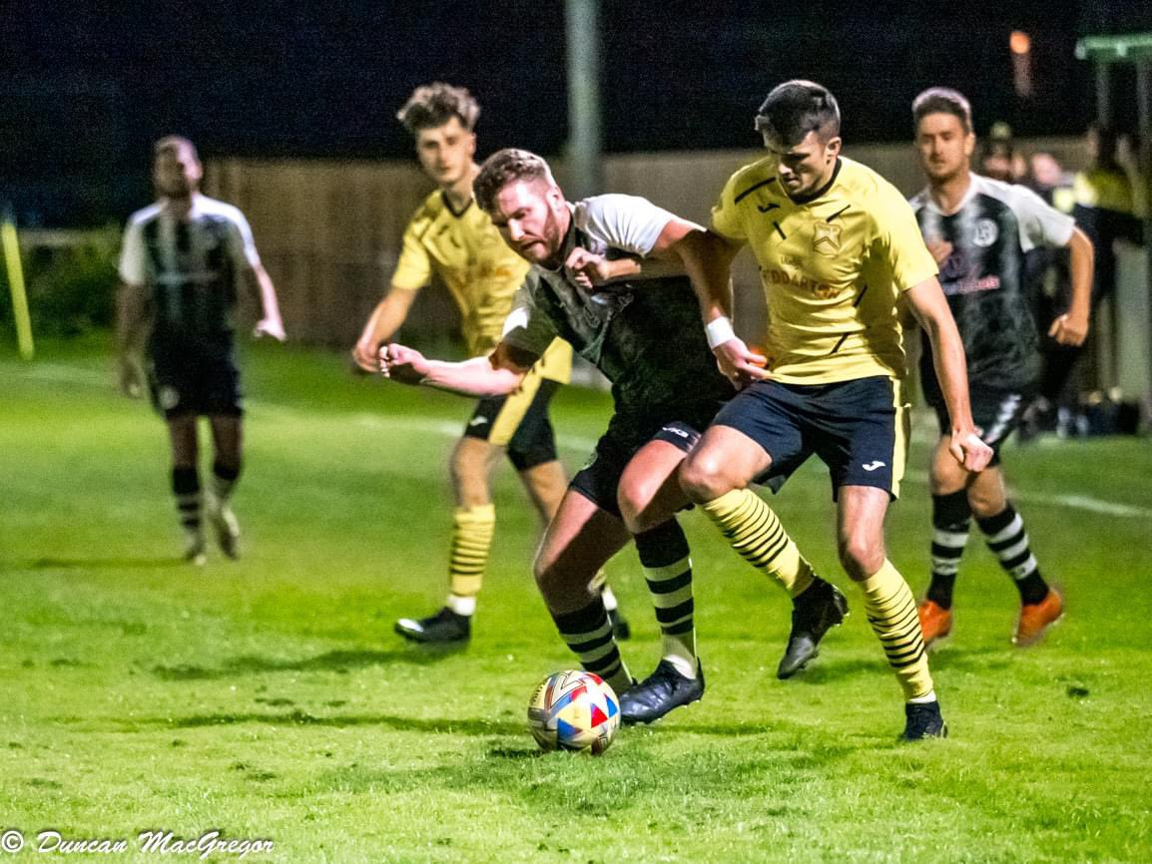
Tuesday’s First Division contests were much more evening, with basement side Bishop Sutton battling back from two goals down to draw 2-2 at Longwell Green Sports. The points were also shared at Hengrove, where Giorgio Mancini handed the hosts an early lead, only for Hallen to peg them back just prior to half-time courtesy of a headed effort from Josiah Dunstan. In the other game that night, Middlezoy brought an end to their four-match losing run by defeating Cheddar 3-1 at the Ethan Berry Pavilion. Goals from Liam Winter and Acey Mead either side of the interval had put the Rovers 2-1 up, with substitute James Millward then adding a third to secure victory over their fellow Somerset side (pictured, below).
24 hours later, Brislington’s frontline continued to flourish during a 4-0 win away at Warminster. In tough conditions, four different Brislington forwards got their names on the scoresheet, with Dean Griffiths, Danny Dodimead, Oaklan Buck and Asa White each beating the home keeper in a sixth-successive league win.

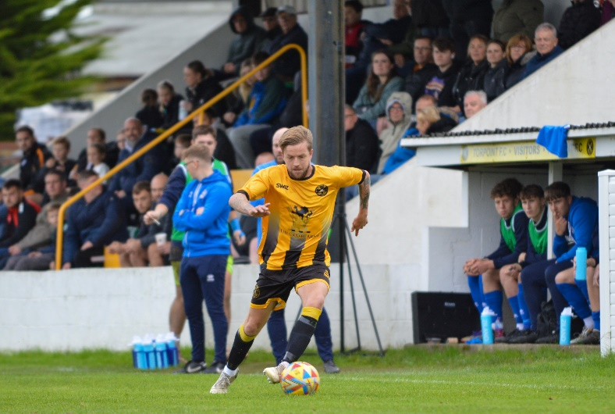
Cup Action: It was a highly-successful day for many of the Western League sides in the FA Vase, with six of the eight ties going in their favour. One of those was a given, considering it was a contest between Saltash and Portishead, with United securing a 2-0 win over the First Division high-flyers. A fast start really paid dividends for the Ashes, with Josh Toulson putting them ahead in just the fifth minute. Having been provider for the opener, Jordan Ewing then added his name to the scoresheet just prior to the half-hour mark, with his penalty ending up being the final goalscoring action of the afternoon. Another Cornish side booking their spot in the second round was Falmouth, who secured a 1-0 victory away at Fareham Town thanks to a goal from James Swan. Barnstaple were much more dominant in their win, with three unanswered goals helping them brush off Okehampton Argyle. Things didn’t start brightly for Town however, and they were reduced to ten men during the first half following a red card to goalkeeper Liam Kingston. With Stu Bowker forced to take over with the gloves, Barum were a little short in attack, but they still managed to go ahead before the break thanks to an Oscar Massey strike. The second half then saw Billy Tucker take over the contest, and after slamming home Barnstaple’s second early in the second period, he then fired home an excellent free kick to round out the victory. Joining them in the draw for the second round will be Nailsea & Tickenham after the Swags overcame Mangotsfield 2-0. Goals either side of the interval from Lucas Vowles proved to be enough for the hosts who rebounded excellently from their heavy midweek loss at Bridgwater. Longwell Green Sports also tasted Vase success on their home patch, beating Dobwalls AFC from Cornwall. Despite their disappointing league position, Longwell Green have now put together back-to-back strong performances in this competition after seeing off Bradford in the last round. Zac Feltham, James Hall and Lewis Coleman all found the back of the net for the First Division outfit, seeing off the challenge of Dobwalls for whom Ryan Knight grabbed a brace. For Helston, the 3-2 scoreline didn’t work in their favour, with first half goals from Jordan Copp and Jacob Smith putting them ahead, before a fightback from visitors Longlevens seeing the Gloucester side progress. Torpoint (pictured, left) were the only other Western League outfit to fall at stage of the competition, with a goalless draw followed by a 4-2 defeat on penalties by Portland United. A shootout worked out much better for Wells City who pegged back Laverstock & Ford before prevailing via penalties. Having fallen behind inside the opening ten minutes despite a penalty save by Harley Wilkinson, the Somerset side drew level ten minutes before half-time thanks to a low-driven effort from Michael Duffy. A goalless second half then followed, with City winning the shootout 5-4 even though they squandered both of their first two spot kicks.
In a one-sided Les Phillips Cup tie, Brixham pulled away in the closing stages of their 6-1 win away at Millbrook. Early goals from Aaron Wellington and Scott Robinson put the visitors in command, with the lowly hosts halving the deficit five minutes before the break. James Moxon’s 63rd minute effort then restored the two-goal advantage, with a late Charlie Johansen brace, and a further Robinson strike completing the victory.
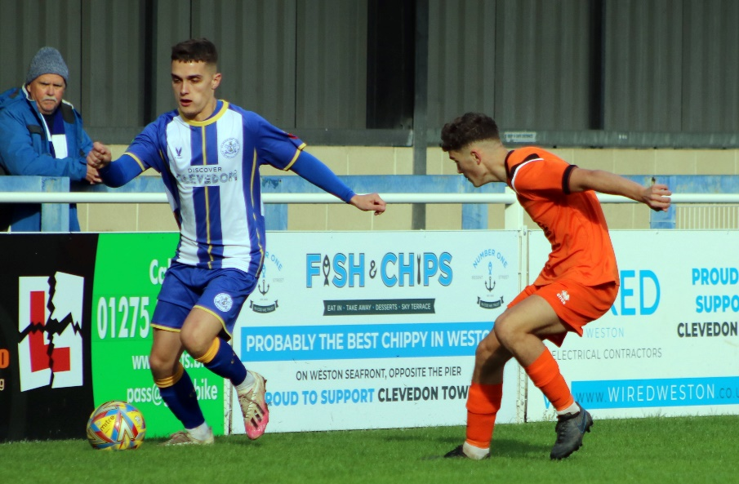
League Action: With a reduced Premier Division fixture list, Clevedon are the new league leaders following a 5-0 win over Wellington (pictured, below left). After Elliot Nicholson had put them one-up in the 7th minute, Town then moved further ahead midway through the first half courtesy of Caleb Selway. The game then went away from Wellington in the moments before half-time, with Sam Beresford and Sol Kent each scoring in added time at the end of the opening period. A fifth goal from Alex Camm 20 minutes from time then rounded out the scoring, with Clevedon one of only two unbeaten sides remaining. There was late drama at Shepton Mallet, where the hosts were stunned in stoppage time and ended up having to make do with a 1-1 draw against Buckland. In what was a tight and tense affair, Mallet looked like they’d done enough to claim victory thanks to a thumping header from Alessandro Costanza on the hour mark. However, the visitors kept pushing, and were finally rewarded in the seventh minute of stoppage time when Jared Lewington nodded home from close range. In Cornwall, St Blazey registered their most impressive victory of the season so far thanks to a 1-0 defeat of Bridgwater. Having only mustered ten points from their opening 12 fixtures, the home side will hope this is a result that can kick-start their campaign, with the three points coming thanks to a goal in first half stoppage time from Ryan Downing.
Top spot in the First Division now belongs to Radstock Town after they produced a thrilling comeback to beat Cheddar 3-2. Having last won in the league at the beginning of September, Cheddar headed into the game as rank outsiders, but started the stronger and moved ahead in the 20th minute thanks to a smart finish from Jack Busby. Not long after, Lewis Chappell then flicked the ball into an empty net to put the away side two goals to the good and on track for a stunning win. Radstock weren’t in the mood for losing on their home patch however, and scored twice in quick succession at the beginning of the second half through Kyle Thomas and Jack Farion to level affairs. It was then left to Adey Harvey to fire home a long ranger midway through the second half to complete the comeback, with the Miners now victorious in 15 of their 19 league outings this term. On a day with no draws, there were several one-sided victories, including Cribbs Reserves’ 5-0 derby-day defeat of Shirehampton. Two goals from standout Liam Clayton helped condemn the visitors to a heavy loss, with Trystan Baker, Aaron Ward-Baptiste and Dan Monk also getting in on the goalscoring action. Gillingham Town also put five past their opponents, following up dominant wins over Longwell Green and Bishop Sutton by handing Keynsham a 5-0 loss at Harding’s Lane. The third and final side to complete a 5-0 victory was Warminster, with Tyson Pollard plundering a hat-trick in their win at bottom side Bishop Sutton. The home side were up against it from the third minute, and never recovered, suffering a 17th league defeat, with Pollard’s influence allowing Warminster to stroll to victory during the second half.
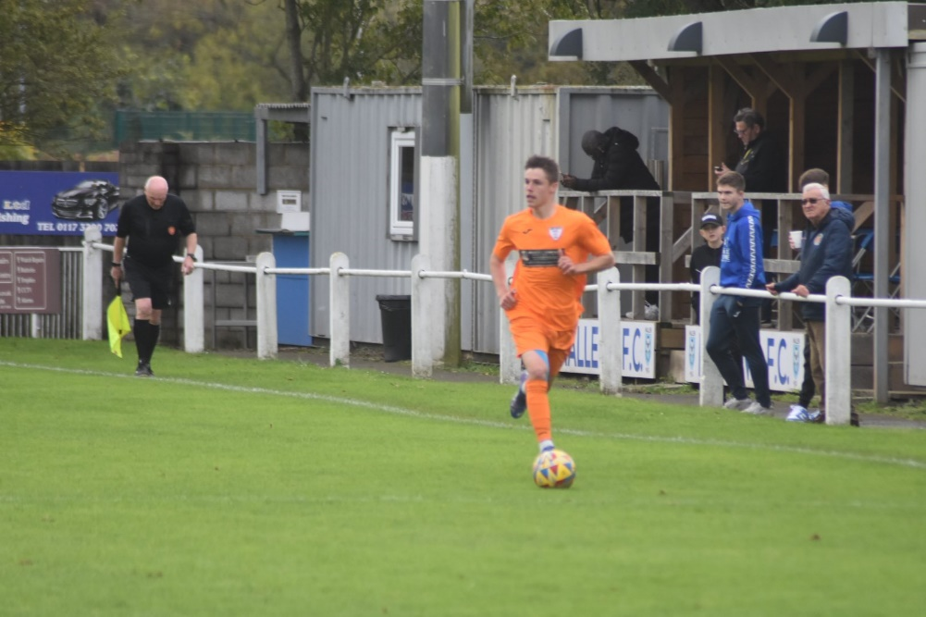
Wincanton Town came out on top in a five-goal thriller at home to Cadbury Heath, helping them rise up into fourth spot. The sides couldn’t be separated for much of the contest, and no sooner had Connor Williams put the home side in front, then Matt Huxley scored his 501st career goal to draw the Heath level. The game then came to life 15 minutes from time, with substitute Charlie Bennington making an immediate impact and scoring with his first touch to put the Wasps back ahead. Huxley then doubled his personal tally to make it two apiece with a late volley, but Wincanton had the final word, with Tom Jarvis dispatching an 88th minute penalty after Bennington had been hauled down in the opposition box. An excellent fightback from Hallen saw them end a three-match winless run by beating the in-form Odd Down 4-1 in Bristol (pictured, right). After the Bath outfit moved ahead in the 30th minute, Liam Attwell scored a crucial leveller shortly after to retain parity. Tom Cheeseman then made it 2-1 on the stroke of half time following a scramble inside the visitors area, with Luke Banfield and substitute Patryk Kosciolek completing the turnaround victory after half-time. A steady run of goals throughout the game helped Boco beat Hengrove 4-0, allowing them to register back-to-back league wins. Boco seemed to score every 20 minutes or so in Hanham, with Isiah Crawford, Will Humphries, Sam Thomas and Seb Scott all finding the back of the net. Another side to secure six points from a possible six over the past few days are Middlezoy, following up their midweek win over Cheddar with another 3-1 defeat of Bitton to complete a season double over the Bristolians.
On this week’s Podcast, Barnstaple Town chairman Bill Wilson reflects on a tragic week for the club, joining Ian to express his thanks to the Football Family for the support and compassion they have shown at this difficult time. There is also a conversation with Odd Down boss, Jason Maggs, who reflects on the rebuilding job they have undertaken this term, and then explains how he’s hoping the Bath side will now be able to progress and improve on last season’s league position.
http://toolstationleague.com/season-2023-24-podcast-episode-12/

Latest Results
Tuesday 17th October 2023
Premier Division
Bridgwater Town 7-2 Nailsea & Tickenham 301
First Division
Hengrove Athletic 1-1 Hallen 62
Longwell Green Sports 2-2 Bishop Sutton 85
Middlezoy Rovers 3-1 Cheddar 57

Wednesday 18th October 2023
First Division
Warminster Town 0-4 Brislington 71

Saturday 21st October 2023
FA Vase First Round
Barnstaple Town 3-0 Okehampton Argyle
Fareham Town 0-1 Falmouth Town
Helston Atheltic 2-3 Longlevens
Laverstock & Ford 1-1 (4-5 pens) Wells City
Longwell Green Sports 3-2 Dobwalls AFC
Nailsea & Tickenham 2-0 Mangotsfield United
Saltash United 2-0 Portishead Town
Torpoint Athletic 0-0 (2-4 pens) Portland United
Les Phillips Cup
Millbrook 1-6 Brixham AFC
Premier Division
Clevedon Town 5-0 Wellington 109
Shepton Mallet 1-1 Buckland Athletic 190
St Blazey 1-0 Bridgwater United 154
First Division
AEK Boco 4-0 Hengrove Athletic 80
Bishop Sutton 0-5 Warminster Town 42
Cribbs Reserves 5-0 Shirehampton 42
Gillingham Town 5-0 Keynsham Town 27
Hallen 4-1 Odd Down 60
Middlezoy Rovers 3-1 Bitton 55
Radstock Town 3-2 Cheddar 97
Wincanton Town 3-2 Cadbury Heath

Upcoming Fixtures
Tuesday 24th October 2023
Les Phillips Cup
Bradford Town vs Oldland Abbotonians 19:30KO
Buckland Athletic vs Torpoint Athletic 19:30KO
Falmouth Town vs Helston Athletic 19:45KO
Gillingham Town vs Bitton 19:30KO
Hengrove Athletic vs Shepton Mallet 19:30KO
Nailsea & Tickenham vs Barnstaple Town 19:30KO
Odd Down vs Longwell Green Sports 19:30KO
Portishead Town vs Bridgwater United 19:30KO
Wells City vs Street 19:30KO
Wincanton Town vs Hallen 19:30KO

Wednesday 25th October 2023
Les Phillips Cup
Shirehampton vs Keynsham Town 19:30KO
St Blazey vs Saltash United 19:30KO
Wellington vs Ilfracombe Town 19:45KO

Friday 27th October 2023
First Division
Odd Down vs Keynsham Town 19:45KO

Saturday 28th October 2023 (3pm kick-off unless noted)
Premier Division
Barnstaple Town vs Falmouth Town
Bridgwater United vs Shepton Mallet
Buckland Athletic vs Helston Athletic
Millbrook vs Welton Rovers
Nailsea & Tickenham vs Saltash United
Oldland Abbotonians vs Ilfracombe Town
Street vs St Blazey
Torpoint Athletic vs Clevedon Town
Wellington vs Brixham AFC
First Division
AEK Boco vs Hallen
Bitton vs Radstock Town
Bradford Town vs Portishead Town
Cadbury Heath vs Brislington
Cribbs Reserves vs Wincanton Town
Gillingham Town vs Cheddar
Middlezoy Rovers vs Bristol Telephones
Shirehampton vs Longwell Green Sports
Warminster Town vs Hengrove Athletic
Wells City vs Bishop Sutton

League Tables
 | PREMIER DIVISION | Played | Won | Drawn | Lost | GD | Points
1 | Clevedon Town | 11 | 8 | 3 | 0 | 20 | 27
2 | Helston Athletic | 11 | 8 | 1 | 2 | 34 | 25
3 | Bridgwater United | 11 | 8 | 1 | 2 | 24 | 25
4 | Brixham AFC | 13 | 7 | 3 | 3 | 20 | 24
5 | Falmouth Town | 11 | 7 | 2 | 2 | 16 | 23
6 | Buckland Athletic | 13 | 6 | 3 | 4 | 12 | 21
7 | Barnstaple Town | 9 | 5 | 4 | 0 | 16 | 19
8 | Shepton Mallet | 12 | 5 | 4 | 3 | 1 | 19
9 | Torpoint Athletic | 12 | 5 | 3 | 4 | 1 | 18
10 | Street | 11 | 5 | 3 | 3 | -1 | 18
11 | Nailsea & Tickenham | 11 | 5 | 0 | 6 | -1 | 15
12 | Ilfracombe Town | 12 | 4 | 3 | 5 | -1 | 15
13 | St Blazey | 13 | 3 | 4 | 6 | -3 | 13
14 | Welton Rovers | 12 | 2 | 3 | 7 | -8 | 9
15 | Saltash United | 12 | 2 | 2 | 8 | -14 | 8
16 | Oldland Abbotonians | 12 | 2 | 0 | 10 | -25 | 6
17 | Wellington | 12 | 1 | 3 | 8 | -30 | 6
18 | Millbrook | 10 | 0 | 0 | 10 | -61 | 0
 | FIRST DIVISION | Played | Won | Drawn | Lost | GD | Points
1 | Radstock Town | 19 | 15 | 1 | 3 | 30 | 46
2 | Portishead Town | 18 | 14 | 3 | 1 | 44 | 45
3 | Brislington | 18 | 13 | 2 | 3 | 45 | 41
4 | Wincanton Town | 19 | 11 | 4 | 4 | 10 | 37
5 | Cribbs Reserves | 18 | 11 | 3 | 4 | 20 | 36
6 | Bitton | 18 | 11 | 3 | 4 | 13 | 36
7 | Bradford Town | 18 | 9 | 5 | 4 | 17 | 32
8 | Wells City | 15 | 8 | 2 | 5 | 8 | 26
9 | Middlezoy Rovers | 19 | 8 | 2 | 9 | -6 | 26
10 | Bristol Telephones | 18 | 8 | 2 | 8 | -10 | 26
11 | Cadbury Heath | 17 | 8 | 1 | 8 | 10 | 25
12 | AEK Boco | 17 | 7 | 4 | 6 | 7 | 25
13 | Odd Down | 19 | 7 | 2 | 10 | -18 | 23
14 | Hallen | 18 | 6 | 4 | 8 | -1 | 22
15 | Longwell Green Sports | 17 | 6 | 3 | 8 | -4 | 21
16 | Shirehampton | 18 | 6 | 2 | 10 | -8 | 20
17 | Warminster Town | 17 | 5 | 2 | 10 | -10 | 17
18 | Hengrove Athletic | 18 | 4 | 4 | 10 | -15 | 16
19 | Gillingham Town | 18 | 5 | 1 | 12 | -18 | 16
20 | Keynsham Town | 14 | 3 | 1 | 10 | -23 | 10
21 | Cheddar | 18 | 3 | 1 | 14 | -25 | 10
22 | Bishop Sutton | 19 | 0 | 2 | 17 | -66 | 2

