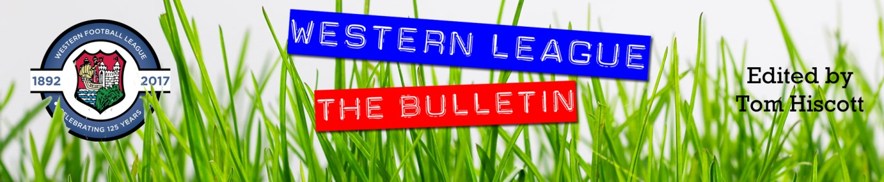
Latest Round-ups:
#12
Season 2023/24

Midweek Action: In the big game of the week in the First Division, Brislington secured an impressive 4-1 win away at Bitton. Last season’s champions have been finding the net with regularity during their recent run of results, and that didn’t slow up at Bitton, with Jordan Williams and Dean Griffiths putting them 2-0 up after 22 minutes. A third goal from Josh Egan put Brislington out of sight, with Danny Dodimead completing the scoring shortly after. There was also a big away win for Gillingham Town, with James Boyland scoring twice in their 5-1 defeat of Bishop Sutton. In a battle between the bottom-two, Gillingham brought an end to their eight-match losing run, with Jordon Clapp, Jack Male and Sam Hodges joining Boyland on the scoresheet at Lakeview. Ben Millett's four-goal performance propelled Odd Down to a comfortable 5-0 win at home to Bristol Telephones. Having suffered late heartbreak in their previous match, the Bath side started strongly under the lights and led 2-0 after 25 minutes thanks to goals from Abdou Mbaye and star-man Millett. The home forward then struck again at the end of the first half to put his side in complete command, before completing his hat-trick two minutes after the interval, and he was then on hand to bring the curtain down on an electric performance by adding his fourth, and Odd Down's fifth as the game ticked over to the 90th minute. Elsewhere on Tuesday, goals from Kyle Thomas, Corey Rawlings and Matt Curnock helped Radstock rack up another 3-0 win, this time over Wincanton, while league leaders Portishead were held to a goalless draw at Hallen. Wednesday’s double included strong showings from a couple of sides who backed up impressive weekend performances to claim back-to-back victories. Cadbury Heath followed up their ten-goal triumph on Saturday with a 4-0 win away at Shirehampton. Tom Withers 29th minute goal was all that separated the sides for much of the evening, but then the Heath dominated the final quarter-hour with Zac Cheetham, Josh Haynes, and Withers again adding some real gloss to the scoreline. Cribbs Reserves are another side full of confidence at the minute, and they overturned a half-time deficit to beat Middlezoy Rovers 4-1. After Noah Brown had put the visitors in front during the first half, Cribbs responded well, drawing level five minutes after the interval through Ollie Dunleavy. The game really turned in the home side’s favour around the hour mark thanks to a quickfire double from Liam Clayton before Tom Headford added Cribbs’ fourth deep into stoppage time. There was one solitary Premier Division fixture during the midweek period, with Phil Ormrod scoring at the death to hand Street a 1-0 victory away at Welton.

In this week’s Les Phillips Cup tie, Barnstaple secured their passage through to the second round after winning 4-2 away at Cheddar. A single goal from Tor Swann put the visitors ahead at the break, but they soon added to their lead, scoring twice in the early stages of the second half through Brodie Montague and Tommy Rogers. The Cheesemen attempted a late fightback, led by goals from Elliot Keen and Craig Njini, but it was the Devonians who progressed thanks to a late fourth from substitute Jamie Hearsey.
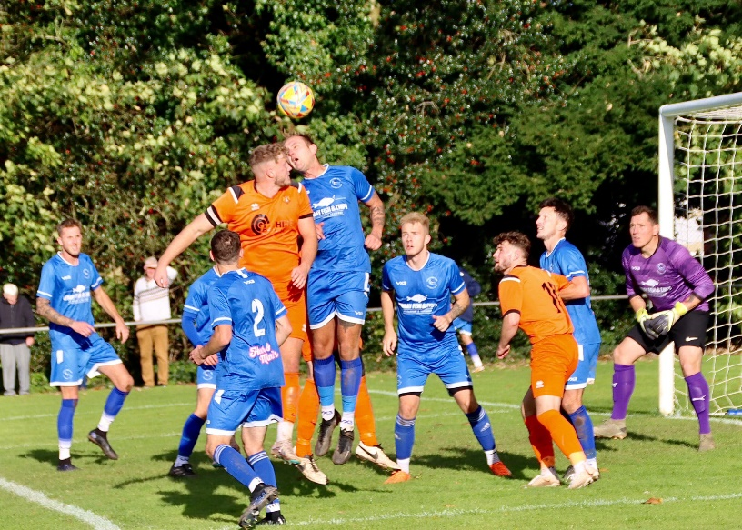
Premier Division: Top beat bottom at Jenkins Park, where Helston followed up their big win last weekend with an 8-0 defeat of fellow Cornish outfit Millbrook. A first half double from Curtis Damerell got the ball rolling for the away side, adding to an eighth minute effort from Aaron Bentley. Sam Carter’s header put Helston four goals clear at the end of the first half, with Baga Mariko then scoring a minute later to notch his first for the club. Rubin Wilson then struck twice during the second half, becoming the third player to complete goalscoring doubles following another goal from Bentley. Second spot now belongs to an ascendant Brixham side who have won five on the spin thanks to a 2-0 victory away at Street. Coming off the back of a title-winning season last time out, the Fishermen were always likely to a confident outfit, and their fifth consecutive clean sheet helped spearhead their last victory. Ben Aldous opened the scoring inside the opening ten minutes, with Scott Robinson then also scoring prior to half time as Brixham ran out victors. Another side to secure all three points away from home were Ilfracombe Town, with Dan Wilson’s treble leading them to a come-from-behind victory at Wellington (pictured, left). Having seen Ryan Brereton drive the Somerset side into a 15th minute, Ilfracombe hit back on the half hour thanks to a simple finish from Wilson. The same man then stroked home a penalty in the 44th minute to complete the turnaround, with his hat-trick goal then coming at the beginning of the second half to help round out the 3-1 win. The same scoreline was also enjoyed by the visiting Shepton Mallet side who handed Falmouth just their second league defeat of the campaign. Charlie Bateson handed the visitors a dream start, maintaining his strong goalscoring form with a third minute effort. After an own goal had double Mallet’s advantage, Jacob Sloggett tucked home a penalty five minutes before half time to make it 3-0. The hosts saw their opportunity of hitting back instantly denied by a Tom Robers penalty save, and despite scoring through Jacob Grange late on they fell to a rare defeat. The most dramatic clash of the afternoon saw Buckland come out on top at home to Saltash, winning 4-3 at the end of a topsy-turvy battle. Having fallen behind to Kieran O’Melia’s third minute opener, Buckland hit back to lead at the break thanks to Cieran Bridger who added to an earlier own goal. Ben Carter’s penalty midway through the second half looked to have put the game to bed, but the Ashes seemed to have other ideas and halved the deficit courtesy of a Jordan Ewing header. Then, with their next attack on goal, United were awarded a spot kick of their own which was converted by Ewing to set up a dramatic finale. Fortunately for the home side, it was they who scored the decisive seventh goal of the afternoon, with Josh Grant finding the back of the net three minutes from time to land all three points. Elsewhere, goals from Henry Westlake, Freddie King and Alex Camm led Clevedon to a 3-0 win at home to Oldland, while Welton and St Blazey battled out a goalless draw at West Clewes. Barnstaple’s scheduled visit to Torpoint was postponed due to a bereavement at the Devon club, and the thoughts and prayers of everyone remains with them at this moment in time.

First Division: On Friday evening, Radstock Town moved into ownership of top spot following a 3-1 win away at Keynsham. Riding a ten-game unbeaten run, the Miners look to be full of confidence, and they shot out of the blocks under the lights at the AJN Stadium, going two goals clear inside 11 minutes courtesy of an early Jacob Reader double. A penalty in first half stoppage time from the ever-reliable Ian Jeffery put Radstock three goals to the good, and despite losing their clean sheet late on, the destination of the points was never in doubt.
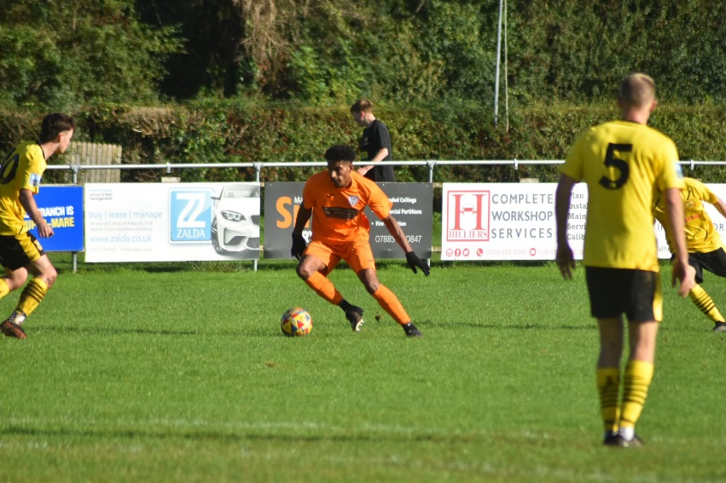
Portishead Town then leapfrogged the Miners back up into first place after beating Bishop Sutton 6-0. Having topped the same opponent by four goals to nil less than a month ago, a solitary header from Calum Townsend was all that separated the sides at half-time this time around. Debutant Ben Griffith was then on hand to double Portishead’s lead early in the second half, with another Townsend effort finally putting some distance between the sides. Jack Harper (2) and Alex O’Keeffe rounded out the scoring for Town in the closing stages on a momentous afternoon which saw Portishead smash their record crowd numbers with 461 in attendance to watch the table-toppers. Another set of fans who will have gone home happy are Brislington, where they equalled Portishead’s six-goal haul in a comfortable win over Middlezoy. The hero of the afternoon was Danny Dodimead, who after scoring twice in the opening 15 minutes, then completed his hat-trick in first half stoppage time. Further goals came via a Dean Griffiths header, Jordan Scadding thunderbolt and a Jack Fillingham lob, with Brislington now riding a five-match winning streak. Equally impressive over recent weeks have been Odd Down, and the Bath side have now prevailed in six of their last seven following a 3-1 win away at Cheddar (pictured, right). The visitors made a breakneck start to the game in Somerset, going two-up inside the opening 12 minutes thanks to goals from usual suspects Milo Murgatroyd and Ben Millett. A strong response from Cheddar saw Mike Busby pull a goal back for the home side, but it was Odd Down who ran out winners with Millett scoring for the second time to take his personal tally to six goals in four days. Another strong showing from Bitton helped them grab their 11th league win this season, firing back to beat Warminster 2-1. George Lloyd had put the away side in front after only ten minutes, before they were pegged back by their hosts midway through the second half. That didn’t deter Bitton however, and no sooner had Warminster equalised, they then pushed back down the other end and scored what turned out to be the winning goal through Scott Gregory. The only other home side to prevail on Saturday were AEK Boco, with a trio of second half goals giving them a 3-0 win over Bristol Telephones. A goalless first half was followed up by a dominant second from the hosts, with Jack Sheppard-Cozens breaking the deadlock two minutes after the restart with a guided header. Shortly after that, Seb Scott rifled home to make it 2-0, with Sheppard-Cozens then extending the advantage to three on the hour mark.
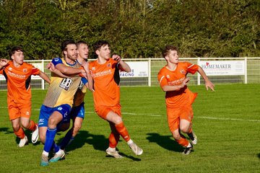
A thrilling encounter at Trowbridge Road saw hosts Bradford score twice in the final 15 minutes to salvage a 3-3 draw with Wincanton. Having gone ahead in the sixth minute via Jack Witcombe’s deflected strike, the Bobcats were pegged back during the first half by a flicked header from Matt Garner. The Wasps had Garner to thank for their turnaround, with the frontman making it 2-1 early in the second half, before the same man fired home again in the 66th minute to complete his hat-trick. Bradford had plenty of time to gain something from the contest, and they did just that, with Jordan Pinder’s penalty followed moments later by a Sammy Jordan leveller as the top-half rivals ended up sharing the spoils. The game also ended all-square at Springfield, where Pete Sheppard’s double helped Hengrove claw back a 2-2 draw against Cadbury Heath, for whom Harry Goldspink and Josh Haynes were on target. Elsewhere, a pair of goals inside the opening 25 minutes from Bailey Croome and Ollie Dunleavy proved to be enough for Cribbs Reserves as they held on to beat Hallen 2-1, while James Bayliss scored early in the second half to lead Wells to a 1-0 win at Shirehampton. Gillingham Town made it back-to-back wins for the first time this term, beating Longwell Green Sports 4-0 to jump up into 19th spot (pictured, above, courtesy of Mark Gourlay).

The podcast this week includes an interview with Shepton Mallet boss, Aaron Seviour, who touches on their season of transition, before explaining how he is looking to develop a whole club ethos, building through the youth setup into the first team. Ian then touches base with new Hallen manager, Karl Baggaley, who talks up the potential that attracted him to the club. There is also a special interview with Mind in Somerset, helping to mark Tuesday’s World Mental Health Day.
http://toolstationleague.com/season-2023-24-podcast-episode-11/

Latest Results
Tuesday 10th October 2023
Premier Division
Welton Rovers 0-1 Street 110
First Division
Bishop Sutton 1-5 Gillingham Town 48
Bitton 1-4 Brislington 172
Hallen 0-0 Portishead Town 64
Odd Down 5-0 Bristol Telephones 50
Radstock Town 3-0 Wincanton Town 113
Les Phillips Cup
Cheddar 2-4 Barnstaple Town 88

Wednesday 11th October 2023
First Division
Cribbs Reserves 4-1 Middlezoy Rovers 30
Shirehampton 0-4 Cadbury Heath 53

Friday 13th October 2023
First Division
Keynsham Town 1-3 Radstock Town 157

Saturday 14th October 2023
Premier Division
Buckland Athletic 4-3 Saltash United 245
Clevedon Town 3-0 Oldland Abbotonians 165
Falmouth Town 1-3 Shepton Mallet 396
Millbrook 0-8 Helston Athletic
Street 0-2 Brixham AFC
Torpoint Athletic P-P Barnstaple Town
Wellington 1-3 Ilfracombe Town 106
Welton Rovers 0-0 St Blazey 115
First Division
AEK Boco 3-0 Bristol Telephones 109
Bradford Town 3-3 Wincanton Town 122
Brislington 6-0 Middlezoy Rovers 116
Cadbury Heath 2-2 Hengrove Athletic 52
Cheddar 1-3 Odd Down 78
Gillingham Town 4-0 Longwell Green Sports 47
Hallen 1-2 Cribbs Reserves 68
Portishead Town 6-0 Bishop Sutton 461
Shirehampton 0-1 Wells City 63
Warminster Town 1-2 Bitton 155

The Toolstation Western League continues to promote the importance of Mental Health thanks to long-term partnerships between member clubs and local charities. For more information on this important work, please head to the following page on our website: http://toolstationleague.com/toolstation-western-league-still-promoting-the-importance-of-mental-health/
Upcoming Fixtures
Tuesday 17th October 2023
Premier Division
Bridgwater Town Nailsea & Tickenham
First Division
Hengrove Athletic vs Hallen 19:30KO
Longwell Green Sports vs Bishop Sutton 19:30KO
Middlezoy Rovers vs Cheddar 19:30KO

Wednesday 18th October 2023
First Division
Cadbury Heath vs Cribbs Reserves 19:30KO
Warminster Town vs Brislington 19:45KO

Saturday 21st October 2023 (3pm kick-off unless noted)
FA Vase First Round
Barnstaple Town vs Okehampton Argyle
Fareham Town vs Falmouth Town
Helston Atheltic vs Longlevens
Laverstock & Ford vs Wells City
Longwell Green Sports vs Dobwalls AFC
Nailsea & Tickenham vs Mangotsfield United
Saltash United vs Portishead Town
Torpoint Athletic vs Portland United
Les Phillips Cup
Millbrook vs Brixham AFC
Premier Division
Clevedon Town vs Wellington
Shepton Mallet vs Buckland Athletic
St Blazey vs Bridgwater United
First Division
AEK Boco vs Hengrove Athletic
Bishop Sutton vs Warminster Town
Cribbs Reserves vs Shirehampton
Gillingham Town vs Keynsham Town
Hallen vs Odd Down
Middlezoy Rovers vs Bitton
Radstock Town vs Cheddar
Wincanton Town vs Cadbury Heath
League Tables
 | PREMIER DIVISION | Played | Won | Drawn | Lost | GD | Points
1 | Helston Athletic | 11 | 8 | 1 | 2 | 34 | 25
2 | Brixham AFC | 13 | 7 | 3 | 3 | 20 | 24
3 | Clevedon Town | 10 | 7 | 3 | 0 | 15 | 24
4 | Falmouth Town | 11 | 7 | 2 | 2 | 16 | 23
5 | Bridgwater United | 9 | 7 | 1 | 1 | 20 | 22
6 | Buckland Athletic | 12 | 6 | 2 | 4 | 12 | 20
7 | Barnstaple Town | 9 | 5 | 4 | 0 | 16 | 19
8 | Shepton Mallet | 11 | 5 | 3 | 3 | 1 | 18
9 | Torpoint Athletic | 12 | 5 | 3 | 4 | 1 | 18
10 | Street | 11 | 5 | 3 | 3 | -1 | 18
11 | Nailsea & Tickenham | 10 | 5 | 0 | 5 | 4 | 15
12 | Ilfracombe Town | 12 | 4 | 3 | 5 | -1 | 15
13 | St Blazey | 12 | 2 | 4 | 6 | -4 | 10
14 | Welton Rovers | 12 | 2 | 3 | 7 | -8 | 9
15 | Saltash United | 12 | 2 | 2 | 8 | -14 | 8
16 | Oldland Abbotonians | 12 | 2 | 0 | 10 | -25 | 6
17 | Wellington | 11 | 1 | 3 | 7 | -25 | 6
18 | Millbrook | 10 | 0 | 0 | 10 | -61 | 0
 | FIRST DIVISION | Played | Won | Drawn | Lost | GD | Points
1 | Portishead Town | 18 | 14 | 3 | 1 | 44 | 45
2 | Radstock Town | 18 | 14 | 1 | 3 | 29 | 43
3 | Brislington | 17 | 12 | 2 | 3 | 41 | 38
4 | Bitton | 17 | 11 | 3 | 3 | 15 | 36
5 | Wincanton Town | 18 | 10 | 4 | 4 | 9 | 34
6 | Cribbs Reserves | 17 | 10 | 3 | 4 | 15 | 33
7 | Bradford Town | 18 | 9 | 5 | 4 | 17 | 32
8 | Wells City | 15 | 8 | 2 | 5 | 8 | 26
9 | Bristol Telephones | 18 | 8 | 2 | 8 | -10 | 26
10 | Cadbury Heath | 16 | 8 | 1 | 7 | 11 | 25
11 | Odd Down | 18 | 7 | 2 | 9 | -15 | 23
12 | AEK Boco | 16 | 6 | 4 | 6 | 3 | 22
13 | Shirehampton | 17 | 6 | 2 | 9 | -3 | 20
14 | Longwell Green Sports | 16 | 6 | 2 | 8 | -4 | 20
15 | Middlezoy Rovers | 17 | 6 | 2 | 9 | -10 | 20
16 | Hallen | 16 | 5 | 3 | 8 | -4 | 18
17 | Hengrove Athletic | 16 | 4 | 3 | 9 | -11 | 15
18 | Warminster Town | 15 | 4 | 2 | 9 | -11 | 15
19 | Gillingham Town | 17 | 4 | 1 | 12 | -23 | 13
20 | Keynsham Town | 13 | 3 | 1 | 9 | -18 | 10
21 | Cheddar | 16 | 3 | 1 | 12 | -22 | 10
22 | Bishop Sutton | 17 | 0 | 1 | 16 | -61 | 1

