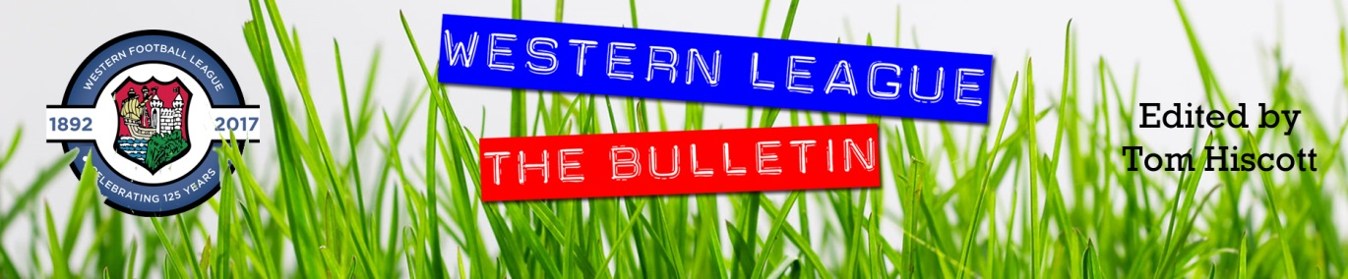
Latest Round-ups:
#11
Season 2023/24

Midweek Action: On Tuesday evening, Bradford Town and Boco shared the points following a dramatic denouement to their First Division clash at Trowbridge Road. Having played out 80 goalless minutes, it was the away side who finally made the breakthrough in the closing stages through Sam Thomas. That goal had looked like a potential winner, but if anything, it awoke the Bobcats and they managed to avoid defeat with Jacob Mead scoring five minutes from time with a fantastically taken free-kick. The following evening, Scott Bamford’s hat-trick inspired Shirehampton to a 5-1 win at home to Hengrove. Having seen the original fixture abandoned with the Shire leading 4-1 after 83 minutes, they made sure to make their dominance count again, with Bamford’s treble completed thanks to a pair of late goals at The Creek. Ryan Radford and Louis Snailham also struck for the home side, who maintained their recent run of high-scoring encounters. There were also a pair of Les Phillips Cup ties on Wednesday involving four First Division sides, with Tom Headford, Liam Clayton and Aaron Coleman all scoring in the opening 34 minutes to give Cribbs Reserves a comfortable 3-0 win over Bristol Telephones. The other side to book their spot in the second round were Longwell Green Sports, with Nathan Hall’s brace helping them secure a 2-1 win away at Cadbury Heath.

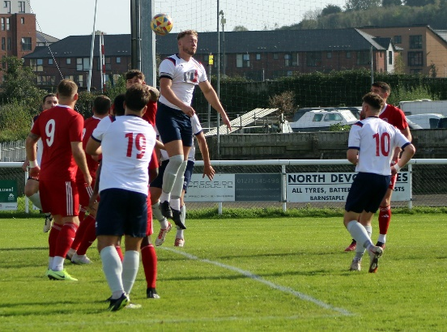
Premier Division: League leaders Falmouth were among a bunch of high-scoring home winners on Saturday afternoon, with a dominant second half leading them past Street. After being pegged back just prior to half-time, Falmouth flew out of the blocks after the interval, eventually winning by six goals to one. Luke Barner and Cam Hutchinson each struck twice for Town, with Jared Sims and Jayden Gilbert also notching during a one-sided second period. Another side to prosper during the second half of their match was Bridgwater, with four of their goals coming after the interval to cap a 5-0 win at home to Torpoint. Sustained pressure from the hosts was finally rewarded two minutes before half-time when Harry Horton fired United into a one-goal lead. The Thorne’s then took over the contest, with Dave making it 2-0 in the early stages of the second half, before Jack then struck twice to put the result beyond doubt. It was then left to recent addition Jay Murray to add the finishing touches, with his late volley capping an excellent five-goal performance. Barnstaple went one better than Bridgy, scoring three times in either half to claim a 6-0 victory at home to Wellington. The visitors made the worst possible start, conceding inside the second minute when Stu Bowker stroked home. The in-form Oscar Massey then came to the fore for Town, with his quickfire double putting them three up at the break. Blake Shepherd was then on hand to fire home Barnstaple’s fourth, before the unstoppable Massey took his personal tally to four with two further goals.
On a day of incredible goalscoring, Brixham went one better again, putting seven past a hapless Millbrook to secure their fourth consecutive league win, all without conceding. Their form man up top right now is Charlie Johansen, and after scoring at the beginning and end of the first half, the former Buckland frontman then struck again early in the second half to complete his hat-trick. There were four other scorers on Saturday afternoon for the home side, with Cole Harford, Jake Chisholm, Jaden Maslen and Kieran Parkin condemning Millbrook to another tough loss. In a less one-sided affair, Clevedon were one of the rare away victors, with Sam Beresford firing them to a 1-0 win at St Blazey, while Ilfracombe defeated Welton 3-0.
The most competitive clash of the afternoon took place at Fryth Way, where Nailsea & Tickenham toppled Buckland by four goals to three. It didn’t look as though the Swags would come out on top after their slow start which saw Josh Webber and Josh Grant fire the visitors into an early two-goal lead. Nailsea then turned the game on its head in the period either side of half-time, scoring four times in the space of 15 minutes to stun the Bucks. Joe Berry and Callum Dunn were each on target twice to hand the home side a 4-2 advantage within moments of the second-half restart. That wasn’t the end of the scoring however, and Rob Farkins struck with four minutes remaining to set up a grandstand finish, but it wasn’t to be for Buckland who have suffered back-to-back defeats. Back towards the top of the table, Helston secured a 5-1 win away at Oldland to bounce back from last Saturday’s surprise home defeat. Rikki Sheppard helped Helston dominate the early passages, and having already broken the deadlock at the end of their first attack, he was then on target again to make it 2-0 after just nine minutes. Oldland kicked into life on the back of that start, and got a lifeline back into the contest when Mitch Dann found the back of the net shortly after Sheppard’s second. That was as close as they got however, and after substitute Sam Carter made it 3-1, Jordan Copp added goal number four, before Sheppard capped an outstanding performance with his hat-trick goal from the penalty spot. The other victors on Saturday afternoon were Shepton Mallet, with debutant Leo Eglin setting them on their way to a 3-1 defeat of Saltash. Eglin took just 12 minutes to make his mark for Mallet, giving the home side a lead which they then added to on the half hour thanks to a free kick from Josh Jenkins. Saltash did manage to reduce the deficit courtesy of Tyler Love-Holmes, but the result was then put to bed in the closing stages when Will Banks added a third for Shepton.
First Division: Goals certainly weren’t on short supply in the First Division either, with Matt Huxley’s historic moment helping lead Cadbury Heath to a 10-0 trouncing of Bishop Sutton. Having watched teammate Josh Haynes bag a hat-trick in the space of 35 minutes, Huxley got in on the action to make it 5-0 just prior to half-time. Haynes was the standout performer of the afternoon, taking his individual tally on the afternoon to five during the second half, but history beckoned for Huxley during the closing stages. After making it 9-0 13 minutes from time, the Heath forward then completed his hat-trick in the final moments to claim his 500th Western league goal. That late effort also took him to 300 for the Heath on a memorable afternoon for himself and the club. Brislington were the days other big winners, putting five past Gillingham Town in the day’s early kick-off. Five different scorers found the back of the net for the visitors, with Josh Egan, Harry Tobin, Jordan Williams, Jack Fillingham and Jordan Scadding each beating the home keeper.

Away wins were popular throughout the entire division on Saturday, with Cribbs Reserves toppling Bristol Telephones by three goals to one to leapfrog their hosts. Having already beaten the same opponent in the Les Phillips Cup earlier this week, Cribbs repeated the trick, scoring three unanswered goals again courtesy of Aaron Coleman, Liam Clayton and Tom Burns. Leaders Portishead won again on their travels, with the league’s hottest forward Ethan Feltham scoring twice in the first half to help them beat Wincanton 3-1. Feltham’s double, plus a worldy from Callum Eastwood put Town three-up at the interval, with Louis Irwin’s goal early in the second half proving to be nothing more than a consolation. 3-1 was also the winning scoreline for Hallen, with a fantastic effort from Josiah McKayle setting them on their way against Middlezoy. Having been defeated by Rovers on the opening day of the season, Hallen gained short term revenge, with Luke Banfield making it 2-0, before Peter Majek-Oduyoye finally wrapped things up in stoppage time.
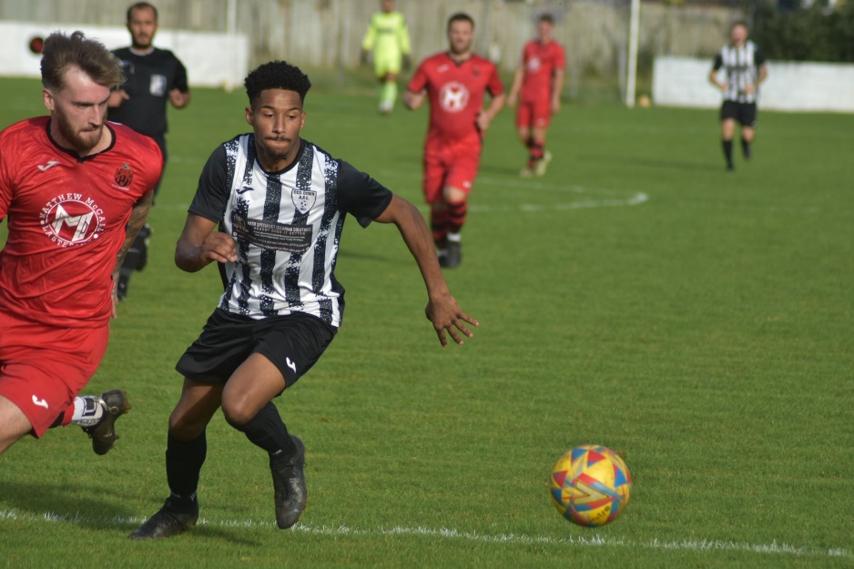
The most entertaining game of the afternoon took place in Bath, with Shirehampton’s Scott Bamford scored a stoppage time winner to help his side come out on top in a seven-goal thriller over Odd Down (pictured, below right). It was the visitors who started much the better, and after Steve Fitzpatrick had broken the deadlock from long range, Will Gallagher then struck moments later to make it 2-0 inside ten minutes. Just as Alfie Andrews looked to have got the home side back into the contest, Louis Snailham responded instantly to restore Shirehampton’s two-goal advantage. That didn’t deter Odd Down however, and having been reduced to ten men following a spate of injuries, they pulled off a dramatic late comeback with skipper Milo Murgatroyd and sub Abdou Mbaye making it 3-3 late on. They continued to push for more in the final minutes, and only saw the most dramatic of victories denied by visiting keeper Will Baldwin who saved a 90th minute penalty. The drama wasn’t finished there however, and the home side were left with nothing to show for their efforts when Bamford struck in the third minute of stoppage time to hand Shirehampton victory. There was also a high-scoring encounter down in Cheddar, where visitors Longwell Green secured a 4-2 victory thanks to goalscoring doubles from Sonny Passco and Joe Harry. Goals from Dean Chrisostomou and Ollie Hucker kept the Cheesemen in the game somewhat, but the away side ground out victory with youngster Harry playing a starring role. Second-placed Radstock defeated Boco 3-0 thanks to goals from Jacob Reader, Corey Rawlings and Ian Jeffery, while a 20th minute chip from Craig Herrod proved to be enough for Wells City in their tight and tense home clash with Bradford. Third spot in the table now belongs to Bitton, after a pair of goals early in the second half from Joe Beardwell and Oliver Sully led them to a 2-1 triumph away at Hengrove.

Latest Results
Tuesday 3rd October 2023
First Division
Bradford Town 1-1 AEK Boco 101

Wednesday 4th October 2023
First Division
Shirehampton 5-1 Hengrove Athletic 51
Les Phillips Cup
Cadbury Heath 1-2 Longwell Green Sports
Cribbs Reserves 3-0 Bristol Telephones

Saturday 7th October 2023
Premier Division
Barnstaple Town 6-0 Wellington
Bridgwater United 5-0 Torpoint Athletic 270
Brixham AFC 7-0 Millbrook 110
Falmouth Town 6-1 Street
Ilfracombe Town 3-0 Welton Rovers
Nailsea & Tickenham 4-3 Buckland Athletic 70
Oldland Abbotonians 1-5 Helston Athletic
Shepton Mallet 3-1 Saltash United 208
St Blazey 0-1 Clevedon Town
First Division
Bristol Telephones 0-3 Cribbs Reserves 35
Cadbury Heath 10-0 Bishop Sutton 46
Cheddar 2-4 Longwell Green Sports 82
Gillingham Town 1-5 Brislington 37
Hengrove Athletic 1-2 Bitton 67
Middlezoy Rovers 1-3 Hallen
Odd Down 3-4 Shirehampton 60
Radstock Town 3-0 AEK Boco 61
Wells City 1-0 Bradford Town 120
Wincanton Town 1-3 Portishead Town 88

This week’s podcast includes an interview with Falmouth Town manager Andrew Westgarth, who describes the jubilation of their later winner at Buckland, and details his ambition to compete against the top sides in the Premier Division. Ian then catches up with Bristol Telephones assistant Manager, Russell Holt, who explains why his side are on track to progress in the First Division, and what it means for him and manager John Allen to be getting the band back together.
http://toolstationleague.com/season-2023-24-podcast-episode-10/

Upcoming Fixtures
Tuesday 10th October 2023
Premier Division
Welton Rovers vs Street 19:30KO
First Division
Bishop Sutton vs Gillingham Town 19:30KO
Bitton vs Brislington 19:30KO
Hallen vs Portishead Town 19:30KO
Odd Down vs Bristol Telephones 19:30KO
Radstock Town vs Wincanton Town 19:45KO
Les Phillips Cup
Cheddar vs Barnstaple Town 19:45KO

Wednesday 11th October 2023
First Division
Cribbs Reserves vs Middlezoy Rovers 19:30KO
Shirehampton vs Cadbury Heath 19:30KO

Friday 13th October 2023
Premier Division
Bridgwater Town vs Nailsea & Tickenham 19:30KO
First Division
Keynsham Town vs Radstock Town 19:45KO

Saturday 14th October 2023 (3pm kick-off unless noted)
Premier Division
Buckland Athletic vs Saltash United
Clevedon Town vs Oldland Abbotonians
Falmouth Town vs Shepton Mallet
Millbrook vs Helston Athletic
Street vs Brixham AFC
Torpoint Athletic vs Barnstaple Town
Wellington vs Ilfracombe Town
Welton Rovers vs St Blazey
First Division
AEK Boco vs Bristol Telephones
Bradford Town vs Wincanton Town
Brislington vs Middlezoy Rovers
Cadbury Heath vs Hengrove Athletic
Cheddar vs Odd Down
Gillingham Town vs Longwell Green Sports
Hallen vs Cribbs Reserves
Portishead Town vs Bishop Sutton
Shirehampton vs Wells City
Warminster Town vs Bitton

League Tables
 | PREMIER DIVISION | Played | Won | Drawn | Lost | GD | Points
1 | Falmouth Town | 10 | 7 | 2 | 1 | 18 | 23
2 | Helston Athletic | 10 | 7 | 1 | 2 | 26 | 22
3 | Bridgwater United | 9 | 7 | 1 | 1 | 20 | 22
4 | Brixham AFC | 12 | 6 | 3 | 3 | 18 | 21
5 | Clevedon Town | 9 | 6 | 3 | 0 | 12 | 21
6 | Barnstaple Town | 9 | 5 | 4 | 0 | 16 | 19
7 | Torpoint Athletic | 12 | 5 | 3 | 4 | 1 | 18
8 | Buckland Athletic | 11 | 5 | 2 | 4 | 11 | 17
9 | Nailsea & Tickenham | 10 | 5 | 0 | 5 | 4 | 15
10 | Street | 9 | 4 | 3 | 2 | 0 | 15
11 | Shepton Mallet | 10 | 4 | 3 | 3 | -1 | 15
12 | Ilfracombe Town | 11 | 3 | 3 | 5 | -3 | 12
13 | St Blazey | 11 | 2 | 3 | 6 | -4 | 9
14 | Welton Rovers | 10 | 2 | 2 | 6 | -7 | 8
15 | Saltash United | 11 | 2 | 2 | 7 | -13 | 8
16 | Oldland Abbotonians | 11 | 2 | 0 | 9 | -22 | 6
17 | Wellington | 10 | 1 | 3 | 6 | -23 | 6
18 | Millbrook | 9 | 0 | 0 | 9 | -53 | 0
 | FIRST DIVISION | Played | Won | Drawn | Lost | GD | Points
1 | Portishead Town | 16 | 13 | 2 | 1 | 38 | 41
2 | Radstock Town | 16 | 12 | 1 | 3 | 24 | 37
3 | Bitton | 15 | 10 | 3 | 2 | 17 | 33
4 | Wincanton Town | 16 | 10 | 3 | 3 | 12 | 33
5 | Brislington | 15 | 10 | 2 | 3 | 32 | 32
6 | Bradford Town | 17 | 9 | 4 | 4 | 17 | 31
7 | Cribbs Reserves | 15 | 8 | 3 | 4 | 11 | 27
8 | Bristol Telephones | 16 | 8 | 2 | 6 | -2 | 26
9 | Wells City | 14 | 7 | 2 | 5 | 7 | 23
10 | Cadbury Heath | 13 | 6 | 0 | 7 | -3 | 18
11 | Shirehampton | 15 | 6 | 2 | 7 | 2 | 20
12 | Longwell Green Sports | 15 | 6 | 2 | 7 | 0 | 20
13 | Middlezoy Rovers | 15 | 6 | 2 | 7 | -1 | 20
14 | AEK Boco | 15 | 5 | 4 | 6 | 0 | 19
15 | Hallen | 14 | 5 | 2 | 7 | -3 | 17
16 | Odd Down | 16 | 5 | 2 | 9 | -22 | 17
17 | Warminster Town | 14 | 4 | 2 | 8 | -10 | 14
18 | Hengrove Athletic | 15 | 4 | 2 | 9 | -11 | 14
19 | Keynsham Town | 12 | 3 | 1 | 8 | -16 | 10
20 | Cheddar | 15 | 3 | 1 | 11 | -20 | 10
21 | Gillingham Town | 15 | 2 | 1 | 12 | -31 | 7
22 | Bishop Sutton | 15 | 0 | 1 | 14 | -51 | 1

