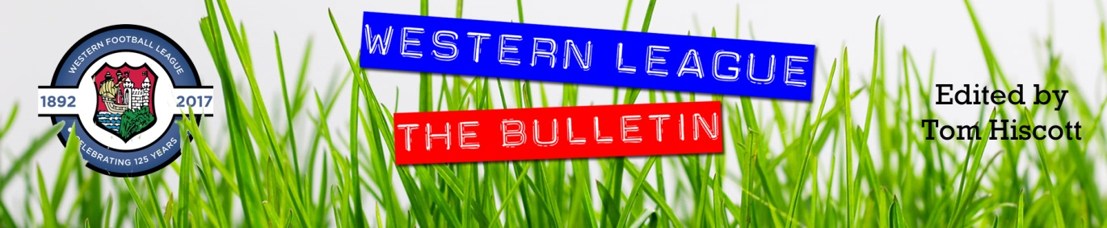
Latest Round-ups:
#10
Season 2023/24

Midweek Action: Portishead continue to go from strength-to-strength in the First Division, and picked up another three points on Tuesday evening after beating Bristol Telephones 6-0. After Josh Honey fired them into an early lead, it was then left to the usual figures of Calum Townsend and Ethan Feltham to extend their advantage before half-time. Yet another Feltham strike made it 4-0 early in the second, before a pair of late efforts from Callum Eastwood rounded out the comfortable victory. Wincanton Town were also big winners on Tuesday, turning a 2-1 half-time advantage into an eventual 5-2 victory at home to Bitton. Goals from Matt Garner and Cam Allen saw them lead at the interval before Joe Beardwell struck in the 58th minute to draw the visitor’s level. An excellent finish from Allen put Town back in front late on, with Garner adding his second shortly after, before Allen completed his hat-trick with another strong finish from the edge of the box. In Somerset, Harry Warwick’s deflected effort helped Wells City come from behind to secure a 1-1 draw at home to Radstock who led at the break courtesy of an Adey Harvey header. The other league fixture went the way of the away side, with Owen Bartley scoring in either half to give Bradford Town a 3-1 victory over Gillingham.
There was also several Les Phillips Cup ties during the week, with AEK Boco’s 4-0 win away at Brislington the pick of the results on Tuesday night. Goals either side of the break from Sam Thomas helped spearhead Boco’s win, with Toby Rennie and Seb Scott also on target for the visitors. In the other games that night, Patryk Kosciolek’s solitary effort saw Hallen beat Welton 1-0, while Hengrove knocked out Bishop Sutton thanks to a 5-2 victory. Having gone ahead in the 13th minute through Mickey Parsons, Hengrove were pegged back shortly after when Chris Pile struck for the away side. Rohan Hartrey made sure it wasn’t a level match for long, putting Hengrove 2-1 ahead, with Pete Sheppard then stretching the lead further at the beginning of the second half. Further goals from Oscar Sullivan and Sonny Parker in the closing stages then helped Hengrove confirm their victory and book them a spot in the next round. Wednesday’s lone tie saw Street come from behind to beat Warminster 4-2. After trailing 2-1 after 45 minutes, the Cobblers powered their way back into the contest early in the second half through Phil Ormrod. Street then struck twice more in the next couple of minutes through Dan Peach and Sullivan McKenna to stun their hosts, before holding on to join Hengrove and the like in the next round.

The draw for the second round of the Les Phillips Cup has taken place, of which details can be found at the following page on the official Toolstation League website: http://toolstationleague.com/les-phillips-cup-draw-3/

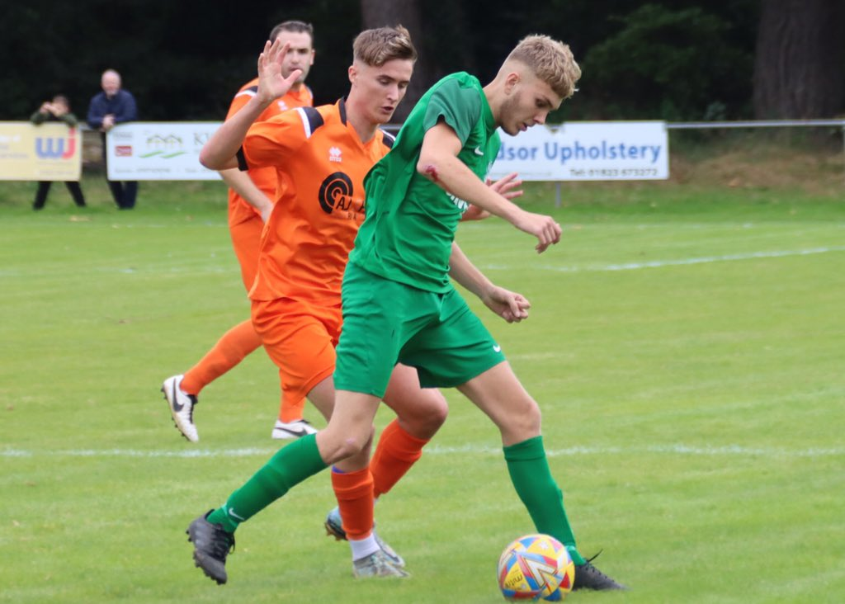
Premier Division: Falmouth now found themselves sitting top of the pile following another dramatic afternoon of action. Travelling to Devon to take on Buckland, Town got off to a flying start and led after only four minutes thanks to a free header at the back post. It looked as though one goal would be enough to separate the sides throughout the contest, but then with three minutes left on the clock, the Bucks managed to force home an equaliser through top scorer Jared Lewington. That goal seemed to energise Falmouth however, and with their next attack, they earned a stoppage time penalty which would give them the chance at all three points. Buckland keeper Andy Collings had other ideas however, and saved the resulting spot kick to seemingly preserve a point for his side. The thrills and spills weren’t over however, and with the corner which followed the penalty save, Andreas Calleja-Stayne headed home to bring the end to a thrilling contest. Former league leaders Helston tasted some of their medicine, squandering a lead on their way to a 3-1 home defeat to Barnstaple. Unlike their previous recent encounters which had seen Helston start slowly, they were quickest to settle on Saturday afternoon and went ahead in the 25th minute through Tyler Elliott. The away side grabbed a much needed leveller just prior to half-time courtesy of Brodie Montague, and then completed the turnaround soon after the break through Oscar Massey. Any chance of a late salvo for the home side were dented when Elliott was dismissed five minutes from time, and they then conceded a third in stoppage time when Massey completed his second half brace. The individual performance of the afternoon belonged to Street’s Jakob Dickens, who scored all four of his sides goals in their thrilling 4-3 win at home to Nailsea & Tickenham. Dickens made an unbelievable start to the game, putting the hosts two-up inside the opening half-hour thanks to a pair of stunning long range efforts. The game then turned entirely in the Swags favour, and after pulling a goal back late in the first half, Jake Horsey was then dismissed to leave the hosts facing a second 45 minutes with just ten men. Two further Nailsea goals put them 3-2 up with the game heading into the final quarter, and it looked as though the red card would prove costly. Dickens had other ideas however, and after he had completed his hat-trick late on, he was then given the chance to steal maximum points, and did just that when converting a penalty in added time. Bridgwater have now won four on the bounce in all competitions, after recent addition Jay Murray fired them to a 1-0 win away at Ilfracombe, while Clevedon overturned a sixth minute deficit to defeat bottom-side Millbrook 6-1 thanks to goals from Freddie King, Brad Probert, Joe Teall and a Sam Beresford treble. Another man to score three this weekend was Harrison Kyte, with all his goals coming before half-time in Oldland’s 4-2 win over St Blazey. Having broken the deadlock in the seventh minute, Kyte then saw his lead added to by Abbots teammate Cash Vinall shortly after. Two more strong finishes from Kyte all-but ended the contest after only 36 minutes, with the away side scoring two late consolations. Brixham are a team on the up, and have now won three consecutive league matches without conceding following a 4-0 victory at home to Shepton Mallet. Charlie Johansen got the ball rolling with his second goal of the week, with Ben Aldous then adding a second for the hosts midway through the opening half. A red card just prior to half time threatened to upset Brixham’s flow, but that wasn’t the case and they pushed on after the break to run out comfortable victors thanks to further goals from Reece Somers and sub Cole Harford. In Somerset, Wellington’s Tom Burt volleyed the only goal in their 1-0 win at home to Welton (pictured, left), while further West, Tyler Love-Holmes rescued a point for Saltash after they had fallen behind to Ryan Richards and Torpoint early in the second half.

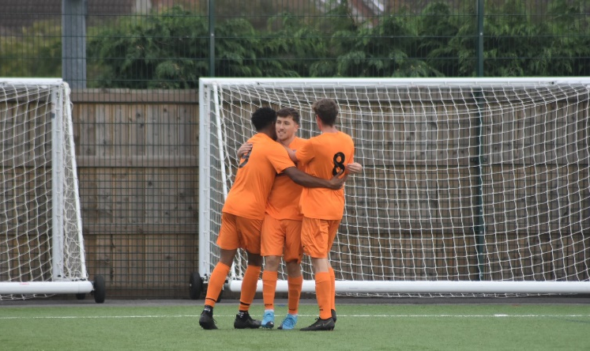
First Division: Wincanton Town have now won ten league matches this season after putting in a strong second-half effort away at Hallen. Matt Garner was the start of the show for the Wasps, and after breaking the deadlock eight minutes after the interval, the same man was then on target once more in the closing stages with a powerful headed effort. Only two sides currently sit above Wincanton in the table, and one of those is Radstock who powered to a 5-1 win away at Bishop Sutton. The Miners flew out of the blocks at Lakeview, and after Jack Pearson had made it 1-0 after just five minutes, they struck again a couple of moments later through Jacob Reader to double their advantage. A further goal from Adey Harvey put the visitors three goals ahead at the interval, and they showed no signs of slowing down during the second period, with Reader heading home once more to double his individual tally. Sutton did manage to grab a late consolation, but it was Radstock who finished the scoring with Corey Rawlings wrapping things up in stoppage time. Top spot still belongs to Portishead, but their winning run was ended following a 1-1 draw at home to 19th placed Keynsham. It was Riley Gifford-Hobbs who handed the away side a surprise lead early in the second half, but they weren’t in front for long and saw Toby Lawrence plant a header of his own in the back of the net to rescue a point for the Posset. The points were also shared in Bristol, where AEK Boco fought back to secure a late 1-1 draw with Warminster. Having saved a first half penalty, Boco keeper Ashley Bryan saw his clean sheet disappear right at the end of the first half when the visitors surged ahead. Boco battled hard during the second period, and grabbed a deserved equaliser in the closing stages when the in-form Seb Scott fired home. Another side to show strong battling qualities were Bradford, and they came from behind to beat Hengrove by three goals to one at Trowbridge Road. With the visitors going in front after 28 minutes, the Bobcats were afforded plenty of time to mount a comeback, and they drew level just prior to the interval thanks to a Jordan Pinder spot kick. Jack Witcombe then made it 2-1 midway through the second half, with Tom Mack then striking late on to put the game to bed. At Bitton, George Lloyd played an influential role in both of their goals during a 2-0 win over Wells City, while strikes at the end of both halves helped the Bristol Telephones beat Cadbury Heath 2-1. The home side also went home happy in Brislington, where last season’s table toppers fought back from a couple of recent losses to beat Cheddar 5-2. A dismal start for the hosts saw them concede after only three minutes to Elliott Keen, but they responded well and found themselves 2-1 up in no time at all thanks to goals from Oaklan Buck and Joe McLennan. Brislington continued to keep their foot on the pedal and made it 4-1 after only 32 minutes of play with Asa White and Dean Griffiths getting in on the goalscoring action. An Ollie Hucker header towards the end of the first half gave the Cheesemen a feint hope of pulling off a stunning fightback, but that was extinguished in the moments after half time when they were denied from the penalty spot. The scoreline remained the same for almost the entirety of the second half, before Brislington finally closed things out with a late George Jones effort. There was also a relatively one-sided victory for Cribbs Reserves, with Jack Guthrie scoring all four of his team’s goals in their 4-2 triumph at home to strugglers Gillingham. Another player who continues to show strong form over the opening months of the campaign is Odd Down’s Milo Murgatroyd (pictured, celebrating, right) , and he was influential once again during their 2-1 win away at Longwell Green. Having broken the deadlock after only four minutes, Murgatroyd was on target again during the final moments of the game to lead his side to victory after Matt Brown had levelled for the home side during the second half.
On a day of high-scoring thrillers, Middlezoy Rovers got in on the act, scoring three goals in the final 20 minutes to pull off a 4-3 victory away at Shirehampton. Having opened the scoring, Rovers found themselves starring down the barrel of defeat following a Louis Snailham equaliser, and a Scott Bamford brace. Middlezoy had won twice in a row away from home during recent weeks, and they somehow managed to extend this run with a trio of late goals to leave the home fans stunned.

Latest Results
Tuesday 26th September 2023
Les Phillips Cup
Brislington 0-4 AEK Boco
Hallen 1-0 Welton Rovers
Hengrove Athletic 5-2 Bishop Sutton
First Division
Gillingham Town 1-3 Bradford Town 47
Portishead Town 6-0 Bristol Telephones 252
Wells City 1-1 Radstock Town 98
Wincanton Town 5-2 Bitton

Wednesday 27th September 2023
Les Phillips Cup
Warminster Town 2-4 Street

Saturday 30th September 2023
Premier Division
Brixham AFC 4-0 Shepton Mallet 112
Buckland Athletic 1-2 Falmouth Town 251
Helston Athletic 1-3 Barnstaple Town 101
Ilfracombe Town 0-1 Bridgwater United 110
Millbrook 1-6 Clevedon Town
Oldland Abbotonians 4-2 St Blazey 75
Saltash United 1-1 Torpoint Athletic 202
Street 4-3 Nailsea & Tickenham 98
Wellington 1-0 Welton Rovers
First Division
AEK Boco 1-1 Warminster Town
Bishop Sutton 1-5 Radstock Town 52
Bitton 2-0 Wells City 48
Bradford Town 3-1 Hengrove Athletic 157
Brislington 5-2 Cheddar 106
Bristol Telephones 2-1 Cadbury Heath 65
Cribbs Reserves 4-2 Gillingham Town 25
Hallen 0-2 Wincanton Town 38
Longwell Green Sports 1-2 Odd Down 94
Portishead Town 1-1 Keynsham Town 164
Shirehampton 3-4 Middlezoy Rovers
Upcoming Fixtures
Tuesday 3rd October 2023
First Division
Bradford Town vs AEK Boco 19:30KO

Wednesday 4th October 2023
First Division
Shirehampton vs Hengrove Athletic 19:30KO
Les Phillips Cup
Cadbury Heath vs Longwell Green Sports 19:30KO
Cribbs Reserves vs Bristol Telephones 19:30KO

Saturday 7th October 2023 (3pm kick-off unless noted)
Premier Division
Barnstaple Town vs Wellington
Bridgwater United vs Torpoint Athletic
Brixham AFC vs Millbrook
Falmouth Town vs Street
Ilfracombe Town vs Welton Rovers
Nailsea & Tickenham vs Buckland Athletic
Oldland Abbotonians vs Helston Athletic
Shepton Mallet vs Saltash United
St Blazey vs Clevedon Town
First Division
Bristol Telephones vs Cribbs Reserves
Cadbury Heath vs Bishop Sutton
Cheddar vs Longwell Green Sports
Gillingham Town vs Brislington 14:00KO
Hengrove Athletic vs Bitton
Middlezoy Rovers vs Hallen
Odd Down vs Shirehampton
Radstock Town vs AEK Boco
Wells City vs Bradford Town
Wincanton Town vs Portishead Town

On the latest episode of the podcast, Ian catches up with Torpoint boss, Dean Cardew, who touches on their FA Vase progress, and explains why his side are well ahead of schedule in their Western League journey. We then hear from Portishead Town manager, Kye Mountford, who describes his managerial journey, before reflecting on his sides incredible start to the campaign.
http://toolstationleague.com/season-2023-24-podcast-episode-9/

League Tables
 | PREMIER DIVISION | Played | Won | Drawn | Lost | GD | Points
1 | Falmouth Town | 9 | 6 | 2 | 1 | 13 | 20
2 | Helston Athletic | 9 | 6 | 1 | 2 | 22 | 19
3 | Bridgwater United | 8 | 6 | 1 | 1 | 15 | 19
4 | Brixham AFC | 11 | 5 | 3 | 3 | 11 | 18
5 | Clevedon Town | 8 | 5 | 3 | 0 | 11 | 18
6 | Torpoint Athletic | 11 | 5 | 3 | 3 | 6 | 18
7 | Buckland Athletic | 10 | 5 | 2 | 3 | 12 | 17
8 | Barnstaple Town | 8 | 4 | 4 | 0 | 10 | 16
9 | Street | 8 | 4 | 3 | 1 | 5 | 15
10 | Nailsea & Tickenham | 9 | 4 | 0 | 5 | 3 | 12
11 | Shepton Mallet | 9 | 3 | 3 | 3 | -3 | 12
12 | St Blazey | 10 | 2 | 3 | 5 | -3 | 9
13 | Ilfracombe Town | 10 | 2 | 3 | 5 | -6 | 9
14 | Welton Rovers | 9 | 2 | 2 | 5 | -4 | 8
15 | Saltash United | 10 | 2 | 2 | 6 | -11 | 8
16 | Wellington | 9 | 1 | 3 | 5 | -17 | 6
17 | Oldland Abbotonians | 10 | 2 | 0 | 8 | -18 | 6
18 | Millbrook | 8 | 0 | 0 | 8 | -46 | 0
 | FIRST DIVISION | Played | Won | Drawn | Lost | GD | Points
1 | Portishead Town | 15 | 12 | 2 | 1 | 36 | 38
2 | Radstock Town | 15 | 11 | 1 | 3 | 21 | 34
3 | Wincanton Town | 15 | 10 | 3 | 2 | 14 | 33
4 | Bradford Town | 15 | 9 | 3 | 3 | 18 | 30
5 | Bitton | 14 | 9 | 3 | 2 | 16 | 30
6 | Brislington | 14 | 9 | 2 | 3 | 28 | 29
7 | Bristol Telephones | 15 | 8 | 2 | 5 | 1 | 26
8 | Cribbs Reserves | 14 | 7 | 3 | 4 | 8 | 24
9 | Wells City | 13 | 6 | 2 | 5 | 6 | 20
10 | Middlezoy Rovers | 14 | 6 | 2 | 6 | 1 | 20
11 | AEK Boco | 13 | 5 | 3 | 5 | 3 | 18
12 | Cadbury Heath | 13 | 6 | 0 | 7 | -3 | 18
13 | Longwell Green Sports | 14 | 5 | 2 | 7 | -2 | 17
14 | Odd Down | 15 | 5 | 2 | 8 | -21 | 17
15 | Shirehampton | 13 | 4 | 2 | 7 | -3 | 14
16 | Hallen | 13 | 4 | 2 | 7 | -5 | 14
17 | Hengrove Athletic | 13 | 4 | 2 | 7 | -6 | 14
18 | Warminster Town | 14 | 4 | 2 | 8 | -10 | 14
19 | Keynsham Town | 12 | 3 | 1 | 8 | -16 | 10
20 | Cheddar | 14 | 3 | 1 | 10 | -18 | 10
21 | Gillingham Town | 14 | 2 | 1 | 11 | -27 | 7
22 | Bishop Sutton | 14 | 0 | 1 | 13 | -41 | 1

