Latest Round-ups:
#9
Season 2023/24

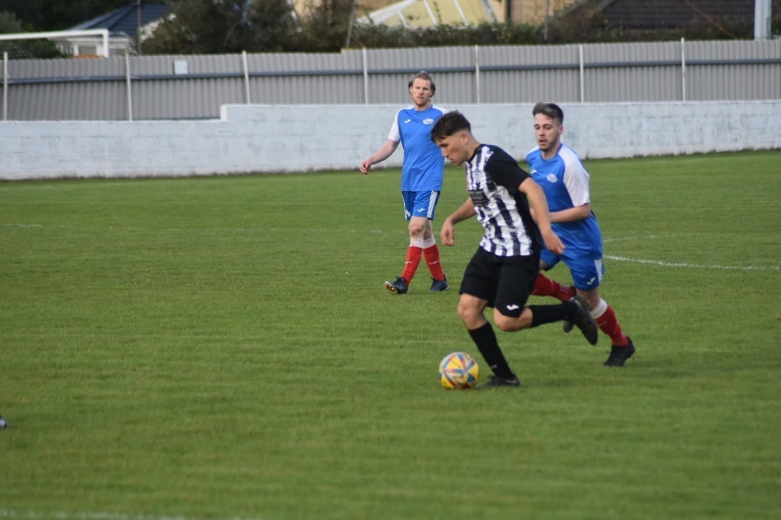
League Action: Shirehampton produced their best performance since the opening day of the season, putting six past Keynsham in their First Division meeting on Friday night. Louis Snailham played a starring role for the home side, striking late in the first period, adding to Scott Bamford‘s first-half brace during a clinical opening 45 minutes which saw the Reds move into an unassailable 4-0 lead. Snailham then added two more after the interval to complete his treble, with Riley Gifford-Hobbs grabbing a consolation for the visitors. The following afternoon, Odd Down made it three wins on the bounce after beating Cribbs Reserves 3-1 in Bath. With the game locked at one-all after 45 minutes, it was the home side who came out stronger after the interval, forging ahead thanks to goals from substitute Alfie Andrews and then Dominic Walter.
Action from Odd Down’s 3-1 win over Cribbs Reserves
Saturday also saw a pair of Premier Division contests, with Brixham defeating Oldland 5-0 in a dominant home win. Having gone one-up through Scott Robinson in the 29th minute, Brixham then struck twice in the closing stages of the first half through Kieran Parkin and Sean Adderley to give themselves a three-goal buffer at the interval. By the time Jaden Maslen made it 4-0, the game was all-but over, with Charlie Johansen putting the cap on a five-star performance with the final kick of the game. Johansen’s former side Buckland also enjoyed a comfortable afternoon’s work in their win at St Blazey, with Sam Stayt setting them on their way with a lobbed finish after 20 minutes. The second half then belonged to Jared Lewington, with the Bucks frontman scoring twice after the interval to round out the visitors 3-0 win and a successful trip into Cornwall.

Cup Action: Bridgwater United booked their place in the next round of the Les Phillips Cup after beating Clevedon 3-0 on Friday evening. After Jay Murray’s penalty had put Bridgy in front, they struck twice more after the break through Jason Quick and Adam Wright to secure what turned out to be a straightforward victory. The following day, Middlezoy qualified for the next round thanks to a 4-1 win on penalties over Radstock after their game had finished one apiece at the end of 90 minutes.
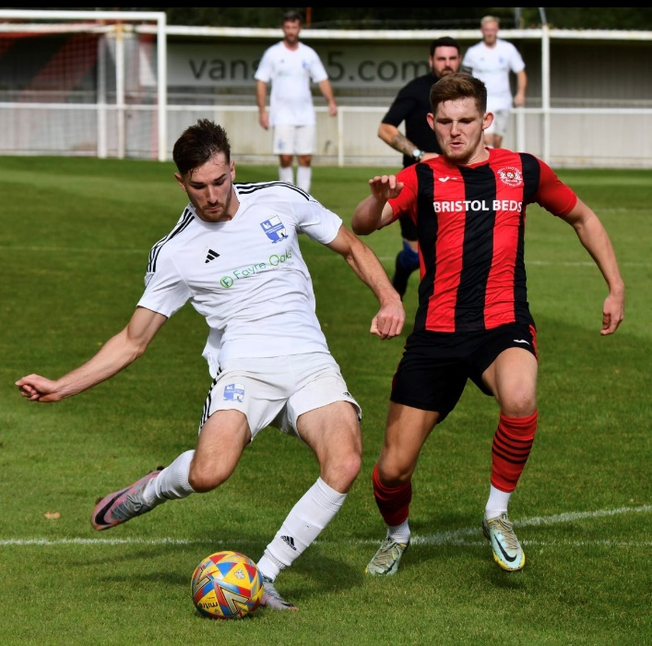
It was also a huge day of action in the FA Vase, with the pick of the ties generally involving head-to-head clashes between Western League sides. One of those included the Premier Division leaders Helston who produced another thrilling comeback to topple Street by four goals to two. Having overturned a two-goal deficit seven days previously against Ilfracombe, Helston found themselves in a similar hole this week also following a pair of strikes in the opening 25 minutes from Phil Ormrod and Kyle Strange. The Cobblers soon saw their lead trimmed however, with Jacob Smith striking for Helston to give them a foothold in the contest. The game then turned midway through the second half, with Curtis Damerell and Rikki Sheppard scoring in quick succession for the home side, before Rubin Wilson helped seal their passage through to the next round. Another side to progress were Nailsea & Tickenham who struck late to secure a 3-2 win away at Brislington. The Swags (pictured attacking, right) started much stronger than their hosts, and surged into a deserved two-goal lead courtesy of efforts from Lucas Vowles and Callum Dunn. Bris weren’t willing to lie down against their higher-ranked opponents, and battled back to make it 2-2 around the hour mark, only for Nailsea to steal it late on when Nick Buxton scored the decisive fifth goal. Scott Laird produced two moments of brilliance for Barnstaple to help lead his side to a 2-1 win away at Shepton Mallet. Having taken an early lead through Josh Jenkins, the home side then saw their hopes of progressing dented after seeing their number one Tom Roberts sent off just before half-time. That dismissal saw a non-specialist keeper have to step in between the sticks, and Jack Newman’s first job was to pick the ball out of his net after being beaten by a Laird set piece. Mallet and Newman proved resolute, holding out for much of the second half, but the stand-in keeper was finally beaten in the closing stages following another well-taken goal from Laird.

The other two clashes which saw opposing sides from the First Division meet both ended in shootouts, with table-toppers Portishead surviving a scare away at Bristol Telephones. Having trailed at the break, the Posset called on the unstoppable Ethan Feltham, and his arrival came with instant impact as he notched his 23rd of the season to make it one apiece early in the second half. Calum Townsend then fired home a thunderbolt 20 minutes from time to complete the visitor’s turnaround, but they couldn’t hang on and conceded an injury time equaliser to send the game to penalties. It then came down to Townsend, and he slotted home the decisive spot kick to send Town through to the First Round proper. They will be joined in the hat for the draw on Monday by Longwell Green Sports who knocked out Bradford following a six-goal thriller. Goals from Jack Witcombe and Charlie Saunders helped the Bobcats overturn an early deficit, before Kieran Williams stepped up to make it two-all on the hour mark. Witcombe then stroked home a penalty ten minutes from time to put Bradford in pole position, but they were pegged back once again with Williams completing a brace of his own to make it 3-3 at the end of normal time. Almost nothing could separate the sides during 90 minutes, and that also came to pass during the shootout, with one solitary miss condemning Bradford to defeat. Ilfracombe’s run in the Vase also came to an end following a shootout, with Harry Taffs second half equaliser proving to be inconsequential after they lost 7-6 on penalties to Elburton Villa.
Other Western League sides to see their runs in the Vase ended included Millbrook, Hengrove and Cadbury Heath who each suffered heavy home defeats, but things were rosier for Falmouth who beat Crediton 3-1. Goals from Luke Brabyn, Jayden Gilbert and Jack Webber did the business for Town, who will join Saltash in looking forward to seeing the outcome of Monday’s draw. For the Ashes, a star performance from Kieran O’Melia helped them claim a 4-2 win away at Wendron United. O’Melia was on target late in the first half to help Saltash complete their turnaround after Tylor Love-Holmes had cancelled out Wendron’s early opener. Josh Johnson then added a third for the away side, and despite conceding shortly after, they responded well, with O’Melia’s second assist of the afternoon leading to an own goal which completed the scoring. 4-2 was a popular result in the Vase, but unfortunately for Wincanton and Warminster, they both came out on the wrong side of that scoreline in home games with Portland United and Fleet Town, respectively.
There was further success elsewhere in the competition for a pair of Western League sides, with Torpoint edging to a 1-0 win away at Wadebridge. In a tight contest which remained goalless for three quarters of play, Torpoint finally grabbed the decisive goal with Ryan Richards rounding the keeper before slotting home. The other victors from our league was Wells City, with second half goals from Harry Warwick and Ali Sen leading them to a 2-0 triumph away at Cullompton Rangers. The luckless Cheddar were denied by an injury time penalty in their 2-1 loss at home to Newquay, while Hallen fell to defeat at Cheltenham Saracens by the same scoreline.

Latest Results
Friday 22nd September 2023
Les Phillips Cup
Clevedon Town 0-3 Bridgwater United
First Division
Shirehampton 6-1 Keynsham Town 87

Saturday 23rd September 2023
Premier Division
Brixham AFC 5-0 Oldland Abbotonians 125
St Blazey 0-3 Buckland Athletic 161
First Division
Odd Down 3-1 Cribbs Reserves 60
Les Phillips Cup
Middlezoy Rovers 1-1 (4-1 pens) Radstock Town
FA Vase Second Round Qualifying
Brislington 2-3 Nailsea & Tickenham
Bristol Telephones 2-2 (4-5 pens) Portishead Town
Cadbury Heath 1-6 Fairford Town
Cheddar 1-2 Newquay
Cheltenham Saracens 2-1 Hallen
Cullompton Rangers 0-2 Wells City
Falmouth Town 3-1 Crediton United
Helston Athletic 4-2 Street
Hengrove Athletic 0-4 Roman Glass St George
Ilfracombe Town 1-1 (6-7 pens) Elburton Villa
Longwell Green Sports 3-3 (5-4 pens) Bradford Town
Millbrook 1-7 Dobwalls
Shepton Mallet 1-2 Barnstaple Town
Wadebridge Town 0-1 Torpoint Athletic
Warminster Town 2-4 Fleet Town
Wendron United 2-4 Saltash United
Wincanton Town 2-4 Portland United

The latest episode of the podcast includes an interview with Buckland boss Dan Hart, who explains why his side are set up to achieve both on and off the pitch. Ian also catches up with Bradford Town manager Jamie Jordan, who reintroduces the Wiltshire club to the Western League following a difficult period of adjustment.
http://toolstationleague.com/season-2023-24-podcast-episode-8/

Upcoming Fixtures
Tuesday 26th September 2023
Les Phillips Cup
Brislington vs AEK Boco 19:30KO
Hallen vs Welton Rovers 19:30KO
Hengrove Athletic vs Bishop Sutton 19:30KO
First Division
Gillingham Town vs Bradford Town 19:30KO
Portishead Town vs Bristol Telephones 19:30KO
Wells City vs Radstock Town 19:30KO
Wincanton Town vs Bitton 19:30KO

Wednesday 27th September 2023
Les Phillips Cup
Warminster Town vs Street 19:45KO

Saturday 30th September 2023 (3pm kick-off unless noted)
Premier Division
Brixham AFC vs Shepton Mallet
Buckland Athletic vs Falmouth Town
Helston Athletic vs Barnstaple Town
Ilfracombe Town vs Bridgwater United
Millbrook vs Clevedon Town
Oldland Abbotonians vs St Blazey
Saltash United vs Torpoint Athletic
Street vs Nailsea & Tickenham
Wellington vs Welton Rovers
First Division
AEK Boco vs Warminster Town
Bishop Sutton vs Radstock Town
Bitton vs Wells City
Bradford Town vs Hengrove Athletic
Brislington vs Cheddar
Bristol Telephones vs Cadbury Heath
Cribbs Reserves vs Gillingham Town
Hallen vs Wincanton Town
Longwell Green Sports vs Odd Down
Portishead Town vs Keynsham Town
Shirehampton vs Middlezoy Rovers

League Tables
 | PREMIER DIVISION | Played | Won | Drawn | Lost | GD | Points
1 | Helston Athletic | 8 | 6 | 1 | 1 | 24 | 19
2 | Buckland Athletic | 9 | 5 | 2 | 2 | 13 | 17
3 | Falmouth Town | 8 | 5 | 2 | 1 | 12 | 17
4 | Torpoint Athletic | 10 | 5 | 2 | 3 | 6 | 17
5 | Bridgwater United | 7 | 5 | 1 | 1 | 14 | 16
6 | Brixham AFC | 10 | 4 | 3 | 3 | 7 | 15
7 | Clevedon Town | 7 | 4 | 3 | 0 | 6 | 15
8 | Barnstaple Town | 7 | 3 | 4 | 0 | 8 | 13
9 | Street | 7 | 3 | 3 | 1 | 4 | 12
10 | Nailsea & Tickenham | 8 | 4 | 0 | 4 | 4 | 12
11 | Shepton Mallet | 8 | 3 | 3 | 2 | 1 | 12
12 | St Blazey | 9 | 2 | 3 | 4 | -1 | 9
13 | Ilfracombe Town | 9 | 2 | 3 | 4 | -5 | 9
14 | Welton Rovers | 8 | 2 | 2 | 4 | -3 | 8
15 | Saltash United | 9 | 2 | 1 | 6 | -11 | 7
16 | Wellington | 8 | 0 | 3 | 5 | -18 | 3
17 | Oldland Abbotonians | 9 | 1 | 0 | 8 | -20 | 3
18 | Millbrook | 7 | 0 | 0 | 7 | -40 | 0
 | FIRST DIVISION | Played | Won | Drawn | Lost | GD | Points
1 | Portishead Town | 13 | 11 | 1 | 1 | 30 | 34
2 | Radstock Town | 13 | 10 | 0 | 3 | 17 | 30
3 | Bitton | 12 | 8 | 3 | 1 | 17 | 27
4 | Wincanton Town | 13 | 8 | 3 | 2 | 9 | 27
5 | Brislington | 13 | 8 | 2 | 3 | 25 | 26
6 | Bradford Town | 13 | 7 | 3 | 3 | 14 | 24
7 | Bristol Telephones | 13 | 7 | 2 | 4 | 6 | 23
8 | Cribbs Reserves | 13 | 6 | 3 | 4 | 6 | 21
9 | Wells City | 11 | 6 | 1 | 4 | 8 | 19
10 | Cadbury Heath | 12 | 6 | 0 | 6 | -2 | 18
11 | AEK Boco | 12 | 5 | 2 | 5 | 3 | 17
12 | Middlezoy Rovers | 13 | 5 | 2 | 6 | 0 | 17
13 | Longwell Green Sports | 13 | 5 | 2 | 6 | -1 | 17
14 | Shirehampton | 12 | 4 | 2 | 6 | -2 | 14
15 | Hallen | 12 | 4 | 2 | 6 | -3 | 14
16 | Hengrove Athletic | 12 | 4 | 2 | 6 | -4 | 14
17 | Odd Down | 14 | 4 | 2 | 8 | -22 | 14
18 | Warminster Town | 13 | 4 | 1 | 8 | -10 | 13
19 | Cheddar | 13 | 3 | 1 | 9 | -15 | 9
20 | Keynsham Town | 11 | 3 | 0 | 8 | -16 | 9
21 | Gillingham Town | 12 | 2 | 1 | 9 | -23 | 7
22 | Bishop Sutton | 13 | 0 | 1 | 12 | -37 | 1

