Latest Round-ups:
#8
Season 2023/24

Midweek Action: The First Division took precedence during the week, with nine fixtures across Tuesday and Wednesday evening throwing up plenty of drama, and one or two surprises. The form player in the division came to the fore again for Portishead, with Ethan Feltham extending his lead atop the scoring charts after scoring all four goals in his side’s victory over Wells City. Feltham’s incredible start to the season has helped Town surge to the top of the table, with their tenth win of the campaign on Tuesday night played out in front of an impressive attendance of 274. The other teams sitting in the top three after the midweek round of fixtures also recorded big wins, with Bitton beating Warminster 6-1 and Radstock scoring five unanswered goals in their victory at Gillingham. For Bitton, goalscoring doubles from Sol Shearer and Dawid Regula helped spearhead their latest triumph, while the Miners extended their winning run in the league to five matches thanks to goals from Jack Pearson, Jacob Reader (x2), Will Osborne and Jack Farion. Two of the other big hitters fell to dramatic defeats elsewhere that night, with Brislington losing 4-3 at home to Longwell Green Sports. Liam Oswin’s brace was the main factor in Longwell Green’s win at Ironmould Lane, with Matt Brown also notching before Finn Williams fired home a terrific free kick to put a cap on the victory. It was also 4-3 to the away side at Trowbridge Road, where Odd Down claimed just their second win of the season thanks to a stunning comeback over Bradford Town. After Sam Jordan broke the deadlock in just the seventh minute, Bradford looked to be in control at the interval following an unfortunate own goal put them two-up. The Bath side then produced an inspired 20 minutes which saw them score four unanswered goals to turn the game completely on its head. Ben Millett struck twice for the visitors, with Josh Swarbrick and leading scorer Milo Murgatroyd also getting in on the act as Odd Down surged into a 4-2 lead. Martin Johnson pulled a goal back five minutes from time, but the Bobcats were unable to force home an equaliser and slipped to a surprise home defeat. There was also an impressive fightback in the other game that evening, with Middlezoy recovering from a two-goal deficit at the break to draw 2-2 with Hengrove. The away side had the better of the opening half and built a strong advantage courtesy of goals from Harvey Impey and Sonny Parker, but Rovers managed to battle back and secure a share of the spoils thanks to strong finishes from Acey Mead and Liam Winter.
24 hours later, all six teams found the back of the net during another goal-laden evening of action, with Hallen coming out on top in a six-goal thriller away at Cribbs Reserves. An early penalty from Cory Thomas-Barker was followed soon after by an Elliot Gardner strike as Hallen stormed into a two-goal lead. The home side then struck either side of the interval courtesy of Tom Headford and Liam Clayton to make it two apiece, before both Thomas-Barker and Gardner scored their second goals of the night to give Hallen maximum points. Shirehampton finally have their first home win this season, at the sixth time of asking, after beating Bishop Sutton 2-1. Ryan Radford and Scott Bamford were both on target for the victorious home side, with Sam Hughes halving the deficit midway through the second half as Sutton attempted to claw themselves back into the contest. 2-1 was also the final score at Springfield, where Saturday’s hat-trick hero Callum Whooley was on target again for Cadbury Heath in their win over Cheddar. A stunning long-ranger from Joe Chandler had already put the Heath in front prior to Whooley’s goal early in the second half, and they managed to hold off a spirited fightback from the visitors for whom Lewis Chappell grabbed a goal on the hour mark.
Premier Division: The weekend action got underway on Friday evening in front of a mega crowd at the Tannery Ground, with visitors Bridgwater rolling to a 3-1 win over Street. The game was all-square after the opening period with Bridgwater finally breaking the deadlock ten minutes into the second half when Jacob Spence headed home a Jake Llewellyn corner. United didn’t have to wait long before doubling their advantage, with debutant Jay Murray also getting his head on a pin-point cross from Jack Thorne. The majority of the 490 in attendance were given reason to cheer 13 minutes from time, with Kyle Strange netting for the Cobblers to set up a grandstand finish. The game was finally put to bed in the eighth minute of stoppage time, with Bridgwater’s firing home from the penalty spot after he had been tripped in the box by a home defender.
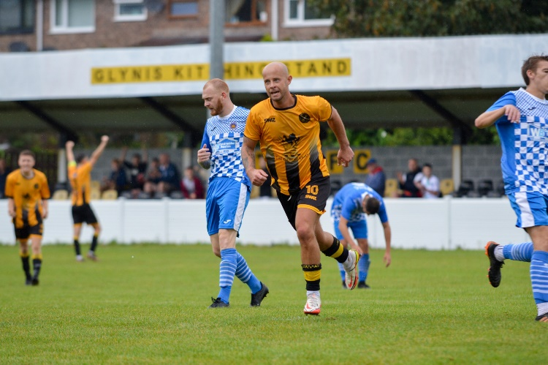
Helston just about managed to hang on to top spot after overturning a two-goal half-time deficit to beat Ilfracombe 5-2. Coming off the back of a big win at Shepton last Saturday, Helston couldn’t pick up where they left off, conceding at the beginning and end of the first half to fall two goals down. The hosts could have been in an even deeper hole if the Bluebirds hadn’t missed a penalty in first half stoppage time, and Helston started to gain a foothold via a spot kick of their own which was converted by Jordan Copp. Rikki Sheppard then scored three minutes later to make it 2-2 midway through the second half as Helston’s confidence continued to grow. The remainder of the game belonged to two men exclusively, with Copp squaring for Sheppard to make it 3-2 in the 80th minute, before the same man then struck again in the closing stages to complete his hat-trick. At the other end of the table, Saltash produced an equally impressive fightback, scoring twice in the final ten minutes to beat Nailsea & Tickenham. The Ashes disappointing start to their season has shown signs of improvement in recent weeks and they went ahead on Saturday afternoon through Jordan Ewing after 35 minutes. That opener seemed to wake their visitors up however, and after Lucas Vowles had struck a near instant equaliser, the same man found the back of the net again shortly after to turn the game in the Swags favour at the interval. That was how it stayed until late on, with Ewing completing his own double to level affairs before Joe Preece secured maximum points for Saltash four minutes from time. Buckland eased to a 6-0 win at Millbrook thanks to a hat-trick from Jared Lewington and a double from Ryan Bush, while the top-five clash between Clevedon and Falmouth at the Hand Stadium finished goalless. New-boys Brixham have now won three, drawn three and lost three after securing a 2-0 victory away at Welton. Having taken a tenth minute lead courtesy of a Kieran Parkin header, the away side wrapped up victory on the hour mark through Charlie Madden. Torpoint were another side to pick up three points on Saturday after beating Oldland Abbotonians 3-1 in a game which started at breakneck speed. A slight delay to kick-off didn’t seem to affect the two sides’ attacking players, with Darren Hicks breaking the deadlock after only four minutes for the Cornishmen. The Abbots responded in kind, levelling affairs two minutes later courtesy of Ellis Clarke, but were soon back behind with Louis Rooney firing home from long range. The fast pace couldn’t be maintained by the two sides, and it took until stoppage time for Torpoint to finally pull away, with Ryan Richards (pictured, left) blasting home to end Oldland’s hopes. The remaining fixtures both ended in scoring draws, with Wellington securing a point at home to St Blazey after Glen Wright’s header cancelled out a first half strike from Luke Cloke. Meanwhile, Barnstaple remain unbeaten this term after coming from two-down to draw 2-2 with Shepton Mallet. A quickfire brace midway through the first half from Doug Ponsillo and Charlie Bateson put Mallet in command as they looked to be rebound from last weekend’s heavy defeat. The hosts had other ideas however, and after sub Jamie Hearsey halved the deficit 20 minutes from time, they then grabbed an equaliser shortly after through Brodie Montague to draw for the fourth time in seven matches.
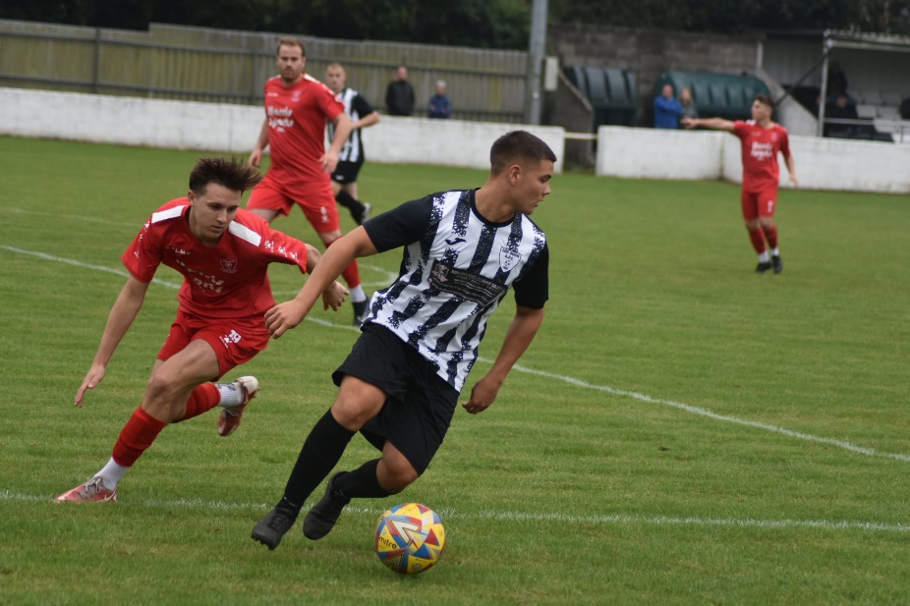
First Division: In the battle between top and bottom, Portishead relied on three goals in the final quarter to finally pull away from hosts Bishop Sutton in a 4-0 win. An early penalty from Kyle Egan had put Posset ahead, but they then had to wait until the 70th minute before they were able to stretch their lead, with Ethan Feltham firing past the Sutton keeper. Things soon started to unravel for the home side, and after Calum Townsend extended the lead further, the seemingly unstoppable Feltham then struck again moments later to bag his 22nd goal of the season. Radstock remain hot on the tail of the early leaders after an injury time goal helped them win 2-1 at home to Longwell Green Sports. Having taken a second minute lead through Adey Harvey, the Miners were pegged back when Matt Brown levelled for the free-scoring visitors. Town managed to keep them at bay for the remainder of the afternoon however, and that gave them the opportunity to steal all three points, and they did just that late in the piece when Will Osborne headed home a Jack Pearson corner. There was also late drama in Bath, where Odd Down scored a 98th minute winner to complete their turnaround at home to AEK Boco (pictured, right). The end of the first half produced a rare commodity, with Boco skipper Sid Partridge scoring at both ends of the pitch to leave the game evenly poised at the interval. It remained 1-1 during much of the second half, but just as though it looked like the points would be shared, Ben Millett followed up his midweek double with a stoppage time winner to secure back-to-back wins for the home side. Another side to leave it late were Cadbury Heath, with Zac Cheetham smashing home in the first minute of added time to complete his double during their 2-1 win over Gillingham Town. Things were slightly easier for Brislington who rebounded to their midweek defeat by beating Hengrove 6-2. Bris looked like a team with a point to prove, storming into a 5-1 lead during a devastating opening 45 minutes with Oaklan Buck starring with a hat-trick during the one-sided victory. Middlezoy also won on their travels, scoring in either half of their 2-0 victory at Bitton, with Bradford beating Cheddar by the same scoreline. A back-post header from Owen Bartley put them ahead midway through the first half, and they then doubled their advantage after 42 minutes when Jack Witcombe fired home from the penalty spot. In one of the games of the day, Warminster came out on top in a seven-goal thriller at home to Bristol Telephones. The first half was an end-to-end affair with both sides’ attacks comfortably on top as they shared six goals between them. An early penalty put Town in front before Miles Hardidige scored twice in the space of five minutes to turn the game in the Phones favour. Eventually it was Warminster who managed to come out on top however, with Nick Taylor grabbing a hat-trick of goals, adding to a strike from Jake Wright to help his side rebound well from back-to-back 6-1 defeats. Another high-scoring affair took place at Wincanton, where the home side battled back to draw 3-3 with Cribbs Reserves. Having fallen two goals behind at the interval, Town managed to find their footing during the second period, grabbing a point courtesy of efforts from Jamie Thompson, Cam Allen and Toby Dolton Cole. Elsewhere in Somerset, Wells City fought back from a slow start to down Shirehampton by three goals to one. After Louis Snailham had broken the deadlock after quarter of an hour, Wells levelled things up just shy of the 30th minute mark when James Bayliss found the back of the net. A further goal from Jake Curtis put City 2-1 at the break, and they then added a third in the closing stages through Craig Herrod to move up into the top half.

Latest Results
Tuesday 12th September 2023
First Division
Bitton 6-1 Warminster Town 61
Bradford Town 3-4 Odd Down 148
Brislington 3-4 Longwell Green Sports 122
Gillingham Town 0-5 Radstock Town 33
Middlezoy Rovers 2-2 Hengrove Athletic 103
Portishead Town 4-2 Wells City 274

Wednesday 13th September 2023
First Division
Cadbury Heath 2-1 Cheddar 65
Cribbs Reserves 2-4 Hallen 64
Shirehampton 2-1 Bishop Sutton 40

Friday 15th September 2023
Premier Division
Street 1-3 Bridgwater United 490

Saturday 16th September 2023
Premier Division
Barnstaple Town 2-2 Shepton Mallet 202
Clevedon Town 0-0 Falmouth Town 153
Helston Athletic 5-2 Ilfracombe Town 78
Millbrook 0-6 Buckland Athletic
Saltash United 3-2 Nailsea & Tickenham 105
Torpoint Athletic 3-1 Oldland Abbotonians 119
Wellington 1-1 St Blazey
Welton Rovers 0-2 Brixham AFC 95
First Division
Bishop Sutton 0-4 Portishead Town 68
Bitton 0-2 Middlezoy Rovers 51
Cadbury Heath 2-1 Gillingham Town 35
Cheddar 0-2 Bradford Town 87
Hengrove Athletic 2-6 Brislington 73
Odd Down 2-1 AEK Boco 65
Radstock Town 2-1 Longwell Green Sports 63
Warminster Town 4-3 Bristol Telephones 86
Wells City 3-1 Shirehampton 60
Wincanton Town 3-3 Cribbs Reserves

Upcoming Fixtures
Friday 22nd September 2023
Les Phillips Cup
Clevedon Town vs Bridgwater United 19:30KO
First Division
Shirehampton vs Keynsham Town 19:30KO

Saturday 23rd September 2023 (3pm kick-off unless noted)
Premier Division
Brixham AFC vs Oldland Abbotonians
St Blazey vs Buckland Athletic
First Division
Odd Down vs Cribbs Reserves
FA Vase Second Round Qualifying
Brislington vs Nailsea & Tickenham
Bristol Telephones vs Portishead Town
Cadbury Heath vs Fairford Town
Cheddar vs Newquay
Cheltenham Saracens vs Hallen
Cullompton Rangers vs Wells City
Falmouth Town vs Crediton United
Helston Athletic vs Street
Hengrove Athletic vs Roman Glass St George
Ilfracombe Town vs Elburton Villa
Longwell Green Sports vs Bradford Town
Millbrook vs Dobwalls
Shepton Mallet vs Barnstaple Town
Wadebridge Town vs Torpoint Athletic
Warminster Town vs Fleet Town
Wendron United vs Saltash United
Wincanton Town vs Portland United
Les Phillips Cup
Middlezoy Rovers vs Radstock Town

The latest episode of the podcast includes an interview with Brixham’s joint manager Jason Couch, who looks back on their journey from the South Devon Leagues, and gives his first impressions on their new surroundings. There is also a conversation with Wells City boss, Shaun Potter, who discusses his second coming at the Somerset club, and challenges his side to mount a promotion charge this term. http://toolstationleague.com/season-2023-24-podcast-episode-7/

League Tables
 | PREMIER DIVISION | Played | Won | Drawn | Lost | GD | Points
1 | Helston Athletic | 8 | 6 | 1 | 1 | 24 | 19
2 | Falmouth Town | 8 | 5 | 2 | 1 | 12 | 17
3 | Torpoint Athletic | 10 | 5 | 2 | 3 | 6 | 17
4 | Bridgwater United | 7 | 5 | 1 | 1 | 14 | 16
5 | Clevedon Town | 7 | 4 | 3 | 0 | 6 | 15
6 | Buckland Athletic | 8 | 4 | 2 | 2 | 9 | 14
7 | Barnstaple Town | 7 | 3 | 4 | 0 | 8 | 13
8 | Street | 7 | 3 | 3 | 1 | 4 | 12
9 | Nailsea & Tickenham | 8 | 4 | 0 | 4 | 4 | 12
10 | Brixham AFC | 9 | 3 | 3 | 3 | 2 | 12
11 | Shepton Mallet | 8 | 3 | 3 | 2 | 1 | 12
12 | St Blazey | 8 | 2 | 3 | 3 | 2 | 9
13 | Ilfracombe Town | 9 | 2 | 3 | 4 | -5 | 9
14 | Welton Rovers | 8 | 2 | 2 | 4 | -3 | 8
15 | Saltash United | 9 | 2 | 1 | 6 | -11 | 7
16 | Oldland Abbotonians | 8 | 1 | 0 | 7 | -15 | 3
17 | Wellington | 8 | 0 | 3 | 5 | -18 | 3
18 | Millbrook | 7 | 0 | 0 | 7 | -40 | 0
 | FIRST DIVISION | Played | Won | Drawn | Lost | GD | Points
1 | Portishead Town | 13 | 11 | 1 | 1 | 30 | 34
2 | Radstock Town | 13 | 10 | 0 | 3 | 17 | 30
3 | Bitton | 12 | 8 | 3 | 1 | 17 | 27
4 | Wincanton Town | 13 | 8 | 3 | 2 | 9 | 27
5 | Brislington | 13 | 8 | 2 | 3 | 25 | 26
6 | Bradford Town | 13 | 7 | 3 | 3 | 14 | 24
7 | Bristol Telephones | 13 | 7 | 2 | 4 | 6 | 23
8 | Cribbs Reserves | 12 | 6 | 3 | 3 | 8 | 21
9 | Wells City | 11 | 6 | 1 | 4 | 8 | 19
10 | Cadbury Heath | 12 | 6 | 0 | 6 | -2 | 18
11 | AEK Boco | 12 | 5 | 2 | 5 | 3 | 17
12 | Middlezoy Rovers | 13 | 5 | 2 | 6 | 0 | 17
13 | Longwell Green Sports | 13 | 5 | 2 | 6 | -1 | 17
14 | Hallen | 12 | 4 | 2 | 6 | -3 | 14
15 | Hengrove Athletic | 12 | 4 | 2 | 6 | -4 | 14
16 | Warminster Town | 13 | 4 | 1 | 8 | -10 | 13
17 | Shirehampton | 11 | 3 | 2 | 6 | -7 | 11
18 | Odd Down | 13 | 3 | 2 | 8 | -24 | 11
19 | Cheddar | 13 | 3 | 1 | 9 | -15 | 9
20 | Keynsham Town | 10 | 3 | 0 | 7 | -11 | 9
21 | Gillingham Town | 12 | 2 | 1 | 9 | -23 | 7
22 | Bishop Sutton | 13 | 0 | 1 | 12 | -37 | 1

