Latest Round-ups:
#7
Season 2023/24

Premier Division: Falmouth Town really look to have hit their straps over the past couple of weeks, following up three recent wins with a thumping 8-0 victory at home to Wellington. The hosts were in control for the entirety of the fixture, storming into a three-goal lead after only 16 minutes courtesy of Tom Annear, Luke Brabyn and Alex Wharton. Town’s Jacob Grange then added his name to the scoresheet before the half hour mark, with Brabyn striking again to make it 5-0 at the interval. Skipper James Ward got the ball rolling in the second half, before late goals from Jared Sims and Cam Hutchinson completed a near perfect afternoon for the home side. Another home team to prevail by a wide scoring margin were Bridgwater, who recorded a 6-2 win over Oldland. Jack Thorne opened the scoring in the 21st minute, before an Adam Wright header and a Tom Llewellyn volley put three goals between the sides at half-time. Thorne and Wright both added to their tallies after the break, with Jason Quick’s 100th minute volley bringing the curtain down on a dominant victory. St Blazey were the latest side to run up a big scoreline against early strugglers Millbrook, with Luke Cloke scoring a hat-trick to cap their 7-0 triumph. In the worst possible start for the away side, Ryan Downing took less than a minute to break the deadlock, before Cloke scored the first of his goals with a header after quarter of an hour. Jed Smale then headed home himself to extend the lead to three, before Cloke struck either side of the interval to complete his treble. Having only picked up their first league win of the season last weekend, St Blazey made it back-to-back, with goals in the final 20 minutes from Jordan Dingle and Aaron Dilley completing the magnificent seven.
Welton didn’t quite hit seven themselves, but were only one short, with a trio of late goals helping them topple Saltash by six goals to one. The Ashes had shown signs of improvement over their recent run of games, but found themselves facing defeat in the face once more with Dan Linham’s quickfire brace putting Welton two goals to the good. A further goal in first half stoppage time from Will Hailston extended the home side’s advantage, before Kieran O’Melia gave United feint hope when he pulled one back three minutes after the interval. 3-1 was how it remained for much of the second half, but Welton really did come home with a wet sail, and doubled their goal tally in the closing stages thanks to a Lewis Russell double and a Lewis Hunt stoppage time strike. In a much less one-sided fixture at Homers Heath, Phil Ormrod’s masterful hat-trick helped Street secure a 3-3 draw away at Buckland. Ormrod opened the scoring in Devon after only ten minutes, but Buckland were quick to respond with Teigan Rosenquest firing home. The home side were then given the opportunity to move ahead for the first time, but Jared Lewington’s penalty was saved by Jason Hutchings, and the Cobblers made them pay soon after with Ormrod notching his second to make it 2-1. Buckland responded well again following the half-time break, and after levelling affairs courtesy of Ben Carter, they then moved into the lead for the first time with Josh Grant striking in the 65th minute. That was how it remained until the closing stages, before Ormrod stepped up once again, curling home a terrific set piece from 25 yards out to capture a share of the spoils for the Somerset side.
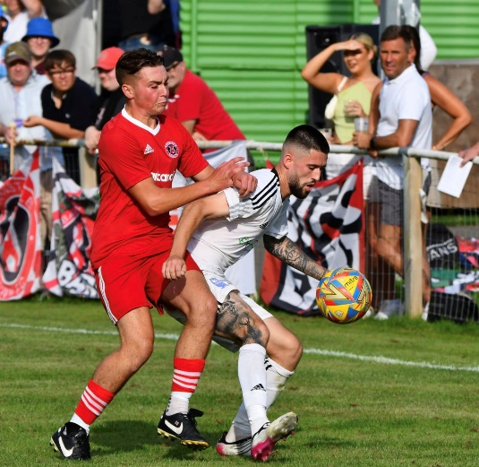
In a quieter game at the Hand Stadium, Alex Camm’s deflected effort helped Clevedon edge to a 1-0 win over Brixham, while a Billy Tucker penalty and a goal late in the first half from Harry Foster saw Barnstaple secure a 2-0 an impressive 2-0 win away at Nailsea & Tickenham (pictured, left). Another side to win well on their travels were Torpoint, with their 3-0 victory at Ilfracombe bringing an end to their five-match winless run. Owen Haslam was the first man to strike for Torpoint, scoring from just inside the area at the end of the first period. Torpoint then struck again at the beginning of the second half through Josh Pope, and after their hosts had been reduced to ten, a goal ten minutes from time courtesy of Ryan Smith confirmed the destination of the points. Helston handed Shepton Mallet just their second defeat of the campaign, capitalising on an early red card to run out 5-1 victors. Mallet faced the worst possible start, and were reduced to ten within the opening 100 seconds of the contest when keeper Tom Roberts was dismissed after hauling down an attacker who bared down on goal. Helston did eventually make the extra man count, going ahead after half an hour, but incredibly Mallet weren’t behind for long with a long range free kick from Charlie Bateson drawing them level. Eventually the dam broke however, and league leaders Helston surged home during the final 20 minutes, scoring four unanswered goals to register their fifth win from seven.
First Division: Earlier in the week, Brislington secured a 3-1 win away at Cribbs Reserves during the only fixture to place on Wednesday evening. First half strikes from the Jordan’s, Metters and Ricketts put Bris two up at the interval, with fourth place up for grabs for the victor. A second Ricketts goal on the hour mark put the result to bed, with Cribbs securing a late consolation courtesy of Kieran Clayton.
Portishead’s outstanding start to the season reached new heights on Saturday afternoon, after they secured a thumping 4-0 win at home to Bradford Town. The visiting Bobcats had only suffered one defeat coming into the fixture, but were second best for much of the afternoon, falling behind in the 40th minute to Portishead’s star man Ethan Feltham. The division’s leading marksman was then on target again on the hour mark to stretch the hosts’ lead before Callum Eastwood made it 3-0 late on. That still left time for Feltham to complete his hat-trick, and following a fantastic run and finish, he did just that, putting the cap on their four-goal triumph. Second-place Wincanton left it late before grabbing a point away at Brislington, denying their hosts the opportunity to leapfrog them in the table. Bris looked set to extend their four-match winning streak thanks to George Jones’ 16th minute effort, but they were pegged back in the dying moments when Matt Garner tucked home his spot kick to salvage a point for the Wasps. The Bristol Telephones registered their seventh league win this term at home to Bishop Sutton, finally seeing off the bottom side thanks to a pair of goals in the final quarter. Sutton have been reeling in recent weeks, but a more determined performance saw them stay in the contest up until the 70th minute, when a quickfire double from their former frontman Craig Wilson giving the Phones all three points. Another strong starter this season have been Radstock, and the Miners picked up another win on Saturday, beating Hallen by a goal to nil. The decisive moment came five minutes before the break courtesy of a Will Osbourne header, but credit must also be shared with keeper Dan Jackson who saved an Elliot Gardner penalty early in the second half to preserve the clean sheet.
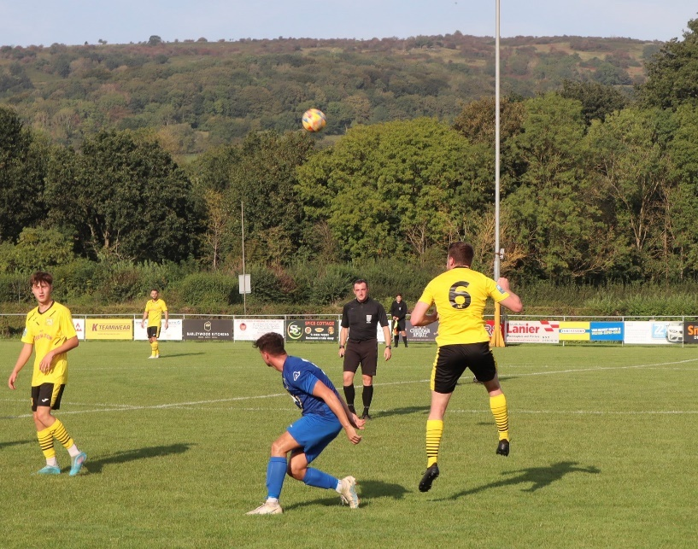
The biggest scorers in the First Division on Saturday afternoon were Cadbury Heath, for whom Callum Whooley cracked home a hat-trick in their 6-1 win away at Warminster. After teammate Josh Haynes opened the scoring in the 14th minute, Whooley added Heath’s second soon after to put the visitors firmly in control. That slipped slightly when Town pulled a goal back early in the second half, but Harry Goldspink soon restored the two-goal advantage to reassert their position of strength. Whooley then took over the contest as it headed into the final quarter, smashing home a pair of strong finishes to make it 5-1, before Haynes popped up in stoppage time to complete the rout. Luke Bryan scored the crucial winner for Boco in their 2-1 defeat of Gillingham, with Longwell Green beating Hengrove by the same scoreline thanks to goals from Lewis Coleman and Liam Oswin. Wells City were another side to prevail by the same 2-1 scoreline, holding off Cheddar to move up into tenth spot (pictured, left). Craig Herrod’s early opener was followed up just prior to half time by Ali Sen, who struck for the second game on the bounce to put Wells two-up. An instant response from the home side saw Lewis Chappell fire home in first half stoppage time, but they couldn’t find an equaliser after the break and have now suffered a pair of defeats to rivals Wells in the space of six weeks. In Bath, Middlezoy brought an end to their poor recent run of form with a 3-1 win over Odd Down (pictured, below). Goals from Daniel Luce and Acey Mead gave the Rovers a strong foothold, before Odd Down hit back at the end of the first half through Milo Murgatroyd. The home side had further chances to get back into the game, but couldn’t quite force home a leveller, and it proved costly when Charlie Bridges’ neat finish put the game to bed in Middlezoy’s favour.
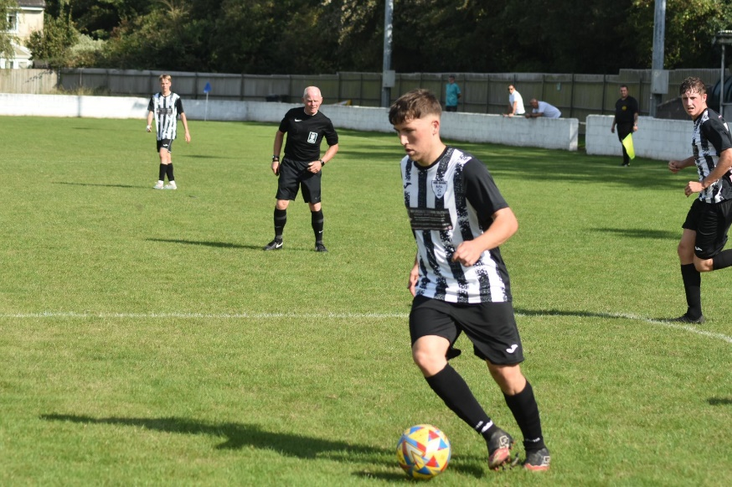

Latest Results
Wednesday 6th September 2023
First Division
Cribbs Reserves 1-3 Brislington 95

Saturday 9th September 2023
Premier Division
Bridgwater United 6-2 Oldland Abbotonians 254
Buckland Athletic 3-3 Street 152
Clevedon Town 1-0 Brixham AFC 125
Falmouth Town 8-0 Wellington 365
Ilfracombe Town 0-3 Torpoint Athletic 82
Nailsea & Tickenham 0-2 Barnstaple Town 69
Shepton Mallet 1-5 Helston Athletic
St Blazey 7-0 Millbrook
Welton Rovers 6-1 Saltash United
First Division
Brislington 1-1 Wincanton Town 130
Bristol Telephones 2-0 Bishop Sutton 55
Cheddar 1-2 Wells City 104
Gillingham Town 1-2 AEK Boco 33
Longwell Green Sports 2-1 Hengrove Athletic 142
Odd Down 1-3 Middlezoy Rovers
Portishead Town 4-0 Bradford Town 235
Radstock Town 1-0 Hallen
Warminster Town 1-6 Cadbury Heath 130

On this weeks podcast, St Blazey joint-manager Andrew Moon chats with Ian about his sides journey to the Western League, the ambition that drives them and the step up in quality that they have faced since promotion. There is also a conversation with Bitton boss Will Justin, who reflects on his sides impressive start to the season, and offers thoughts on the major rebuilding job he has had on his hands.
http://toolstationleague.com/season-2023-24-podcast-episode-6/

Upcoming Fixtures
Tuesday 12th September 2023
First Division
Bitton vs Warminster Town 19:30KO
Bradford Town vs Odd Down 19:30KO
Brislington vs Longwell Green Sports 19:30KO
Gillingham Town vs Radstock Town 19:30KO
Middlezoy Rovers vs Hengrove Athletic 19:30KO
Portishead Town vs Wells City 19:30KO

Wednesday 13th September 2023
First Division
Cadbury Heath vs Cheddar 19:30KO
Cribbs Reserves vs Hallen 19:30KO
Shirehampton vs Bishop Sutton 19:30KO

Friday 15th September 2023
Premier Division
Street vs Bridgwater United 19:45KO

Saturday 16th September 2023 (3pm kick-off unless noted)
Premier Division
Barnstaple Town vs Shepton Mallet
Clevedon Town vs Falmouth Town
Helston Athletic vs Ilfracombe Town
Millbrook vs Buckland Athletic
Saltash United vs Nailsea & Tickenham
Torpoint Athletic vs Oldland Abbotonians
Wellington vs St Blazey
Welton Rovers vs Brixham AFC
First Division
Bishop Sutton vs Portishead Town
Bitton vs Middlezoy Rovers
Cadbury Heath vs Gillingham Town
Cheddar vs Bradford Town
Hengrove Athletic vs Brislington
Keynsham Town vs Hallen
Odd Down vs AEK Boco
Radstock Town vs Longwell Green Sports
Warminster Town vs Bristol Telephones
Wells City vs Shirehampton
Wincanton Town vs Cribbs Reserves

League Tables
 | PREMIER DIVISION | Played | Won | Drawn | Lost | GD | Points
1 | Helston Athletic | 7 | 5 | 1 | 1 | 21 | 16
2 | Falmouth Town | 7 | 5 | 1 | 1 | 12 | 16
3 | Clevedon Town | 6 | 4 | 2 | 0 | 6 | 14
4 | Torpoint Athletic | 9 | 4 | 2 | 3 | 4 | 14
5 | Bridgwater United | 6 | 4 | 1 | 1 | 12 | 13
6 | Barnstaple Town | 6 | 3 | 3 | 0 | 8 | 12
7 | Street | 6 | 3 | 3 | 0 | 6 | 12
8 | Nailsea & Tickenham | 7 | 4 | 0 | 3 | 5 | 12
9 | Buckland Athletic | 7 | 3 | 2 | 2 | 3 | 11
10 | Shepton Mallet | 7 | 3 | 2 | 2 | 1 | 11
11 | Brixham AFC | 8 | 2 | 3 | 3 | 0 | 9
12 | Ilfracombe Town | 8 | 2 | 3 | 3 | -2 | 9
13 | St Blazey | 7 | 2 | 2 | 3 | 2 | 8
14 | Welton Rovers | 7 | 2 | 2 | 3 | -1 | 8
15 | Saltash United | 8 | 1 | 1 | 6 | -12 | 4
16 | Oldland Abbotonians | 7 | 1 | 0 | 6 | -13 | 3
17 | Wellington | 7 | 0 | 2 | 5 | -18 | 2
18 | Millbrook | 6 | 0 | 0 | 6 | -34 | 0
 | FIRST DIVISION | Played | Won | Drawn | Lost | GD | Points
1 | Portishead Town | 11 | 9 | 1 | 1 | 24 | 28
2 | Wincanton Town | 12 | 8 | 2 | 2 | 9 | 26
3 | Bitton | 10 | 7 | 3 | 0 | 14 | 24
4 | Radstock Town | 11 | 8 | 0 | 3 | 11 | 24
5 | Brislington | 11 | 7 | 2 | 2 | 22 | 23
6 | Bristol Telephones | 12 | 7 | 2 | 3 | 7 | 23
7 | Bradford Town | 11 | 6 | 3 | 2 | 13 | 21
8 | Cribbs Reserves | 10 | 6 | 2 | 2 | 10 | 20
9 | AEK Boco | 11 | 5 | 2 | 4 | 4 | 17
10 | Wells City | 9 | 5 | 1 | 3 | 8 | 16
11 | Longwell Green Sports | 11 | 4 | 2 | 5 | -1 | 14
12 | Hengrove Athletic | 10 | 4 | 1 | 5 | 0 | 13
13 | Middlezoy Rovers | 11 | 4 | 1 | 6 | -2 | 13
14 | Cadbury Heath | 10 | 4 | 0 | 6 | -4 | 12
15 | Hallen | 11 | 3 | 2 | 6 | -5 | 11
16 | Warminster Town | 11 | 3 | 1 | 7 | -6 | 10
17 | Cheddar | 11 | 3 | 1 | 7 | -12 | 10
18 | Keynsham Town | 10 | 3 | 0 | 7 | -11 | 9
19 | Shirehampton | 9 | 2 | 2 | 5 | -6 | 8
20 | Gillingham Town | 10 | 2 | 1 | 7 | -17 | 7
21 | Odd Down | 11 | 1 | 2 | 8 | -26 | 5
22 | Bishop Sutton | 11 | 0 | 1 | 10 | -32 | 1

