Latest Round-ups:
#6
Season 2023/24

Midweek Action: On a busy Tuesday evening, Falmouth secured an impressive looking 2-0 win at home to Torpoint in their top-half Premier Division clash. Cam Hutchinson’s brace fired Town to their third successive league victory in front of a mega crowd of 383 who piled into Bickland Park for this Cornish derby. In the coastal town of Brixham, visitors Saltash showed signs of improvement, securing their first point of the campaign following a 1-1 draw. Having fallen behind to Cole Harford’s 8th minute opener, the Ashes managed to grab a share of the spoils just after the hour mark when Kieran O’Melia slotted home. Nailsea & Tickenham’s strong start continued, with goals from Joe Berry, Lucas Vowles and Nick Buxton leading them to a 3-1 win at Shepton Mallet, while Wellington will be glad to have picked up a point following their 1-1 draw away at Ilfracombe Town. The following evening, an attendance of over 200 were on hand to enjoy Buckland’s 5-1 win over St Blazey. A strong start for the hosts saw them lead 3-0 after 32 minutes courtesy of goals from Josh Grant, Owen Stockton and Teigan Rosenquest. A close range effort from Cieran Bridger then put the Bucks out of sight, with Jared Lewington beating the offside trap to add a late fifth. Wednesday’s other encounter saw Clevedon claim a 2-0 win away at Oldland Abbotonians thanks to goals either side of the break from Owen Punselie and Sam Beresford.
There was also some large crowds in the First Division, including at Portishead, where the home side snatched a late point to move into top spot at the end of the night. After seeing Dawid Regula put Bitton in front, the home side were willed on by much of the 241 in attendance, and it paid off with substitute Jack Harper drawing the hosts’ level late on. The biggest winners of the night were Keynsham, who put seven past Odd Down in their bottom-three battle. In an incredible start to the game, Town flew out of the blocks and were three goals to the good within nine minutes of the kick-off thanks to Jaheim Allen, Theo Jeremy and Jamal Salawu. A further goal just before the break from Brandon Oputeri increased the K’s advantage before the Bath side battled back to reduce the deficit to two courtesy of efforts from Lloyd Land and Ben Millett. That was as close as they came however, with Jake Wilson making it 5-2, before substitutes Joe Davis and Amadou Jawo both found the back of the net as Keynsham completed their comprehensive victory. It was also relatively one-sided at Wincanton, where the visiting Bradford Town outfit stormed to a 5-1 win. A dream start for the Bobcats saw Jack Witcombe put them ahead inside the opening minute, with Jamie Jordan then doubling their advantage midway through the first half. Early second half strikes from Ben Wickens and Charlie Saunders put the result beyond doubt, before Martin Johnson came off the bench in the closing stages to add Town’s fifth. The individual performance of the night belonged to Corey Rawlings, with the Radstock forward notching a hat-trick in his sides 4-2 win away at ten-man Cheddar. The game was one apiece at the interval, but the home side lost Luke Prosser to a red card which derailed their chances, and the Miners ran out comfortable winners. George Jones was at the double during Brislington’s 5-1 win at home to strugglers Bishop Sutton, while an incredible finish in the other fixture saw Bristol Telephones eventually down AEK Boco by three goals to two. A pair of Craig Wilson efforts looked to have secured three points for the Phones, only for Mitchell Tippins and Sidney Partridge to score in the 87th and 94th minutes respectively to level affairs. Somehow the home side managed to find enough time to force another attack, and substitute Connor Saunders was the man to force the ball home to claim the craziest of late wins.
24 hours later, Cribbs Reserves maintained their excellent early season form, with Tom Headford, Jack Guthrie, and James Clayton all on target in their 3-1 win away at Shirehampton.
There was also plenty of drama in the FA Vase on Tuesday evening, with Wells requiring penalties to see off Welton Rovers at West Clewes. Following the abandonment of their game on Saturday afternoon, it was Wells who struck first with Conrad Peck putting the visitors in front during the first half. Welton then struck twice in quick succession through Connor Linham and Lewis Russell to turn the game in their favour before Harry Warwick sent the game to penalties with his equalising goal during the second half. Wells stopper Tom Creed proved to be the hero, saving two Welton spot kicks to send the First Division side through to the next round, setting up a meeting with Cullompton Rangers later this month.
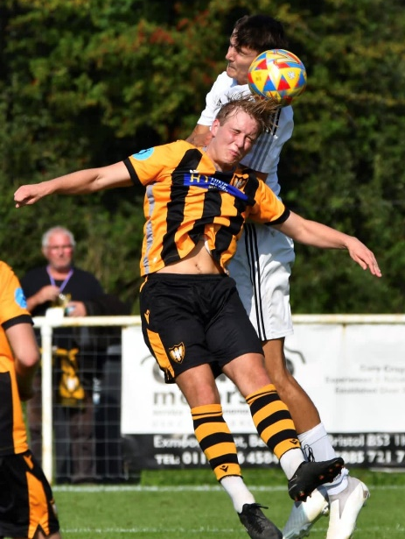
Premier Division: Falmouth Town moved level on points atop the league following an impressive 1-0 win away at Nailsea & Tickenham (pictured, right). In a tight affair between two of this season’s strong starters, it was the away side who came out on top thanks to a Bradley Leivers strike, allowing them to leapfrog their hosts up into second spot. Early table-toppers Helston suffered their first league defeat of the campaign, falling to a 3-1 loss at the hands of Brixham. In a fascinating battle which saw four penalties awarded, Charlie Johansen bookended the first half with a pair of goals to give the home side a two-goal lead at the interval. Tom Payne then converted a spot kick of his own to get Helston back into the game on the hour mark before Cole Harford struck ten minutes from time to wrap up the home side’s second win of the campaign. Saltash’s recent revival continued on Saturday afternoon after they secured a 4-1 win at home to Wellington. Kieran O’Melia scored for the third game running to put the Ashes in front after only 12 minutes, only for Welly to hit back midway through the first half courtesy of Doug Camillo. A goal early in the second half from Jordan Ewing put the home side back ahead, and they seemed to take confidence from that, pushing on to claim their first league win this term thanks to further strikes from Joe Preece and Tyler Love-Holmes. Street are another side who have enjoyed an encouraging opening month to their season, with their 4-2 win away at Oldland moving them up into fourth. The Cobblers fell behind twice to a pair of Harrison Kyte efforts, but weren’t behind for long on either occasion, hitting back through Freddie Frazer and Phil Ormrod to make it two apiece on the hour mark. A special long-range strike from Eli Collins gave Street their first lead of the afternoon 17 minutes from time, with Kye Sampson scoring soon after to condemn the Abbots to their second loss to the same opponent in two and a half weeks. Lowly Millbrook were also beaten for the fifth time this term, with Shepton Mallet securing a 4-0 win at Jenkins Park to rise into the top five. A brace of penalties towards the end of the first half were both converted by Jacob Sloggett, putting the Cornish outfit in a tough spot as they attempted to gain their first points. Things got even worse in first half stoppage time when Charlie Bateson added a third for the visitors, with Joe Banks then striking soon after the interval to complete the scoring. Unlike Millbrook, two sides were able to break their duck, with both St Blazey and Welton registering their first league wins of the campaign. For St Blazey, they finally held off the challenge of Ilfracombe to prevail by three goals to two at Blaise Park. Having already seen Lewis Russell’s 14th minute opener cancelled out, St Blazey went back ahead just prior to half time thanks to an excellent individual effort from Isaac McCue. Ilfracombe weren’t willing to lie down however, and they responded well again, drawing level ten minutes into the second half, but they were finally defeated as the game headed into the final 20 minutes when Russell’s leaping header completed the defender’s match-winning brace. Welton were also forced to battle hard for their first three point haul, with a volleyed finish from debutant Logan Cassidy in the 72nd minute leading them to a 2-1 victory away at Torpoint Athletic.
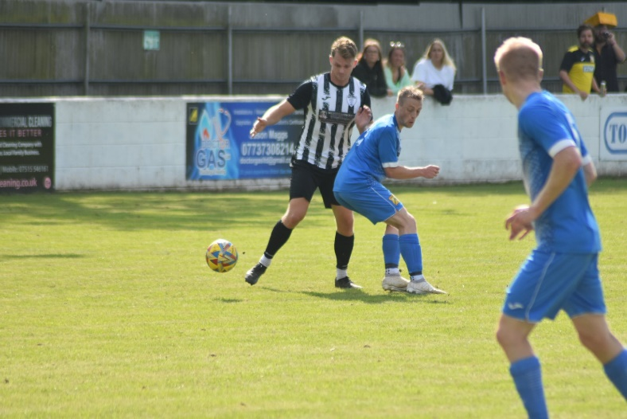
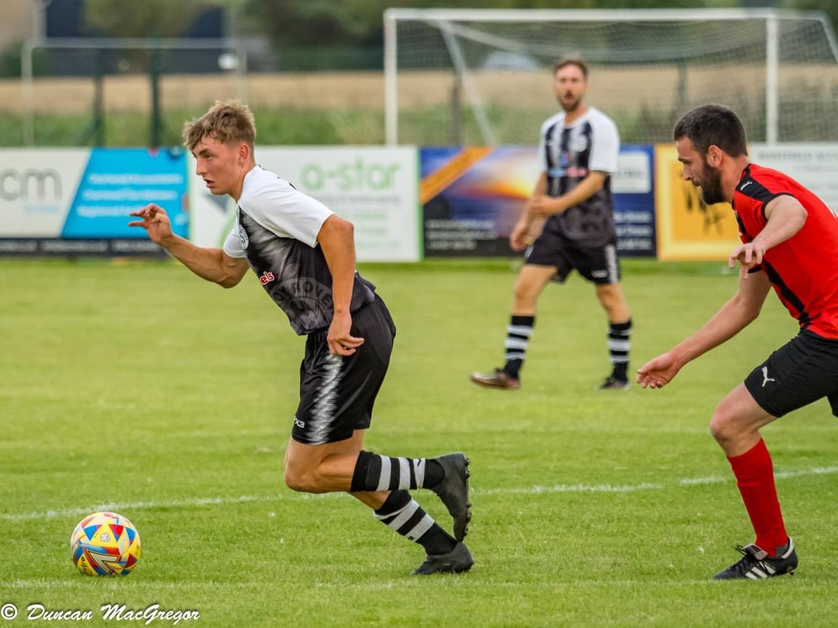
First Division: The early season form of Portishead Town showed no signs of slowing down on Saturday afternoon, with a dominant first half performance leading them to a 4-0 win away at AEK Boco. Town scored all four of their goals during a mightily impressive opening 45 minutes, with Kyle Egan and Josh Honey putting them two up in the opening stages. Honey then turned provider, laying it off for Calum Townsend to crack home a third, with leading scorer Ethan Feltham bagging their fourth just prior to the interval. Wincanton Town joined Portishead on 25 points atop the table, but found things slightly tougher going at home to Hallen, holding off the Bristol side to eventually prevail by three goals to two. Things looked to be going swimmingly for the home side early on, with goals from Ben Murcer and Jamie Thompson putting them two goals to the good inside the opening 25 minutes. A flicked finish from Cory Thomas-Barker got Hallen back into the contest on the half-hour mark, but Winky came out strongly after the break and restored their two-goal advantage courtesy of another Thompson effort. That was how it stayed for the majority of the second half, before Wincanton were given a slight scare in the closing stages when Thomas-Barker scored again two minutes from time, but it was too little, too late for the away side. At the opposite end of the table, Bishop Sutton remain the only winless side after suffering a 5-2 defeat at the fast-improving Keynsham. The K’s were far too strong during the first half at Lakeview, taking a three-goal lead to the break courtesy of efforts from Jake Wilson, Yonis Hussein and Brandon Oputeri. Keynsham have secured back-to-back high scoring victories, with further goals from Oputeri and Hussein early in the second half putting the game to bed before Sutton subs Cole Campbell and Sam Hughes gave the final scoreline an ounce of respectability. The only undefeated side in the league are Bitton, and they kept pace with the top two with a 3-0 win at home to Gillingham, all thanks to hat-trick hero George Lloyd. The Bristol Telephones proved that their impressive run of early-season results was no fluke, battling back to secure a 3-3 draw away at Bradford. After a pair of goals inside the opening ten minutes from Ben Wickens put the Bobcats in total command early on, Mike Grist’s effort early in the second half seemed to bring the game to life. Bradford responded well to that setback, moving back into a two-goal lead through Jack Witcombe, only for Leon Britton to strike again for the Phones to set up a frantic finish. With one of their final attacks on goal, the visitors secured a deserved point with Archie Dark striking at the death to bring the curtain down on a thrilling afternoon’s entertainment. There was plenty of excitement too for those in Bath who ventured out to see Cheddar’s 4-3 win away at Odd Down (pictured, left). After the home side went ahead inside the third minute through Tyrone Mulholland, the Cheesemen hit back through Liam Graham and Elliott Keen to make it 2-1 after half an hour. There was then still time for Cheddar to add a third prior to the interval, with Oscar Collins making amends for an earlier penalty miss by slotting home to make it 3-1. Odd Down regrouped well, and despite their lowly league position, they have a player in Milo Murgatroyd who has really shone during the first ten games, and it was his quickfire double during the second half which saw the hosts draw level 20 minutes from time. Unfortunately for Murgatroyd and his teammates, they fell just short again, with George Fairchild’s attempted cross from a set-piece floating into the back of the net and giving Cheddar a memorable 4-3 victory. Another side to win on their travels were Radstock, with three goals in added time at the end of the second half adding plenty of gloss to their 5-1 win at Cadbury Heath. Having fallen behind to Matt Huxley’s 13th minute header, a pair of well-taken goals from Ian Jeffery and Jacob Reader turned the game in the Miners favour midway through the second half. A tap-in from Seb Hounsell made it 3-1 in the 91st minute, yet somehow Radstock found time to score twice more against a waning defence, with Corey Rawlings and Jeffery completing the scoring. There were a couple of 1-1 draws in the clashes involving Longwell Green and Wells, while Brislington produced the comeback of the day, overturning a two-goal deficit to beat Middlezoy 3-2 (pictured, left). Following a goalless first half, it was Rovers who shot out of the blocks after half-time, with Harry Smith and Liam Gilbert handing them a two-goal advantage. Facing a third loss, Brislington showed the fighting spirit which led to them to last year’s title, securing maximum points thanks to goals from Oaklan Buck, Josh Egan and Lewis Dunn.
Cup Action: The Western League’s presence in the FA Cup this season has come to an end after the three remaining sides all suffered away defeats on Saturday afternoon at higher-ranked opponents. Barnstaple were handed a 3-0 defeat at the hands of Poole Town, while Clevedon fell to a 3-1 loss at Badgers Hill against Frome. It was Bridgwater who came closest to sealing a spot in the next round after they were narrowly beaten 3-2 by Salisbury. After going behind in just the fourth minute, Bridgy got level just prior to half time courtesy of a Jack Thorne strike. Salisbury then struck twice in the opening ten minutes of the second half and it proved too steep a slope for United to fight back, with Adam Wright’s late curler not quite enough for the away side.

On the podcast this week, we hear from Saltash boss Mackenzie Brown, who talks about the ambitions for his side in the wake of a total first team rebuild, while also discussing the need to turn around their Premier Division form following a big win in the Vase last Saturday. Ian also catches up with Jamie Hillman of Hengrove, who explains his commitment to youth, his lofty ambitions for the club, while also giving his reflections on how the new refereeing protocols are working out at Step 6.
http://toolstationleague.com/season-2023-24-podcast-episode-5/

Latest Results
Tuesday 29th August 2023
Premier Division
Brixham AFC 1-1 Saltash United 190
Falmouth Town 2-0 Torpoint Athletic 383
Ilfracombe Town 1-1 Wellington 154
Shepton Mallet 1-3 Nailsea & Tickenham 156
First Division
Brislington 5-1 Bishop Sutton 89
Bristol Telephones 3-2 AEK Boco 49
Cheddar 2-4 Radstock Town 82
Keynsham Town 7-2 Odd Down 117
Portishead Town 1-1 Bitton 241
Wincanton Town 1-5 Bradford Town
FA Vase
Welton Rovers 2-2 (2-3 pens) Wells City

Wednesday 30th August 2023
Premier Division
Buckland Athletic 5-1 St Blazey 210
Oldland Abbotonians 0-2 Clevedon Town
First Division
Shirehampton 1-3 Cribbs Reserves 54

Saturday 2nd September 2023
FA Cup – First Round Qualifying
Frome Town 3-1 Clevedon Town
Poole Town 3-0 Barnstaple Town
Salisbury 3-2 Bridgwater United
Premier Division
Brixham AFC 3-1 Helston Athletic 129
Millbrook 0-4 Shepton Mallet
Nailsea & Tickenham 0-1 Falmouth Town 100
Oldland Abbotonians 2-4 Street
Saltash United 4-1 Wellington 108
St Blazey 3-2 Ilfracombe Town 158
Torpoint Athletic 1-2 Welton Rovers 121
First Division
AEK Boco 0-4 Portishead Town 112
Bishop Sutton 2-5 Keynsham Town 80
Bitton 3-0 Gillingham Town 58
Bradford Town 3-3 Bristol Telephones 153
Cadbury Heath 1-5 Radstock Town 48
Longwell Green Sports 1-1 Warminster Town 94
Middlezoy Rovers 2-3 Brislington 100
Odd Down 3-4 Cheddar
Wells City 1-1 Cribbs Reserves
Wincanton Town 3-2 Hallen

Upcoming Fixtures
Wednesday 6th September 2023
First Division
Cribbs Reserves vs Brislington 19:30KO

Saturday 9th September 2023 (3pm kick-off unless noted)
Premier Division
Bridgwater United vs Oldland Abbotonians
Buckland Athletic vs Street
Clevedon Town vs Brixham AFC
Falmouth Town vs Wellington
Ilfracombe Town vs Torpoint Athletic
Nailsea & Tickenham vs Barnstaple Town
Shepton Mallet vs Helston Athletic
St Blazey vs Millbrook
Welton Rovers vs Saltash United
First Division
Brislington vs Wincanton Town
Bristol Telephones vs Bishop Sutton
Cheddar vs Wells City
Gillingham Town vs AEK Boco
Keynsham Town vs Bitton
Longwell Green Sports vs Hengrove Athletic
Odd Down vs Middlezoy Rovers
Portishead Town vs Bradford Town
Radstock Town vs Hallen
Warminster Town vs Cadbury Heath

League Tables
 | PREMIER DIVISION | Played | Won | Drawn | Lost | GD | Points
1 | Helston Athletic | 6 | 4 | 1 | 1 | 17 | 13
2 | Falmouth Town | 6 | 4 | 1 | 1 | 4 | 13
3 | Nailsea & Tickenham | 6 | 4 | 0 | 2 | 7 | 12
4 | Street | 5 | 3 | 2 | 0 | 6 | 11
5 | Shepton Mallet | 6 | 3 | 2 | 1 | 5 | 11
6 | Clevedon Town | 5 | 3 | 2 | 0 | 5 | 11
7 | Torpoint Athletic | 8 | 3 | 2 | 3 | 1 | 11
8 | Bridgwater United | 5 | 3 | 1 | 1 | 8 | 10
9 | Buckland Athletic | 6 | 3 | 1 | 2 | 3 | 10
10 | Barnstaple Town | 5 | 2 | 3 | 0 | 6 | 9
11 | Brixham AFC | 7 | 2 | 3 | 2 | 1 | 9
12 | Ilfracombe Town | 7 | 2 | 3 | 2 | 1 | 9
13 | St Blazey | 6 | 1 | 2 | 3 | -5 | 5
14 | Welton Rovers | 6 | 1 | 2 | 3 | -6 | 5
15 | Saltash United | 7 | 1 | 1 | 5 | -7 | 4
16 | Oldland Abbotonians | 6 | 1 | 0 | 5 | -9 | 3
17 | Wellington | 6 | 0 | 2 | 4 | -10 | 2
18 | Millbrook | 5 | 0 | 0 | 5 | -27 | 0
 | FIRST DIVISION | Played | Won | Drawn | Lost | GD | Points
1 | Portishead Town | 10 | 8 | 1 | 1 | 20 | 25
2 | Wincanton Town | 11 | 8 | 1 | 2 | 9 | 25
3 | Bitton | 10 | 7 | 3 | 0 | 14 | 24
4 | Bradford Town | 10 | 6 | 3 | 1 | 17 | 21
5 | Radstock Town | 10 | 7 | 0 | 3 | 10 | 21
6 | Cribbs Reserves | 9 | 6 | 2 | 1 | 12 | 20
7 | Bristol Telephones | 11 | 6 | 2 | 3 | 5 | 20
8 | Brislington | 9 | 6 | 1 | 2 | 20 | 19
9 | AEK Boco | 10 | 4 | 2 | 4 | 3 | 14
10 | Wells City | 8 | 4 | 1 | 3 | 7 | 13
11 | Hengrove Athletic | 9 | 4 | 1 | 4 | 1 | 13
12 | Longwell Green Sports | 10 | 3 | 2 | 5 | -2 | 11
13 | Hallen | 10 | 3 | 2 | 5 | -4 | 11
14 | Warminster Town | 10 | 3 | 1 | 6 | -1 | 10
15 | Middlezoy Rovers | 10 | 3 | 1 | 6 | -4 | 10
16 | Cheddar | 10 | 3 | 1 | 6 | -11 | 10
17 | Cadbury Heath | 9 | 3 | 0 | 6 | -9 | 9
18 | Keynsham Town | 10 | 3 | 0 | 7 | -11 | 9
19 | Shirehampton | 9 | 2 | 2 | 5 | -6 | 8
20 | Gillingham Town | 9 | 2 | 1 | 6 | -16 | 7
21 | Odd Down | 10 | 1 | 2 | 7 | -24 | 5
22 | Bishop Sutton | 10 | 0 | 1 | 9 | -30 | 1

