Latest Round-ups:
Season 2023/24

#5
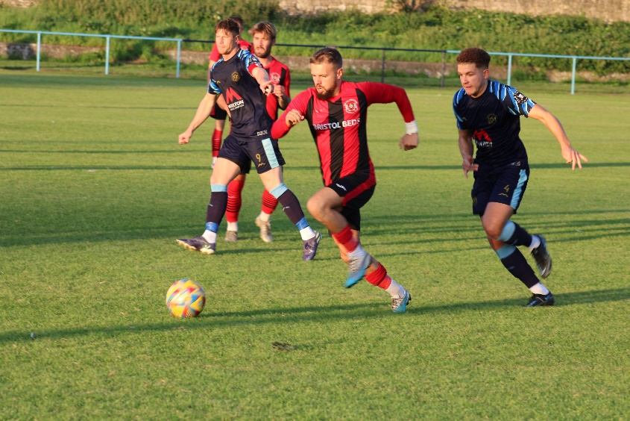
Midweek Action: Buckland Athletic’s hopes of progressing in the FA Cup were ended on Tuesday evening after they were defeated in their replay at Okehampton Argyle. Having trailed 2-0 at the interval, Buckland attempted a comeback courtesy of Ryan Bush’s goal but couldn’t quite find an equaliser during the final half hour. The remainder of the midweek action centred around the First Division, with the top-two scratching out away victories. Wincanton sit top of the pile after eight rounds of fixtures, with their seventh win of the campaign coming away at Cheddar thanks to a second half strike from Matt Garner. Portishead Town have also won seven of their eight games so far, with a first half header from Calum Townsend leading them to 1-0 victory away at Longwell Green Sports. Things were slightly more straight forward for Bitton who stormed to a 6-2 defeat of Odd Down thanks to goalscoring doubles from Dawid Regula, Stefan Lee and Will Manning. Cribbs Reserves impressive start shows no signs of slowing up, and they grabbed a 2-0 win over Hengrove with goals either side of the interval from brothers Liam and Kieran Clayton. The top-eight clash between Bradford and Brislington (pictured, below) finished one apiece, with Jordan Ricketts securing a point for the visitors after Ben Wickens had put Town ahead on the hour mark. The points were also shared in Bristol, where Middlezoy Rovers fought back from a two-goal deficit to deny the Telephones. Following a goalless first half, Craig Wilson struck twice to put the hosts in charge, but they were unable to hang on, with Liam Winter and substitute Acey Mead helping the Rovers to bring an end to their two-match losing run. Second half goals from Kieran Cooper and Scott Cousins saw Hallen win 2-0 at Bishop Sutton, while a brace from Jack Farion spearheaded Radstock’s 3-0 defeat of Shirehampton. There was also a 3-2 come-from-behind victory for Gillingham over Warminster, with Wells beating Boco 4-1 thanks in part to three goals in seven minutes from Charlie Crook, Harry Warwick, and Charlie Moon late in the first half. Wednesday’s only game was a tight affair, with Joe Smith’s goal after half an hour giving Cadbury Heath a tense 1-0 win over Keynsham.

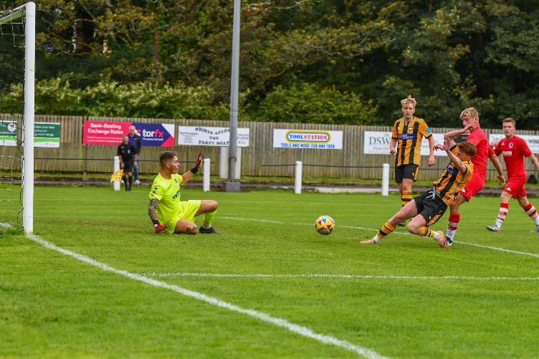
FA Vase: Goals were flying in on an entertaining afternoon of cup action, with mixed results for the many Western League sides looking to reach the Second Round of Qualifying. One of the sides to impress on Saturday were Cheddar, who flew out of the blocks in their 4-1 win at home to Torridgeside. The hosts went looking for a strong start, and they were rewarded with just that when Oscar Collins fired them ahead inside the opening two minutes. A second goal from Collins put Cheddar two-up at the interval, and despite conceding early in the second half, they pushed on for victory with Liam Graham scoring a brace of his own. Falmouth were another of the Western League sides to impress, scoring six unanswered goals in their home tie with Honiton. Luke Barner’s early double set Town on their way, with Cam Hutchinson then adding a third for the rampant hosts. There was still plenty of time for Falmouth to continue adding to their tally, and they did just that, with Kian Thomas, Olly Walker and Max Everell taking the final score to 6-0. Street didn’t have home comforts to bank on during their one-sided victory over Axminster, with four different scorers helping them progress to the next round. Kyle Simpson and Phil Ormrod scored either side of the interval to put the Cobblers two goals ahead, and they didn’t stop there, with Eli Collins and Freddie Frazer rounding out the 4-0 win. Portishead Town are flying in the First Division, and they brought that form into the Vase, scoring four times after the break to see off Berks County. Following 45 goalless minutes, in-form forward Ethan Feltham was thrust into action, and made an immediate impact, putting Town one-up on the hour mark. Feltham then struck again soon after to double the hosts lead, with Mitch Osmond’s screamer and a late effort from Kyle Egan wrapping up the 4-0 victory.
Action from Falmouth’s big win in the Vase over Honiton. Image courtesy of Matt Friday (@MattFri94)
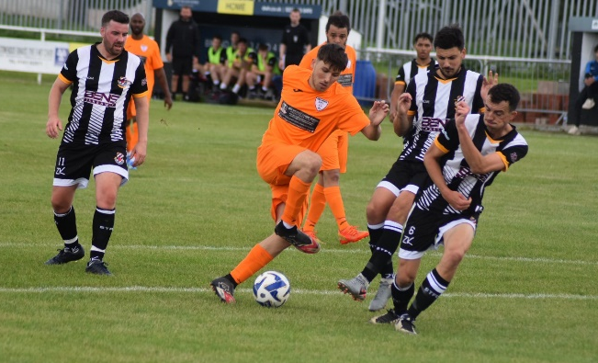
Bradford Town were the other side to knock out opposition from outside the Toolstation League’s, securing a dramatic 3-2 win away at Calne. The Bobcats took command late in the first half courtesy of a Sam Jordan double, only for Calne to fight their way back into the contest, levelling affairs 15 minutes from time. With penalties looking like they would be required to decide the outcome, Liam Watson produced a sublime piece of skill, converting the ball into the back of the net with a bicycle kick to claim an impressive 3-2 victory. For three other sides, penalties put paid to their hopes of progressing, with AEK Boco, Shirehampton and Odd Down (pictured, right) all knocked out following their shootouts.
Unfortunately, there were a number of other sides whose progress was ended at the first stage, including Wellington who saw Oli Snow score a hat-trick in Okehampton Argyle’s 3-0 victory in Somerset. Gillingham fell to the same scoreline in their home clash with Fareham, with Bishop Sutton and St Blazey beaten 3-1 by Wadebridge and Dobwalls, respectively. Keynsham were unable to respond from conceding early on in their 1-0 loss at home to Longlevens, while the all-Western League clash between Welton and Wells had to be abandoned early on following a bad injury to home forward Courtney Charles. The other three ties involved Western League sides going up against one another, and Saltash look to have gained some much needed confidence after beating Radstock 6-0. It has been a tough start for last season’s runners up in the Premier Division, but they enjoyed a near faultless performance in the Vase from the moment Kieran O’Melia gave them a tenth minute lead. Further first half efforts from Josh Toulson and Jordan Ewing put the Ashes three-up at the interval, and they then repeated the trick during the second half, with Ed Goodman, Tyler Love-Holmes and Reece Thomson completing the scoring. Nailsea & Tickenham claimed a come-from-behind victory over ten-man Bitton, with the hosts surging ahead in just the third minute courtesy of a long-range screamer from George Lloyd. Joe Beardwell was then dismissed after picking up two yellow cards in the opening 34 minutes, and the Swags took full advantage during the second half, with goals from Nat Groom and Luke Osgood completing the turnaround. The final tie also went the way of the visitors, with Brislington scoring three times in the final 20 minutes to stun Oldland who were punished for missing a penalty in first half stoppage time.
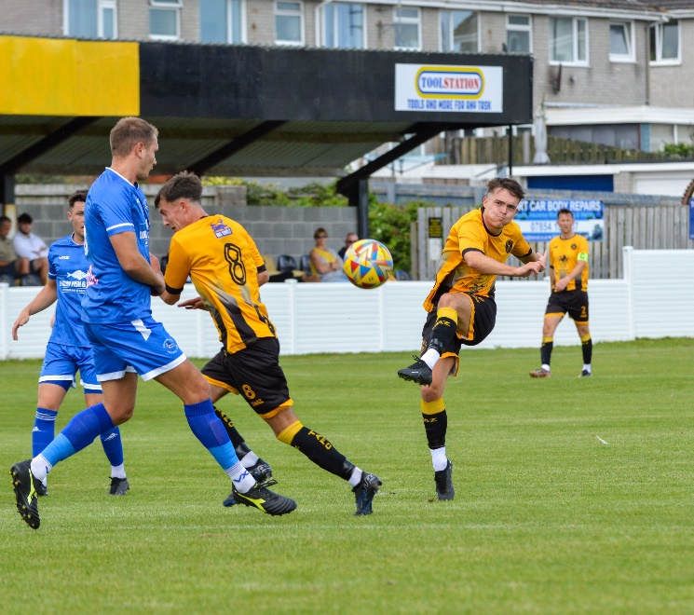
League Action: For those not involved in the Vase, there was an opportunity to climb up the early season tables. In the Premier Division, Helston were in unbelievable form at home to Millbrook, reaching double figures against their Cornish rivals. The signs weren’t good for the visitors during the early stages of the clash at Kellaway Park, with Rikki Sheppard, Callum O’Brien and Tyler Elliot making it 3-0 after only 13 minutes. Sheppard was the standout performer during the first half, and he was on target again to extend the lead further, with Curtis Damerell making it five soon after. Damerell then took centre stage, knocking in two more to complete his hat-trick, with Rubin Wilson and Declan Cornish adding their name the scoresheet during the closing stages. Things were a little tighter elsewhere on Cornish soil, with Ilfracombe preserving a point away at Torpoint despite battling for 70 minutes with ten men (pictured, above left).

Sharing the points seemed to be very much the flavour of the day in the top division with the other three games also all ending in draws. An incredible encounter at Barnstaple saw visitors Bridgwater come from three goals down early in the second half to earn a 4-4 draw deep into stoppage time. Having gone in front courtesy of Jack Thorne, Bridgwater soon found themselves on the back-foot, with Billy Tucker scoring twice to put Town in front. A further goal from Myles Perkins extended Barnstaple’s advantage, before Tucker looked to have put the result beyond doubt when he completed his hat-trick soon after the interval. A smart finish from Jack Taylor on the hour mark gave the away side some feint hope which was increased further 15 minutes from time when Thorne scored his second of the afternoon. In the ninth minute of added time, Thorne then found enough time and space to equal Tucker’s hat-trick, bringing the curtain down on a memorable afternoon for all at Mill Road. Buckland’s Ryan Bush struck 15 minutes from time to salvage a 1-1 draw at home to Clevedon, with the Seasiders having led for much of the afternoon courtesy of Freddie King’s early effort. There was also late drama at Shepton Mallet, with the home side pegging visitors Brixham back in stoppage time to claim a 2-2 draw. Having gone ahead through Jacob Sloggett, Mallet suddenly saw things go awry and were 2-1 down after an hour following goals from Josh Parry and Ewan Howarth for the visitors. Shepton kept pushing until the very end however, and following an excellent run and cross from Aaron Seviour, Callum Gould was on hand to put the ball into the back of the net to the delight of the home fans in attendance.
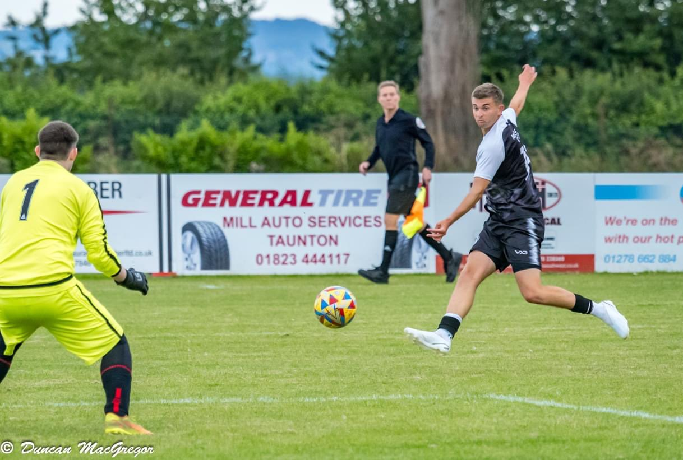
Hengrove were the big winners in the First Division, putting four past Cadbury Heath. Having earned a first half lead through Jack Jones, the Grove pushed on after the break, adding to their advantage thanks to Mickey Parsons, Jacob Grinnell and Pete Sheppard. Another pair of high-scoring home winners were Bristol Telephones and Warminster, with both picking up 4-1 victories over Wincanton and Middlezoy, respectively. The other game was a tight-tussle between a pair of mid-table sides, with Hallen fighting back to secure a 2-2 draw at home to Longwell Green. Having conceded twice in quick succession midway through the first half, Hallen got themselves back into the contest early in the second half thanks to Archie Perry. It was then left to substitute Patryk Kosciolek to complete the comeback, with his 74th minute effort helping to guarantee a point for the home side.
Warminster on the attack during their big win over Middlezoy

Latest Results
Tuesday 22nd August 2023
FA Cup Preliminary Round - Replay
Okehampton Argyle 2-1 Buckland Athletic
First Division
Bishop Sutton 0-2 Hallen 58
Bitton 6-2 Odd Down 123
Bradford Town 1-1 Brislington 126
Bristol Telephones 2-2 Middlezoy Rovers 32
Cheddar 0-1 Wincanton Town 98
Cribbs Reserves 2-0 Hengrove Athletic 58
Gillingham Town 3-2 Warminster Town 41
Longwell Green Sports 0-1 Portishead Town 208
Radstock Town 3-0 Shirehampton 79
Wells City 4-1 AEK Boco 87

Wednesday 23rd August 2023
First Division
Cadbury Heath 1-0 Keynsham Town 106

Saturday 26th August 2023
FA Vase First Qualifying Round
AEK Boco 1-1 (1-4pens) Tuffley Rovers
Axminster 0-4 Street
Bishop Sutton 1-3 Wadebridge Town
Bitton 1-2 Nailsea & Tickenham
Calne Town 2-3 Bradford Town
Cheddar 4-1 Torridgeside
Dobwalls AFC 3-1 St Blazey
Falmouth Town 6-0 Honiton
Gillingham Town 0-3 Fareham Town
Keynsham Town 0-1 Longlevens
Oldland Abbotonians 0-3 Brislington
Portishead Town 4-0 Berks County
Saltash United 6-0 Radstock Town
Shirehampton 1-1 (4-5 pens) Wantage
Stonehouse Town 2-2 (5-3 pens) Odd Down
Wellington 0-3 Okehampton Argyle
Welton Rovers A-A Wells City
Premier Division
Barnstaple Town 4-4 Bridgwater United 218
Buckland Athletic 1-1 Clevedon Town 170
Helston Athletic 10-0 Millbrook
Shepton Mallet 2-2 Brixham AFC 176
Torpoint Athletic 0-0 Ilfracombe Town 132
First Division
Bristol Telephones 4-1 Wincanton Town 42
Hallen 2-2 Longwell Green Sports 66
Hengrove Athletic 4-0 Cadbury Heath 82
Warminster Town 4-1 Middlezoy Rovers 132
Upcoming Fixtures
Tuesday 29th August 2023
Premier Division
Brixham AFC vs Saltash United 19:30KO
Falmouth Town vs Torpoint Athletic 19:45KO
Ilfracombe Town vs Wellington 19:45KO
Shepton Mallet vs Nailsea & Tickenham 19:30KO
First Division
Brislington vs Bishop Sutton 19:30KO
Bristol Telephones vs AEK Boco 19:45KO
Cheddar vs Radstock Town 19:45KO
Keynsham Town vs Odd Down 19:45KO
Portishead Town vs Bitton 19:30KO
Wincanton Town vs Bradford Town 19:30KO
FA Vase
Welton Rovers vs Wells City 19:30KO

Wednesday 30th August 2023
Premier Division
Buckland Athletic vs St Blazey 19:30KO
Oldland Abbotonians vs Clevedon Town 19:45KO
First Division
Shirehampton vs Cribbs Reserves 19:30KO
Friday 1st September 2023
First Division
Shirehampton vs Hengrove Athletic 19:30KO

Saturday 2nd September 2023 (3pm kick-off unless noted)
FA Cup – First Round Qualifying
Frome Town vs Clevedon Town
Poole Town vs Barnstaple Town
Salisbury vs Bridgwater United
Premier Division
Brixham AFC vs Helston Athletic
Millbrook vs Shepton Mallet
Nailsea & Tickenham vs Falmouth Town
Oldland Abbotonians vs Barnstaple Town
Saltash United vs Wellington
St Blazey vs Ilfracombe Town
Torpoint Athletic vs Welton Rovers
First Division
AEK Boco vs Portishead Town
Bishop Sutton vs Keynsham Town
Bitton vs Gillingham Town
Bradford Town vs Bristol Telephones
Cadbury Heath vs Radstock Town
Longwell Green Sports vs Warminster Town
Middlezoy Rovers vs Brislington
Odd Down vs Cheddar
Wells City vs Cribbs Reserves
Wincanton Town vs Hallen

