Latest Round-ups:
Season 2023/24

#4
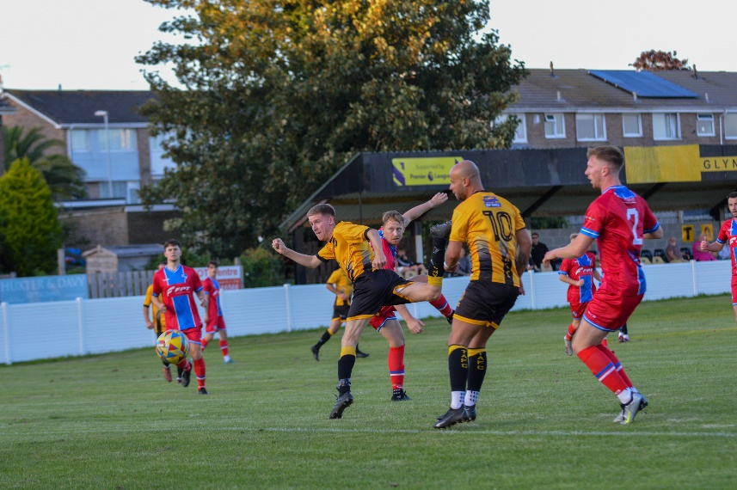
Midweek Action: On a busy Tuesday evening, Nailsea & Tickenham continued their impressive start to life in the Premier Division with a 4-0 win at home to Wellington. The promoted side swatted their Somerset opponents aside, with Lucas Vowles bagging a treble to give them their fourth win on the bounce in all competitions. Bridgwater bounced back well from their heavy defeat the previous weekend by beating Welton 4-0 at Fairfax Park. The hosts had four different goalscorers during the victory, with Sam Towler, Jack Thorne, Adam Wright and Jack Taylor all finding the back of the net. Another 4-0 victor was Barnstaple Town, with stand-in skipper Matty Andrew striking a hat-trick during their home victory over Millbrook. In a much tighter affair, Brixham AFC overturned a half-time deficit on their way to securing a 2-1 win away at Torpoint (pictured, left). Having fallen behind to Owen Haslam’s effort five minutes before the interval, Brixham stormed back to gain all three points courtesy of goals from Kieran Parkin and Cole Harford.
Saltash’s tough start continued, with visiting Falmouth handing them a fourth consecutive defeat to start the campaign. In front of another healthy crowd at the Waterways Stadium, it was Falmouth who came out on top with Cameron Hutchinson, Brad Leivers and late sub Jayden Gilbert leading them to a 3-1 win. The other game that night was a nail-biter, with Buckland claiming a dramatic late winner at home to Ilfracombe. Having taken the lead through Josh Grant, Buckland found themselves in arrears following goals from Town duo Harry Stevens and Jack Magarotto. An effort from Rob Farkins then got the hosts back on level terms, and with time almost up, centre-half Sam Leary popped up to score the injury time winner to hand Buckland a 3-2 victory. 24 hours later, Rikki Sheppard scored 15 minutes from time to give Helston a 1-0 win away at ten-man St Blazey, while the Kyle’s, Strange and Simpson, both struck inside the opening quarter as Street claimed a 2-0 victory over Oldland.

It was an equally packed Tuesday in the First Division, with some high-scoring encounters thrilling the crowds in attendance up and down the league. One of those games to including plenty of scoring action took place at Radstock, where the hosts came out on top by four goals to three over new-boys Middlezoy. Early efforts from Adrian Harvey and Kyle Thomas gave the Miners a dream start, with Jake Reader then scoring just prior to half-time to hand them a 3-1 lead at the break. Rovers came back into the contest, with substitute Dan Lismore scoring a brace off the bench for the second consecutive fixture, but it was Radstock who had the last word, with a sub of their own, Seb Hounsell, scoring five minutes from time to hand them all three points. In an incredible game at Cheddar, all eight goals were scored after the interval, with Warminster running out 6-2 winners over the Cheesemen. Jack Seviour and Nick Taylor both struck braces for the away side, with Sam Wright and Ben Harris also on target, with Warminster steamrolling into a 5-0 advantage prior to the hosts scoring a couple of goals in the closing stages.
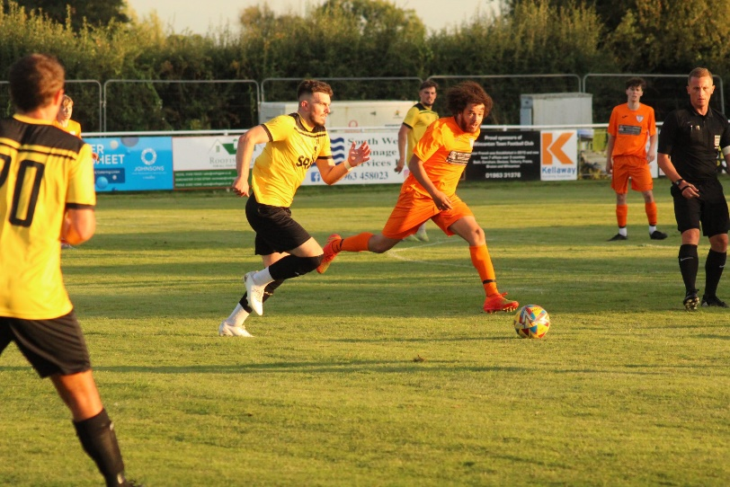
Another side to score six were Brislington, with visitors Hengrove suffering a heavy defeat which wasn’t aided by an early red card. Last year’s champions were in blistering goalscoring form once again, with Asa White and Danny Dodimead both grabbing doubles during the big win. The man of the moment in the First Division right now is Ethan Feltham, with the Portishead forward adding to his league-leading tally with a hat-trick in their 4-1 win away at Keynsham. Joel Bayliss also struck during victory for the away side, but Feltham’s goalscoring feat, which has seen him bag ten goals in four games has helped propel the Posset to a lofty early-season standing in the division. At Lakeview, first half goals from Sam Thomas and Nathan Gore led AEK Boco to a 2-0 win away at Bishop Sutton, while Louis Irwin and Jamie Thompson were each on target during Wincanton’s 2-1 victory over Odd Down. There was also a 2-1 win for Hallen away at Wells which was kick-started by a long-range special from Tyrel Squire, with Longwell Green defeating Gillingham 4-1 thanks to a pair of goals from both Sonny Pascoe and Liam Oswin. In a highly-anticipated affair at Bitton, the hosts secured a share of the spoils, with Jacob Watson cancelling out an early effort from Tom Mack during their 1-1 draw with early pacesetters Bradford Town. Wednesday’s solitary game went the way of the visitors, with Bristol Telephones defeating Shirehampton 3-1 thanks to goals from Callum Baker, Connor Saunders and James Batchelor.
Action from Wincanton Town’s midweek 2-1 victory over Odd Down. Image courtesy of Jess Harris.

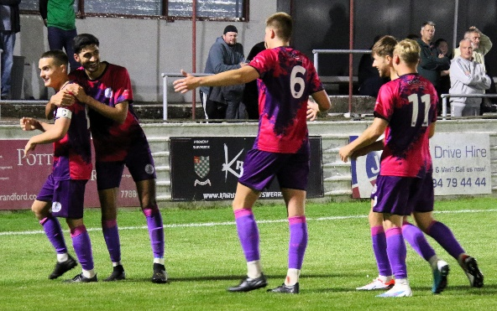
FA Cup Preliminary Round: A pair of Friday night clashes saw some success for Western League sides, with Clevedon and Bridgwater booking their spots in the next round. For the Seasiders, it was a 2-0 win away at Aylesbury which saw them progress, with Owen Punselie putting them ahead at the end of the first half. Clevedon (pictured celebrating, left) were never out of sight and had to wait until the final 20 minutes before finally pulling clear, with Alex Camm doubling their lead from the spot following a foul on James Wakefield. Bridgwater’s passage through to the next round came thanks to a 4-0 win at home to Street. Following a goalless first half, Bridgy flew out of the blocks after the interval with Jake Llewellyn and George King putting them two goals clear. Substitute Jack Taylor then entered the fray on the hour mark, and made an instant impact with a pair of quickfire strikes ending any hopes of a Cobblers fightback.
Saturday wasn’t quite as successful for the league, with only Barnstaple securing a spot in the next round following an epic comeback away at Tavistock. Two goals from Alex Battle put the Lambs ahead early on, before Tommy Rogers and Merson Ham both struck towards the end of the first half to get Town on level terms. The turnaround was then complete on the hour mark courtesy of a Stuart Bowker effort, with the same man then scoring again ten minutes later to put the visitors 4-2 up. That wasn’t the end of the tension however, and after Battle had completed his hat-trick, the Lambs were given a man advantage following a red-card to Barnstaple’s Harvey Dennis. Despite the sudden change, the Western League outfit managed to regroup, and it was the ten-men who closed out the memorable 5-3 victory thanks to a late goal from Harry Foster. Buckland were moments away from joining them as qualifiers for the next round, but will have to face a replay away at Okehampton after drawing one apiece at Homers Heath. The Bucks led for much of the afternoon courtesy of a Josh Grant strike, but unfortunately for the Devonians, they were denied victory in stoppage time with Luke Alden converting from the penalty spot. The other sides representing the Western League all suffered heavy defeats, with Helston falling 4-0 away at Bideford, for whom Ryan Turner struck a hat-trick. Frome’s Ben Griffith was the man to plunder a treble in his sides’ 6-2 win away at Falmouth, with Jake Grange and Olly Walker scoring consolation goals for the hosts. Nailsea & Tickenham were beaten 3-0 by Highworth Town, while St Blazey went down to a 5-1 defeat at the hands of Mousehole.
The latest episode of the podcast is available by following this link.
You will hear from Nailsea & Tickenham’s coaching duo, Nic Steadman and Jamie Smith, who explain why it’s a case of so far, so good for the newly promoted side. There is also a welcome to Middlezoy Rovers boss Craig Berry who joins Ian to discuss the rise of his side into the Toolstation Western League.

League Action: Saltash’s surprising start to the season continued on Saturday afternoon, with the Cornish outfit now defeated in all five of their Premier Division contests this term. Their latest loss came at the hands of Ilfracombe, with the hosts taking the lead with their first attack of the game which was finished off by Tyler Evans-Loude. Rory Paine’s free-kick doubled Town’s advantage towards the end of the first half, and despite halving the deficit late on courtesy of sub Henry Bunning, the Ashes were unable to claim their first point. The other game finished all-square, with Welton equalising late on to deny Torpoint at West Clewes. A Ryan Richards penalty in the 43rd minute looked to be enough for the away side, but after losing Jordan Rundle to a red card, they were pegged back in the closing stages, with Will Hailston scoring his first Rovers goal to claim a share of the spoils.
In a top-half clash between two of the highly fancied sides, Bitton laid down an early season marker by claiming a 3-2 win away at 2022/23 champs Brislington. Ash McGrane played a starring role in the victory, opening the scoring after 34 minutes, before scoring a long-ranger to put his side 2-1 up following Dean Griffiths equaliser. McGrane’s second half replacement, Harry Neil, then produced an excellent finish to make it 3-1 a couple of minutes after coming on, with Oaklan Buck’s late effort not quite enough for Brislington in their comeback attempt. The only other side to remain unbeaten this season in the First Division are Wincanton Town, with goals in either half helping them see off Cadbury Heath. The away side went ahead very much against the run of play thanks to Toby Cole before Matt Garner’s seventh goal of the campaign put the result beyond doubt 20 minutes from time. Bradford Town left the group of unbeaten sides on Saturday afternoon, conceding three times during a poor first half in their 3-1 loss at home to Cheddar. A dream start for the Cheesemen saw Dean Chrisostomou capitalise on a defensive error to put them ahead inside the opening minute, before Oscar Collins struck a couple of moments later to double their tally. Lewis Chappell then capped an excellent opening period for the away side, with a late consolation from Sam Jordan all Bradford had to show for their afternoon’s work. At the opposite end of the table, Odd Down finally got their first win at the seventh time of asking by beating Wells City 3-1 in Bath (pictured, right). Having gone ahead through in-form midfielder Milo Murgatroyd, the Down were pegged back almost immediately with Wells’ Harry Warwick finding the back of the net. A Ben Millett goal towards the end of the first half helped Odd Down go back ahead, and they then pushed on after the interval, with Millett striking again to close out the 3-1 win. Warminster are another side who have been struggling early doors, but they have now won two on the spin after Jake Seviour struck a tremendous hat-trick in their thumping 5-0 victory over basement boys Bishop Sutton.
Three goals in the final half-hour saw Hengrove produce an excellent fightback at home to Radstock, with the Miners finishing with nine men during a second half implosion. An 81st minute penalty completed the turnaround for Hengrove, with their win at the AVB Stadium ending a tricky spell of recent form. Another side to win by three goals to two were Longwell Green Sports, with Matt Brown’s double and a Zac Feltham effort leading them to victory away at Keynsham. A couple of other sides to win by the odd goal on their travels were Bristol Telephones and Shirehampton, with both delivering 1-0 victories over Hallen and Middlezoy respectively. Portishead have now stormed to five consecutive victories, after a first-half blitz helped them beat Gillingham 4-1. Posset did all of their scoring during a devastating opening half, with Troy Simpson, Toby Lawrence, Mitch Osmond and George Fowler all beating the visiting keeper. There was late drama at the LA Clark Pavilion, with Liam Clayton’s stoppage time penalty rescuing a point for Cribbs Reserves in their 1-1 draw away at AEK Boco.
Midweek Results
Tuesday 15th August 2023
Premier Division
Barnstaple Town 4-0 Millbrook 134
Bridgwater United 4-0 Welton Rovers 258
Buckland Athletic 3-2 Ilfracombe Town 212
Nailsea & Tickenham 4-0 Wellington 66
Saltash United 1-3 Falmouth Town 170
Torpoint Athletic 1-2 Brixham AFC 162
First Division
Bishop Sutton 0-2 AEK Boco 52
Bitton 1-1 Bradford Town 167
Brislington 6-1 Hengrove Athletic 108
Cheddar 2-6 Warminster Town 73
Keynsham Town 1-4 Portishead 152
Longwell Green Sports 4-1 Gillingham Town 94
Radstock Town 4-3 Middlezoy Rovers 73
Wells City 1-2 Hallen 90
Wincanton Town 2-1 Odd Down

Wednesday 16th August 2023
Premier Division
St Blazey 0-1 Helston Athletic 175
Street 2-0 Oldland Abbotonians 92
First Division
Shirehampton 1-3 Bristol Telephones 56

Friday 18th August 2023
FA Cup Preliminary Round
Aylesbury United 0-2 Clevedon Town
Bridgwater United 4-0 Street
Weekend Results
Saturday 19th August 2023
FA Cup Preliminary Round
Bideford 4-0 Helston Athletic
Buckland Athletic 1-1 Okehampton Argyle
Falmouth Town 2-6 Frome Town
Nailsea & Tickenham 0-3 Highworth Town
St Blazey 1-5 Mousehole
Tavistock 3-5 Barnstaple Town
Premier Division
Ilfracombe Town 2-1 Saltash United 76
Welton Rovers 1-1 Torpoint Athletic 102
First Division
AEK Boco 1-1 Cribbs Reserves 64
Bradford Town 1-3 Cheddar 96
Brislington 2-3 Bitton 135
Cadbury Heath 0-2 Wincanton Town 45
Hallen 0-1 Bristol Telephones 52
Hengrove Athletic 3-2 Radstock Town 67
Keynsham Town 2-3 Longwell Green Sports 87
Middlezoy Rovers 0-1 Shirehampton
Odd Down 3-1 Wells City 60
Portishead Town 4-1 Gillingham Town 132
Warminster Town 5-0 Bishop Sutton

Upcoming Fixtures
Tuesday 22nd August 2023
FA Cup Preliminary Round - Replay
Okehampton Argyle vs Buckland Athletic 19:30KO
First Division
Bishop Sutton vs Hallen 19:30KO
Bitton vs Odd Down 19:30KO
Bradford Town vs Brislington 19:30KO
Bristol Telephones vs Middlezoy Rovers 19:45KO
Cheddar vs Wincanton Town 19:45KO
Cribbs Reserves vs Hengrove Athletic 19:30KO
Gillingham Town vs Warminster Town 19:30KO
Longwell Green Sports vs Portishead Town 19:30KO
Radstock Town vs Shirehampton 19:45KO
Wells City vs AEK Boco 19:30KO

Wednesday 23rd August 2023
First Division
Cadbury Heath vs Keynsham Town 19:30KO

Fixtures Continued
Saturday 26th August 2023 (3pm kick-off unless noted)
FA Vase First Qualifying Round
AEK Boco vs Tuffley Rovers
Axminster vs Street
Bishop Sutton vs Wadebridge Town
Bitton vs Nailsea & Tickenham
Calne Town vs Bradford Town
Cheddar vs Torridgeside
Dobwalls AFC vs St Blazey
Falmouth Town vs Honiton
Gillingham Town vs Fareham Town
Keynsham Town vs Longlevens
Oldland Abbotonians vs Brislington
Portishead Town vs Berks County
Saltash United vs Radstock Town
Shirehampton vs Wantage
Stonehouse Town vs Odd Down
Wellington vs Okehampton Argyle
Welton Rovers vs Wells City

Premier Division
Barnstaple Town vs Bridgwater United
Buckland Athletic vs Clevedon Town
Helston Athletic vs Millbrook
Shepton Mallet vs Brixham AFC
Torpoint Athletic vs Ilfracombe Town

First Division
Bristol Telephones vs Wincanton Town
Hallen vs Longwell Green Sports
Hengrove Athletic vs Cadbury Heath
Warminster Town vs Middlezoy Rovers

