Latest Round-ups:
Season 2023/24

#2
Midweek Action: Bridgwater United followed up their opening day win with a come-from-behind victory against Brixham to go two from two in the Premier Division. After both sides struck towards the end of the first half, the visitors went ahead 12 minutes after the break through Ewan Howarth. Having scored a headed hat-trick three days previously, Jack Thorne maintained his storming start with a late equaliser, before second-half sub Adam Wright grabbed United’s winner five minutes from time. The other side to maintain their winning start to the campaign was Torpoint, with star striker Ryan Richards scoring all four of their goals in the away victory at Buckland. Richards’ first-half double had put the visitors in command at the interval, only for the Bucks to hit back, with Jared Lewington’s penalty followed up soon after by a leveller from Sam Morcom. With only six minutes remaining, Richards was on target once more to complete his hat-trick, before then adding his fourth in stoppage time to cap an incredible individual performance. After star performer during Tuesday night’s feast of action was Rikki Sheppard, with his brace helping Helston secure an eye-opening 4-0 win away at Saltash. Former Ashes defender Callum O’Brien was also on target at the home of his previous club, with Curtis Damerell also scoring his first Helston goal after joining from Torpoint at the end of last season. Two goals from Joe Berry and a Lucas Vowles strike were enough for Nailsea & Tickenham to pick up their first three points of the season thanks to a 3-0 win over Oldland, while Alex Wharton’s strike was the difference between the sides at Bickland Park where Falmouth beat St Blazey 1-0. Another home side to triumph were Shepton Mallet, with goals from Will Banks and Josh Jenkins helping them see off ten-man Wellington. Both Barnstaple and Street remain unbeaten after two games following their entertaining 2-2 draw which had seen Charlie Prentice fire the hosts into a slender half-time lead. The Cobblers then turned the tables, with Jakob Dickens and Jake Mawford scoring twice in five minutes, before Stu Bowker’s long-ranger managed to rescue a point for Barnstaple. The spoils were shared at West Clewes also, where Alex Camm’s dramatic 98th minute equaliser for Clevedon meant that Welton remain winless after two home games despite leading for much of this game courtesy of Joe Durrant.
All 22 First Division sides were back in action during the week, with five teams managing to secure their second successive victories to open the season. One of those with six points from six are Bradford Town, with a quickfire start helping them beat Longwell Green Sports by three goals to one. Efforts inside the opening six minutes from both Tom Mack and Ben Wickens gave Town a dream start, before the visitors managed to trim the deficit courtesy of a Kieran Williams strike after half an hour. Scott Hatcher was then dismissed in first half stoppage time, but the ten-man hosts managed to actually increase their lead five minutes after the restart through Jack Witcombe, holding on to secure the 3-1 win.
Wincanton have also made a flying start to their campaign, and overturned an early deficit to thump Keynsham 6-1 on Tuesday evening. The game was very much in the balance at half-time, before Wincanton enjoyed an incredible start to the second half, with Matt Garner scoring four times during their one-sided victory. Hengrove Athletic equalled the result of Wincanton, capitalising on an early red card to topple Warminster by six goals to one at the AVB Stadium. An early brace from Pete Sheppard set the Grove on their way, with his two goals inside the opening quarter sandwiching the red card to Warminster’s Tyler Gane. The extra man worked very much in Hengrove’s favour, and they ran out big winners thanks to further goals from Jack Jones, Rohan Hartrey, Mickey Parsons and late sub Sonny Parker. New-boys Middlezoy Rovers made it back-to-back wins, with Charlie Lintell helping them edge past Bishop Sutton, while reigning champions Brislington got back on track, with Oaklan Buck and Joe McLennan both on target in their 2-0 win at home to AEK Boco. The points were shared in Bath, where Milo Mutgatroyd struck a late leveller for Odd Down, after Hallen had surged ahead during the second half following a quickfire double from Patryk Kosciolek and Harrison Fairman. Tuesday’s other games went the way of the home sides, with Corey Rawlings and Matt Curnock striking in Radstock’s 2-1 victory over Portishead, while Cheddar defeated Gillingham 4-1 thanks to goalscoring doubles from Dean Chrisostomou and Lewis Chappell. In the pick of Wednesday’s games, Cribbs Reserves made it two wins from two after coming out on top in a seven-goal thriller at home to Bristol Telephones. After Luke Marshall had put the hosts ahead inside the opening minute, Kieran Clayton was then on hand to double Cribbs’ advantage with less than 20 minutes on the clock. The Phones hit back soon after, but the home side soon restored their two-goal advantage, leading 3-1 at the break thanks to Jack Guthrie’s first goal of the season. The visitors enjoyed the better of the second half, and managed to claw their way back into the contest, looking like they had secured a share of the spoils, only for Momodou Janneh to pop up eight minutes from time with a strong finish to give Cribbs the 4-3 victory. There was also a 2-0 win for Bitton away at Shirehampton, courtesy of goals from Stefan Lee and Jack Jenkins, while Callum Whooley’s double was enough for Cadbury Heath to capture a 3-2 win at home to Wells.
After an entertaining opening day, Bridgwater boss Dave Pearse joins Ian to look ahead to the upcoming season with a reflection on how disappointing they were at the end of the 2022/23 campaign. There is also an introduction to Cribbs Reserves, with co-manager Alec Mills describing his side’s meteoric rise through the feeder leagues, while also discussing the relationship with their Southern League bound First Team.
Season 2023/24 Podcast Episode 2 | Toolstation Western League (toolstationleague.com)

First Division: A trio of sides maintained their winning starts to the season on Saturday afternoon, with Wincanton’s superior goal difference handing them top spot at the end of the opening week of action. The Wasps third successive victory came away at Bishop Sutton, with a strong second half showing allowing them to grab maximum points. Having fallen behind to Finley Maddern’s 23rd minute opener, the away side got back on level terms after half an hour through Jamie Thompson. A poked finish from Cam Vere then turned the tie in Wincanton’s favour, before further goals from Jamie Irwin and Brad Pike wrapped up the victory. Bradford Town are another side who have enjoyed a stellar start, and just like their fellow early leaders, they were forced to overturn an early deficit to capture their third win. Middlezoy had broken the deadlock after only 13 minutes, but Town weren’t behind for long with Ben Wickens heading home a leveller. Jack Witcombe’s 32nd minute effort gave Bradford their first lead of the afternoon, and they held on for the remainder of the contest before adding a third in the closing stages through Corey Gardner. The third side to maintain a 100% record are Radstock, with an early Jack Farion effort and a late Kyle Thomas penalty helping them win 2-0 away at Bristol Telephones. At the opposite end of the table, there are four sides who remain pointless after three games including Keynsham who suffered a tough 5-0 loss at home to Hengrove. Pete Sheppard struck in either half for the visitors who could have been even further out of sight if it hadn’t been for an impressive performance by K’s keeper Louis Smith who saved a penalty towards the end of the first half. Warminster’s tough start shows no signs of slowing, and they fell away at the hands of Hallen, with Corey Thomas-Barker, Sam Cousins and Sam Hedges all notching during the second half of a 3-0 victory for the Bristolians. Another side to prevail by three goals to nil were Cadbury Heath, with Matt Huxley making an instant impact in their victory away at Gillingham. Having entered the fray early in the second half, Huxley struck with one of his first touches to break the deadlock, before Callum Whooley and Zac Cheetham struck in quick succession during the final ten minutes to lead the Heath to victory. A tense affair at Bitton saw Joe Beardwell’s 24th minute strike help lead the hosts to a 1-0 win over Cribbs Reserves, while two goals from Liam Oswin and a Zac Feltham effort helped Longwell Green come from behind to beat Shirehampton 3-1. There were also big victories for a couple of sides, with Luke Bryan continuing his excellent start to life at AEK Boco during their 5-0 win away at Cheddar. The former Odd Down has really hit the ground running at his new club, and he claimed a hat-trick in Somerset, with Seb Scott also on target twice during the big win. Bryan’s former side look to be struggling without his services, with the Bath outfit falling to a heavy 6-0 defeat at the hands of Portishead. An Ethan Feltham header was all that separated the teams at the break, but that soon changed in the early knockings of the second period, with another Feltham header followed up in quick succession by further goals from George Fowler and Calum Townsend. Feltham then secured ownership of the match-ball when he completed his hat-trick in the closing stages, with Callum Eastwood capping a near perfect performance in stoppage time.

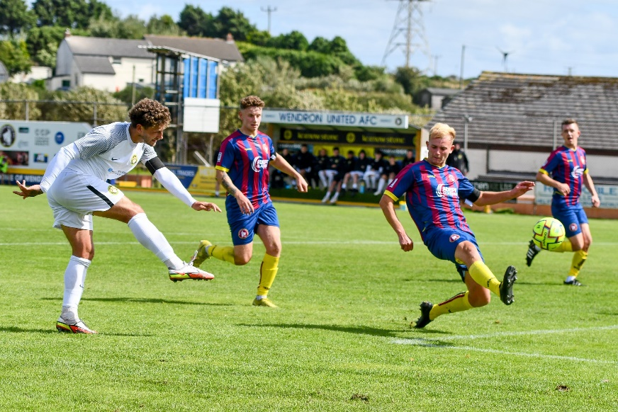
FA Cup: Several of the Western League sides in action on Saturday produced strong showings in the Extra Preliminary Round of the FA Cup, giving hope of a long run in this season’s competition. Included among the big winners on Saturday afternoon were Helston Athletic, who produced a strong second half performance to see off Willand Rovers by three goals to one. Having gone in front during stoppage time at the end of the first half through Aaron Bentley, Helston were pegged back in the early knockings of the second period when Doug Camilo fired home for the visitors. Jamie Simmonds then restored Helston’s advantage just prior to the hour mark, and they eventually booked their passage through to the next round when Curtis Damerell wrapped things up in added time. For St Blazey, it was Luke Cloke’s brace which proved influential in their 3-1 win away at Wendron United. Following 44 goalless minutes, Cloke smashed the visitors in front from close range, before the same man then struck again right at the beginning of the second half to double the Cornish side’s advantage. A goal for the home side on the hour mark gave St Blazey a slight scare, but the outcome was put to bed not long after when Callum Kenny restored the two-goal difference between the sides. Nailsea & Tickenham will also be taking their place in the next round, after goals from Nick Buxton and Luke Osgood led them to a 2-0 win away at Tring. Syd Camper’s winning effort 20 minutes from time saw Clevedon Town defeat Wantage 2-1, while Falmouth came from behind to beat Exmouth by the same scoreline thanks to second half strikes from Tom Annear and Luke Brabyn. Unfortunately, a few sides did fall at the first hurdle, with Brislington losing 1-0 at home to Shaftsbury, and Ilfracombe falling to a 4-1 defeat away at reigning Western League champions Mousehole. There were also tight losses for Wellington and Wells City at home to Bideford and AFC Portchester, respectively, while Welton suffered a heavy 7-1 thumping at the hands of Fareham Town. The highest scorers of the day, however, were Street, with their forwards enjoying a strong day in front of goal at the Tannery Ground on their way to toppling fellow Western League outfit Millbrook 9-1. Both Jake Mawford and Sullivan McKenna plundered hat-tricks during the one-sided affair, with the Cobblers putting their visitors to the sword during their first win of the season. One side who aren’t struggling for victories at this stage of the campaign are Bridgwater, and they made it three from three after beating Liskeard Athletic 4-2 at Fairfax Park. Having fallen behind in the 16th minute, Bridgy managed to turn the game around prior to half-time with the in-form Jack Thorne and George King both finding the back of the net. An equaliser midway through the second half gave Liskeard hope, but the home side finished strongly, and after Jack Taylor put United back ahead in the 85th minute, Thorne struck again in the closing stages to round out the victory.
Luke Cloke fires home during St Blazey’s 3-1 victory away at Wendron United, courtesy of @sportscornwall
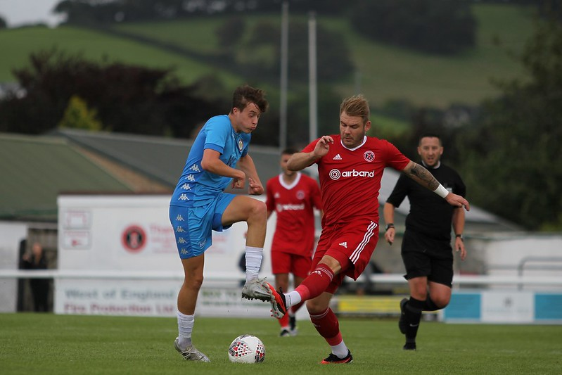
The other Western League sides to progress both did so at the hands of Premier Division rivals, with Barnstaple overturning an early deficit to see off Saltash 3-1. Jack Wood’s fifth minute opener saw the Ashes start on the front foot, but they were pegged back in the 29th minute when Callum Laird levelled for the hosts. Moments later, Saltash were reduced to ten men, and that cost them dearly, with Harry Foster and Tom Rogers each striking during the second half. The other all-Western League saw the home side stroll to a comfortable victory, with Buckland knocking out Torpoint. Only one goal separated the sides at the interval, but Buckland were no match for their visitors during the second half, with Sam Morcom, Ryan Bush, Jared Lewington and Sam Stayt all finding the back of the net. For the remainder of the sides in action, they will have to go again after drawing at the end of 90 minutes. Brixham were unable to hold on away at Okehampton despite a pair of first half strikes from Ewan Howarth, while goals from Will and Joe Banks weren’t quite enough for Shepton Mallet who conceded seven minutes from time to draw two apiece with Sherborne. 2-2 was also the final score at Oldland, where the Abbots led by two goals to nil over Blackfield & Langley courtesy of Harry Pruett and Harrison Kyte, only to see a 97th minute bundle mean they will require a replay to move onto the next round.
Players from Barnstaple and Saltash battle for possession during their FA Cup clash on Saturday, courtesy of Nathan Bennett

Latest Results
Tuesday 1st August 2023
Premier Division
Barnstaple Town 2-2 Street 207
Bridgwater United 3-2 Brixham 375
Buckland Athletic 2-4 Torpoint Athletic 230
Falmouth Town 1-0 St Blazey 337
Nailsea & Tickenham 3-0 Oldland Abbotonians 93
Saltash United 0-4 Helston Athletic 247
Shepton Mallet 2-0 Wellington 193
Welton Rovers 1-1 Clevedon Town 132

First Division
Bradford Town 3-1 Longwell Green Sports 108
Brislington 2-0 AEK Boco 239
Cheddar 4-1 Gillingham Town 86
Hengrove Athletic 6-1 Warminster Town 82
Middlezoy Rovers 1-0 Bishop Sutton
Odd Down 2-2 Hallen 75
Radstock Town 2-1 Portishead Town 79
Wincanton Town 6-1 Keynsham Town 136

Wednesday 2nd August 2023
First Division
Cadbury Heath 3-2 Wells City 72
Cribbs Reserves 4-3 Bristol Telephones 55
Shirehampton 0-2 Bitton 74

Saturday 5th August 2023
First Division
Bishop Sutton 1-4 Wincanton Town 48
Bitton 1-0 Cribbs Reserves 56
Bristol Telephones 0-2 Radstock Town 53
Cheddar 0-5 AEK Boco 51
Gillingham Town 0-3 Cadbury Heath 32
Hallen 3-0 Warminster Town 52
Keynsham Town 0-5 Hengrove Athletic 90
Longwell Green Sports 3-1 Shirehampton 125
Middlezoy Rovers 1-3 Bradford Town
Portishead Town 6-0 Odd Down 107

FA Cup Extra Preliminary Round
Barnstaple Town 3-1 Saltash United
Bridgwater United 4-2 Liskeard Athletic
Brislington 0-1 Shaftsbury Town
Buckland Athletic 5-1 Torpoint Athletic
Clevedon Town 2-1 Wantage
Falmouth Town 2-1 Exmouth Town
Helston Athletic 3-1 Willand Rovers
Mousehole 4-1 Ilfracombe Town
Okehampton Argyle 2-2 Brixham
Oldland Abbotonians 2-2 Blackfield & Langley
Shepton Mallet 2-2 Sherborne Town
Street 9-1 Millbrook
Tring 0-2 Nailsea & Tickenham
Wellington 0-2 Bideford
Wells City 1-2 AFC Portchester
Welton Rovers 1-7 Fareham Town
Wendron United 1-3 St Blazey
Upcoming Fixtures
Tuesday 8th August 2023
FA Cup Extra Preliminary Round - Replay
Brixham AFC vs Okehampton Argyle 19:30KO
Blackfield & Langley vs Oldland Abbotonians 19:45KO
First Division
Bradford Town vs Keynsham Town 19:30KO Brislington vs Radstock Town 19:30KO
Hallen vs Bitton 19:30KO
Hengrove Athletic vs AEK Boco 19:30KO
Odd Down vs Gillingham Town 19:30KO
Portishead Town vs Middlezoy Rovers 19:30KO
Wells City vs Longwell Green Sports 19:30KO

Wednesday 9th August 2023
FA Cup Extra Preliminary Round - Replay
Sherborne Town vs Shepton Mallet 19:45KO

First Division
Cadbury Heath vs Bristol Telephones 19:30KO
Cribbs Reserves vs Bishop Sutton 19:30KO
Shirehampton vs Cheddar 19:30KO
Warminster Town vs Wincanton Town 19:45KO

Saturday 12th August 2023 (3pm kick-off unless noted)
Premier Division
Barnstaple Town vs St Blazey
Brixham AFC vs Nailsea & Tickenham
Clevedon Town vs Saltash United
Helston Athletic vs Bridgwater United
Ilfracombe Town vs Falmouth Town
Millbrook vs Street
Oldland Abbotonians vs Buckland Athletic
Shepton Mallet vs Welton Rovers
Torpoint Athletic vs Wellington
First Division
AEK Boco vs Wincanton Town
Bishop Sutton vs Shirehampton
Bradford Town vs Hallen
Cheddar vs Keynsham Town
Cribbs Reserves vs Longwell Green Sports
Gillingham Town vs Bristol Telephones
Hengrove Athletic vs Wells City
Middlezoy Rovers vs Cadbury Heath
Odd Down vs Brislington
Radstock Town vs Bitton
Warminster Town vs Portishead Town

