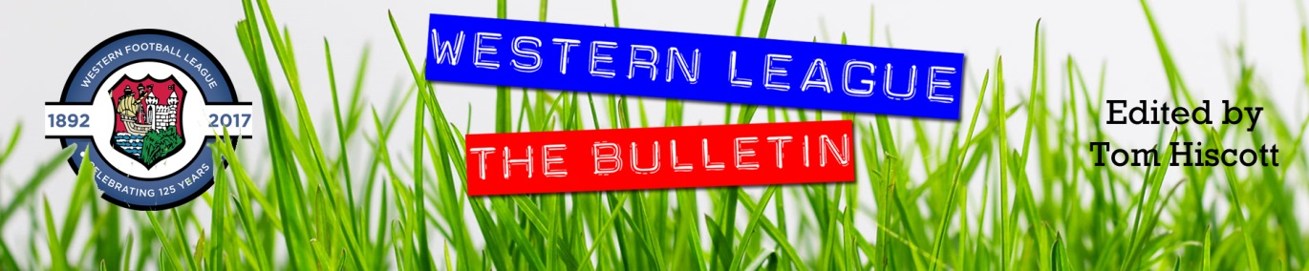
Latest Round-ups:
Season 2023/24

#1
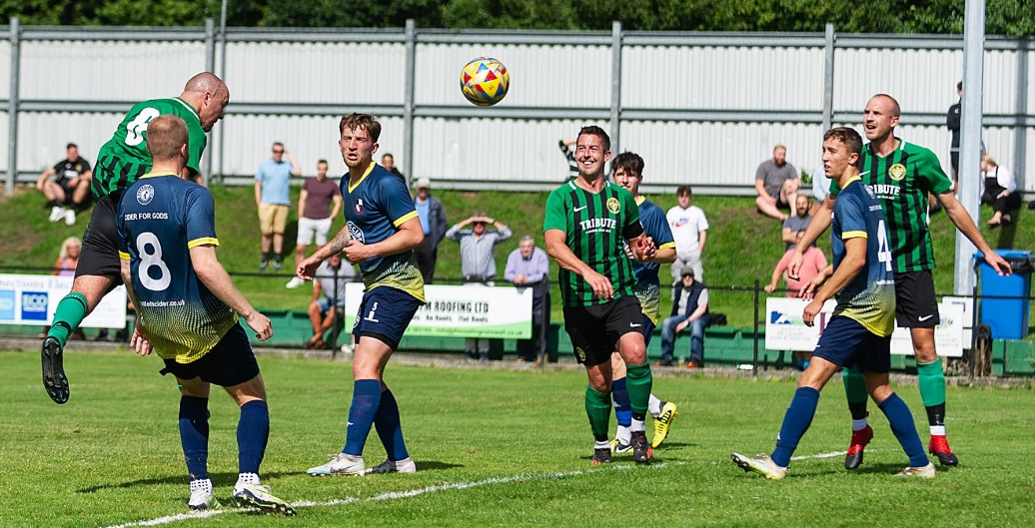
Premier Division: Bridgwater laid down an early warning shot to the remainder of the Western League by storming to an 8-1 way away at Millbrook on the opening day of the season. Following an underwhelming end to the previous campaign, Bridgy couldn’t have dreamed of a better start this term, blowing away their hosts behind a first-half hat-trick of headers by Jack Thorne. Having already nodded home twice, Thorne completed his treble in added time at the end of the first period from a Tom Llewellyn corner to put the visitor’s three goals to the good at the interval. Adam Wright added a second-half brace, with Jake Llewellyn, Sam Towler and Jack Taylor also adding their names to the scoresheet to cap a rampant performance. The only other away side to taste success on the opening day was Barnstaple, with new signing Harry Foster making an instant impact in their 4-2 victory at Welton. Having seen Matty Andrew’s eighth minute opener cancelled out by Toby Cole’s equaliser, Foster struck just prior to half time to put Barnstaple ahead at the break. The former Street frontman was then on target once more in the 61st minute to put some distance between the sides, with Callum Laird then increasing Town’s advantage further to mean Lewis Russell’s late penalty was nothing more than a consolation for the hosts. Goals in either half from Ryan Richards and James Lorenz were enough for Torpoint to defeat promoted outfit Nailsea & Tickenham 2-0, while fellow Premier Division new-boys Oldland fared better thanks to an entertaining 3-2 win over Saltash. Having taken a 23rd minute lead, the Abbots found themselves on the back-foot early in the second half following goals either side of the interval from Ashes forward Kieran O’Melia. The playoff winners responded excellently however, and after Mason Davis had got them back on level terms, they pushed on and grabbed the decisive fifth goal with Harrison Kyte scoring from close range. Clevedon also came out on the right side of a 3-2 victory, with Freddie King’s double proving to be enough for them to hold off the challenge of Buckland. Following a goalless opening half, King struck twice in the opening 12 minutes of the second period to put Town two goals to the good. Buckland’s Jared Lewington then pulled a goal back, before Sam Beresford restored the home side’s two-goal buffer with a well-taken goal ten minutes from time. The Bucks continued to fight until the last, and despite scoring through Ryan Bush, their attempts at gaining any opening day points fell short at the end of an entertaining topsy-turvy battle. The remaining four fixtures all ended in ties, with the promoted duo of Brixham and St Blazey both held on home soil. St Blazey were pegged back late on by Shepton Mallet, with Harry Rutty cancelling out Martin Giles’ bullet header at Blaise Park in Cornwall (pictured above, courtesy of Colin Bradbury).
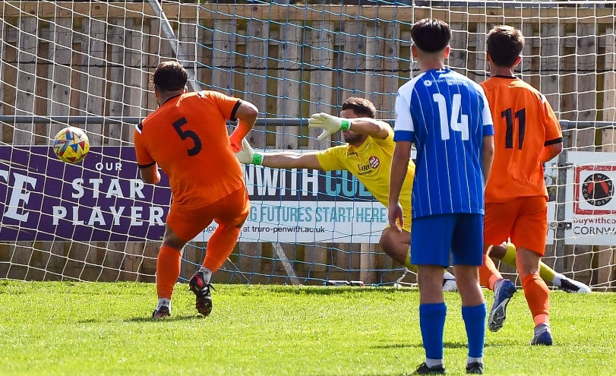
For Brixham, a goalless draw with Falmouth reveals very little about their credentials for the upcoming season, and they will continue to be tested with a midweek visit to Bridgwater. Helston will be disappointed to have thrown away three points, with Wellington coming from two goals down to grab a share of the spoils at Kellaway Park. Goals from Rikki Sheppard and Rubin Wilson had put the hosts in a real position of strength, but after debutant James Cottrill saw his deflected effort hit the back of the net after 62 minutes, Wellington completed their comeback late on with Jack Bown-Porter scoring from the spot (pictured left, courtesy of SportsCornwall) Ilfracombe Town were the other side to pull off a second-half fightback, with Dan Wilson and Finn King-Smith scoring in the final quarter of their away clash with Street. Goals from Sullivan McKenna and Callum Corbridge had put the Cobblers two-up as the game headed into the final 25 minutes, before Ilfracombe struck twice in the space of three second-half minutes to secure a well-earned point.

First Division: Bradford Town made a strong return to life in the Western League, scoring five unanswered second-half goals to secure a big win away at Bishop Sutton. A goalless opening half at Lakeview indicated it would be a tight contest between the two sides, but the visitors had other ideas, storming out of the blocks for the second period and quickly moving two goals ahead courtesy of Jacob Mead and Ben Wickens. A further goal from Fabian Stanislas in the following minutes gave Bradford a commanding three-goal advantage, with Owen Bartley and Corey Gardner also notching to complete the one-sided second half display. Another big winner was Shirehampton, with Ryan Sharpe scoring in either half of their 4-0 victory away at Gillingham. Having broken the deadlock after 32 minutes, Sharpe was on target again midway through the second half, with Scott Bamford and Louis Snailham also notching for the dominant visitors. Another side to enjoy a 4-0 to open their account this term was Wells City, with four different goalscorers, James Bayliss, Conrad Peck, Harry Warwick and Rhys Cook, helping them outgun Cheddar in Somerset. Cribbs Reserves made an outstanding start to their season, toppling last season’s champions Brislington by three goals to two. In a contest which was only decided in the final seconds, Brislington had twice come from behind to draw level before suffering late heartbreak. It was goals from Liam Clayton and Ollie Dunleavy which had put the new-boys 2-1 up after an hour, sandwiching a leveller from Jordan Scadding. The home side then equalised again 15 minutes from time courtesy of a penalty from skipper Jordan Ricketts, but the visitors regained their forward momentum and secured all three points thanks to a 97th minute winner from James Clayton. There was also late drama in Bitton, where the ten-man visitors from Hengrove struck during the final ten minutes to claim a share of the spoils. Following the red card early in the second half, Bitton took advantage of the man advantage courtesy of a Harry Neil strike, but they were unable to hang on with Aidan Jones striking a long-range free kick which nestled in the back of the net. Luke Bryan made a strong start to life at AEK Boco, opening the scoring in their 2-0 victory at home to Keynsham, while Bryan’s former side Odd Down fell to a 3-1 defeat at the hands of Bristol Telephones, for whom Connor Saunders, Cam Shorney and Craig Wilson all found the back of the net.

Western League debutants Middlezoy Rovers went one better than the Phones, pulling away during the second half of their 4-1 victory away at Hallen. It took just 13 minutes for Rovers to break their duck at this level, with Danny Lismore beating the home keeper, but Hallen responded in kind with Harrison Fairman making it one apiece after half an hour. Lismore then struck again early in the second half to put the Rovers back ahead, and this time the hosts had no response, with further goals from Liam Winter and Cam Birch helping Middlezoy open their account with maximum points. A much tighter contest in Portishead saw Joel Bayliss’ 31st minute strike help the hosts sneak past Cadbury Heath by a goal to nil, while Wincanton and Radstock both picked up 2-0 wins away at Longwell Green and Warminster respectively.
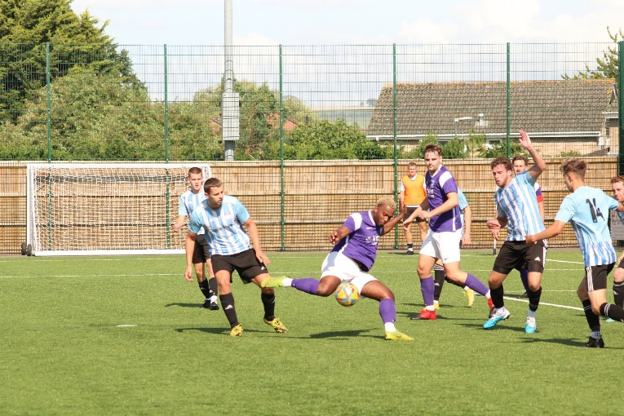
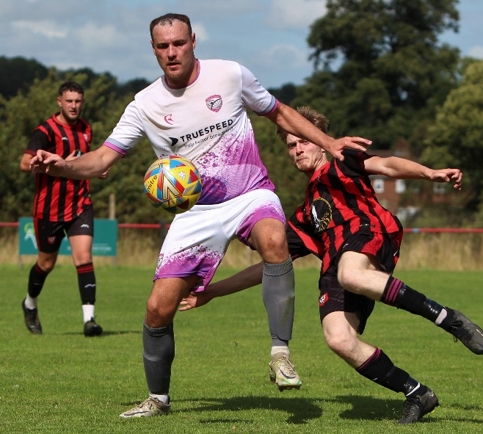
First Division action from the contests at Radstock and Longwell Green, courtesy of Jamie House (left), and Jess Harris.

The first podcast of the season was broadcast prior the season starting, with Ian joined by Josh Thomas and Ross Reid to preview the upcoming campaign. There is also a conversation with Western League Fixture Secretary, George McCaffery, who talks about how promotion and relegation will work in 2023/24.
Season 2023/24 Podcast Episode 1 | Toolstation Western League (toolstationleague.com)

To find the full draw for this season’s Les Phillips Cup, please head to the following link on our website.
The draw took place at the recent AGM, with Martin from Hengrove and Wayne from Falmouth completing the proceedings.

Opening Day Results
Saturday 29th July 2023
Premier Division
Brixham 0-0 Falmouth Town 217
Clevedon Town 3-2 Buckland Athletic 145
Helston Athletic 2-2 Wellington 168
Millbrook 1-8 Bridgwater United 107
Oldland Abbotonians 3-2 Saltash United 242
St Blazey 1-1 Shepton Mallet 305
Street 2-2 Ilfracombe Town
Torpoint Athletic 2-0 Nailsea & Tickenham 171
Welton Rovers 2-4 Barnstaple Town
First Division
AEK Boco 2-0 Keynsham Town 88
Bishop Sutton 0-5 Bradford Town 76
Bitton 1-1 Hengrove Athletic 163
Brislington 2-3 Cribbs Reserves 97
Bristol Telephones 3-1 Odd Down 68
Gillingham Town 0-4 Shirehampton 42
Hallen 1-4 Middlezoy Rovers 62
Longwell Green Sports 0-2 Wincanton Town
Portishead Town 1-0 Cadbury Heath 153
Warminster Town 0-2 Radstock Town
Wells City 4-0 Cheddar 140

Upcoming Fixtures
Tuesday 1st August 2023
Premier Division
Barnstaple Town vs Street 19:45KO
Bridgwater United vs Brixham 19:45KO
Buckland Athletic vs Torpoint Athletic 19:30KO
Falmouth Town vs St Blazey 19:45KO
Nailsea & Tickenham vs Oldland Abbotonians 19:30KO
Saltash United vs Helston Athletic 19:45KO
Shepton Mallet vs Wellington 19:30KO
Welton Rovers vs Clevedon Town 19:30KO
First Division
Bradford Town vs Longwell Green Sports 19:30KO Brislington vs AEK Boco 19:30KO
Cheddar vs Gillingham Town 19:45KO
Hengrove Athletic vs Warminster Town 19:30KO
Middlezoy Rovers vs Bishop Sutton 19:30KO
Odd Down vs Hallen 19:30KO
Radstock Town vs Portishead Town 19:45KO
Wincanton Town vs Keynsham Town 19:30KO

Wednesday 2nd August 2023
First Division
Cadbury Heath vs Wells City 19:30KO
Cribbs Reserves vs Bristol Telephones 19:30KO
Shirehampton vs Bitton 19:30KO

Saturday 5th August 2023 (3pm kick-off unless noted)
First Division
Bishop Sutton vs Wincanton Town
Bitton vs Cribbs Reserves
Bristol Telephones vs Radstock Town
Cheddar vs AEK Boco
Gillingham Town vs Cadbury Heath
Hallen vs Warminster Town
Keynsham Town vs Hengrove Athletic
Longwell Green Sports vs Shirehampton
Middlezoy Rovers vs Bradford Town
Portishead Town vs Odd Down
FA Cup Extra Preliminary Round
Barnstaple Town vs Saltash United
Bridgwater United vs Liskeard Athletic
Brislington vs Shaftsbury Town
Buckland Athletic vs Torpoint Athletic
Clevedon Town vs Wantage
Falmouth Town vs Exmouth Town
Helston Athletic vs Willand Rovers
Mousehole vs Ilfracombe Town
Okehampton Argyle vs Brixham
Oldland Abbotonians vs Blackfield & Langley
Shepton Mallet vs Sherborne Town
Street vs Millbrook
Tring vs Nailsea & Tickenham
Wellington vs Bideford
Wells City vs AFC Portchester
Welton Rovers vs Fareham Town
Wendron United vs St Blazey

