Les Phillips Cup Final Four Round-up:
#39
Season 2022/23
Semi Finals: Helston completed their passage through to the final thanks to a 2-0 win away at Ilfracombe. On the first day in May, Rikki Sheppard scored a quickfire brace midway through the second half to give Helston an opportunity to end their season with some silverware. Two days later, Shepton Mallet overturned an early deficit to progress from the last four after seeing off First Division champions Brislington. Mallet had no form to talk of heading into Wednesday’s game, and they started slowly, falling behind to an eighth minute effort from Oaklan Buck. They responded well however, and with 21 minutes on the clock, they managed to get back on level terms with Joe Morgan finding the back of the net. They then completed their turnaround early in the second half when Jacob Sloggett powered home, with Danny Constable wrong-footing the visiting keeper 20 minutes from time to end Brislington’s hopes.
Final: At the home of Tiverton Town, Helston completed a cup double thanks to a 2-0 win over Shepton Mallet. Having beaten the same opponents by a slim one-goal margin on the final day of the league season, Helston proved to be too strong for Mallet, becoming the first Cornish side to take home the Les Phillips Cup. Their first goal came midway through the first half with Rubin Wilson on hand to poke the ball home after Tom Payne had seen his long-range chip come back off the crossbar. Athletic then strengthened their position at the beginning of the second half, with Rikki Sheppard following up his double in the semi-final with another important goal. After being slid through, Sheppard rounded Shepton keeper Tom Easterbrook with a drop of the shoulder before slotting home to put the Blues in control. They held out for the remainder of the afternoon, grabbing their second trophy of a very fruitful campaign following on from their Cornwall Senior Cup triumph over Millbrook on penalties last month.
Final Four Results
Monday 1st May
Les Phillips Cup Semi Final
Ilfracombe Town 0-2 Helston Athletic

Wednesday 3rd May
Les Phillips Cup Semi Final
Shepton Mallet 3-1 Brislington

Saturday 13th May
Les Phillips Cup Final @ Tiverton Town FC
Helston Athletic 2-0 Shepton Mallet 311
Les Phillips Cup Final Photo Gallery – Courtesy of John Newport
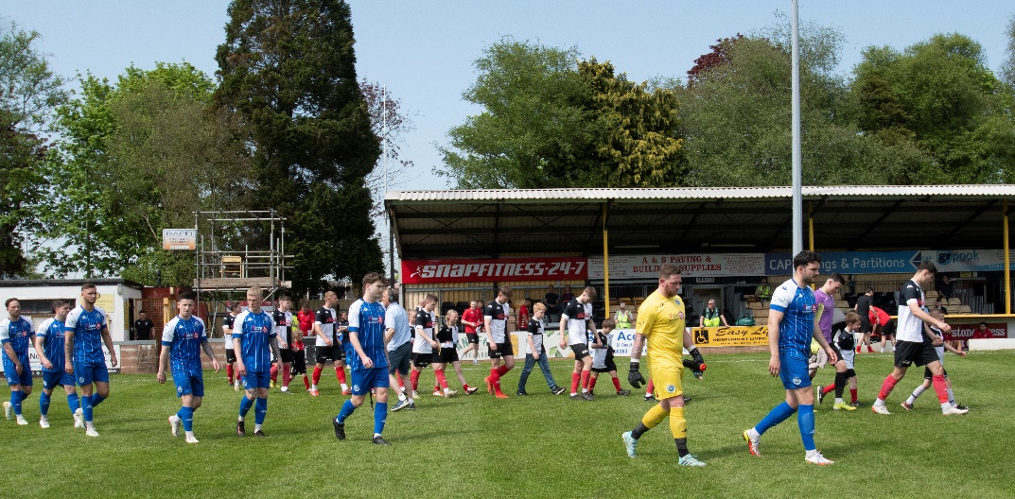
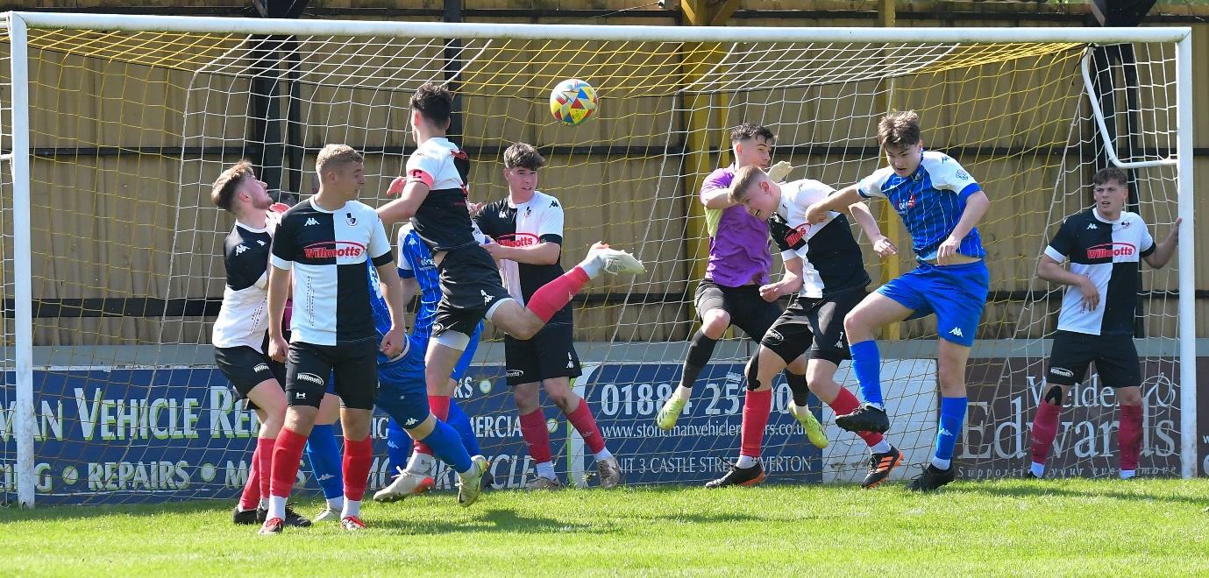
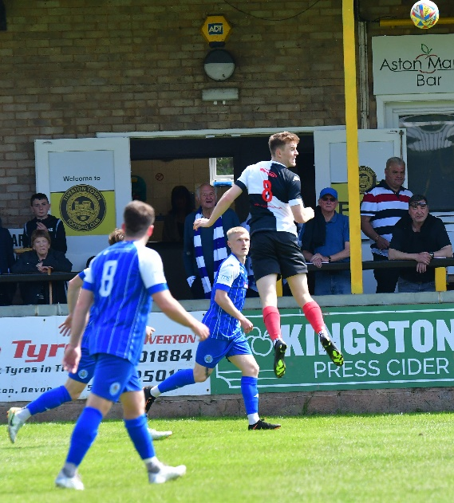
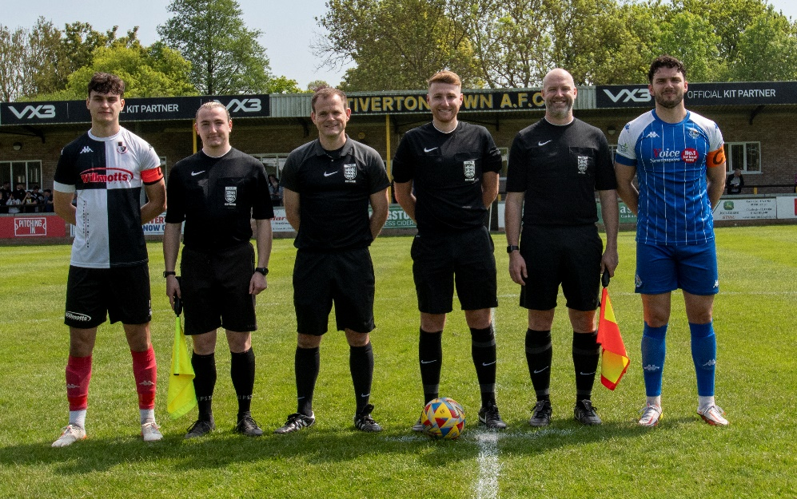
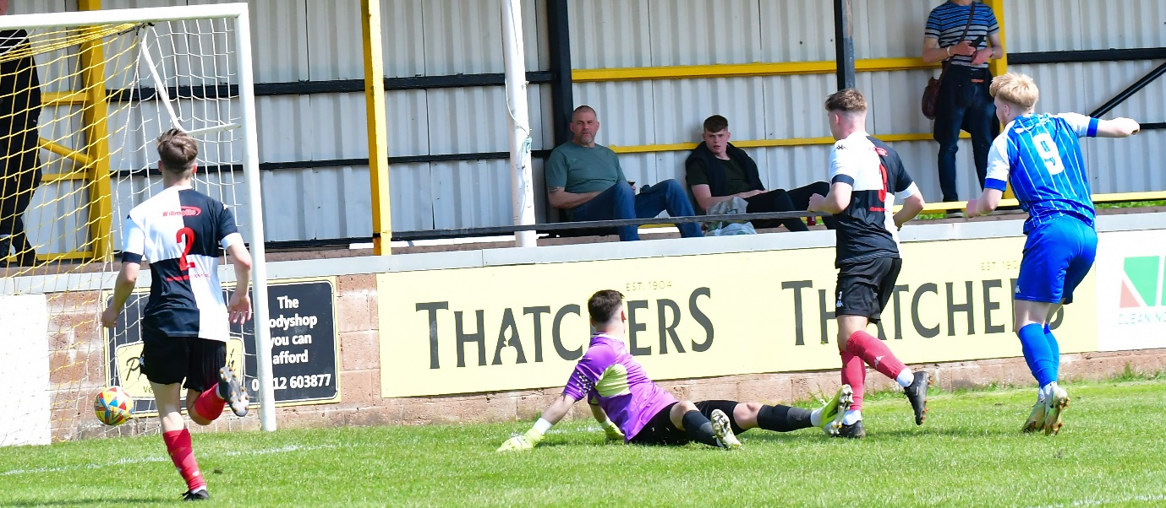
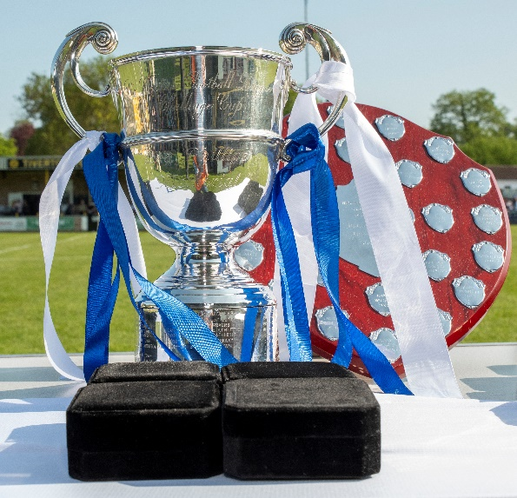
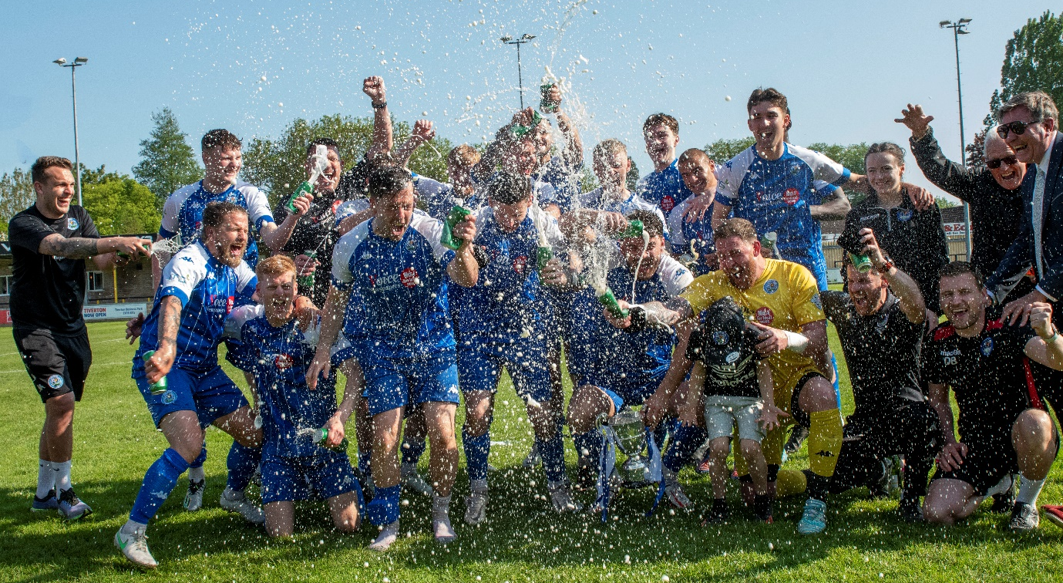
League Constitutions for 2023/24 season:
On Monday afternoon, the FA unveiled the league constitutions for competitions at Steps 5 and 6 of the National League System for the 2023/24 season.
There are a fair few changes, with Middlezoy Rovers and Cribbs Reserves joining the First Division along with relegated duo Cadbury Heath (voluntary) and Keynsham. Bitton also re-join at this level, with Bradford Town dropping down from the Hellenic League Premier.
The Premier Division welcomes a pair of champion sides, with Brixham and St Blazey making the move following their title-winning seasons in the South West Peninsula’s East and West Divisions respectively. Mangotsfield United move laterally from the Hellenic Premier, where they will be joined by the promoted duo of Oldland Abbotonians and Nailsea & Tickenham.
The Western League wishes all departing clubs the very best, and looks forward to working all new member clubs.
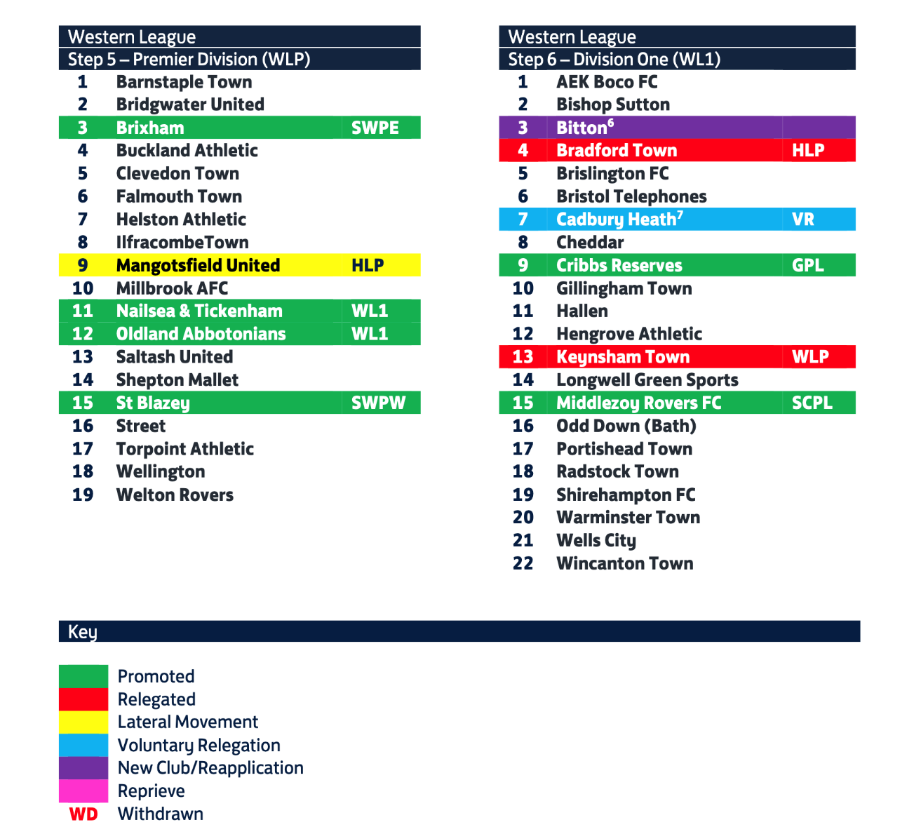
The allocations below are subject to both FA Council ratification and any subsequent appeals. Any amendments will be confirmed in due course.

The most recent episode sees Ian catch up with Nailsea & Tickenham management duo Jamie Smith and Nic Steadman. The Swags coaching staff explain why supporting people and making them better has been integral in their ascension from County League to Step 5 football.
The second half of the podcast then centres on a conversation with RefSupport CEO, Martin Cassidy. Martin gives a no holds barred assessment of the state of match official abuse at all levels of the game, as well as reflecting on the positive things that are being done to help us all Love the Whistle.
Season 2022/23 Podcast Episode 39 | Toolstation Western League (toolstationleague.com)
Episode 38 of the Western League Podcast includes an interview with Saltash United boss, Danny Lewis, who explains why this season has been the best of times and the worst of times for the Ashes. Lewis reflects on an extraordinary campaign where perserverance and loyalty helped to propel his side to within touching distance of the Premier Division title.
There is also a conversation with Oldland Assistant Manager, Lee Lintern, who celebrates his sides’ epic passage through the First Division Play Offs, and describes why this is only the beginning for the Abbots, both on and off the pitch.
Season 2022/23 Podcast Episode 38 | Toolstation Western League (toolstationleague.com)
Leading Goalscorers (Stats courtesy of FA Fulltime Website)
First Division
Scott Bamford (Shirehampton) – 36
Sacha Tong (FC Bristol) – 32
Luke Bryan (Odd Down) – 31
Adam Wright (Wells) – 30
Luke Osgood (Nailsea) - 24
Matt Garner (Wincanton) – 24
Craig Wilson (Bishop Sutton) – 24
Joe Berry (Nailsea&Tickenham) - 23
Elliot Gardner (Hallen) - 22
Mason Davis (Oldland) – 22
George Jones (Brislington) – 21
Premier Division
Curtis Damerell (Torpoint) – 25
Hayden Turner (Mousehole) – 24
Harry Foster (Street) – 21
Rubin Wilson (Helston) – 18
Ryan Richards (Torpoint) - 16
Jacob Brown (Bridgwater) – 16
Adam Carter (Saltash) -16
Stu Bowker (Barnstaple) – 16
Harry Stevens (Ilfracombe) – 14
Josh Webber (Buckland) – 14
Tim Nixon (Falmouth) - 14

All Competitions
Scott Bamford (Shirehampton) – 42
Sacha Tong (FC Bristol) – 34
Curtis Damerell (Torpoint) – 32
Adam Wright (Wells) – 32
Luke Bryan (Odd Down) – 31
Jack Thorne (Bridgwater/N&T) – 29
Hayden Turner (Mousehole) - 28
Matt Garner (Wincanton) – 28
Asa White (Brislington) – 25
Craig Wilson (Bishop Sutton) - 25

Final League Tables
 | PREMIER DIVISION | Played | Won | Drawn | Lost | GD | Points
C | Mousehole | 36 | 26 | 8 | 2 | 61 | 86
2 | Saltash United | 36 | 26 | 6 | 4 | 59 | 84
3 | Barnstaple Town | 36 | 24 | 3 | 9 | 28 | 75
4 | Bridgwater United | 36 | 20 | 9 | 7 | 43 | 69
5 | Buckland Athletic | 36 | 22 | 2 | 12 | 21 | 68
6 | Helston Athletic | 36 | 18 | 12 | 6 | 22 | 66
7 | Falmouth Town | 36 | 16 | 8 | 12 | 14 | 56
8 | Shepton Mallet | 36 | 15 | 10 | 11 | 13 | 55
9 | Street | 36 | 15 | 10 | 13 | -14 | 49
10 | Ashton & Backwell United | 36 | 14 | 6 | 16 | 8 | 48
11 | Clevedon Town | 36 | 13 | 7 | 16 | -11 | 46
12 | Torpoint Athletic | 36 | 12 | 9 | 15 | -7 | 45
13 | Millbrook | 36 | 11 | 7 | 18 | -14 | 40
14 | Welton Rovers | 36 | 10 | 6 | 20 | -36 | 36
15 | Wellington | 36 | 9 | 8 | 19 | -21 | 35
16 | Ilfracombe Town | 36 | 7 | 11 | 18 | -18 | 32
17 | Sherborne Town | 36 | 8 | 7 | 21 | -23 | 31
VR | Cadbury Heath | 36 | 4 | 6 | 26 | -53 | 18
R | Keynsham Town | 36 | 5 | 3 | 28 | -74 | 18
 | FIRST DIVISION | Played | Won | Drawn | Lost | GD | Points
C | Brislington | 42 | 36 | 2 | 4 | 95 | 110
P | Nailsea & Tickenham | 42 | 31 | 5 | 6 | 75 | 98
3 | Wells City | 42 | 29 | 9 | 4 | 56 | 96
PO | Oldland Abbotonians | 42 | 24 | 9 | 9 | 39 | 81
5 | Wincanton Town | 42 | 22 | 5 | 15 | 22 | 71
6 | Shirehampton | 42 | 21 | 6 | 15 | 19 | 69
7 | Bishop Sutton | 42 | 19 | 9 | 14 | 7 | 66
8 | FC Bristol | 42 | 19 | 4 | 19 | -3 | 61
9 | Hallen | 42 | 16 | 17 | 15 | 7 | 59
10 | Warminster Town | 42 | 16 | 10 | 16 | -1 | 58
11 | AEK Boco | 42 | 17 | 4 | 21 | -15 | 55
12 | Longwell Green Sports | 42 | 16 | 5 | 21 | -18 | 53
13 | Portishead Town | 42 | 15 | 7 | 20 | -15 | 52
14 | Odd Down | 42 | 13 | 12 | 17 | 0 | 51
15 | Hengrove Athletic | 42 | 14 | 8 | 20 | -4 | 50
16 | Bristol Telephones | 42 | 14 | 11 | 17 | -9 | 50*
17 | Gillingham Town | 42 | 11 | 8 | 23 | -28 | 41
18 | Cheddar | 42 | 10 | 9 | 23 | -19 | 39
19 | Radstock Town | 42 | 8 | 13 | 21 | -22 | 37
20 | Tytherington Rocks | 42 | 9 | 9 | 24 | -56 | 36
21 | Bishops Lydeard | 42 | 8 | 8 | 26 | -56 | 32
R | Almondsbury | 42 | 7 | 10 | 25 | -74 | 31

