Latest Round-ups:
#35
Season 2022/23
Midweek Action: On a busy Tuesday night of action, Saltash produced an excellent fightback at home to Bridgwater, with their 3-1 victory confirming a top-two finish in the Premier Division. The visitors made a strong start to the quickly-rearranged fixture, going ahead in just the fifth minute thanks to a smart finish from Jacob Spence. The Ashes remained in arrears for the remainder of the opening half, but then started the second period excellently, and had soon turned the game on its head thanks to a quickfire double from Mike Smith. It was then left to Harrison Davis to put the game to bed, with his effort 17 minutes from time putting enough distance between the sides to confirm the destination of the points. Mousehole kept pace with their title rivals, producing a comeback of their own to win 3-1 away at Wellington. Having fallen behind in the 12th minute, the Cornish outfit drew level midway through the first half courtesy of a Max Hill strike. Top scorer Hayden Turner then produced the match-winning performance the visitors required, and after putting his side ahead after 32 minutes, the forward then struck again at the beginning of the second half to complete the comeback win. The other clashes on Tuesday also went the way of the away sides, with Shea Bennington-Mannings’ solitary goal after half-an-hour proving to be enough for Ashton & Backwell on their visit to Ilfracombe. Another side to take home maximum points were Shepton Mallet, with Josh Jenkins’ producing a pair of assists in their 2-0 triumph at Cadbury Heath. Having teed up Sam Jordan for the opener midway through the first half, Jenkins then crossed for second-half sub Jacob Sloggett who poked home Mallet’s second just after the hour mark to complete the victory. In the First Division, Brislington continue to put distance between themselves and any potential title rivals after adding another three points to their ever-increasing tally atop the table. Their latest victory came at home to Radstock, with two goals inside the opening 20 minutes from George Jones and Danny Dodimead helping to maintain their incredible winning run. Shirehampton also picked up a 2-0 win away at Gillingham thanks to goals from Matty McCall and Harvey Baker, while Sacha Tong’s brace helped spearhead FC Bristol’s 3-1 victory over Cheddar. There was big-scoring elsewhere in the division, with AEK Boco securing their biggest win of the season by handing out a 6-0 defeat to Tytherington. An early goal from George Lloyd set the visitors on their way, with Ash McGrane and Toby Rennie then adding further to the half-time lead. Lloyd struck again to put Boco four goals to the good early in the second half, and after Ollie Williams increased the lead further, Lloyd completed his hat-trick eight minutes from time thanks to a well-taken penalty. The other hat-trick hero was Mason Davis, with his impressive season continuing during Oldland’s 5-2 win at home to Portishead. After conceding to Ben Greenslade in just the eighth minute, Oldland finished the first half in complete control thanks to two quickfire efforts from Davis, which was followed shortly after with a devastating finish from Harrison Kyte in added time. Joe Fitzgerald gave Portishead a slight chance after the interval, but that was soon put to bed by Davis, with his 67th minute penalty completing his treble. Having only won twice in their seven league fixtures since March began, Oldland made sure to make this one count, and they continued to push forward in the final minutes, with substitute Jai McLeod adding a late fifth.
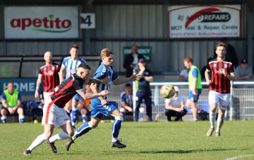
Good Friday Action: Mousehole missed out on their first opportunity to take top spot from Saltash in the Premier Division after falling to a 2-0 derby day defeat at Helston. Good Friday saw their title rivals without a fixture, so this was one of Mousehole’s games in hand, but two goals at the beginning of the second half saw them suffer just a second league defeat of the campaign. It was Teigan Rosenquest who opened the scoring for Helston after 57 minutes, and then with their next attack on goal, Sam Carter also found the back of the net to give the hosts bragging rights. At the opposite end of the table, Keynsham moved off bottom spot for the first time in ages after coming from behind to beat Ashton & Backwell United 2-1. Having scored the winner during their midweek triumph, Shea Mannings was on target once more for the visitors, with his goal on the half-hour mark giving them a slim lead at the interval. Keynsham’s Sahr Nanoh was then introduced to the contest at half-time, and he provided an immediate impact, levelling affairs less than five minutes after entering the fray. The winning goal then came 15 minutes from time, with Jemar Thomas prodding home to make it back-to-back home wins for the K’s. It is now Cadbury Heath who are propping up the division after they suffered a heavy 5-1 defeat away at Falmouth. An unfortunate own goal from Heath keeper Jordan Schofield helped give the home side the lead after 26 minutes, but the scores were soon level once more when Tom Withers smashed home at the back post. Falmouth responded excellently to conceding, and made sure they would take a lead with them to the half-time break with Luke Barner slotting home in added time. Substitute Olly Walker was prominent during the second half, and after pulling the ball back to teammate Luke Brabyn who fired home for 3-1, he then added a fourth soon after with a delightful lobbed finish. Tim Nixon added a late fourth for the dominant hosts who have now won four of their last six and are ending the season on a high. There was an entertaining early kickoff at West Clewes, where Welton came back from an early two-goal deficit to grab a creditable 2-2 draw against Shepton Mallet. The away side shot out of the blocks, and took the lead inside the second minute when Fin Haines flicked the ball beyond the home keeper and into the bottom corner. Things then got worse for Welton when Aaron Seviour finished off a slick breakaway to double Mallet’s lead, but they then grabbed a lifeline in first half stoppage time when Lewis Russell stroked home from the penalty spot. Then, ten minutes into the second half, Mallet were penalised close to their goal once more, and Russell stepped up to double his tally from 12 yards and claim a share of the spoils. Clevedon and Bridgwater also ended the afternoon with a point apiece after their clash ended one-all (pictured left, courtesy of Josh Thomas) After former-Nailsea strike Jack Thorne fired Bridgy in front from the edge of the box, Archie Ferris then unleashed an unstoppable long range strike to level affairs in the 31st minute. That was how it remained for the next hour, before Thorne was hauled down in the Clevedon box, giving the away side a chance to grab all three points in the closing stages. However, the usually reliable Jake Llewellyn was thwarted by Clevedon keeper Ryan Thacker, who dived to his right to save the spot kick and preserve a well-earned point for the home side.
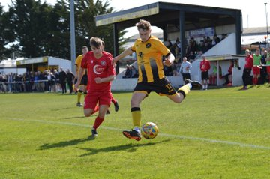
One side who weren’t made to pay for a penalty miss were Buckland, with Ryan Bush’s lone strike helping them secure a 1-0 win at Wellington. The 28th minute penalty miss from Jared Lewington could have derailed the visitors, but Bush saved his teammates blushes less than five minutes later to extend Buckland’s winning streak to four. Another side to win on their travels were Street, for whom Ali Mawford’s free kick early in the second half helped them claim a slender victory at Raleigh Grove against Sherborne. Having not played a league game in over three weeks, Torpoint returned to action with a 2-0 win at home to Millbrook. Leading scorer Curtis Damerell put the hosts one-up towards the end of the first half with an exquisite long-ranger, and then with the visitors chasing a late equaliser, they were hit on the counter with Ryan Richards rounding the keeper and rolling the ball into an empty net. Barnstaple also kick-started their Easter with maximum points, after goals midway through the second half from both Stu Bowker and Tor Swann led them to a 2-1 victory at home to Ilfracombe in their North Devon derby.
Torpoint on the attack during their win over Millbrook
Brislington have got one hand on the First Division title after smashing their way through the 100-point barrier with four games still remaining. Unlike for many of their 33 league wins so far this season, the 2-1 victory away at Shirehampton on Good Friday was hard to come by, with nothing to choose between the sides after 45 minutes. Then, two goals early in the second half tipped the balance in Brislington’s favour, with the league’s Player of the Month, George Jones breaking the deadlock within three minutes of the restart. A further effort shortly after from Oaklan Buck stretched the visitors lead, and that goal proved crucial considering Louie Snailham halved the deficit just after the hour mark. Wells City are the only side who can mathematically still catch the table toppers after they secured a 3-0 win at home to Bishop Sutton. Goals either side of the interval from Wells hotshot Adam Wright put them in control, before Jake Curtis added a late third to end their two-match winless run. Second-place Nailsea & Tickenham are still on target to reach triple-figures for points this season, but cannot now catch Brislington despite beating Portishead by two goals to nil. Goals from Andy Head and Jared Ford did the business for the Swags who will remain locked in a battle with Wells to secure the runners-up spot during the final weeks of the campaign. Outside of Brislington, the form team in the league are most likely Longwell Green Sports, with their outstanding 4-1 victory away at fourth-placed Oldland giving them their sixth win in their last seven fixtures. Two goals inside the opening ten minutes from Jake Hicks and Matt Brown stunned the hosts, before Liam Oswin extended the lead to three after half-an-hour to give Longwell Green complete control. Stefan Lee pulled a goal back 20 minutes from time, but any hopes of a fightback from the Abbots were soon extinguished when Zac Feltham restored the away side’s three-goal advantage.

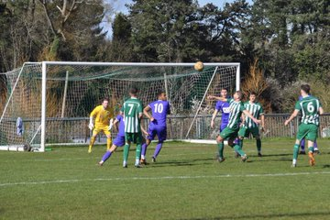
In a mirror of the Premier Division, Almondsbury rose from the bottom position in the table after beating fellow strugglers Tytherington 1-0 (pictured, left). In a rare victory for the Almonds, Louis Holden fired home with his week foot in the 29th minute to put them ahead, and they managed to hang on to secure the crucial win. It is now Bishops Lydeard who reside at the foot of the table after they conceded twice in the final 15 minutes to let slip a lead in their 2-1 loss away at fellow-relegation candidates Cheddar. Lydeard keeper Charlie Hawkings was the hero of the opening half, keeping the Cheesemen at bay, and then pulling off a penalty save in the 42nd minute from home forward Kieran Ireland. The visitors looked to have taken the boost that save had given them at the end of the first half, moving ahead soon after the break when Josh Wadham fired into the Cheddar net. With a win on the horizon, Lydeard suddenly fell apart in a costly spell around the 75th minute, where Lewis Chappell and Tom Davies both struck in quick succession to give the hosts a crucial victory which has helped move them up into 18th spot. Radstock’s strong second half to the campaign hasn’t seen them move away from the relegation zone, and they suffered a 1-0 loss at home to Warminster on Friday, with Eben Mortimer-Taylor’s first half strike proving to be enough for the away side. Another away winner was Odd Down, with Luke Bryan’s 67th minute penalty firing them past Hengrove by a goal to nil, while Cam Vere and Matt Garner were each on target during Wincanton’s 2-1 victory at Gillingham. The two Bristolian derbies both went the way of the home sides, with Hallen now unbeaten in seven after beating FC Bristol 3-0. An early lob from star man Elliot Gardner set the ball rolling for Hallen, who scored all three of their goals during a rampant first half performance. Ethan McMahon was next to find the back of the net, doubling the lead from close range, before Gardner struck again at the end of the opening period following a strong run down the right flank. 14th beat 13th at Stockwood Lane, where a 32nd minute goal from Callum Baker was followed after the break by a Lee Pitman penalty to help Bristol Telephones hand AEK Boco a 2-1 defeat.
On the latest episode of the podcast, Ian is joined by special guest host Kieran Baggs, the manager of FA Vase semi-finalists and former Western League outfit, Corsham Town. There is also a conversation with Barnstaple boss Craig Laird, who explains why he’s been impressed with the standard his side have come up against this season, and looks ahead to a very busy April. Longwell Green manager Chris Always also joins the show to look back on his sides’ development in 2023 and looks forward to their progression going forward.
Season 2022/23 Podcast Episode 34 | Toolstation Western League (toolstationleague.com)

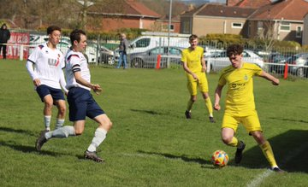
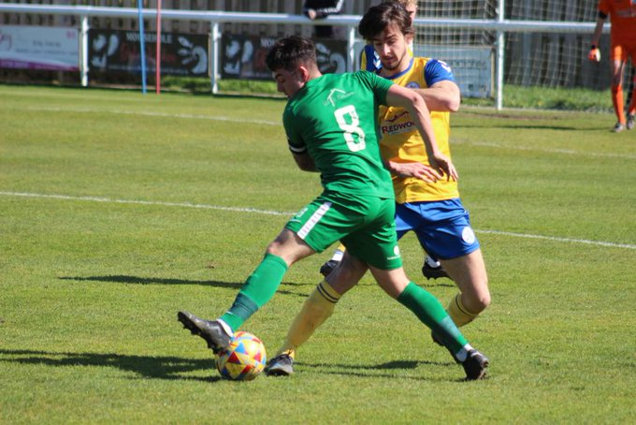
Easter Monday Action: The Bank Holiday rain put pay to a number of Western League clashes due to waterlogged pitches, but for the games that did go ahead there was plenty to enjoy for the bumper crowds. The day’s early kickoff in the Premier Division set the wheels in motion for an entertaining day, with Torpoint winning 6-3 away at Keynsham. In what would be more recognisable as a rugby score, Torpoint scored three times in either half during what turned out to be a pretty resounding victory, with Ryan Richards bagging a hat-trick. There was also a goal in either half from Callum Thompson, with Curtis Damerell then grabbing his 30th of the campaign to help the visitors complete their third win on the bounce. Later in the day, there was a big result at Trungle Parc where Mousehole beat Clevedon 2-0 to move top of the table (pictured, left). With Saltash’s game among those lost to the weather, the Seagulls took full advantage and have grabbed a one point lead with three fixtures left remaining thanks to a hard-fought home victory. The only goal that separated the sides at the interval came courtesy of Mark Goldsworthy who charged down an attempted clearance to make it 1-0 in the 24th minute. That was how it stayed for the remainder of the 90 minutes, with the game always on a knife-edge, but then in the sixth minute of stoppage time, Jack Calver curled home a terrific free-kick to put the game to bed. In another entertaining encounter, Falmouth handed Bridgwater their first home defeat of the campaign thanks to a 3-2 victory at Fairfax Park. The game started at a break-neck speed, and after Tim Nixon had given the visitors a fifth minute lead, Bridgy hit back almost instantly through Jack Taylor to make it one apiece. Falmouth then restored their advantage ten minutes before the break through Olly Walker, but the home side regrouped and levelled affairs once more with Jacob Spence scoring in the early knockings of the second half. The fifth and final goal of the contest saw James Ward power home a header, and this time Falmouth were able to hold on to their advantage to complete a near-perfect Easter period. Fifth-placed Barnstaple also completed back-to-back wins in the space of four days after goals from Tor Swann and Billy Tucker led them to a 2-0 victory over Welton Rovers, while at Marlborough Park, a second half strike from Ben Musselwhite saw Ilfracombe edge past Shepton Mallet by a goal to nil. Wellington produced a stunning second half performance away at bottom-side Cadbury Heath to end a five-match losing run (pictured, right). Having gone ahead thanks to a headed effort Ryan Brereton, Wellington were pegged back in added time at the end of the first half when Matt Isaacs powered home a header of his own from a Tom Withers cross. A goal right at the beginning of the second period from Alfie Clark gave the Somerset outfit all the impetus they required to push for victory, and after Jake Quick extended their lead further, a couple of excellent finishes from Jamie Nicholson in the final 20 minutes saw Wellington run out convincing winners.
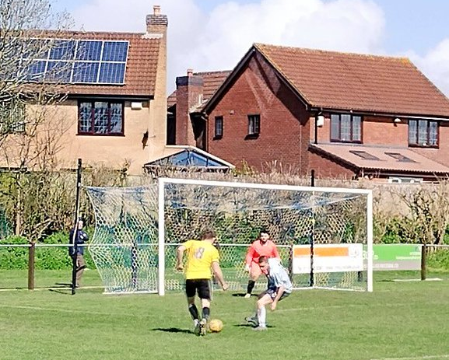
The First Division programme was more heavily affected, with six games lost to the wet conditions, and the goalscoring actions was also a little sparser during the games that did take place. The biggest scorers during the afternoon of action were FC Bristol who held off the challenge of Almondsbury to win 3-2. Having struck from the penalty spot midway through to the first half to break the deadlock, Bristol’s leading scorer Sacha Tong then struck again in the 32nd minute to put his side two goals to the good. The visitors began their fightback soon after Tong’s second, halving the deficit courtesy of a back post finish from Lewis Hedges, and then within ten minutes of the restart they managed to get back on level terms thanks to a Finley Coombs drive. The game was then decided midway through the second half when Alfie Clarke’s corner sailed directly into the back of the net, but the Almonds will feel they should have come away with something after seeing a late penalty saved by the home keeper. The terrific form of Longwell Green Sports continued away at AEK Boco, where the visitors overturned a half-time deficit to prevail by two goals to one. Boco have recently dropped into the bottom half of the division, but they managed to forge ahead after 13 minutes when a cross from Nathan Hull dropped into the back of the visitors net. Longwell Green’s equaliser came on the hour mark courtesy of Rob Belcher, and the same man was then on hand to knock home their winner during the final 20 minutes to maintain their perfect start to the month of April. Another side who have enjoyed an excellent run of late are Bristol Telephones, with their 2-0 victory away at Tytherington giving them 19 points from a possible 24 since a disappointing away loss at Bishops Lydeard. Goals from Javi Blazquez and Lee Pitman did the business at Hardwicke Field on Monday, with their struggling opponents now without a win in seven. The remaining fixtures both ended in draws, with Hallen and Hengrove playing out a goalless 90 minutes, while Gillingham’s Max Westlake levelled midway through the second half of their 1-1 draw away at Warminster.
Two-goal hero Rob Belcher attacks during Longwell Green’s win over AEK Boco
Two Western League sides also battled it out in the Cornwall Senior Cup final, with Helston claiming the trophy after victory on spot kicks over Millbrook. Helston twice went ahead during the 120 minutes prior to the shootout, with Rikki Sheppard kick-starting the goalscoring action very early in the day. Ben Goulty then drew Millbrook level midway through the second half, with a Tom Payne effort during extra time then seemingly putting Helston on course for victory. Millbrook had other ideas however, and hit back with their next attacking foray when Ed Goodman fired home from a corner to send the game to penalties. Helston went five from five with their attempts, and alongside a Mike Searle save that saw them come out on top to claim the top county honourszx.

Recent Results
Tuesday 4th April 2023
Premier Division
Cadbury Heath 0-2 Shepton Mallet
Ilfracombe Town 0-1 Ashton & Backwell United
Saltash United 3-1 Bridgwater United
Wellington 1-3 Mousehole
First Division
Brislington 2-0 Radstock Town
FC Bristol 3-1 Cheddar
Gillingham Town 0-2 Shirehampton
Oldland Abbotonians 5-2 Portishead Town
Tytherington Rocks 0-6 AEK Boco
Friday 7th April 2023
Premier Division
Barnstaple Town 2-1 Ilfracombe Town
Clevedon Town 1-1 Bridgwater United
Falmouth Town 5-1 Cadbury Heath
Helston Athletic 2-0 Mousehole
Keynsham Town 2-1 Ashton & Backwell United
Sherborne Town 0-1 Street
Torpoint Athletic 2-0 Millbrook
Wellington 0-1 Buckland Athletic
Welton Rovers 2-2 Shepton Mallet
First Division
Almondsbury 1-0 Tytherington Rocks
Bristol Telephones 2-1 AEK Boco
Cheddar 2-1 Bishops Lydeard
Gillingham Town 1-2 Wincanton Town
Hallen 3-0 FC Bristol
Hengrove Athletic 0-1 Odd Down
Nailsea & Tickenham 2-0 Portishead Town
Oldland Abbotonians 1-4 Longwell Green Sports
Radstock Town 0-1 Warminster Town
Shirehampton 1-2 Brislington
Wells City 3-0 Bishop Sutton
Monday 10th April 2023
Premier Division
Barnstaple Town 2-0 Welton Rovers
Bridgwater United 2-3 Falmouth Town
Cadbury Heath 1-5 Wellington
Ilfracombe Town 1-0 Shepton Mallet
Keynsham Town 3-6 Torpoint Athletic
Mousehole 2-0 Clevedon Town
First Division
AEK Boco 1-2 Longwell Green Sports
FC Bristol 3-2 Almondsbury
Hallen 0-0 Hengrove Athletic
Tytherington Rocks 0-2 Bristol Telephones
Warminster Town 1-1 Gillingham Town
Upcoming Fixtures
Wednesday 12th April 2023
Premier Division
Ashton & Backwell United vs Torpoint Athletic 19:30KO
Cadbury Heath vs Barnstaple Town 19:30KO
Wellington vs Ilfracombe Town 19:45KO
First Division
Bishop Sutton vs Bristol Telephones 19:30KO
FC Bristol vs Radstock Town 19:45KO
Odd Down vs Wells City 19:45KO
Portishead Town vs Hallen 19:30KO
Shirehampton vs Wincanton Town 19:30KO

Saturday 15th April 2023 (3pm kick-off unless noted)
Premier Division
Barnstaple Town vs Shepton Mallet
Buckland Athletic vs Millbrook
Cadbury Heath vs Helston Athletic
Clevedon Town vs Saltash United
Ilfracombe Town vs Street
Keynsham Town vs Mousehole
Sherborne Town vs Falmouth Town
Wellington vs Torpoint Athletic 14:00KO
First Division
AEK Boco vs FC Bristol
Bishop Sutton vs Nailsea & Tickenham
Bishops Lydeard vs Tytherington Rocks
Bristol Telephones vs Odd Down
Gillingham Town vs Portishead Town
Longwell Green Sports vs Brislington
Oldland Abbotonians vs Cheddar
Radstock Town vs Shirehampton
Warminster Town vs Hallen
Wells City vs Almondsbury
Wincanton Town vs Hengrove Athletic
Leading Goalscorers (Stats courtesy of FA Fulltime Website)
Premier Division
Curtis Damerell (Torpoint) – 23
Hayden Turner (Mousehole) - 22
Harry Foster (Street) – 18
Jacob Brown (Bridgwater) – 16
Rubin Wilson (Helston) – 16
Harry Stevens (Ilfracombe) – 14
Josh Webber (Buckland) – 14

First Division
Scott Bamford (Shirehampton) – 30
Luke Bryan (Odd Down) – 29
Adam Wright (Wells) – 29
Sacha Tong (FC Bristol) – 27
Luke Osgood (Nailsea) - 24
Matt Garner (Wincanton) –23
Craig Wilson (Bishop Sutton) – 21
Mason Davis (Oldland) - 21
All Competitions
Scott Bamford (Shirehampton) – 34
Adam Wright (Wells) – 31
Curtis Damerell (Torpoint) – 30
Sacha Tong (FC Bristol) – 29
Luke Bryan (Odd Down) – 29
Jack Thorne (Bridgwater/N&T) – 28
Hayden Turner (Mousehole) - 26
Matt Garner (Wincanton) - 25
Luke Osgood (Nailsea&Tickenham) – 24

League Tables
 | PREMIER DIVISION | Played | Won | Drawn | Lost | GD | Points
1 | Mousehole | 33 | 24 | 7 | 2 | 55 | 79
2 | Saltash United | 33 | 24 | 6 | 3 | 55 | 78
3 | Bridgwater United | 34 | 19 | 8 | 7 | 41 | 65
4 | Buckland Athletic | 33 | 21 | 2 | 10 | 23 | 65
5 | Barnstaple Town | 30 | 19 | 3 | 8 | 20 | 60
6 | Helston Athletic | 32 | 15 | 11 | 6 | 17 | 56
7 | Shepton Mallet | 32 | 15 | 10 | 7 | 24 | 55
8 | Falmouth Town | 32 | 14 | 7 | 11 | 11 | 49
9 | Clevedon Town | 34 | 12 | 7 | 15 | -9 | 43
10 | Ashton & Backwell United | 31 | 12 | 6 | 13 | 5 | 42
11 | Street | 32 | 10 | 9 | 13 | -18 | 39
12 | Torpoint Athletic | 32 | 10 | 8 | 14 | -8 | 38
13 | Millbrook | 33 | 10 | 7 | 16 | -16 | 37
14 | Welton Rovers | 34 | 10 | 6 | 18 | -33 | 36
15 | Wellington | 32 | 9 | 7 | 16 | -13 | 34
16 | Ilfracombe Town | 31 | 6 | 9 | 16 | -15 | 27
17 | Sherborne Town | 32 | 6 | 6 | 20 | -23 | 24
18 | Keynsham Town | 34 | 5 | 3 | 26 | -69 | 18
19 | Cadbury Heath | 32 | 3 | 6 | 23 | -47 | 15
 | FIRST DIVISION | Played | Won | Drawn | Lost | GD | Points
1 | Brislington | 38 | 33 | 2 | 3 | 90 | 101
2 | Nailsea & Tickenham | 39 | 29 | 4 | 6 | 71 | 91
3 | Wells City | 38 | 28 | 6 | 4 | 54 | 90
4 | Oldland Abbotonians | 38 | 23 | 8 | 7 | 38 | 77
5 | Wincanton Town | 36 | 20 | 5 | 11 | 26 | 65
6 | Shirehampton | 38 | 18 | 5 | 15 | 15 | 59
7 | Bishop Sutton | 36 | 17 | 7 | 12 | 6 | 58
8 | FC Bristol | 38 | 18 | 4 | 16 | 1 | 58
9 | Longwell Green Sports | 40 | 16 | 5 | 19 | -15 | 53
10 | Hallen | 38 | 14 | 10 | 14 | 4 | 52
11 | Odd Down | 35 | 13 | 10 | 12 | 11 | 49
12 | Warminster Town | 37 | 14 | 7 | 16 | -7 | 49
13 | Bristol Telephones | 40 | 13 | 10 | 17 | -11 | 46*
14 | AEK Boco | 39 | 14 | 4 | 21 | -19 | 46
15 | Portishead Town | 35 | 13 | 3 | 19 | -16 | 42
16 | Hengrove Athletic | 38 | 11 | 8 | 19 | -9 | 41
17 | Gillingham Town | 40 | 11 | 8 | 21 | -24 | 41
18 | Cheddar | 38 | 9 | 7 | 22 | -19 | 34
19 | Radstock Town | 37 | 7 | 12 | 18 | -17 | 33
20 | Tytherington Rocks | 40 | 7 | 9 | 24 | -58 | 30
21 | Almondsbury | 40 | 7 | 9 | 24 | -73 | 30
22 | Bishops Lydeard | 36 | 7 | 7 | 22 | -48 | 28

