Latest Round-ups:
#33
Season 2022/23
Midweek Action: Despite losing a trio of fixtures to the wet weather on Wednesday, there was still plenty happening up and down the Western League during the week, with all 16 teams in action on Tuesday evening finding the back of the net. In the Premier Division, Saltash pulled off a thrilling comeback at home to Barnstaple, overturning an early two-goal deficit to win 5-2. A pair of Stu Bowker goals inside the opening quarter of the match gave the visitors a strong foothold, before the Ashes were presented with the opportunity to come back into the game after being awarded a penalty on the half-hour mark. Adam Carter did the business from the spot, before he then struck again in added time at the end of the first half to make it two-apiece as the sides headed to the changing rooms. Saltash maintained their momentum during the early stages of the second half, and completed their turnaround within three minutes of the restart, with Harrison Davis forcing the defence into a mistake which saw the ball ricochet into the net for an own goal. Mike Smith then added the finishing touches, scoring twice during the next 20 minutes to put the result beyond doubt and maintain Saltash’s title charge. In the other Premier Division clash that night, Helston struck at the death to secure a 2-1 win away at Welton. Having gone ahead on the hour mark through Sam Carter, Helston’s hard work looked to be undone eight minutes from time when the hosts forced home an equaliser. Athletic weren’t to be denied however, and three minutes after conceding, they went back ahead thanks to a Tom Payne headed to claim all three points.
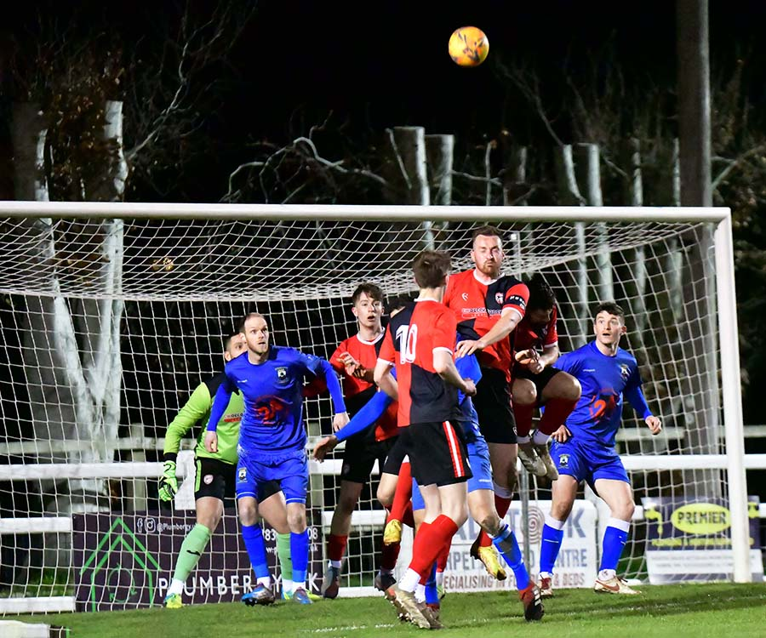
It was also a tense night of action in the First Division, with title chasing Wells held to a 1-1 draw away at Radstock (pictured right, courtesy of John Newport). A cross-come-shot from Ian Jeffery had put the Miners in front, with Wells’ Charlie Crook then scoring right at the end of the first half to grab a point at a wet and windy Southfields Rec. The points were also shared between Hallen and Gillingham, with the away side making it 2-2 in the closing minutes to deny the Bristolians. In a frantic start to the contest, Gillingham led after only five minutes through Tom Jarvis, only for the in-form Elliot Gardner to respond for the home side straight from the kickoff. Gardner’s influence showed again at the beginning of the second half, when his run saw Callum Black put Hallen 2-1 ahead, but they couldn’t quite cling on to their lead and Kieran Burpitt struck two minutes from time to earn the Gills a share of the spoils. The other game in the division was a little more one sided with Josh Clark, Ethan Ballantine, Jacob Reader and Luke Hall-Cousins all netting in the first half of Bishop Sutton’s 4-2 victory over AEK Boco.
There was also a big win in the Les Phillips Cup for Ilfracombe, with four second-half goals leading them to a 5-2 victory at home to Clevedon. With Joe Barker’s goal separating the sides at the interval, Ilfracombe’s Tyler Evans-Loude then took over the contest during the second period, notching a hat-trick to help the Devonians progress to the next round. The other clash was much tighter, with First Division leaders Brislington requiring penalties to knock out Prem strugglers Keynsham. Having fallen behind, Bris got back on level terms towards the end of the first half when Joel Smith notched his first goal for the club. The game remained 1-1 for the entirety of the second half, meaning spot kicks would be the deciding factor, and it was home keeper George Dorrington who proved to be the hero, with his three saves helping them book a semi-final spot.
Premier Division: On a heavily disrupted weekend schedule due to the poor weather, all four matches in the top division saw each of the home sides’ secure maximum points. Among the victors were Shepton Mallet, who secured their first league win of 2023 by beating the in-form Falmouth 2-0. In a battle between 7th and 8th, it was Danny Constable’s two goals which did the business for Mallet. After breaking the deadlock midway through the first half, Constable added a second less than five minutes later to bring an abrupt end to Falmouth’s four-match unbeaten run. 2-0 was also the scoreline at Fairfax Park where Bridgwater saw off bottom-side Keynsham to secure their 19th league win of the campaign. The opening half-hour was relatively quiet in terms of chances, before Bridgwater forged ahead with Jake Llewellyn’s pin-point cross met by a diving header from Jacob Spence. The second Bridgy goal came within three minutes of the second half getting underway and it had been a while coming for mid-season signing Jack Thorne, with his first home goal for the club helping them secure the win. In Cornwall, Helston extended their unbeaten run in all competitions to 12 games after coming from behind to beat Clevedon Town 3-1. Callum Eastwood’s left-footed had helped put the away side in front midway through the first half, before Rubin Wilson levelled affairs soon after to give Helston a share of the spoils at the interval. Rikki Sheppard then struck at the beginning of the second half to complete the turnaround, before Wilson struck for the second time as the game entered the final 20 minutes, condemning Clevedon to their third defeat of the week. Meanwhile for Millbrook, they have won all three of their matches over the past seven days after easing to a 4-2 victory over Sherborne. Following on from wins over Cadbury Heath and Wendron, the Zebras proved to be no match for the Cornish side, with Ryan Knight converting Josh Johnson’s cross to open the scoring early on. Tylor Love-Holmes then struck twice in quick succession to make it 3-0 at the break, before Noah Crump put the result beyond doubt 12 minutes from time. To their credit, Sherborne kept battling until the final whistle, and despite being reduced to ten men in the closing stages, goals from Benjani and Alex Murphy gave a little respect to the scoreline.
First Division: Brislington went a long way towards confirming the title on Saturday afternoon after brushing aside second place Wells City at the Athletic Ground on Saturday afternoon. Bris dominated much of the early proceedings and deservedly went ahead in the 34th minute when Joe McLennan reacted fastest to a loose ball in the Wells box before slotting home. In terms of league position, this was likely to be Brislington’s toughest match remaining over the final few weeks of the season, but they surged to victory thanks to two more McLennan goals to extend their winning streak to 22. His second of the game came thanks to a fine assist from Josh Egan, before McLennan completed his treble in stoppage time, tapping home a rebound after he had seen his penalty saved by the home keeper.
There was also a hat-trick in the clash at Shellards Road, where Longwell Green fought off an incredible fightback from Bishops Lydeard to secure a 5-3 victory. Having built what looked to be an unassailable three-goal half-time lead, Longwell Green soon found themselves level, with Adam Willis, Josh Wadham and Tai Bewes all scoring in the space of seven minutes at the beginning of the second half. Fortunately for the hosts, they found a second wave and managed to forge back ahead, with Rob Belcher’s perfect hat-trick spearheading their big win. Two of the league’s in-form strikers were each on target at the Hallen Centre, where the home side battled back to secure a 1-1 draw with Oldland Abbotonians. It was Oldland’s Harrison Kyte who got the ball rolling on Saturday afternoon, with his 25th minute effort putting the fourth-placed visitors in contention for back-to-back away wins. Hallen have a sharpshooter of their own however, and with 15 minutes left on the clock, Elliot Gardner buried his effort into the bottom corner to make it one apiece, just as it was when these two sides met earlier in the campaign.
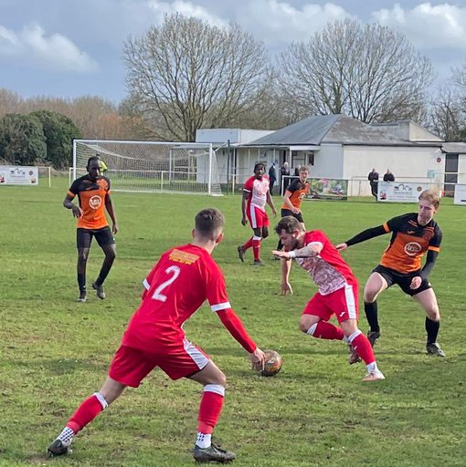
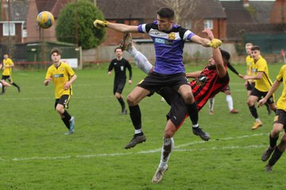
1-1 was the most popular scoreline in the division on Saturday, with Warminster finally taking advantage of the extra man to salvage a point at home to Cheddar (pictured, right, courtesy of Jamie House). Having fallen behind to Jack Busby’s fifth minute opener, Warminster were given a boost right at the end of the first half when visiting keeper Kieran Webster was dismissed, meaning forward Morgan Bacon would have to don the goalkeeping gloves. Incredibly, the Cheesemen came within 15 minutes of pulling off the remarkable victory, but it wasn’t to be and the hosts finally managed to force home an equaliser which came via a set piece. Early goals were the story in the day’s other 1-1 tie at Hardwicke Field (pictured, left), with Bishop Sutton skipper Craig Wilson seeing his eighth-minute opener cancelled out by an excellent finish from Tytherington Rocks forward Michael Johnson before the game had even reach the 20-minute mark. Back towards the top of the league, third-place Nailsea & Tickenham secured their 27th victory of the season by thumping Bristol Telephones 5-1 at Fryth Way. A pair of debut goals from recent addition Alfie Hemmings helped lead the Swags to victory, with usual suspects Luke Osgood and Callum Dunn also netting for the hosts who responded well to their recent defeat at the hands of table-topping Brislington. A strong second-half display from Gillingham Town ended a four-match winless run, after they handed bottom-side Almondsbury a 3-1 defeat. James Boyland’s calm finish within five minutes of the restart should have settled home nerves, but the Almonds responded excellently and managed to draw level within a couple of moments of conceding. Town continued to push forward however, and following a foul on Boyland in the penalty area, they were afforded the opportunity to go back ahead. Jordan Clapp took full advantage, converting his spot kick to make it 2-1, with Jack Male then stabbing home the Gills’ third of the afternoon five minutes from time.
Recent Results
Tuesday 21st March 2023
Premier Division
Saltash United 5-2 Barnstaple Town
Welton Rovers 1-2 Helston Athletic
First Division
Bishop Sutton 4-2 AEK Boco
Hallen 2-2 Gillingham Town
Radstock Town 1-1 Wells City
Les Phillips Cup
Brislington (3-2 pens) 1-1 Keynsham Town
Ilfracombe Town 5-2 Clevedon Town

Saturday 25th March 2023
Premier Division
Bridgwater United 2-0 Keynsham Town
Helston Athletic 3-1 Clevedon Town
Millbrook 4-2 Sherborne Town
Shepton Mallet 2-0 Falmouth Town
First Division
Gillingham Town 3-1 Almondsbury
Hallen 1-1 Oldland Abbotonians
Longwell Green Sports 5-3 Bishops Lydeard
Nailsea & Tickenham 5-1 Bristol Telephones
Tytherington Rocks 1-1 Bishop Sutton
Warminster Town 1-1 Cheddar
Wells City 0-3 Brislington

Leading Goalscorers (Stats courtesy of FA Fulltime Website)
Premier Division
Curtis Damerell (Torpoint) – 21
Hayden Turner (Mousehole) - 20
Harry Foster (Street) – 18
Jacob Brown (Bridgwater) – 16

First Division
Scott Bamford (Shirehampton) – 30
Luke Bryan (Odd Down) – 28
Adam Wright (Wells) – 27
Luke Osgood (Nailsea & Tickenham) - 24
Sacha Tong (FC Bristol) – 22
Matt Garner (Wincanton) –21

All Competitions
Scott Bamford (Shirehampton) – 34
Adam Wright (Wells) – 29
Luke Bryan (Odd Down) – 28
Curtis Damerell (Torpoint) – 28
Jack Thorne (Bridgwater/N&T) – 27
Sacha Tong (FC Bristol) – 24
Hayden Turner (Mousehole) - 24
Luke Osgood (Nailsea & Tickenham) – 24
Asa White (Brislington) – 23
Matt Garner (Wincanton) - 23

Upcoming Fixtures
Tuesday 28th March 2023
Premier Division
Ashton & Backwell United vs Cadbury Heath 19:30KO
First Division
Bishop Sutton vs Bristol Telephones 19:30KO
Brislington vs Radstock Town 19:30KO
Gillingham Town vs Shirehampton 19:30KO
Portishead Town vs Hallen 19:30KO
Odd Down vs FC Bristol 19:45KO
Les Phillips Cup
Helston Athletic vs Buckland Athletic 19:45KO

Wednesday 29th March 2023
Premier Division
Sherborne Town vs Clevedon Town 19:30KO
Wellington vs Ilfracombe Town 19:45KO

Friday 31st March 2023
First Division
Tytherington Rocks vs AEK Boco 19:45KO

Saturday 1st April 2023 (3pm kick-off unless noted)
Premier Division
Ashton & Backwell United vs Torpoint Athletic
Buckland Athletic vs Keynsham Town
Cadbury Heath vs Barnstaple Town
Clevedon Town vs Sherborne Town
Mousehole vs Shepton Mallet
Saltash United vs Bridgwater United
Street vs Millbrook
Wellington vs Helston Athletic
Welton Rovers vs Falmouth Town
First Division
Bishop Sutton vs FC Bristol
Bishops Lydeard vs Warminster Town
Hallen vs Radstock Town
Hengrove Athletic vs Gillingham Town
Longwell Green Sports vs Portishead Town
Odd Down vs Wells City
Oldland Abbotonians vs Nailsea & Tickenham
Wincanton Town vs Cheddar
On the latest podcast, Keynsham’s joint-manager, Marvin Brown, explains why he’s hopeful that their tough season will bring benefits to his players development, both this season and next. Ian also catches up with Wells City manager, Shaun Potter, who reflects on a season of over-achievement that dangles the prospect of promotion as well as the potential torture of the play offs!
Season 2022/23 Podcast Episode 33 | Toolstation Western League (toolstationleague.com)

League Tables
 | PREMIER DIVISION | Played | Won | Drawn | Lost | GD | Points
1 | Saltash United | 32 | 23 | 6 | 3 | 53 | 75
2 | Mousehole | 29 | 21 | 7 | 1 | 51 | 70
3 | Bridgwater United | 31 | 19 | 7 | 5 | 44 | 64
4 | Buckland Athletic | 31 | 19 | 2 | 10 | 19 | 59
5 | Barnstaple Town | 28 | 17 | 3 | 8 | 17 | 54
6 | Helston Athletic | 31 | 14 | 11 | 6 | 15 | 53
7 | Shepton Mallet | 28 | 14 | 9 | 5 | 25 | 51
8 | Falmouth Town | 30 | 12 | 7 | 11 | 6 | 43
9 | Ashton & Backwell United | 28 | 11 | 5 | 12 | 5 | 38
10 | Clevedon Town | 30 | 10 | 6 | 14 | -11 | 36
11 | Millbrook | 31 | 10 | 6 | 15 | -14 | 36
12 | Street | 30 | 9 | 8 | 13 | -19 | 35
13 | Welton Rovers | 32 | 10 | 5 | 17 | -31 | 35
14 | Torpoint Athletic | 30 | 8 | 8 | 14 | -13 | 32
15 | Wellington | 29 | 8 | 7 | 14 | -14 | 31
16 | Ilfracombe Town | 28 | 5 | 9 | 14 | -14 | 24
17 | Sherborne Town | 29 | 6 | 6 | 17 | -18 | 24
18 | Keynsham Town | 31 | 4 | 3 | 24 | -64 | 15
19 | Cadbury Heath | 28 | 3 | 5 | 20 | -37 | 14
 | FIRST DIVISION | Played | Won | Drawn | Lost | GD | Points
1 | Brislington | 36 | 31 | 2 | 3 | 87 | 95
2 | Wells City | 37 | 27 | 6 | 4 | 51 | 87
3 | Nailsea & Tickenham | 37 | 27 | 4 | 6 | 67 | 85
4 | Oldland Abbotonians | 35 | 22 | 8 | 5 | 40 | 74
5 | Wincanton Town | 35 | 19 | 5 | 11 | 25 | 62
6 | Bishop Sutton | 35 | 17 | 7 | 11 | 9 | 58
7 | Shirehampton | 36 | 17 | 5 | 14 | 14 | 56
8 | FC Bristol | 34 | 15 | 4 | 15 | -3 | 49
9 | Hallen | 36 | 13 | 9 | 14 | 1 | 48
10 | Odd Down | 33 | 12 | 10 | 11 | 14 | 46
11 | Warminster Town | 35 | 13 | 6 | 16 | -8 | 45
12 | Longwell Green Sports | 37 | 13 | 5 | 19 | -22 | 44
13 | AEK Boco | 36 | 13 | 4 | 19 | -23 | 43
14 | Portishead Town | 32 | 13 | 3 | 16 | -8 | 42
15 | Hengrove Athletic | 36 | 11 | 7 | 18 | -8 | 40
16 | Bristol Telephones | 38 | 11 | 10 | 17 | -14 | 40*
17 | Gillingham Town | 37 | 11 | 7 | 19 | -21 | 40
18 | Radstock Town | 35 | 7 | 12 | 16 | -14 | 33
19 | Cheddar | 36 | 8 | 7 | 21 | -18 | 31
20 | Tytherington Rocks | 37 | 7 | 9 | 21 | -49 | 30
21 | Bishops Lydeard | 35 | 7 | 7 | 21 | -47 | 28
22 | Almondsbury | 38 | 6 | 9 | 23 | -73 | 27

