Latest Round-ups:
#23
Season 2022/23
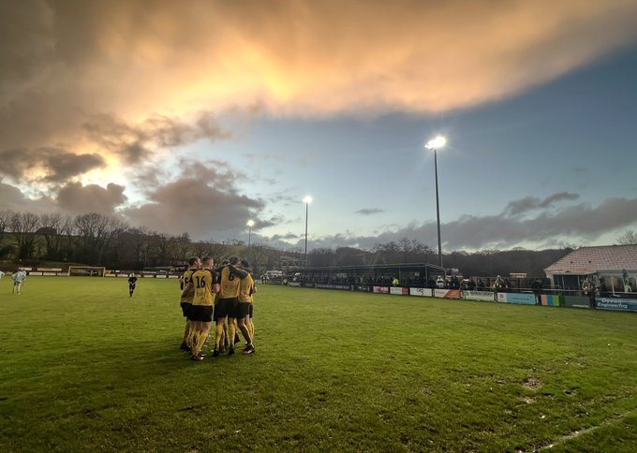
League Action: With rain curtailing the majority of Saturday’s league fixtures, Buckland hosted the only game of the day in the Premier Division, and were rewarded for doing so by beating Sherborne Town 3-1. Conditions played a huge part in the opening goal, with Cieran Bridger’s sixth minute effort slipping through the visiting keeper. Frazer Clark then tapped home to double Buckland’s advantage on the half hour mark, with Jared Lewington adding a third towards the beginning of the second half. Sherborne grabbed a late consolation thanks to a near-post header from Anthony Herrin, but never truly threatened the home side who gained ground on the top four.
A stunning view of Homer’s Heath, courtesy of Glenn Holmes.
First Division leaders Wells added three more points to their tally after sneaking past Longwell Green Sports on Saturday afternoon. Having won by a single goal to open 2023, City repeated the trick at the Athletic Ground, with Adam Wright providing the finishing touch from close range to help them secure the 1-0 win. It was a good day all round for the home sides, with FC Bristol claiming a 3-0 victory over Shirehampton in their top-six battle. Elan Plummer gave the hosts a dream start, breaking the deadlock after just 11 seconds, before further goals from Kris Miller and Alfie Clarke fired them to victory. In the opening fixture of the day, Cheddar put four past Wincanton to jump a couple of spots in the bottom half. After Lewis Chappell’s early opener had been cancelled out, Morgan Bacon slotted home to restore Cheddar’s advantage towards the end of the first half. A sharp free-kick from Ethan Reed put the Cheesemen two goals clear early in the second half, with Chappell’s second of the afternoon wrapping up the win.

Recent Results
Saturday 7th January 2023
Premier Division
Buckland Athletic 3-1 Sherborne Town
First Division
Cheddar 4-1 Wincanton Town
FC Bristol 3-0 Shirehampton
Wells City 1-0 Longwell Green Sports

This week’s podcast includes a conversation with Sherborne Town Chairman, John Bowers, who explains why he believes the Zebras are a better team than their league position would suggest. Radstock Town boss, Ray Johnston, also joins Ian to talk about the Miners progress this season and why he hopes they can build upon their dream start to 2023.
Season 2022/23 Podcast Episode 22 | Toolstation Western League (toolstationleague.com)

Leading Goalscorers (Stats courtesy of FA Fulltime Website)

Premier Division
Jacob Brown (Bridgwater) – 16
Curtis Damerell (Torpoint) - 14
Harry Stevens (Ilfracombe) – 14
Harry Foster (Street) – 13
Rubin Wilson (Helston) – 12
Josh Webber (Buckland) – 11
Hayden Turner (Mousehole) - 11

All Competitions
Luke Bryan (Odd Down) – 23
Jack Thorne (Bridgwater) – 23
Sacha Tong (FC Bristol) – 22
Adam Wright (Wells) – 22
Curtis Damerell (Torpoint) – 21
Scott Bamford (Shirehampton) – 20
Jacob Brown (Bridgwater) – 18
Craig Wilson (Bishop Sutton) – 17
Joe Berry (Nailsea/Tickenham) – 17

First Division
Luke Bryan (Odd Down) – 24
Sacha Tong (FC Bristol) – 22
Adam Wright (Wells) – 20
Scott Bamford (Shirehampton) – 17
Craig Wilson (Bishop Sutton) - 17
Joe Berry (Nailsea/Tickenham) – 17

Upcoming Fixtures
Tuesday 10th January 2023
Premier Division
Ilfracombe Town vs Wellington 19:45KO
First Division
Brislington vs AEK Boco 19:30KO
Gillingham Town vs Odd Down 19:30KO
Portishead Town vs Longwell Green Sports 19:30KO
Les Phillips Cup - Second Round
Almondsbury vs Shirehampton 19:45KO
Mousehole vs Buckland Athletic 19:45KO

Wednesday 11th January 2023
First Division
Warminster Town vs Bishop Sutton 19:45KO
Les Phillips Cup - Second Round
Falmouth Town vs Barnstaple Town 19:45KO

Saturday 14th January 2023 (3pm kick-off unless noted)
FA Vase - Fourth Round
Bridgwater United vs Erith Town 14:00KO
Buckland Athletic vs Ascot United
Clevedon Town vs Harefield United
Premier Division
Ashton & Backwell United vs Ilfracombe Town
Helston Athletic vs Street
Keynsham Town vs Torpoint Athletic
Millbrook vs Cadbury Heath 14:00KO
Mousehole vs Welton Rovers
Saltash United vs Barnstaple Town 14:00KO
Shepton Mallet vs Sherborne Town
Wellington vs Falmouth Town
First Division
Brislington vs Tytherington Rocks
Gillingham Town vs Bishops Lydeard
Hallen vs Warminster Town
Nailsea & Tickenham vs Radstock Town
Odd Down vs Bishop Sutton
Oldland Abbotonians vs Wells City
Wincanton Town vs Portishead Town 14:00KO

League Tables
 | PREMIER DIVISION | Played | Won | Drawn | Lost | GD | Points
1 | Saltash United | 23 | 15 | 5 | 3 | 29 | 50
2 | Bridgwater United | 21 | 15 | 4 | 2 | 40 | 49
3 | Mousehole | 19 | 12 | 6 | 1 | 29 | 42
4 | Shepton Mallet | 20 | 13 | 3 | 4 | 24 | 42
5 | Buckland Athletic | 22 | 12 | 2 | 8 | 9 | 38
6 | Barnstaple Town | 18 | 10 | 2 | 6 | 9 | 32
7 | Helston Athletic | 19 | 8 | 6 | 5 | 2 | 30
8 | Falmouth Town | 18 | 7 | 6 | 5 | 7 | 27
9 | Ashton & Backwell United | 19 | 8 | 3 | 8 | 4 | 27
10 | Clevedon Town | 19 | 7 | 4 | 8 | -4 | 25
11 | Street | 18 | 7 | 2 | 9 | -13 | 23
12 | Millbrook | 21 | 6 | 5 | 10 | -14 | 23
13 | Ilfracombe Town | 18 | 4 | 8 | 6 | 1 | 20
14 | Torpoint Athletic | 21 | 5 | 5 | 11 | -13 | 20
15 | Sherborne Town | 21 | 5 | 4 | 12 | -9 | 19
16 | Welton Rovers | 22 | 5 | 4 | 13 | -32 | 19
17 | Wellington | 17 | 3 | 5 | 9 | -6 | 14
18 | Cadbury Heath | 20 | 3 | 5 | 12 | -19 | 14
19 | Keynsham Town | 22 | 3 | 3 | 16 | -44 | 12
 | FIRST DIVISION | Played | Won | Drawn | Lost | GD | Points
1 | Wells City | 26 | 21 | 2 | 3 | 43 | 65
2 | Nailsea & Tickenham | 26 | 19 | 3 | 4 | 52 | 60
3 | Brislington | 23 | 18 | 2 | 3 | 38 | 56
4 | FC Bristol | 26 | 14 | 4 | 8 | 10 | 46
5 | Oldland Abbotonians | 22 | 13 | 5 | 4 | 18 | 44
6 | Shirehampton | 23 | 12 | 4 | 7 | 15 | 40
7 | Odd Down | 25 | 10 | 8 | 7 | 19 | 38
8 | Wincanton Town | 23 | 11 | 4 | 8 | 17 | 37
9 | Warminster Town | 23 | 11 | 4 | 8 | 4 | 37
10 | Bishop Sutton | 23 | 10 | 4 | 9 | 1 | 34
11 | Portishead Town | 21 | 10 | 3 | 8 | 6 | 33
12 | Hallen | 24 | 9 | 5 | 10 | 4 | 32
13 | AEK Boco | 25 | 10 | 2 | 13 | -17 | 32
14 | Hengrove Athletic | 27 | 8 | 6 | 13 | -8 | 30
15 | Cheddar | 27 | 7 | 5 | 15 | -16 | 26
16 | Longwell Green Sports | 26 | 7 | 5 | 14 | -21 | 26
17 | Gillingham Town | 23 | 7 | 4 | 12 | -9 | 25
18 | Almondsbury | 27 | 5 | 6 | 16 | -47 | 21
19 | Bristol Telephones | 26 | 5 | 7 | 14 | -19 | 19*
20 | Tytherington Rocks | 24 | 4 | 7 | 13 | -33 | 19
21 | Radstock Town | 24 | 2 | 10 | 12 | -22 | 16
22 | Bishops Lydeard | 22 | 3 | 4 | 15 | -35 | 13

