Latest Round-ups:
#22
Season 2022/23
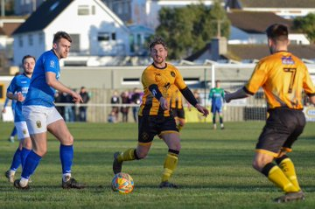
Premier Division: The New Year started with a pair of surprising results atop the Western League, with the two title favourites suffering defeats in their opening matches of 2023. Leaders Saltash were hit by a couple of late sucker-punches away at Barnstaple, with United falling to a 2-0 defeat. After 72 goalless minutes, the home side finally broke through thanks to Stu Bowker, and Barnstaple then wrapped things up in stoppage time, with Matty Andrew doubling their victory margin. Second-place Bridgwater were also on the end of an away defeat, with Falmouth putting four past their visitors at Bickland Park. Having already toppled Saltash on Boxing Day, Falmouth would have been full of confidence, and that certainly showed in the opening stages on Monday afternoon when Luke Barner fired them ahead after 15 minutes. Bridgy responded well however, and were back on level terms soon after when Jack Thorne headed home a corner, only for Falmouth to then re-take the lead towards the end of the first half thanks to a curled finish from Tim Nixon. An excellent individual goal from Luke Brabyn then put substantial distance between the two sides, with Marcello Jones tucking home a late fourth from the spot for Falmouth after he had been hauled down inside the area. Another standout result saw Torpoint topple Buckland, with the resurgent hosts beating their fifth-placed visitors by four goals to two (pictured, left). The home side’s dominance at the back-end of the first half was the main factor behind the result, with Gary Hird scoring twice in a ten-minute spell, either side of a Ryan Richards penalty to help Torpoint build a three-goal advantage at the interval. Buckland’s Ryan Bush gave his side a lifeline ten minutes into the second half thanks to a smart headed finish, but Torpoint hit back instantly through Callum Thompson to restore their control, and render Sam Stayt’s late effort to be nothing more than a consolation.
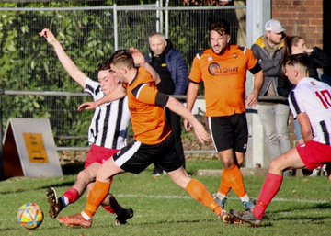
Another bottom-half side who started their year off with a positive outcome were Sherborne, who held on to beat Ilfracombe 2-1 at Raleigh Grove. Having taken a tenth minute lead through Tom Budden, Sherborne were hauled back by their visitors just prior to half-time when Harry Stevens converted from the penalty spot. The Zebras then re-took the lead in the 72nd minute through Henry Lawrence-Napier, but this time they managed to keep their visitors at bay, allowing them to claim their first league win since late-October. First-half goals from Jack Bray-Evans and Hayden Turner helped lead Mousehole to a 2-0 win away at Clevedon, while the early kickoff between Wellington and Millbrook ended in a goalless stalemate (pictured, right). There was also a share of the points at Helston, where Aaron Seviour struck for Shepton to deny the home side who had gone ahead 20 minutes from time thanks to a powerful headed finish from Rubin Wilson. Ashton & Backwell United completed a perfect festive period by beating Cadbury Heath 3-1 at Springfield. Having put four unanswered goals past Keynsham on Boxing Day, the Stags backed that up with another one-sided win which was kick-started early in the second half thanks to a Miles Hardidge long-ranger. Alfie Cummings then doubled the visitors lead, with a solo run-and-finish from Joe Cattermole making it 3-0, before Ali Boyer claimed Heath’s consolation goal at the death.
First Division: Wincanton Town responded incredibly well to their surprise home defeat last week by thumping Odd Down 7-2 to open the year on a huge high. Having taken an early lead through Jamie Thompson, the home side then continued to ram home their advantage with the returning Jamie Garner striking twice to put his side three to the good. A goal late at the end of the first half threatened to spark a fightback for the Bath side, but that never materialised, with Cam Vere and Thompson helping build a 5-1 lead midway through the second period. Garner then capped an excellent individual performance, completing his hat-trick late on, with Louis Irwin adding a seventh for the rampant Winky. The remainder of the division saw a number of tight tussles in general, with a number of 2-1 and 2-2 scorelines. One such game took in Somerset, where league leaders Wells City came from behind to beat Cheddar by two goals to one.
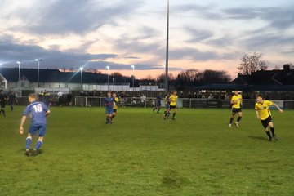
After Lewis Chappell had fired the Cheesemen ahead after only ten minutes, it looked like it was going to be a tough afternoon for City for whom Adam Wright then saw a penalty saved against his former side. Fortunately for the hosts, that penalty miss wasn’t allowed to fester for long, and they got back on level terms in the 44th minute when Craig Herrod found enough time and space to fire past the visiting keeper. The winning goal came soon after the interval, and it was Wright who made amends for his earlier miscue by slotting home to secure all three points on a dramatic afternoon at the Athletic Ground (pictured, left). Second-placed Nailsea & Tickenham were also forced to battle until the final minutes of their clash away at strugglers Bishops Lydeard, eventually holding on to secure a 2-1 victory. Things looked to be going swimmingly for the visitors when goals from Joe Berry and Luke Osgood put them two-up inside half an hour, but a tight finish ensued after a wonder goal from Mark Jones had given the Lyds late hope. Warminster were another side to win away from home, with Corey Gardner and James Vincent scoring in either half of their 2-0 triumph at Gillingham, while Boco defeated Longwell Green Sports 2-1 despite the majority of the 604 fans in attendance rooting for the home side. Ashley Knight struck equalisers late in either half to help Almondsbury secure an impressive 2-2 draw at home to FC Bristol, with Tytherington coming from behind to also claim a 2-2 tie away at Bristol Telephones. Archie Dark’s double had put the Phones in control at the break, but it was the Rocks who finished the game in the ascendancy, and they grabbed a share of the spoils thanks to goals from Mischa Collins and Connor Davey. Radstock Town began the year on a massive high, putting three past Bishop Sutton to secure their second league win of the campaign. Their only previous three point haul this season came in early November, but this was their most complete performance to date, with Corey Rawlings double, and a further goal from Will Osborne leading them to the 3-0 win. Hallen came out on top in their away game at Hengrove, leapfrogging their opponents up into 12th spot thanks to the 2-1 win. Elliot Gardner’s two goals were crucial for Hallen, with his second of the afternoon proving to be the winner after Jack Jones had headed Hengrove level towards the end of the first half.

Recent Results
Monday 2nd January 2023
Premier Division
Barnstaple Town 2-0 Saltash United
Cadbury Heath 1-3 Ashton & Backwell United
Clevedon Town 0-2 Mousehole
Falmouth Town 4-1 Bridgwater United
Helston Athletic 1-1 Shepton Mallet
Sherborne Town 2-1 Ilfracombe Town
Torpoint Athletic 4-2 Buckland Athletic
Wellington 0-0 Millbrook
First Division
Almondsbury 2-2 FC Bristol
Bishops Lydeard 1-2 Nailsea & Tickenham
Bristol Telephones 2-2 Tytherington Rocks
Gillingham Town 0-2 Warminster Town
Hengrove Athletic 1-2 Hallen
Longwell Green Sports 1-2 AEK Boco
Oldland Abbotonians P-P Brislington
Radstock Town 3-0 Bishop Sutton
Wells City 2-1 Cheddar
Wincanton Town 7-2 Odd Down

Leading Goalscorers (Stats courtesy of FA Fulltime Website)
Premier Division
Jacob Brown (Bridgwater) – 16
Curtis Damerell (Torpoint) - 14
Harry Stevens (Ilfracombe) – 14
Harry Foster (Street) – 13
Rubin Wilson (Helston) – 12
Josh Webber (Buckland) - 11

All Competitions
Luke Bryan (Odd Down) – 23
Sacha Tong (FC Bristol) – 22
Jack Thorne (Bridgwater) – 22
Adam Wright (Wells) – 21
Curtis Damerell (Torpoint) – 21
Scott Bamford (Shirehampton) – 20
Jacob Brown (Bridgwater) – 18
Craig Wilson (Bishop Sutton) – 17
Joe Berry (Nailsea/Tickenham) – 17

First Division
Luke Bryan (Odd Down) – 23
Sacha Tong (FC Bristol) – 22
Adam Wright (Wells) – 19
Scott Bamford (Shirehampton) – 18
Craig Wilson (Bishop Sutton) - 17
Joe Berry (Nailsea/Tickenham) – 17

Upcoming Fixtures
Saturday 7th January 2023 (3pm kick-off unless noted)
Premier Division
Ashton & Backwell United vs Wellington
Barnstaple Town vs Keynsham Town 14:00KO
Bridgwater United vs Mousehole
Buckland Athletic vs Sherborne Town
Falmouth Town vs Cadbury Heath
Saltash United vs Millbrook 14:00KO
Shepton Mallet vs Torpoint Athletic
Street vs Clevedon Town
Welton Rovers vs Helston Athletic
First Division
AEK Boco vs Bishops Lydeard
Almondsbury vs Oldland Abbotonians
Bristol Telephones vs Radstock Town
Cheddar vs Wincanton Town 14:00KO
FC Bristol vs Shirehampton
Gillingham Town vs Brislington
Nailsea & Tickenham vs Hengrove Athletic 14:00KO
Portishead Town vs Hallen 14:00KO
Tytherington Rocks vs Warminster Town 14:00KO
Wells City vs Longwell Green Sports
Les Phillips Cup
Bishop Sutton vs Ilfracombe Town

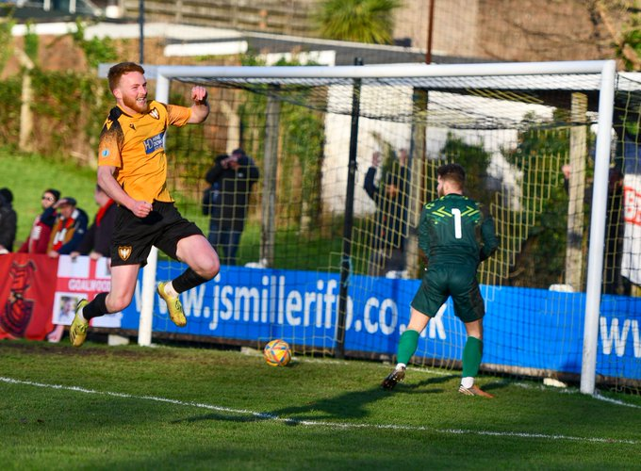
On the final podcast of 2022, Ian catches up with Shepton Mallet manager Aaron Seviour, who discusses his footballing journey to the Mallet dugout, and his pride in taking up an opportunity that was too good to pass up. There is also a conversation with Brislington boss Lee Perks, who explains why 2022 was a good year for his club, and why he’s happy to be chasing rather than leading the First Division title race.
Season 2022/23 Podcast Episode 21 | Toolstation Western League (toolstationleague.com)
League Tables
 | PREMIER DIVISION | Played | Won | Drawn | Lost | GD | Points
1 | Saltash United | 23 | 15 | 5 | 3 | 29 | 50
2 | Bridgwater United | 21 | 15 | 4 | 2 | 40 | 49
3 | Mousehole | 19 | 12 | 6 | 1 | 29 | 42
4 | Shepton Mallet | 20 | 13 | 3 | 4 | 24 | 42
5 | Buckland Athletic | 21 | 11 | 2 | 8 | 7 | 35
6 | Barnstaple Town | 18 | 10 | 2 | 6 | 9 | 32
7 | Helston Athletic | 19 | 8 | 6 | 5 | 2 | 30
8 | Falmouth Town | 18 | 7 | 6 | 5 | 7 | 27
9 | Ashton & Backwell United | 19 | 8 | 3 | 8 | 4 | 27
10 | Clevedon Town | 19 | 7 | 4 | 8 | -4 | 25
11 | Street | 18 | 7 | 2 | 9 | -13 | 23
12 | Millbrook | 21 | 6 | 5 | 10 | -14 | 23
13 | Ilfracombe Town | 18 | 4 | 8 | 6 | 1 | 20
14 | Torpoint Athletic | 21 | 5 | 5 | 11 | -13 | 20
15 | Sherborne Town | 20 | 5 | 4 | 11 | -7 | 19
16 | Welton Rovers | 22 | 5 | 4 | 13 | -32 | 19
17 | Wellington | 17 | 3 | 5 | 9 | -6 | 14
18 | Cadbury Heath | 20 | 3 | 5 | 12 | -19 | 14
19 | Keynsham Town | 22 | 3 | 3 | 16 | -44 | 12
 | FIRST DIVISION | Played | Won | Drawn | Lost | GD | Points
1 | Wells City | 25 | 20 | 2 | 3 | 42 | 62
2 | Nailsea & Tickenham | 26 | 19 | 3 | 4 | 52 | 60
3 | Brislington | 23 | 18 | 2 | 3 | 38 | 56
4 | Oldland Abbotonians | 22 | 13 | 5 | 4 | 18 | 44
5 | FC Bristol | 25 | 13 | 4 | 8 | 7 | 43
6 | Shirehampton | 22 | 12 | 4 | 6 | 18 | 40
7 | Odd Down | 25 | 10 | 8 | 7 | 19 | 38
8 | Wincanton Town | 22 | 11 | 4 | 7 | 20 | 37
9 | Warminster Town | 23 | 11 | 4 | 8 | 4 | 37
10 | Bishop Sutton | 23 | 10 | 4 | 9 | 1 | 34
11 | Portishead Town | 21 | 10 | 3 | 8 | 6 | 33
12 | Hallen | 24 | 9 | 5 | 10 | 4 | 32
13 | AEK Boco | 25 | 10 | 2 | 13 | -17 | 32
14 | Hengrove Athletic | 27 | 8 | 6 | 13 | -8 | 30
15 | Longwell Green Sports | 25 | 7 | 5 | 13 | -20 | 26
16 | Gillingham Town | 23 | 7 | 4 | 12 | -9 | 25
17 | Cheddar | 26 | 6 | 5 | 15 | -19 | 23
18 | Almondsbury | 27 | 5 | 6 | 16 | -47 | 21
19 | Bristol Telephones | 26 | 5 | 7 | 14 | -19 | 19*
20 | Tytherington Rocks | 24 | 4 | 7 | 13 | -33 | 19
21 | Radstock Town | 24 | 2 | 10 | 12 | -22 | 16
22 | Bishops Lydeard | 22 | 3 | 4 | 15 | -35 | 13

