Latest Round-ups:
#21
Season 2022/23
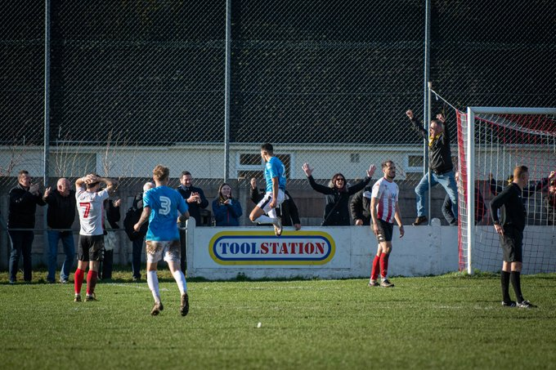
Premier Division: Leaders Saltash fell away in the closing stages of their Boxing Day clash with Falmouth, suffering a 3-1 defeat against their Cornish adversaries at the Waterways Stadium. Having gone ahead in added on time at the end of the first half through Adam Carter, the Ashes had put themselves in strong position to grab their 16th league win of the campaign. Falmouth had other ideas however, and after drawing level through Tim Nixon in the 75th minute, they suddenly saw an opportunity to snatch all three points. The visitors ended up doing exactly that, and with Olly Walker and Marcello Jones both finding the back of the net during the final ten minutes, Falmouth secured a memorable victory (pictured, celebrating above). Second-placed Bridgwater failed to capitalise on the Ashes slip-up, and sit one point behind top spot at the turn of the year after drawing 2-2 at home to Clevedon. A glancing header from Jack Taylor put United ahead, before Archie Ferris responded in kind, nodding home a Freddie King corner early in the second half to draw Clevedon level. The visitors then completed the turnaround ten minutes from time after an audacious chip from Glen Hayer nestled in the back of the net from 25 yards out. Bridgwater did manage to salvage a point from the contest however, and after Jake Brown had been tripped in the box, Taylor made no mistake from the spot to deny Clevedon as the game headed towards the finish-line. Shepton Mallet have now won four on the bounce after coming from behind to beat Welton 3-1, maintaining their spot in the top three. Things didn’t start ideally for Mallet, with their visitors going ahead after 28 minutes thanks to a smart finish from the returning Toby Cole. Shepton are among a plethora of sides who have seen games postponed recently, and having not played in over three weeks, rust might have been an excuse for the hosts who drew level three minutes into first half stoppage time thanks to a Fin Haines header. The turnaround was complete midway through the second half following a Jacob Sloggett penalty, with the same man then providing an assist for Josh Jenkins who wrapped things up during the closing stages.
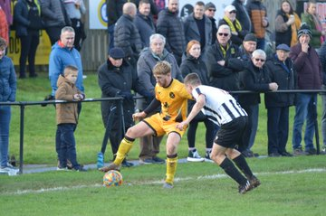
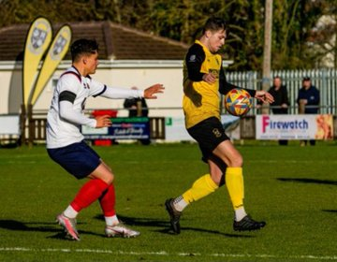
Another side to pull off a comeback were Buckland Athletic, who twice came from behind to beat Wellington 3-2 in the game of the day at Homers Heath (pictured, right). The visitors made a dream start to the game, taking the lead after only two minutes when Jake Quick fired home in a battle between sides at different ends of the table. Buckland finally drew level towards the end of the first half through Cieran Bridger, but the hosts then fell back behind within two minutes of the second half restarting when Quick struck again in a repeat of the opening to the contest. With Buckland forced to battle back once again, they finally got back on level footing with ten minutes remaining thanks to a penalty from Owen Stockton. The drama wasn’t finished there however, and after Miles Quick was dismissed following a cynical foul, the resulting free kick ended up in the back of the Wellington net after Sam Morcom’s deflected set piece gave Buckland maximum points. Another home side to secure victory were Ashton & Backwell, with a Lewis Hedges brace bookending their 4-0 triumph over Keynsham. After Hedges had opened the scoring, Joe Banks was on target towards the end of the opening half to put United two-up at the break. Shea Mannings extended the hosts advantage on the hour mark, with Hedges then volleying home as the game entered the final ten minutes to put a cap on an excellent performance for both team and individual alike. Second half goals from Hayden Turner, Jack Rhead and Mark Goldsworthy led Mousehole to a strong 3-0 win at home to Helston, with Barnstaple beating Devon rivals Ilfracombe by the same scoreline thanks in part to a late brace from Matt Andrew. In the remaining post-Christmas contests, bottom-half duo Millbrook and Torpoint battled out a rare goalless draw at Mill Road (pictured, left), while Sherborne were held to a 1-1 draw away at Street despite taking the lead through Benjani Mwaruwari Jr, the son of the former Portsmouth and Manchester City star.
First Division: With Wells’ Boxing Day clash falling foul to a waterlogged pitch at Bishop Sutton, second-placed Nailsea & Tickenham missed out on the opportunity to end the year atop the division after drawing 1-1 away at Portishead. The Swags made a dream start at Bristol Road, and led after only ten seconds following a fast finish from Callum Dunn, but they were unable to hang on and could only secure a point following Rob Latham’s 20th minute equaliser.

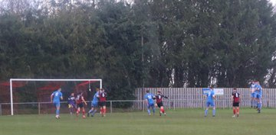
With both sides starting the day in the top five, Brislington’s home clash with Shirehampton looked like the pick of the day’s fixtures, and it certainly played out that way, with Bris coming from three down to win 4-3 in a remarkable Christmas clash. Shirehampton’s away form has been impressive for much of the season, and it looked like they would be enjoying another victory on their travels after goals from Dan Spicer, Ryan Radford and Scott Bamford helped them storm into a three-goal lead inside the opening half hour. Brislington grabbed a lifeline late in the first half thanks to an Asa White penalty, and that proved to be just the boost they needed, with a further White spot kick, plus a goal from Jordan Metters drawing the visitor’s level soon after the break. That set up an unmissable ending to the contest, and it was Brislington who scored the crucial seventh goal of the afternoon, with Oaklan Buck forcing the ball home ten minutes from time to pull off the unbelievable turnaround. In the midday kickoff, Odd Down were the early risers, putting five past Hengrove to pick up their fourth win on the bounce in all competitions. Top scorer Luke Bryan struck in either half for the Bath side, adding to a 28th minute opener from Tyrone Mulholland, with goals in the closing stages from Louis Short and Raphael Waugh completing the one-sided victory. Warminster also enjoyed home comforts, and brought an end to their three-match losing streak by beating Radstock Town 3-1. Having led at the break thanks to Corey Gardner’s opener, Warminster were pegged back early in the second half, before confirming their victory in the closing stages thanks to a fine finish from Eden Mortimer-Taylor. Gillingham Town showed no mercy away at Wincanton, winning 3-0 thanks in part to a pair of first-half dismissals for the home side. The two red cards came inside the opening half hour, but Gillingham could only open up a slim one-goal lead at the interval which was given to them by Tom Jarvis. The visitor’s nerves were eased somewhat 20 minutes from time when Joe Maunsell doubled their advantage, with Jarvis completing his double late in the piece for the victorious Gills. There was also an early red card in the clash at Cothelstone Road, but Cheddar managed to survive for 70 minutes with ten men in their 1-0 win away at Bishops Lydeard (pictured, left). That opening quarter dismissal looked to have given the hosts the impetus, but that didn’t materialise, with Tom Davies’ headed goal, plus a string of impressive saves from Kieran Webster helping the Cheesemen pull off the 1-0 victory. Home sides came out on top in the two Bristol derbies, with AEK Boco holding off Bristol Telephones to prevail by three goals to two, while Kris Miller’s brace helped FC Bristol win 2-1 despite a late stunner from Cory Thomas-Barker for visitors Hallen. In another tight contest, Oldland Abbotonians managed to rescue a 1-1 draw away at Longwell Green, with Mason Davis scoring the equaliser after an hour following Stefan Lee’s flick on. 24 hours later, Almondsbury ended their year on a high, scoring twice early in the second half to take control of their 3-1 win away at Tytherington. With the game level one apiece at the interval, the Almonds scored twice within ten minutes of the restart, with Sam Maunder’s penalty save helping keep their hosts at bay during the closing stages.
Recent Results
Monday 26th December
Premier Division
Ashton & Backwell United 4-0 Keynsham Town
Bridgwater United 2-2 Clevedon Town
Buckland Athletic 3-2 Wellington
Ilfracombe Town 0-3 Barnstaple Town
Millbrook 0-0 Torpoint Athletic
Mousehole 3-0 Helston Athletic
Saltash United 1-3 Falmouth Town
Shepton Mallet 3-1 Welton Rovers
Street 1-1 Sherborne Town
First Division
AEK Boco 3-2 Bristol Telephones
Bishop Sutton P-P Wells City
Bishops Lydeard 0-1 Cheddar
Brislington 4-3 Shirehampton
FC Bristol 2-1 Hallen
Longwell Green Sports 1-1 Oldland Abbotonians
Odd Down 5-1 Hengrove Athletic
Portishead Town 1-1 Nailsea & Tickenham
Warminster Town 3-1 Radstock Town
Wincanton Town 0-3 Gillingham Town

Tuesday 27th December
First Division
Tytherington Rocks 1-3 Almondsbury
Leading Goalscorers (Stats courtesy of FA Fulltime Website)
Premier Division
Jacob Brown (Bridgwater) – 16
Curtis Damerell (Torpoint) - 14
Harry Foster (Street) – 13
Harry Stevens (Ilfracombe) – 13
Rubin Wilson (Helston) – 11

All Competitions
Luke Bryan (Odd Down) – 23
Sacha Tong (FC Bristol) – 22
Jack Thorne (Bridgwater) – 22
Curtis Damerell (Torpoint) – 21
Scott Bamford (Shirehampton) – 21
Adam Wright (Wells) – 20
Jacob Brown (Bridgwater) – 18
Craig Wilson (Bishop Sutton) – 17
Joe Berry (Nailsea/Tickenham) – 16

First Division
Luke Bryan (Odd Down) – 23
Sacha Tong (FC Bristol) – 22
Adam Wright (Wells) – 18
Scott Bamford (Shirehampton) – 18
Craig Wilson (Bishop Sutton) - 17
Joe Berry (Nailsea/Tickenham) – 16

New Year’s Fixtures
Friday 30th December 2022
Premier Division
Welton Rovers vs Street 19:30KO
First Division
Shirehampton vs Portishead Town 19:45KO

Monday 2nd January 2023 (3pm kick-off unless noted)
Premier Division
Barnstaple Town vs Saltash United
Cadbury Heath vs Ashton & Backwell United
Clevedon Town vs Mousehole
Falmouth Town vs Bridgwater United
Helston Athletic vs Shepton Mallet
Sherborne Town vs Ilfracombe Town
Torpoint Athletic vs Buckland Athletic
Wellington vs Millbrook 13:00KO
First Division
Almondsbury vs FC Bristol 14:00KO
Bishops Lydeard vs Nailsea & Tickenham
Bristol Telephones vs Tytherington Rocks 13:00KO
Gillingham Town vs Warminster Town 13:00KO
Hengrove Athletic vs Hallen
Longwell Green Sports vs AEK Boco 13:30KO
Oldland Abbotonians vs Brislington
Radstock Town vs Bishop Sutton
Wells City vs Cheddar
Wincanton Town vs Odd Down 14:00KO

On the most recent episode of the official Podcast, we hear from Mousehole’s Jake Ash and also Alex Pope of Wellington, who reflect on the tragic deaths of Rheiss McLean and Lloyd Manning, and look at what other clubs can learn about the fight for mental heatlh support. There is also a conversation with League Chairman, John Pool, and South West Peninsula League Secretary, Phil Hiscox, who look ahead to the plans for the merger, including what the new league will be called.
Season 2022/23 Podcast Episode 20 | Toolstation Western League (toolstationleague.com)

League Tables
 | PREMIER DIVISION | Played | Won | Drawn | Lost | GD | Points
1 | Saltash United | 22 | 15 | 5 | 2 | 31 | 50
2 | Bridgwater United | 20 | 15 | 4 | 1 | 43 | 49
3 | Shepton Mallet | 19 | 13 | 2 | 4 | 24 | 41
4 | Mousehole | 18 | 11 | 6 | 1 | 27 | 39
5 | Buckland Athletic | 20 | 11 | 2 | 7 | 9 | 35
6 | Barnstaple Town | 17 | 9 | 2 | 6 | 7 | 29
7 | Helston Athletic | 18 | 8 | 5 | 5 | 2 | 29
8 | Clevedon Town | 18 | 7 | 4 | 7 | -2 | 25
9 | Falmouth Town | 17 | 6 | 6 | 5 | 4 | 24
10 | Ashton & Backwell United | 18 | 7 | 3 | 8 | 2 | 24
11 | Street | 18 | 7 | 2 | 9 | -13 | 23
12 | Millbrook | 20 | 6 | 4 | 10 | -14 | 22
13 | Ilfracombe Town | 17 | 4 | 8 | 5 | 2 | 20
14 | Welton Rovers | 22 | 5 | 4 | 13 | -32 | 19
15 | Torpoint Athletic | 20 | 4 | 5 | 11 | -15 | 17
16 | Sherborne Town | 19 | 4 | 4 | 11 | -8 | 16
17 | Cadbury Heath | 19 | 3 | 5 | 11 | -17 | 14
18 | Wellington | 16 | 3 | 4 | 9 | -6 | 13
19 | Keynsham Town | 22 | 3 | 3 | 16 | -44 | 12
 | FIRST DIVISION | Played | Won | Drawn | Lost | GD | Points
1 | Wells City | 24 | 19 | 2 | 3 | 41 | 59
2 | Nailsea & Tickenham | 25 | 18 | 3 | 4 | 51 | 57
3 | Brislington | 23 | 18 | 2 | 3 | 38 | 56
4 | Oldland Abbotonians | 22 | 13 | 5 | 4 | 18 | 44
5 | FC Bristol | 24 | 13 | 3 | 8 | 7 | 42
6 | Shirehampton | 22 | 12 | 4 | 6 | 18 | 40
7 | Odd Down | 24 | 10 | 8 | 6 | 24 | 38
8 | Wincanton Town | 21 | 10 | 4 | 7 | 15 | 34
9 | Bishop Sutton | 22 | 10 | 4 | 8 | 4 | 34
10 | Warminster Town | 22 | 10 | 4 | 8 | 2 | 34
11 | Portishead Town | 21 | 10 | 3 | 8 | 6 | 33
12 | Hengrove Athletic | 26 | 8 | 6 | 12 | -7 | 30
13 | Hallen | 23 | 8 | 5 | 10 | 3 | 29
14 | AEK Boco | 24 | 9 | 2 | 13 | -18 | 29
15 | Longwell Green Sports | 24 | 7 | 5 | 12 | -19 | 26
16 | Gillingham Town | 22 | 7 | 4 | 11 | -7 | 25
17 | Cheddar | 25 | 6 | 5 | 14 | -18 | 23
18 | Almondsbury | 26 | 5 | 5 | 16 | -47 | 20
19 | Bristol Telephones | 25 | 5 | 6 | 14 | -19 | 18*
20 | Tytherington Rocks | 23 | 4 | 6 | 13 | -33 | 18
21 | Radstock Town | 23 | 1 | 10 | 12 | -25 | 13
22 | Bishops Lydeard | 21 | 3 | 4 | 14 | -34 | 13

