Latest Round-ups:
#19
Season 2022/23
Les Phillips Cup: First Division leaders Wells City moved through to the third round of the competition after claiming a 2-1 win away at Warminster. After Craig Herrod put City ahead, they were pegged back soon after when Seb Hounsell levelled for the home side. It was then left to Tom Ellis to score Wells’ winner, with his goal midway through the second half settling the contest in their favour. There was also an away win on Tuesday evening for Helston at Millbrook, with Harrison Jewell putting them one-up during the first half, before second-half sub Rikki Sheppard wrapped things up with the final kick of the game. The other contest that night was a battle between two Cornish sides, with Saltash grabbing a late 2-1 victory at home to Torpoint. Having gone in front through Mike Smith, the hosts saw their lead disappear when former-Ashes skipper Ryan Richards drew Torpoint level. With penalties looming, Jake Miller popped up with an injury time winner to help Saltash qualify for the last 16. There were a couple of high-scoring second round ties on Wednesday, including Clevedon Town’s thumping 6-0 win over Radstock. After Ethan Feltham opened the scoring in the third minute, Nathanial Groom then struck twice inside the opening quarter-hour thanks to a pair of excellent crosses from Freddie King. Hat-trick hero Feltham then scored twice more during the first half to give the Seasiders a five-goal lead at the interval, with King adding the finishing touches five minutes from time with a goal of his own. The other fixture that evening involved nine goals, and involved a ton of drama, with Brislington coming from four goals down to beat Bristol Telephones 5-4! The visitors trailed 4-1 at the interval, before roaring back to draw level thanks to a double from Asa White, plus further goals from Dean Griffiths and Oaklan Buck. It looked as though spot kicks would be required to decide the outcome, but Brislington had one more attack in them, and Buck found enough space and time to fire home to spark dramatic scenes, capping an unbelievable fightback.
League links up with Kitmas Appeal
The Toolstation Western League are delighted to be linking up with this year’s Kitmas Appeal.
Kitmas hopes to brighten to Christmas of many children in the UK, distributing football shirts to children who may not otherwise receive presents this year.
There are two ways you can help brighten a child’s Christmas with a new football shirt this year.
To donate to the Western League’s Kitmas appeal, please follow this link.
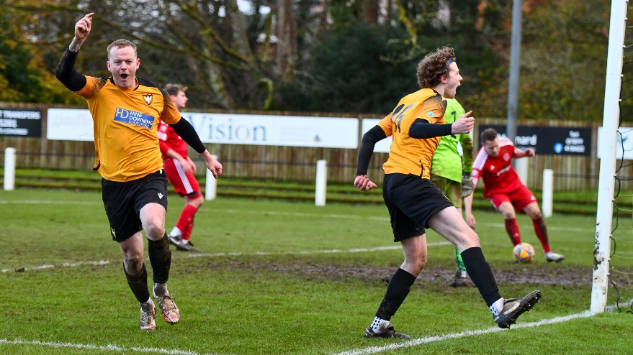
Weekend Action: Despite the weather heavily affecting Saturday’s schedule, there certainly wasn’t a lack of drama, with Falmouth coming out on top in a nine-goal thriller at home to Barnstaple. The first half was a relatively quiet affair in the grand scheme of things, with Callum Laird scoring right before half time to cancel out Tim Nixon’s opener for the hosts. Falmouth then started to turn it on during the opening stages of the second half, and after assisting Luke Brabyn’s first, Nixon then doubled his personal tally to put the home side 3-1 up after an hour. After Brabyn ran clear to extend the lead to 4-1, the game looked to be heading towards a one-sided victory, but Barnstaple had other ideas and set up a frantic final ten minutes following a quickfire double from Laird and Matt Andrew. Then, with five minutes left, the away side found the leveller with Laird completing his hat-trick after reacting fastest to a loose ball in the box. That wasn’t the end of the drama however, and in the second minute of the stoppage time, Falmouth were given a penalty which Tom Annear (pictured celebrating, above) stroked home to put the cap on a memorable fixture. The other Premier Division to survive saw a 1-1 draw between Helston and Buckland, with Rikki Sheppard’s deflected effort bringing the hosts level following Josh Webber’s 21st minute opener. Unfortunately, the majority of Saturday’s football in the First Division fell to pitch inspections, with the only fixture to beat the thaw seeing FC Bristol defeat Longwell Green Sports 2-1 at Oaklands Park.
Recent Results
Tuesday 6th December 2022
Les Phillips Cup
Millbrook 0-2 Helston Athletic
Saltash United 2-1 Torpoint Athletic
Warminster Town 1-2 Wells City

Wednesday 7th December 2022
Les Phillips Cup
Bristol Telephones 4-5 Brislington
Clevedon Town 6-0 Radstock Town

Saturday 10th December
Premier Division
Falmouth Town 5-4 Barnstaple Town
Helston Athletic 1-1 Buckland Athletic
First Division
FC Bristol 2-1 Longwell Green Sports
Upcoming Fixtures
Tuesday 13th December 2022
Premier Division
Clevedon Town vs Keynsham Town 19:30KO First Division
Longwell Green Sports vs Bristol Telephones 19:30KO

Wednesday 14th December 2022
Les Phillips Cup
Almondsbury vs Shirehampton 19:45KO
First Division
FC Bristol vs Cheddar 19:45KO

Saturday 17th December (3pm kick-off unless noted)
Premier Division
Barnstaple Town vs Welton Rovers
Buckland Athletic vs Falmouth Town
Ilfracombe Town vs Shepton Mallet
Keynsham Town vs Helston Athletic
Millbrook vs Street 14:00KO
Saltash United vs Bridgwater United 14:00KO
Sherborne Town vs Cadbury Heath
Torpoint Athletic vs Ashton & Backwell United
Wellington vs Mousehole
First Division
Almondsbury vs Wincanton Town 14:00KO
Bristol Telephones vs Bishops Lydeard 14:00KO
Cheddar vs Longwell Green Sports
Gillingham Town vs Odd Down
Hallen vs AEK Boco
Nailsea & Tickenham vs Brislington
Oldland Abbotonians vs Portishead Town
Radstock Town vs Tytherington Rocks
Warminster Town vs Bishop Sutton
Wells City vs Shirehampton
On the latest episode of the podcast, we hear from Buckland Athletic manager, Dan Hart, who reflects on their terrific run in the FA Vase. There is also a conversation with former Bristol Telephones boss Joe Pople, who reflected on the progress they had made since the start of the season.
Season 2022/23 Podcast Episode 19 | Toolstation Western League (toolstationleague.com)

League Tables
 | PREMIER DIVISION | Played | Won | Drawn | Lost | GD | Points
1 | Saltash United | 21 | 15 | 5 | 1 | 33 | 50
2 | Bridgwater United | 19 | 15 | 3 | 1 | 43 | 48
3 | Shepton Mallet | 18 | 12 | 2 | 4 | 22 | 38
4 | Mousehole | 17 | 10 | 6 | 1 | 24 | 36
5 | Buckland Athletic | 19 | 10 | 2 | 7 | 8 | 32
6 | Helston Athletic | 17 | 8 | 5 | 4 | 5 | 29
7 | Barnstaple Town | 16 | 8 | 2 | 6 | 4 | 26
8 | Clevedon Town | 17 | 7 | 3 | 7 | -2 | 24
9 | Street | 17 | 7 | 1 | 9 | -13 | 22
10 | Falmouth Town | 16 | 5 | 6 | 5 | 2 | 21
11 | Ashton & Backwell United | 16 | 6 | 3 | 7 | 0 | 21
12 | Millbrook | 19 | 6 | 3 | 10 | -14 | 21
13 | Ilfracombe Town | 16 | 4 | 8 | 4 | 5 | 20
14 | Welton Rovers | 21 | 5 | 4 | 12 | -30 | 19
15 | Sherborne Town | 18 | 4 | 3 | 11 | -8 | 15
16 | Cadbury Heath | 19 | 3 | 5 | 11 | -17 | 14
17 | Wellington | 15 | 3 | 4 | 8 | -5 | 13
18 | Torpoint Athletic | 18 | 3 | 4 | 11 | -17 | 13
19 | Keynsham Town | 21 | 3 | 3 | 15 | -40 | 12
 | FIRST DIVISION | Played | Won | Drawn | Lost | GD | Points
1 | Wells City | 24 | 19 | 2 | 3 | 41 | 59
2 | Nailsea & Tickenham | 24 | 18 | 2 | 4 | 51 | 56
3 | Brislington | 22 | 17 | 2 | 3 | 37 | 53
4 | Oldland Abbotonians | 21 | 13 | 4 | 4 | 18 | 43
5 | Shirehampton | 21 | 12 | 4 | 5 | 19 | 40
6 | FC Bristol | 23 | 12 | 3 | 8 | 6 | 39
7 | Odd Down | 23 | 9 | 8 | 6 | 20 | 35
8 | Wincanton Town | 20 | 10 | 4 | 6 | 18 | 34
9 | Bishop Sutton | 22 | 10 | 4 | 8 | 4 | 34
10 | Portishead Town | 20 | 10 | 2 | 8 | 6 | 32
11 | Warminster Town | 21 | 9 | 4 | 8 | 0 | 31
12 | Hengrove Athletic | 25 | 8 | 6 | 11 | -3 | 30
13 | Hallen | 22 | 8 | 5 | 9 | 4 | 29
14 | AEK Boco | 23 | 8 | 2 | 13 | -19 | 26
15 | Longwell Green Sports | 22 | 7 | 4 | 11 | -17 | 25
16 | Gillingham Town | 21 | 6 | 4 | 11 | -10 | 22
17 | Cheddar | 24 | 5 | 5 | 14 | -19 | 20
18 | Tytherington Rocks | 22 | 4 | 6 | 12 | -31 | 18
19 | Almondsbury | 25 | 4 | 5 | 16 | -49 | 17
20 | Bristol Telephones | 23 | 4 | 6 | 13 | -20 | 15*
21 | Radstock Town | 22 | 1 | 10 | 11 | -23 | 13
22 | Bishops Lydeard | 20 | 3 | 4 | 13 | -33 | 13

