Latest Round-ups:
#18
Season 2022/23
FA Vase: Bridgwater United survived with ten men for the entirety of the second half during their hard-fought 1-0 victory at home to Cribbs on Friday evening. Having been given a soft booking within one minute of the game kicking-off, Jack Thorne was then dismissed in first half stoppage time after being awarded his second yellow of the night. Incredibly, the undermanned hosts then took the lead four minutes after the restart, with Jack Taylor heading home a George King cross, and despite upward of ten minutes being added at the end of the game, United held on to book their spot in the fourth round.
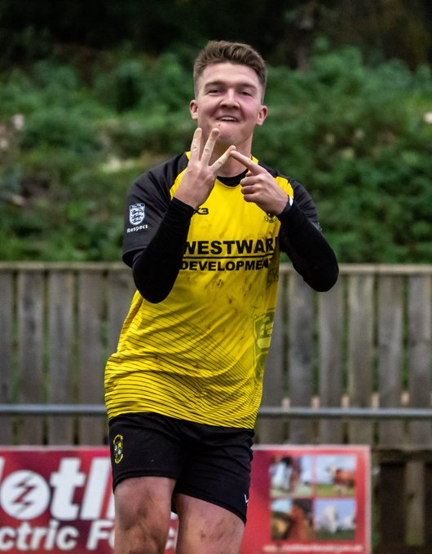
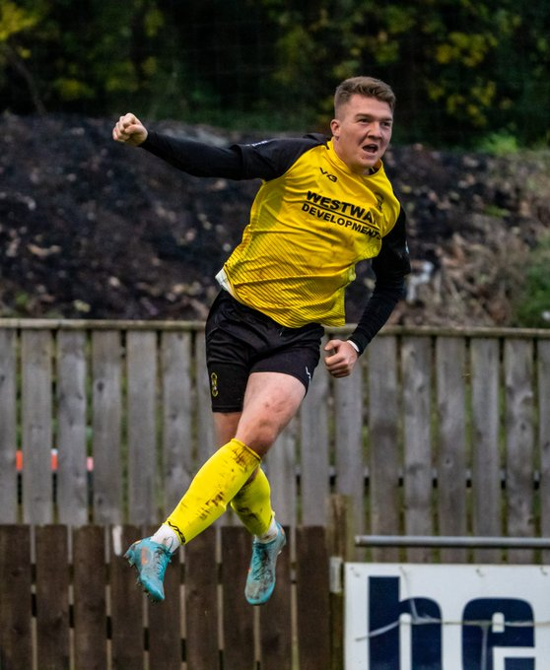
Saturday was equally successful for Western League sides, with both Buckland and Clevedon joining Bridgwater in the last 32 of the competition. For Buckland, it was very much the Ryan Bush show in their 3-0 win over Laverstock & Ford, with the frontman striking a first-half hat-trick. Bush’s first of the afternoon came after 13 minutes, with a left-footed strike across the keeper nestling in the back of the net. He then beat the offside trap to double Buckland’s advantage, before completing his hat-trick in the build up to half-time with a sliding finish (pictured twice, courtesy of Iain Morland). Things were slightly tougher for Clevedon who battled back from late heartbreak to knock out New Milton Spurs thanks to some exemplary spot kicks. A close range finish from Nathanial Groom after 28 minutes looked to have done the business for the Seasiders, but they were denied at the very death with the visitors drawing level from a stoppage time corner. The game then headed to penalties, and after his four teammates had all slotted home from 12 yards, Syd Camper followed suit to confirm Town’s passage through to next round of the competition.

Premier Division: On Friday night, Welton secured their first clean sheet of the entire season in beating Cadbury Heath 2-0. Billy Manning scored with Rovers first attack of the game to put them ahead, with Lewis Russell then doubling their advantage early in the second half, as Welton grabbed the victory, in the process registering their first shutout this season at the 25th time of asking. The following afternoon, Shepton Mallet continued their perfect start under the new management team by beating Millbrook 3-0. Fin Haines’ opener at the end of the first half put Mallet in front, with Danny Constable then doubling their advantage two minutes after the restart to put their visitors firmly on the back foot. It was then left to Haines to complete the victory, with his glancing header 15 minutes from time ending any hopes of a Millbrook fightback. Saltash managed to extend their lead atop the division by a single point after salvaging a late 2-2 draw at home to Ilfracombe. Having gone ahead at the beginning of the second half through Charlie Elkington, the Ashes found themselves 2-1 down heading into the final 15 minutes following a pair of smart finishes from Ilfracombe regulars Liam Short and Harry Stevens. Then, with just five minutes left on the clock, Adam Carter struck for the hosts to grab a share of the spoils, extending their long unbeaten run in the process. Elsewhere in Cornwall, a couple of the county’s sides drew one apiece, with Torpoint’s leading scorer Curtis Damerell helping his side come from a goal down to tie Falmouth who had led for less than three minutes through Olly Walker. Mousehole racked up their tenth league victory of the campaign after overturning an early deficit to beat Keynsham 3-2 at Trungle Parc. After Owen Brain gave the K’s a surprise fourth minute lead, Mousehole managed to get back on level terms just after the half hour mark through Jack Calver. A quickfire double from Mark Goldsworthy and Tallan Mitchell around the mid-point of the second half suddenly saw the hosts move two in front, and despite conceding to Tyler Linton, and also seeing Mitchell red carded, the Seagulls managed to hold on for an entertaining home victory. In the day’s early kickoff, Sam Farthing scored a second-half equaliser in Sherborne’s 2-2 draw away at Ashton & Backwell, while goals from Rikki Sheppard and Sam Carter, and a penalty save by Kyle Moore helped Helston secure an impressive 2-0 win away at Barnstaple.

On the latest episode of the podcast, Western League Fixture Secretary, George McCaffery joins Ian to talk about the impact a bad weekend of weather has had on the fixtures. There is a also a conversation with AEK Boco manager Spencer Thomas, who explains why he’s committed to the clubs philosophy of developing young players, even when results don’t go their way.
Season 2022/23 Podcast Episode 18 | Toolstation Western League (toolstationleague.com)

First Division: On a busy Friday evening of action, Wincanton Town made a strong return to Moor Lane, scoring twice in either half to defeat Tytherington 4-0 in front of a healthy home crowd. Having not played on home turf since January, the Wasps made a dream start, with Dan Dix and Callum Small putting them two-up within the opening 12 minutes. Wincanton then had to wait until the closing stages before confirming the victory, with Dan Quirke and Jamie Irwin adding further goals in the final few minutes. Elsewhere that evening, second half goals from Dan Spicer and Will Gallagher led Shirehampton to a 2-0 win away at Warminster, while super-sub Zac Cheetham grabbed a dramatic 88th minute winner for Longwell Green Sports, helping them defeat Hallen 2-1 in an entertaining contest under the lights.
In a big day at the top of the table, Wells City moved three points clear thanks to a come-from-behind 2-1 win away at FC Bristol. Having fallen behind to their sixth-placed hosts during the opening moments, Wells completed a late turnaround, with Ben Robertson’s header followed by a free kick from Ali Sen helping them grab maximum points. Nailsea & Tickenham have now fallen three points back after suffering a rare 3-1 defeat at the hands of Gillingham Town. Jordon Clapp’s double and a Max Westlake effort did the business for the Gills who ended a four-match winless run in terrific fashion. Third-place Brislington also capitalised on Nailsea’s defeat, and are now just three points in arrears after beating AEK Boco 4-1. Oaklan Buck gave the visitors a dream start, putting them in front after less than 60 seconds, with George Jones then making it 2-0 inside the opening ten minutes. A second Jones effort midway through the first half continued Brislington’s ascendancy, with Jordan Ricketts adding the finishing touches late on from the penalty spot. Another side to win on their travels were Bishop Sutton, with their poor recent run in the league put to bed following a 2-1 triumph at Portishead. Sutton’s leading marksman Craig Wilson was the difference between the two sides, and after breaking the deadlock in the 21st minute, Wilson then struck again in the closing stages to keep the home side at bay. The biggest winners of the day were Bristol Telephones, with Archie Dark’s double helping spearhead their thumping 5-0 win at home to Almondsbury. Sam Thomas, Finn Sykes and Javi Blazquez also got on the scoresheet for the Phones who are now unbeaten in three and have moved off of bottom spot thanks to their recent run. In Bath, Courtney Charles played a starring role for Odd Down who came out on top in a five-goal thriller at home to Cheddar. Having gifted their visitors a 21st minute lead following an own-goal, Charles executed a scissor kick to draw Odd Down level after half an hour. Charles then struck once more to put his side 2-1 up at the interval, with the Cheesemen fighting back to level affairs midway through the second half. The influential Charles had a major hand in the winning goal, with his flick through putting Luke Bryan in position to rifle home with his left foot after 85 minutes to grab all three points. Oldland Abbotonians skipper Cash Vinall beat four men before striking a 93rd minute equaliser in his side’s 1-1 draw away at Bishops Lydeard, with Radstock and Hengrove sharing the points after their contest finished with the same scoreline.

Recent Results
Friday 2nd December
FA Vase Third Round
Bridgwater United 1-0 Cribbs
Premier Division
Welton Rovers 2-0 Cadbury Heath
First Division
Longwell Green Sports 2-1 Hallen
Warminster Town 0-2 Shirehampton
Wincanton Town 4-0 Tytherington Rocks

Saturday 3rd December
FA Vase Third Round
Buckland Athletic 3-0 Laverstock & Ford
Clevedon Town 1-1 (5-3 pens) New Milton Town
Premier Division
Ashton & Backwell United 2-2 Sherborne Town
Barnstaple Town 0-2 Helston Athletic
Mousehole 3-2 Keynsham Town
Saltash United 2-2 Ilfracombe Town
Shepton Mallet 3-0 Millbrook
Torpoint Athletic 1-1 Falmouth Town
First Division
AEK Boco 1-4 Brislington
Bishops Lydeard 1-1 Oldland Abbotonians
Bristol Telephones 5-0 Almondsbury
FC Bristol 1-2 Wells City
Gillingham Town 3-1 Nailsea & Tickenham
Odd Down 3-2 Cheddar
Portishead Town 1-2 Bishop Sutton
Radstock Town 1-1 Hengrove Athletic
Leading Goalscorers (Stats courtesy of FA Fulltime Website)
Premier Division
Jacob Brown (Bridgwater) – 16
Harry Foster (Street) – 13
Curtis Damerell (Torpoint) - 14
Harry Stevens (Ilfracombe) – 12
Rubin Wilson (Helston) – 11

All Competitions
Jack Thorne (Bridgwater) – 22
Luke Bryan (Odd Down) – 21
Sacha Tong (FC Bristol) – 21
Scott Bamford (Shirehampton) – 20
Adam Wright (Wells) – 20
Curtis Damerell (Torpoint) – 19
Jacob Brown (Bridgwater) – 18
Craig Wilson (Bishop Sutton) – 17
Joe Berry (Nailsea/Tickenham) – 16
Harry Foster (Street) – 15
Rubin Wilson (Mousehole) - 15

First Division
Sacha Tong (FC Bristol) – 21
Jack Thorne (Nailsea/Tickenham) – 21
Luke Bryan (Odd Down) – 21
Adam Wright (Wells) – 18
Craig Wilson (Bishop Sutton) - 17
Scott Bamford (Shirehampton) – 17
Joe Berry (Nailsea/Tickenham) – 16

Upcoming Fixtures
Tuesday 6th December 2022
Les Phillips Cup
Millbrook vs Helston Athletic 19:45KO
Saltash United vs Torpoint Athletic 19:30KO
Warminster Town vs Wellington 19:45KO

Wednesday 7th December 2022
Les Phillips Cup
Clevedon Town vs Radstock Town 19:30KO
First Division
Shirehampton vs Gillingham Town 19:30KO

Saturday 10th December (3pm kick-off unless noted)
Premier Division
Ashton & Backwell United vs Bridgwater United
Cadbury Heath vs Millbrook 14:00KO
Falmouth Town vs Barnstaple Town
Helston Athletic vs Buckland Athletic
Keynsham Town vs Saltash United
Shepton Mallet vs Torpoint Athletic
Sherborne Town vs Clevedon Town
Wellington vs Ilfracombe Town 14:00KO
Welton Rovers vs Mousehole
First Division
AEK Boco vs Portishead Town 14:00KO
Almondsbury vs Hallen 14:00KO
Bishop Sutton vs Bristol Telephones
Brislington vs Radstock Town
Cheddar vs Oldland Abbotonians
FC Bristol vs Longwell Green Sports
Gillingham Town vs Shirehampton
Hengrove Athletic vs Bishops Lydeard
Odd Down vs Nailsea & Tickenham
Tytherington Rocks vs Wells City
Wincanton Town vs Warminster Town 14:00KO

League Tables
 | PREMIER DIVISION | Played | Won | Drawn | Lost | GD | Points
1 | Saltash United | 21 | 15 | 5 | 1 | 33 | 50
2 | Bridgwater United | 19 | 15 | 3 | 1 | 43 | 48
3 | Shepton Mallet | 18 | 12 | 2 | 4 | 22 | 38
4 | Mousehole | 17 | 10 | 6 | 1 | 24 | 36
5 | Buckland Athletic | 18 | 10 | 1 | 7 | 8 | 31
6 | Helston Athletic | 16 | 8 | 4 | 4 | 5 | 28
7 | Barnstaple Town | 15 | 8 | 2 | 5 | 5 | 26
8 | Clevedon Town | 17 | 7 | 3 | 7 | -2 | 24
9 | Street | 17 | 7 | 1 | 9 | -13 | 22
10 | Ashton & Backwell United | 16 | 6 | 3 | 7 | 0 | 21
11 | Millbrook | 19 | 6 | 3 | 10 | -14 | 21
12 | Ilfracombe Town | 16 | 4 | 8 | 4 | 5 | 20
13 | Welton Rovers | 21 | 5 | 4 | 12 | -30 | 19
14 | Falmouth Town | 15 | 4 | 6 | 5 | 1 | 18
15 | Sherborne Town | 18 | 4 | 3 | 11 | -8 | 15
16 | Cadbury Heath | 19 | 3 | 5 | 11 | -17 | 14
17 | Wellington | 15 | 3 | 4 | 8 | -5 | 13
18 | Torpoint Athletic | 18 | 3 | 4 | 11 | -17 | 13
19 | Keynsham Town | 21 | 3 | 3 | 15 | -40 | 12
 | FIRST DIVISION | Played | Won | Drawn | Lost | GD | Points
1 | Wells City | 24 | 19 | 2 | 3 | 41 | 59
2 | Nailsea & Tickenham | 24 | 18 | 2 | 4 | 51 | 56
3 | Brislington | 22 | 17 | 2 | 3 | 37 | 53
4 | Oldland Abbotonians | 21 | 13 | 4 | 4 | 18 | 43
5 | Shirehampton | 21 | 12 | 4 | 5 | 19 | 40
6 | FC Bristol | 22 | 11 | 3 | 8 | 5 | 36
7 | Odd Down | 23 | 9 | 8 | 6 | 20 | 35
8 | Wincanton Town | 20 | 10 | 4 | 6 | 18 | 34
9 | Bishop Sutton | 22 | 10 | 4 | 8 | 4 | 34
10 | Portishead Town | 20 | 10 | 2 | 8 | 6 | 32
11 | Warminster Town | 21 | 9 | 4 | 8 | 0 | 31
12 | Hengrove Athletic | 25 | 8 | 6 | 11 | -3 | 30
13 | Hallen | 22 | 8 | 5 | 9 | 4 | 29
14 | AEK Boco | 23 | 8 | 2 | 13 | -19 | 26
15 | Longwell Green Sports | 21 | 7 | 4 | 10 | -16 | 25
16 | Gillingham Town | 21 | 6 | 4 | 11 | -10 | 22
17 | Cheddar | 24 | 5 | 5 | 14 | -19 | 20
18 | Tytherington Rocks | 22 | 4 | 6 | 12 | -31 | 18
19 | Almondsbury | 25 | 4 | 5 | 16 | -49 | 17
20 | Bristol Telephones | 23 | 4 | 6 | 13 | -20 | 15*
21 | Radstock Town | 22 | 1 | 10 | 11 | -23 | 13
22 | Bishops Lydeard | 20 | 3 | 4 | 13 | -33 | 13

