Latest Round-ups:
#16
Season 2022/23
Midweek Action: The weather saw much of the midweek Les Phillips Cup schedule wiped out, but three fixtures managed to beat the rain as the competition starts to reach the latter stages. The only clash on Wednesday evening saw FC Bristol defeat fellow First Division outfit Wincanton 2-0, with Andre Freckleton and substitute Niekell Plummer scoring either side of the interval. Also qualifying for the next round were Wellington, who produced an outstanding performance to win 4-2 away at Bridgwater United. The visitors were excellent during the opening half, and led 3-1 at the interval thanks to efforts from Jake Quick, Harvey Dorothy and Joe Wragg. Bridgwater pulled back to within a goal, but it was Wellington who had the last word, with Quick wrapping up the victory in stoppage time to complete his goalscoring double. The other tie to survive the rain saw Cadbury Heath edge past Longwell Green Sports on penalties, after the game finished 2-2 at the end of 90 minutes. Two goals from Heath forward Ali Boyer helped send the game to spot kicks, where Jordan Schofield saved crucially to give the visitors a nail-biting 8-7 penalty victory.
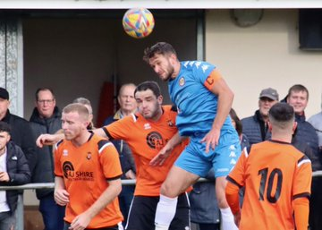
Premier Division: Bridgwater United moved to within a point of top spot on Saturday afternoon after claiming an impressive 2-0 win away at Barnstaple. The contest didn’t start too well for Bridgy who lost Jordan Greenwood to a 25th minute red card, but they responded extremely well, going ahead just moments later when debutant Jack Thorne slotted home. Having joined from Nailsea & Tickenham earlier in the week, Thorne made an instant impact for his new club, adding to his reputation which saw him atop the First Division scoring charts this term. The ten men continued to battle, and managed to wrap up victory 20 minutes from time when Jack Taylor slotted past the Town keeper. Saltash still sit in top spot despite dropping two points in a 1-1 draw away at 17th placed Wellington (pictured right, courtesy of @AroundWelly). Having gone in front towards the end of the first half thanks to a header from skipper Dave Barker, Saltash let slip their winning position when Jamie Nicholson levelled for the hosts with an excellent dipping finish.
Bottom-side Keynsham earned their first victory since early September after striking late on to defeat Millbrook by two goals to one. The game didn’t start well for the K’s who fell behind inside the opening five minutes, but they soon managed to get back on level terms thanks to a well-taken finish from Henry Sady. The score remained locked at one apiece for the reminder of the 90 minutes, but Keynsham produced some late magic with Sady striking again in stoppage time to secure the much-awaited win. The most dominant performance of the day belonged to Buckland who strolled to a 6-1 thumping of Street at Homers Heath. Goals from Josh Webber and Cieran Bridger saw the Bucks lead by two at the interval, with Ryan Bush then adding a third just 11 seconds after the restart. Bush then struck again three minutes later to push the lead out to four, with further goals from Scott Crocker and Sam Stayt completing the scoring. Helston’s strong recent form continued at home to Welton, where three goals in the final 15 minutes helped push them to a 4-0 victory. Tom Payne’s chip had put Helston ahead in added time at the end of the first half, with Rubin Wilson’s belter 14 minutes from time finally giving them a two-goal advantage. Sam Carter then added home Helston’s third, before Wilson struck again just prior to the full-time whistle to extend the hosts winning run. At Raleigh Grove, Reece Thomson’s magnificent hat-trick spearheaded Mousehole’s 4-1 win over Sherborne Town. After Mark Goldsworthy put the visitors in front after only two minutes, Thomson then doubled their advantage midway through the first half. Alex Murphy pulled a goal back for the Zebras on the hour mark, but it was Thomson and Mousehole who took home maximum points, with his two second-half strikes seeing him complete a terrific treble. Harry Stevens and Jed Harper-Penman were each on the scoresheet during Ilfracombe’s 3-0 win away at Cadbury Heath, while Falmouth topped Ashton & Backwell by two goals to one thanks to efforts from Charlie Edney and Jack Bray-Evans. At the Hand Stadium (pictured below), Clevedon Town eventually came out on top in a topsy-turvy encounter over Torpoint Athletic following Alex Camm’s injury time winner. A Sam Tillson header early in the second half cancelled out Freddie King’s opener, before Nathaniel Groom powered home a headed effort of his own 15 minutes from time to restore Clevedon’s advantage. Torpoint responded instantly to set up a dramatic finish, and it was the home side who made the decisive move with Camm converting an injury time penalty after King had been felled in the area.

First Division: Nailsea & Tickenham have taken ownership of first place, with their 3-0 victory away at Almondsbury helping them leapfrog Wells City on goal difference. Luke Osgood’s first half strike set Nailsea on their way, before efforts after the interval from Joe Berry and Jared Ford rounded out the win. Wells meanwhile were denied by Hengrove, with their 1-1 draw overshadowed by three red cards. An own goal had put City in position to secure another three points, but Hengrove battled back and secured a share of the spoils thanks a leveller from Connor Kingdon. Brislington have become the third team to reach 50 points this season after beating Bishop Sutton by three goals to nil at Lakeview. After former Sutton frontman Oaklan Buck had broken the deadlock 18 minutes from time, Brislington continued to push during the closing stages, with Joe McLennan and Asa White adding some gloss to the scoreline during the final ten minutes. Portishead were another side to prevail by three goals to nil, with a brace from Hamish Hurst helping lead them to victory at home to Bishops Lydeard. Elsewhere, the top –five battle between Oldland and Shirehampton went the way of the home side, with the Abbots securing a come-from-behind 5-2 triumph. Jay Spicer’s third minute effort gave Shirehampton a dream start, but they had fallen behind by the time the game reached half-time, with Owen McCallum’s tight finish followed up late in the first period by an excellent free-kick from Harry Pruett. Substitute Mason Davis helped extend Oldland’s advantage, with Stefan Lee then making it 4-1 soon after to put the result beyond doubt. To their credit, the visitors kept pushing and claimed a late consolation thanks to a George Brimson header, but it was the gallant Oldland side who had the last word, with Cash Vinall’s injury time penalty giving them their fifth of the afternoon.
The weekend action actually got underway on Friday evening under the lights at Hallen, where Aaron Blakemore grabbed an equaliser for the hosts during their 1-1 draw with Bristol Telephones. That scoreline was then mirrored on Saturday afternoon at Cheddar, with the Cheesemen denying Radstock at the death. The Miners had put themselves in position to claim back-to-back wins when Josh Brace’s stunner put them ahead early in the second half, but they were unable to hang on to their lead with Ryan Eardley levelling two minutes from time. The points were also shared in Tytherington’s goalless home draw against Odd Down, while a solitary goal from Tyson Pollard on his second debut for Warminster helped them edge past AEK Boco by the barest of margins. Things were slightly easier for Longwell Green Sports who put four past the in-form Gillingham to leapfrog them in the table. Matt Brown was very much the hero for Longwell Green, with his hat-trick help put an end to the Gills six-match unbeaten run. Another side to run out home winners were Wincanton Town, with a dominant second half performance helping lead them to a 5-1 defeat of FC Bristol. In fact it was the visitors who went ahead after 33 minutes thanks to a Jennison Williams long ranger, only for Lewis Voizey to draw Winky level in first half stoppage time. Town then completed their turnaround early in the second half through Louis Irwin, before a Cam Allen double and a further effort from Callum Small helped the home side run out comfortable victors.

Recent Results
Tuesday 15th November
Les Phillips Cup
Bridgwater United 2-4 Wellington
Longwell Green Sports 2-2 (7-8 pens) Cadbury Heath
Wednesday 16th November
Les Phillips Cup
FC Bristol 2-0 Wincanton Town

Friday 18th November
First Division
Hallen 1-1 Bristol Telephones

Saturday 19th November
Premier Division
Barnstaple Town 0-2 Bridgwater United
Buckland Athletic 6-1 Street
Cadbury Heath 0-3 Ilfracombe Town
Clevedon Town 3-2 Torpoint Athletic
Falmouth Town 2-1 Ashton & Backwell United
Helston Athletic 4-0 Welton Rovers
Keynsham Town 2-1 Millbrook
Sherborne Town 1-4 Mousehole
Wellington 1-1 Saltash United
First Division
Almondsbury 0-3 Nailsea & Tickenham
Bishop Sutton 0-3 Brislington
Cheddar 1-1 Radstock Town
Hengrove Athletic 1-1 Wells City
Longwell Green Sports 4-1 Gillingham Town
Oldland Abbotonians 5-2 Shirehampton
Portishead Town 3-0 Bishops Lydeard
Tytherington Rocks 0-0 Odd Down
Warminster Town 1-0 AEK Boco
Wincanton Town 5-1 FC Bristol
On this week’s podcast, we hear from Barnstaple boss, Craig Laird, who discusses their five-year strategy, and why he supports the planned merger. There is also a conversation with Hengrove’s manager, Jamie Hillman, who touches on the development of his young side and why he’s looking to turn performances into points.
Season 2022/23 Podcast Episode 16 | Toolstation Western League (toolstationleague.com)

Upcoming Fixtures
Tuesday 22nd November
Les Phillips Cup
Bishop Sutton vs Ilfracombe Town 19:30KO
Gillingham Town vs Sherborne Town 19:45KO
Tytherington Rocks vs Keynsham Town 19:45KO
Premier Division
Millbrook vs Mousehole 19:45KO

Wednesday 23rd November
Les Phillips Cup
Bristol Telephones vs Brislington 19:45KO
Falmouth Town vs Barnstaple Town 19:45KO

Thursday 24th November
First Division
Nailsea & Tickenham vs Longwell Green Sports 19:30KO

Saturday 26th November (3pm kick-off unless noted)
Premier Division
Clevedon Town vs Welton Rovers
Falmouth Town vs Sherborne Town
Ilfracombe Town vs Helston Athletic
Keynsham Town vs Shepton Mallet
Mousehole vs Ashton & Backwell United
Saltash United vs Millbrook
Street vs Barnstaple Town
Torpoint Athletic vs Wellington
First Division
Brislington vs Tytherington Rocks
Bristol Telephones vs Wincanton Town
Cheddar vs Almondsbury 14:00KO
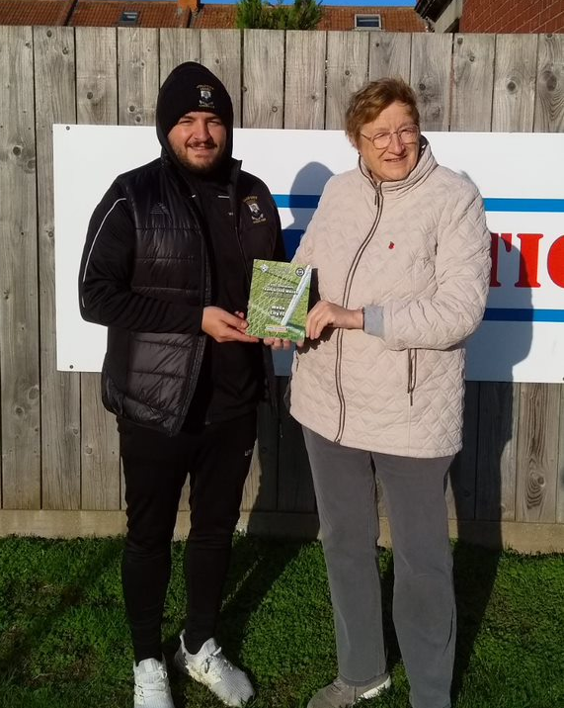
FC Bristol vs Warminster Town
Gillingham Town vs Hengrove Athletic
Hallen vs Bishops Lydeard
Oldland Abbotonians vs Radstock Town
Portishead Town vs Odd Down
Shirehampton vs Bishop Sutton
Wells City vs AEK Boco

Awards Update
Pictured right is Wells City manager Shaun Potter receiving the First Division Team of the Month Award from league Director, Sue Merrill.

League Tables
 | PREMIER DIVISION | Played | Won | Drawn | Lost | GD | Points
1 | Saltash United | 20 | 15 | 4 | 1 | 33 | 49
2 | Bridgwater United | 19 | 15 | 3 | 1 | 43 | 48
3 | Mousehole | 16 | 9 | 6 | 1 | 23 | 33
4 | Shepton Mallet | 16 | 10 | 2 | 4 | 13 | 32
5 | Buckland Athletic | 18 | 10 | 1 | 7 | 8 | 31
6 | Helston Athletic | 15 | 7 | 4 | 4 | 3 | 25
7 | Barnstaple Town | 13 | 7 | 2 | 4 | 6 | 23
8 | Street | 16 | 7 | 1 | 8 | -11 | 22
9 | Clevedon Town | 16 | 6 | 3 | 7 | -3 | 21
10 | Millbrook | 18 | 6 | 3 | 9 | -11 | 21
11 | Ashton & Backwell United | 15 | 6 | 2 | 7 | 0 | 20
12 | Ilfracombe Town | 15 | 4 | 7 | 4 | 5 | 19
13 | Falmouth Town | 14 | 4 | 5 | 5 | 1 | 17
14 | Welton Rovers | 19 | 4 | 4 | 11 | -31 | 16
15 | Sherborne Town | 17 | 4 | 2 | 11 | -8 | 14
16 | Cadbury Heath | 18 | 3 | 5 | 10 | -15 | 14
17 | Wellington | 15 | 3 | 4 | 8 | -5 | 13
18 | Torpoint Athletic | 17 | 3 | 3 | 11 | -17 | 12
19 | Keynsham Town | 19 | 3 | 3 | 13 | -33 | 12
 | FIRST DIVISION | Played | Won | Drawn | Lost | GD | Points
1 | Nailsea & Tickenham | 23 | 18 | 2 | 3 | 53 | 56
2 | Wells City | 22 | 18 | 2 | 2 | 41 | 56
3 | Brislington | 21 | 16 | 2 | 3 | 34 | 50
4 | Oldland Abbotonians | 20 | 13 | 3 | 4 | 18 | 42
5 | Shirehampton | 20 | 11 | 4 | 5 | 17 | 37
6 | FC Bristol | 20 | 11 | 3 | 6 | 10 | 36
7 | Portishead Town | 18 | 10 | 2 | 6 | 8 | 32
8 | Bishop Sutton | 21 | 9 | 4 | 8 | 3 | 31
9 | Wincanton Town | 18 | 9 | 3 | 6 | 14 | 30
10 | Odd Down | 21 | 7 | 8 | 6 | 18 | 29
11 | Warminster Town | 19 | 8 | 4 | 7 | -2 | 28
12 | Hallen | 20 | 7 | 5 | 8 | -2 | 26
13 | Hengrove Athletic | 23 | 7 | 5 | 11 | -4 | 26
14 | AEK Boco | 21 | 7 | 2 | 12 | -17 | 23
15 | Longwell Green Sports | 20 | 6 | 4 | 10 | -17 | 22
16 | Gillingham Town | 19 | 5 | 4 | 10 | -11 | 19
17 | Tytherington Rocks | 21 | 4 | 6 | 11 | -27 | 18
18 | Cheddar | 22 | 4 | 5 | 13 | -19 | 17
19 | Almondsbury | 23 | 4 | 5 | 14 | -43 | 17
20 | Bristol Telephones | 21 | 3 | 5 | 13 | -25 | 14
21 | Radstock Town | 21 | 1 | 9 | 11 | -23 | 12
22 | Bishops Lydeard | 18 | 3 | 3 | 12 | -26 | 12

