Latest Round-ups:
#15
Season 2022/23
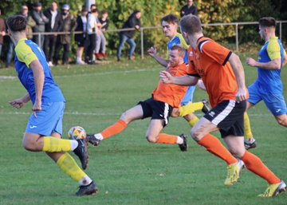
FA Vase: It was a mixed bag results wise for the Western League sides in Vase action, with a trio of Premier Division sides moving through to the next round following resounding wins. Clevedon Town were one of those to progress after they flew out of the blocks in their 4-0 victory at home to Mangotsfield. After Mitch Osmond’s long ranger put the Seasiders ahead within two minutes of the game kicking off, they then moved two clear soon after thanks to Ethan Feltham. Archie Ferris then curled home a third in the 13th minute to add to Clevedon’s dream start, with Alex Camm’s second half penalty then completing the scoring. Things went equally well for Bridgwater who scored four unanswered goals of their own in a win away at Elburton Villa. A 16th minute penalty from Jack Taylor sent the ball rolling, with an effort early in the second half from David Thorne then giving them a slightly more comfortable buffer. Top scorer Jake Brown increased the lead to three with Bridgwater’s next attack, before the influential Tom Llewellyn then added a late fourth. The other Toolstation side to move on to the next round were Buckland, with Ryan Bush helping spearhead a come-from-behind win at home to Cullompton Rangers. Having fallen behind to a counter-attacking goal after half an hour, the Bucks regrouped at the interval, with Bush stroking them level five minutes after the restart. Bush then struck again on the hour mark to turn the game in the home side’s favour, with Cieran Badger pushing the lead out to two with a curled finish. Buckland then scored twice more in stoppage time to add some gloss to the victory, with Rob Farkins and Owen Stockton adding their names to the scoresheet. Wellington (pictured, left) were unfortunate not to add their name to the list of Western League success stories, after they were defeated on penalties by Royal Wootton Bassett Town. Having fallen behind in the opening stages, Wellington responded extremely well, and went 2-1 up in added time at the end of the first half thanks to a pair of goals from Henry Woodward and Jake Quick. The Royal visitors kept pushing however, and were rewarded ten minutes from time following Landon Golding’s equaliser, before then prevailing on spot kicks. A pair of Cornish sides were also came unstuck on Saturday afternoon, with Mousehole losing 2-1 against Hartpury College, and Falmouth suffering defeat by the same scoreline away at Laverstock & Ford.
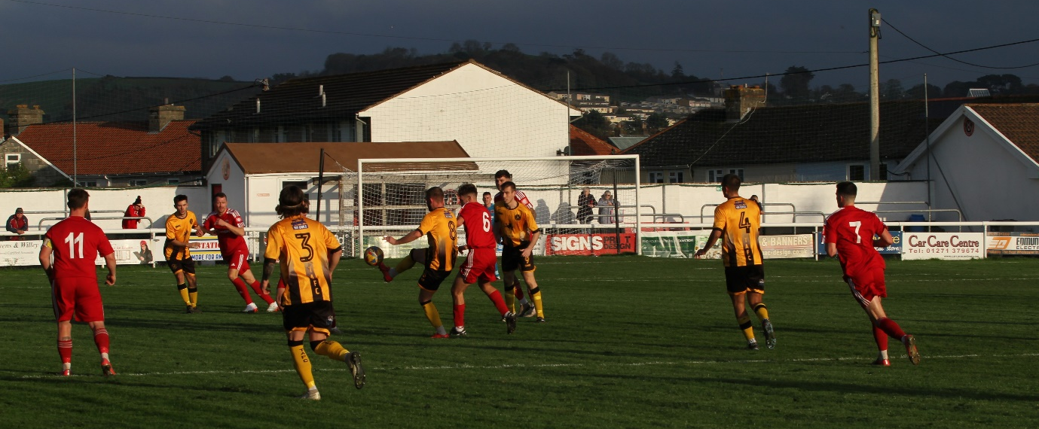
Premier Division: Saltash United took full advantage of Bridgwater being in cup action, with a 2-0 win away at Sherborne helping them jump up into top spot. The Ashes showed no signs that they were feeling the pressure during the opening passages, taking a ninth minute lead through Mike Smith after he did well to convert Alex Cairo’s pin-point cross. Smith’s goal was all that stood between the sides for much of the afternoon, but then with just three minutes remaining, Harrison Davis fired home a set-piece to confirm Saltash’s ascension to the head of the division. It was a day of tight matches up and down the division, with a trio of 1-0 victories helping some of the other top half clubs gather three points. One such victor were Shepton Mallet, who battled back after a tough week to beat Ashton & Backwell thanks to Josh Jenkins’ 25-yarder in first half stoppage time. Tommy Rogers was the difference maker for Barnstaple, scoring on his first start for the club in their 1-0 win over Torpoint, while Toby Davey struck deep into stoppage time to help lead Street to a dramatic victory over Keynsham at the Tannery Ground. Things were equally tight between Millbrook and Ilfracombe, with the visitors levelling early in the second half to grab a 1-1 draw, and at Kellaway Park, Helston moved up to 7th after a first-half double from Tom Payne helped them defeat Cadbury Heath by two goals to nil.
Action from Barnstaple’s Premier Division clash with Torpoint, courtesy of Nathan Bennett.
First Division: Home teams were thoroughly on top during Saturday’s slate of First Division contests, suffering just one defeat between them. Among the home victors were Brislington who excelled after the interval in their 4-1 defeat of Bishops Lydeard. After Danny Dodimead put them ahead in the 27th minute, Jordan Ricketts then turned home a corner to give Bris the perfect start to the second half. The Lyds did manage to trim the deficit, but their high-flying hosts ran out comfortable victors thanks to a couple of smart finishes from Oaklan Buck and James Dunn. Shirehampton continue to impress, and remain unbeaten since early September following a 5-0 victory at home to Bristol Telephones. Scott Bamford was the star man for Shirehampton, and after scoring the only first half goal, he then added a quickfire double in the closing stages to round out the victory. At the opposite end of the table, Radstock Town’s recent improvements finally paid off as they captured their first league win of the campaign. A couple of recent draws had seen the Miners start to increase their point tally, and they added three more after goals from Jack Farion and Kieran Cooper led them to a 2-1 triumph over Longwell Green Sports. Table-toppers Wells City survived a late penalty attempt to defeat Hallen in an entertaining affair at the Athletic Ground. A frantic start to the contest saw Wells go 2-1 up inside the opening quarter, with Cory Thomas-Barker then drawing the visitors level 15 minutes from time. City converted their second penalty of the game to move back ahead less than three minutes later, and then with the final kick of the game, Hallen’s Adnan Hiroli missed the chance to grab a share of the spoils after failing to score from the spot himself.
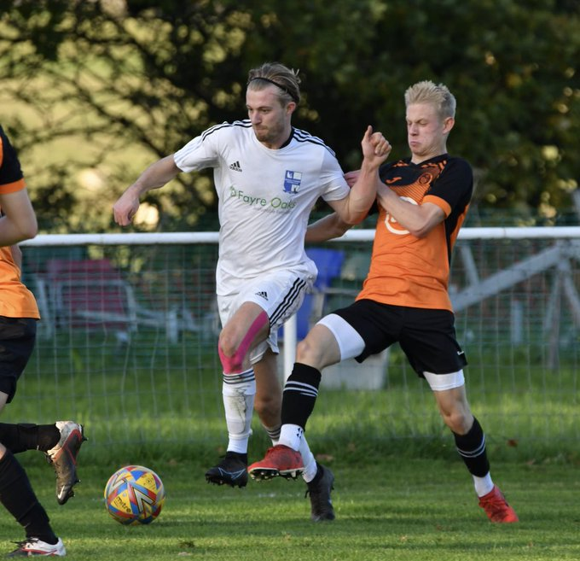
The individual performance of the day belonged to Hengrove’s Jack Jones, with his four goals leading them to a 5-2 defeat of Warminster. It was Alfie Hemmings who struck first for the Grove, before an own goal levelled affairs soon after. Jones then took over the contests, striking twice at the end of the half to put Hengrove 3-1 up at the interval. Warminster battled their way back into the contest once again through Spencer Dymond, but Jones wouldn’t allow them to get any closer, with his two goals in the final 20 minutes completing Hengrove’s victory. The other side to grab five were Wincanton, with the lone away victors on Saturday gaining revenge over an AEK Boco outfit they suffered defeat to earlier in the campaign. Second-placed Nailsea & Tickenham maintained their own winning run, with Jack Thorne’s double helping lead them to a 3-1 victory over Tytherington (pictured, left) while in the day’s early kick-off, Josh Honey curled home ten from time to help Portishead sneak past Almondsbury 1-0. There was a surprising goalless draw at Lakeview between Bishop Sutton and the free-scoring Gillingham Town, with the points also shared in Bath where Odd Down drew one apiece with Oldland Abbotonians.

On the latest episode of the podcast, Bridgwater United boss, Dave Pearse, reflects on where his side are at the halfway stage of their season. There is also a conversation with Ray Johnston, who explains why there’s plenty of positivity at Radstock despite the fact that the Miners haven’t won a league game yet this season!
Season 2022/23 Podcast Episode 15 | Toolstation Western League (toolstationleague.com)

Recent Results
Saturday 12th November
FA Vase
Buckland Athletic 5-1 Cullompton Rangers
Clevedon Town 4-0 Mangotsfield United
Elburton Villa 0-4 Bridgwater United
Laverstock & Ford 2-1 Falmouth Town
Mousehole 1-2 Hartpury College
Wellington 2-2 (4-5 pens) Royal Wootton Basset Town
Premier Division
Ashton & Backwell United 0-1 Shepton Mallet
Barnstaple Town 1-0 Torpoint Athletic
Helston Athletic 2-0 Cadbury Heath
Millbrook 1-1 Ilfracombe Town
Sherborne Town 0-2 Saltash United
Street 1-0 Keynsham Town
First Division
AEK Boco 1-5 Wincanton Town
Bishop Sutton 0-0 Gillingham Town
Brislington 4-1 Bishops Lydeard
Hengrove Athletic 5-2 Warminster Town
Nailsea & Tickenham 3-1 Tytherington Rocks
Odd Down 1-1 Oldland Abbotonians
Portishead Town 1-0 Almondsbury
Radstock Town 2-1 Longwell Green Sports
Shirehampton 5-0 Bristol Telephones
Wells City 3-2 Hallen

Leading Goalscorers (Stats courtesy of FA Fulltime Website)

Premier Division
Jacob Brown (Bridgwater) – 16
Harry Foster (Street) – 13
Curtis Damerell (Torpoint) - 12
Josh Webber (Buckland) - 10
Harry Stevens (Ilfracombe) – 10

All Competitions
Sacha Tong (FC Bristol) – 21
Jack Thorne (Nailsea/Tickenham) – 21
Scott Bamford (Shirehampton) – 20
Luke Bryan (Odd Down) – 20
Adam Wright (Wells) – 18
Curtis Damerell (Torpoint) – 17
Jacob Brown (Bridgwater) – 17
Harry Foster (Street) – 15
Joe Berry (Nailsea/Tickenham) – 15
Craig Wilson (Bishop Sutton) – 15
Hayden Turner (Mousehole) - 13

First Division
Sacha Tong (FC Bristol) – 21
Jack Thorne (Nailsea/Tickenham) – 21
Luke Bryan (Odd Down) – 20
Scott Bamford (Shirehampton) – 17
Adam Wright (Wells) – 16
Joe Berry (Nailsea/Tickenham) – 15
Craig Wilson (Bishop Sutton) - 15

Upcoming Fixtures
Tuesday 15th November
Les Phillips Cup
Bridgwater United vs Wellington 19:45KO
Gillingham Town vs Sherborne Town 19:30KO
Longwell Green Sports vs Cadbury Heath 19:30KO
Millbrook vs Helston Athletic 19:45KO
Mousehole vs Buckland Athletic 19:45KO
Odd Down vs Portishead Town 19:45KO
Saltash United vs Torpoint Athletic 19:30KO

Wednesday 16th November
Les Phillips Cup
Almondsbury vs Shirehampton 19:45KO
Clevedon Town vs Radstock Town 19:30KO
Falmouth Town vs Barnstaple Town 19:45KO
FC Bristol vs Wincanton Town 19:30KO
Warminster Town vs Wells City 19:45KO

Friday 18th November
First Division
Hallen vs Bristol Telephones

Saturday 19th November (3pm kick-off unless noted)
Premier Division
Barnstaple Town vs Bridgwater United 14:00KO
Buckland Athletic vs Street
Cadbury Heath vs Ilfracombe Town
Clevedon Town vs Torpoint Athletic
Falmouth Town vs Ashton & Backwell United
Helston Athletic vs Welton Rovers
Keynsham Town vs Millbrook
Sherborne Town vs Mousehole
Wellington vs Saltash United 14:00KO
First Division
Almondsbury vs Nailsea & Tickenham 14:00KO
Bishop Sutton vs Brislington
Cheddar vs Radstock Town
Hengrove Athletic vs Wells City
Longwell Green Sports vs Gillingham Town
Oldland Abbotonians vs Shirehampton
Portishead Town vs Bishops Lydeard 14:00KO
Tytherington Rocks vs Odd Down 14:00KO
Warminster Town vs AEK Boco 14:00KO
Wincanton Town vs FC Bristol

League Tables
 | PREMIER DIVISION | Played | Won | Drawn | Lost | GD | Points
1 | Saltash United | 19 | 15 | 3 | 1 | 33 | 48
2 | Bridgwater United | 18 | 14 | 3 | 1 | 41 | 45
3 | Shepton Mallet | 16 | 10 | 2 | 4 | 13 | 32
4 | Mousehole | 15 | 8 | 6 | 1 | 20 | 30
5 | Buckland Athletic | 17 | 9 | 1 | 7 | 3 | 28
6 | Barnstaple Town | 12 | 7 | 2 | 3 | 7 | 23
7 | Helston Athletic | 14 | 6 | 4 | 4 | -1 | 22
8 | Street | 15 | 7 | 1 | 7 | -6 | 22
9 | Millbrook | 17 | 6 | 3 | 8 | -10 | 21
10 | Ashton & Backwell United | 14 | 6 | 2 | 6 | 1 | 20
11 | Clevedon Town | 15 | 5 | 3 | 7 | -4 | 18
12 | Ilfracombe Town | 14 | 3 | 7 | 4 | 2 | 16
13 | Welton Rovers | 18 | 4 | 4 | 10 | -27 | 16
14 | Falmouth Town | 13 | 3 | 5 | 5 | 0 | 14
15 | Sherborne Town | 16 | 4 | 2 | 10 | -5 | 14
16 | Cadbury Heath | 17 | 3 | 5 | 9 | -12 | 14
17 | Wellington | 14 | 3 | 3 | 8 | -5 | 12
18 | Torpoint Athletic | 16 | 3 | 3 | 10 | -16 | 12
19 | Keynsham Town | 18 | 2 | 3 | 13 | -34 | 9
 | FIRST DIVISION | Played | Won | Drawn | Lost | GD | Points
1 | Wells City | 21 | 18 | 1 | 2 | 41 | 55
2 | Nailsea & Tickenham | 22 | 17 | 2 | 3 | 50 | 53
3 | Brislington | 20 | 15 | 2 | 3 | 31 | 47
4 | Oldland Abbotonians | 19 | 12 | 3 | 4 | 15 | 39
5 | Shirehampton | 19 | 11 | 4 | 4 | 20 | 37
6 | FC Bristol | 19 | 11 | 3 | 5 | 14 | 36
7 | Bishop Sutton | 20 | 9 | 4 | 7 | 6 | 31
8 | Portishead Town | 17 | 9 | 2 | 6 | 5 | 29
9 | Odd Down | 20 | 7 | 7 | 6 | 18 | 28
10 | Wincanton Town | 17 | 8 | 3 | 6 | 10 | 27
11 | Hallen | 19 | 7 | 4 | 8 | -2 | 25
12 | Warminster Town | 18 | 7 | 4 | 7 | -3 | 25
13 | Hengrove Athletic | 22 | 7 | 4 | 11 | -4 | 25
14 | AEK Boco | 20 | 7 | 2 | 11 | -16 | 23
15 | Gillingham Town | 18 | 5 | 4 | 9 | -8 | 19
16 | Longwell Green Sports | 19 | 5 | 4 | 10 | -20 | 19
17 | Tytherington Rocks | 20 | 4 | 5 | 11 | -27 | 17
18 | Almondsbury | 22 | 4 | 5 | 13 | -40 | 17
19 | Cheddar | 21 | 4 | 4 | 13 | -19 | 16
20 | Bristol Telephones | 20 | 3 | 4 | 13 | -25 | 13
21 | Bishops Lydeard | 17 | 3 | 3 | 11 | -23 | 12
22 | Radstock Town | 20 | 1 | 8 | 11 | -23 | 11

