Latest Round-ups:
#14
Season 2022/23
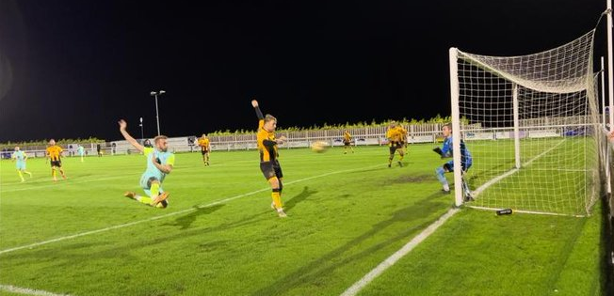
Midweek Action: Home sides very much enjoyed themselves on Tuesday evening, with six of the eight fixtures falling their favour. Street were one of those to grab maximum points, storming to a memorable 4-0 win over Buckland Athletic in the Premier Division. After Jake Horsey had headed them ahead in the 12th minute, the Cobblers then doubled their lead midway through the second half thanks to a clipped finish from the in-form Harry Foster. Further goals from Jake Mawford and Kyle Strange in the final ten minutes completed the scoring, with Street handing Buckland their heaviest defeat of the season. Millbrook were another team to enjoy home comforts, with Josh Johnson and Laurence Murray striking in their triumph over Helston, while Mousehole left it late before confirming their 3-0 victory at Trungle Parc over Torpoint (pictured, left). Top-scorer Hayden Turner put them in front just prior to half-time, but it then took until stoppage time for Mousehole to surge clear, with skipper Jack Calver and Kyle Fraser putting the hosts out of reach. In the game of the night, Shepton Mallet came out on the right side of a seven-goal thriller at home to Wellington. Mallet had gone the entire month of October without securing a league victory, so they will have been over the moon to kick-start November with a victory despite falling behind in the opening minute to Miles Quick’s opener. Joe Morgan and Josh Jenkins then struck either side of the interval to put Mallet 2-1 up, before Quick grabbed his second of the night to draw the Somerset side level. A Callum Ball header had put Mallet back in front 20 minutes from time, but it looked like their chances of victory had disappeared when Sam Towler slotted home from the penalty spot as the game headed towards added time. The terrific contest did however throw up one more dramatic moment, with Matt Wood scoring four minutes into stoppage time to help Shepton secure a memorable 4-3 victory. Welton were the only home side not to secure three points, but they will have been the happier side at West Clewes, after they levelled deep into stoppage time to come from two-down to secure a 2-2 draw with Clevedon. Goals from Ethan Feltham and Mitch Osmond inside the opening five minutes gave the Seasiders a dream start, with Welton only getting a foothold in the game early in the second half when Ben Wych fires home from outside the box. Then, with time nearly expired, Jaiden Savery was felled in the box, and after the linesman had flagged for a spot kick, Lewis Russell converted under immense pressure to grab a share of the spoils.
Brislington were the only team to enjoy success away from home on Tuesday,;6p16 overturning an early deficit to beat Hengrove Athletic 4-1 in the First Division. A 15th minute effort from Mickey Parsons put the home side in front, before goals from Oaklan Buck and Jordan Ricketts towards the back-end of the first half completed the turnaround in speedy fashion. It was then left until added time before Brislington confirmed their win, with Jayden Neilson making it 3-1, followed soon after by a fourth from Jordan Scadding. First half goals from Aron Robbins and Craig Wilson helped Sutton beat Lydeard 2-0 in the “Battle of the Bishop’s”, while Wincanton edged past Bristol Telephones by a goal to nil. In Wednesday’s lone encounter, Shirehampton collected their seventh consecutive win in all competitions thanks to a 5-1 defeat of Almondsbury. First half goals from leading scorer Scott Bamford and George Brimson put them in command against their struggling visitors. Shirehampton skipper Matty McCall then added a double after the interval, sandwiching an effort from James Kenway to help complete their second win over the Almonds in the space of 14 days.
On the latest podcast, Saltash United boss Danny Lewis talks about the strength in depth in the Premier Division, and why he is focussed on making his side competitive for each and every fixture. There is also a conversation with Odd Down manager Jason Maggs, who reflects on their strong form against the top sides in the First Division, while also commenting on their readiness for promotion if that can be achieved on the pitch.
Season 2022/23 Podcast Episode 14 | Toolstation Western League (toolstationleague.com)

Leading Goalscorers (Stats courtesy of FA Fulltime Website)

All Competitions
Sacha Tong (FC Bristol) – 21
Luke Bryan (Odd Down) – 20
Jack Thorne (Nailsea/Tickenham) – 19
Scott Bamford (Shirehampton) – 17
Adam Wright (Wells) – 17
Curtis Damerell (Torpoint) – 16
Jacob Brown (Bridgwater) – 16
Harry Foster (Street) – 15
Joe Berry (Nailsea/Tickenham) – 15
Craig Wilson (Bishop Sutton) – 14
Hayden Turner (Mousehole) - 13
Premier Division
Jacob Brown (Bridgwater) – 16
Harry Foster (Street) – 13
Josh Webber (Buckland) - 10
Harry Stevens (Ilfracombe) – 10

First Division
Sacha Tong (FC Bristol) – 21
Luke Bryan (Odd Down) – 20
Jack Thorne (Nailsea/Tickenham) – 19
Adam Wright (Wells) – 15
Joe Berry (Nailsea/Tickenham) – 15
Scott Bamford (Shirehampton) – 14
Craig Wilson (Bishop Sutton) - 14

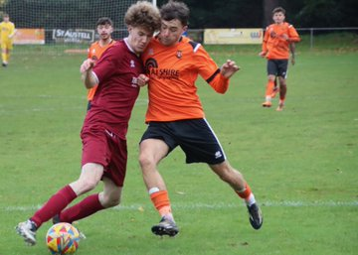
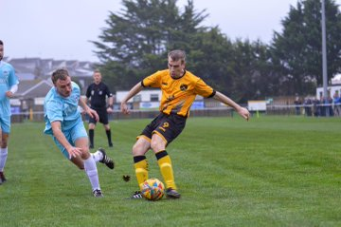
Premier Division: With goal difference currently deciding top spot, Saltash did themselves a favour on Saturday afternoon after thumping Welton Rovers 9-0 in Cornwall. It took the Ashes 29 minutes to break the deadlock, but from the moment Sam Leary found the back of the net, the floodgates very much seemed to open. Adam Carter was the main beneficiary of some slick Rovers defending, with the frontman scoring twice in either half to help complete the rout. Lewis Webber scored his first two Saltash goals during the final 20 minutes, with Harrison Davis and Mike Smith also finding the back of the net. Top spot still belongs to Bridgwater United who secured a 3-0 victory away at Ilfracombe in one of the day’s early kick-offs. Jake Brown put the visitors ahead just prior to half-time, continuing his prolific season, before Ross Edwards headed home for 2-0, with Tom Llewellyn then completing the scoring. Torpoint Athletic secured just their third league win this term after coming from two goals down to beat Sherborne 5-2 at The Mill. After Alex Murphy had put the Zebras in front on 20 minutes, the away side then moved two goals clear thanks to an excellent long-range effort from Ashley Guppy. Torpoint showed impressive fortitude to strike twice at the end of the first half to draw level, before pulling away after the interval. Curtis Damerell (pictured, left) was very much the star of the show for Athletic, with his hat-trick extending his lead atop the Cornish sides’ scoring charts. Another side to grab five goals were Wellington, with a late flurry helping them dispatch Keynsham early on Saturday afternoon. Joe Wragg was vital in Welly’s big win, with his fourth minute finish handing them the ascendancy early on. Wragg then curled home a second midway through the second half, before Jake Quick headed home a cross from twin brother Miles to put the result beyond doubt in the 87th minute. Quick then struck again less than a minute later, before Jamie Nicholson made it five in stoppage time as Keynsham capitulated in the closing stages. Goals either side of half-time from Sam Carter and Rubin Wilson led Helston to a 2-0 win away at Clevedon, while a double from Jack Fillingham proved crucial in Ashton & Backwell’s 3-1 home victory over Millbrook. At Homers Heath, Buckland survived with ten men for the entirety of the second half to beat Shepton Mallet 1-0. Finn Roberts had put the home team in front after just seven minutes, but they were forced to hold on during much of the second period after Nick Milton was dismissed in the top-five battle. That result meant that Mousehole hung on to third spot despite only drawing 1-1 away at Cadbury Heath, with Reece Thomson rescuing a point for the visitors following Josiah McKayle’s excellent header had handed Heath the lead after 34 minutes.
Action from Wellington’s win over Keynsham

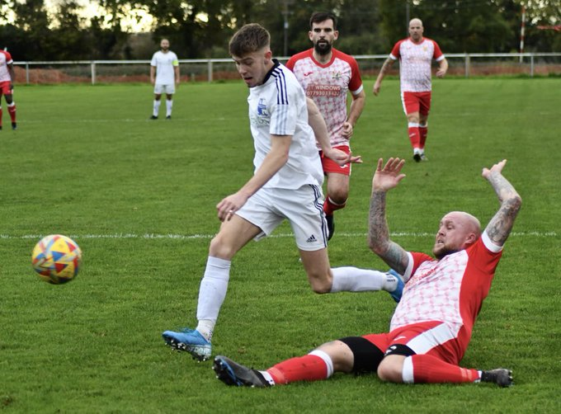
First Division: Hallen responded well to a disappointing run of recent results, beating Cheddar by a goal to nil on Friday evening. Cheddar themselves have been short of points over recent weeks, but it was Hallen who came out on top at Bowdens Park, with Adnan Hiroli’s goal early in the second half leading the visitors to victory. At the other end of the form table are Gillingham Town, and they have now won five on the bounce after demolishing Tytherington by nine goals to nil. Having opened their campaign with a 12-match winless run, the Gills are now enjoying a dream-like run, with Max Westlake and Jordon Clapp each bagging hat-tricks in the one-sided affair. James Boyland also netted twice, with Tom Jarvis joining them on the scoresheet, as Town moved up to 16th spot. There was also a dominant victory for Nailsea & Tickenham, with the free-scoring Somerset outfit putting seven past Bishop Sutton to maintain their pursuit of top spot (pictured, left). Jack Thorne added three more goals to his ever-growing tally, finding the back of the net for the fourth consecutive fixture. Joe Berry is also among the league’s top scorers, and he notched once again, with Dan Cook, Callum Dunn and Tyler Manning also beating the Sutton keeper. Third-placed Brislington snuck past Bristol Telephones thanks to Jordan Ricketts’ first half penalty, while Wells are still in top spot after scoring four first-half goals in their 4-1 win away at Bishops Lydeard. In Bath, Odd Down extended their winning streak to three matches after scoring three in each half at home to Longwell Green Sports. Luke Bryan’s latest treble spear-headed Down’s second consecutive 6-0 triumph, with Raphael Waugh also striking in either half to edge the home side into the top half. Sacha Tong showed his importance for FC Bristol once again, scoring early in either half to help lead his side to a 3-1 win over Portishead Town. 3-1 was a popular result on Saturday afternoon, and that was also the case at Warminster where the home side stretched their unbeaten run to six matches thanks to a win over fourth-placed Oldland. Corey Gardner gave Warminster a dream start to the contest, with his fine finish making it 1-0 just three minutes into the contest. Dave Paterson’s bullet header then levelled affairs midway through the first half, before an own goal put the Abbots behind once again. It was then left to Max Wyatt to add the finishing touches for Warminster who suddenly find themselves in tenth place following a strong uptick in form. The other 3-1 victors were Hengrove who overturned a deficit to beat AEK Boco in a reverse of their result from back in August. Having fallen behind, goals from Alfie Hemmings and Pete Sheppard then put Hengrove 2-1 up at the interval, with super sub Luke Crewe heading home with his first touch to complete the impressive come-from-behind victory. Bottom-side Radstock remain winless, but have now taken a point from three of their previous four games after Harrison Newman equalised in the final ten minutes during their 1-1 draw at home to Almondsbury.

Recent Results
Tuesday 1st November
Premier Division
Millbrook 2-0 Helston Athletic
Mousehole 3-0 Torpoint Athletic
Shepton Mallet 4-3 Wellington
Street 4-0 Buckland Athletic
Welton Rovers 2-2 Clevedon Town
First Division
Bishop Sutton 2-0 Bishops Lydeard
Hengrove Athletic 1-4 Brislington
Wincanton Town 1-0 Bristol Telephones
Wednesday 2nd November
First Division
Shirehampton 5-1 Almondsbury
Friday 4th November
First Division
Cheddar 0-1 Hallen

Saturday 5th November
Premier Division
Ashton & Backwell United 3-1 Millbrook
Buckland Athletic 1-0 Shepton Mallet
Cadbury Heath 1-1 Mousehole
Clevedon Town 0-2 Helston Athletic
Falmouth Town P-P Street
Ilfracombe Town 0-3 Bridgwater United
Saltash United 9-0 Welton Rovers
Torpoint Athletic 5-2 Sherborne Town
Wellington 5-0 Keynsham Town
First Division
AEK Boco 1-3 Hengrove Athletic
Bishops Lydeard 1-4 Wells City
Bristol Telephones 0-1 Brislington
FC Bristol 3-1 Portishead Town
Gillingham Town 9-0 Tytherington Rocks
Nailsea & Tickenham 7-1 Bishop Sutton
Odd Down 6-0 Longwell Green Sports
Radstock Town 1-1 Almondsbury
Warminster Town 3-1 Oldland Abbotonians

Upcoming Fixtures
Tuesday 8th November
Premier Division
Ilfracombe Town vs Wellington 19:45KO
First Division
Brislington vs AEK Boco 19:30KO
Bishops Lydeard vs Portishead Town 19:30KO

Wednesday 9th November
Premier Division
Cadbury Heath vs Shepton Mallet 19:30KO

Saturday 12th November (3pm kick-off unless noted)
FA Vase
Buckland Athletic vs Cullompton Rangers
Clevedon Town vs Mangotsfield United
Elburton Villa vs Bridgwater United
Laverstock & Ford vs Falmouth Town
Mousehole vs Hartpury College
Wellington vs Royal Wootton Basset Town
Premier Division
Ashton & Backwell United vs Shepton Mallet
Barnstaple Town vs Torpoint Athletic
Helston Athletic vs Cadbury Heath
Millbrook vs Ilfracombe Town 14:00KO
Sherborne Town vs Saltash United
Street vs Keynsham Town
First Division
AEK Boco vs Wincanton Town
Bishop Sutton vs Gillingham Town
Brislington vs Bishops Lydeard
FC Bristol vs Cheddar
Hengrove Athletic vs Warminster Town
Nailsea & Tickenham vs Tytherington Rocks
Odd Down vs Oldland Abbotonians
Portishead Town vs Almondsbury 14:00KO
Radstock Town vs Longwell Green Sports
Shirehampton vs Bristol Telephones
Wells City vs Hallen

League Tables
 | PREMIER DIVISION | Played | Won | Drawn | Lost | GD | Points
1 | Bridgwater United | 18 | 14 | 3 | 1 | 41 | 45
2 | Saltash United | 18 | 14 | 3 | 1 | 31 | 45
3 | Mousehole | 15 | 8 | 6 | 1 | 20 | 30
4 | Shepton Mallet | 15 | 9 | 2 | 4 | 12 | 29
5 | Buckland Athletic | 17 | 9 | 1 | 7 | 3 | 28
6 | Barnstaple Town | 11 | 6 | 2 | 3 | 6 | 20
7 | Ashton & Backwell United | 13 | 6 | 2 | 5 | 2 | 20
8 | Millbrook | 16 | 6 | 2 | 8 | -10 | 20
9 | Helston Athletic | 13 | 5 | 4 | 4 | -3 | 19
10 | Street | 14 | 6 | 1 | 7 | -7 | 19
11 | Clevedon Town | 15 | 5 | 3 | 7 | -4 | 18
12 | Welton Rovers | 18 | 4 | 4 | 10 | -27 | 16
13 | Ilfracombe Town | 13 | 3 | 6 | 4 | 2 | 15
14 | Falmouth Town | 13 | 3 | 5 | 5 | 0 | 14
15 | Sherborne Town | 15 | 4 | 2 | 9 | -3 | 14
16 | Cadbury Heath | 16 | 3 | 5 | 8 | -10 | 14
17 | Wellington | 14 | 3 | 3 | 8 | -5 | 12
18 | Torpoint Athletic | 15 | 3 | 3 | 9 | -15 | 12
19 | Keynsham Town | 17 | 2 | 3 | 12 | -33 | 9
 | FIRST DIVISION | Played | Won | Drawn | Lost | GD | Points
1 | Wells City | 20 | 17 | 1 | 2 | 40 | 52
2 | Nailsea & Tickenham | 21 | 16 | 2 | 3 | 48 | 50
3 | Brislington | 19 | 14 | 2 | 3 | 28 | 44
4 | Oldland Abbotonians | 18 | 12 | 2 | 4 | 15 | 38
5 | FC Bristol | 19 | 11 | 3 | 5 | 14 | 36
6 | Shirehampton | 18 | 10 | 4 | 4 | 15 | 34
7 | Bishop Sutton | 19 | 9 | 3 | 7 | 6 | 30
8 | Odd Down | 19 | 7 | 6 | 6 | 18 | 27
9 | Portishead Town | 16 | 8 | 2 | 6 | 4 | 26
10 | Warminster Town | 17 | 7 | 4 | 6 | 0 | 25
11 | Hallen | 18 | 7 | 4 | 7 | -1 | 25
12 | Wincanton Town | 16 | 7 | 3 | 6 | 6 | 24
13 | AEK Boco | 19 | 7 | 2 | 10 | -12 | 23
14 | Hengrove Athletic | 21 | 6 | 4 | 11 | -7 | 22
15 | Longwell Green Sports | 18 | 5 | 4 | 9 | -19 | 19
16 | Gillingham Town | 17 | 5 | 3 | 9 | -8 | 18
17 | Tytherington Rocks | 19 | 4 | 5 | 10 | -25 | 17
18 | Almondsbury | 21 | 4 | 5 | 12 | -39 | 17
19 | Cheddar | 21 | 4 | 4 | 13 | -19 | 16
20 | Bristol Telephones | 19 | 3 | 4 | 12 | -20 | 13
21 | Bishops Lydeard | 16 | 3 | 3 | 10 | -20 | 12
22 | Radstock Town | 19 | 0 | 8 | 11 | -24 | 8

