Latest Round-ups:
#9
Season 2022/23
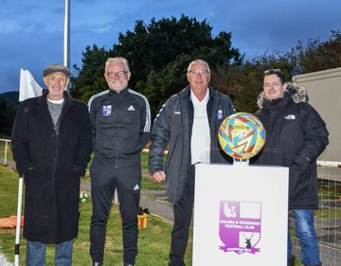
Midweek Action: In the battle between the early season top two in the Premier Division, Bridgwater defeated Saltash 2-1 at Fairfax Park to extend their advantage at the head of the table. The home side enjoyed the better of the first half, and after top scorer Jake Brown struck once again, their task was made less daunting when Owen Howe saw red for the Ashes. That dismissal was followed soon after by a Jordan Greenwood strike to double Bridgwater’s advantage, with the away side falling short in their comeback attempts despite trimming the deficit thanks to an Alex Cairo header. Shepton Mallet are still perfect in league play this season, and that continued on Tuesday evening, with goals from Nick Hewlett and Callum Gould at either end of the match leading them to a 2-0 win over Keynsham. The other match that night also went the way of the home side, with Helston warming up for their huge FA Cup clash with a 3-0 victory over Millbrook. After a pair of quick-fire strikes at the end of the first half from Aaron Bentley and Tom Payne put them in control, they then wrapped things up late on thanks to a first goal for the club from Jamie Simmonds. 24 hours later, Mousehole registered an impressive 2-0 victory away at Falmouth Town, with goals coming either side of the interval from Max Hill and Andy Elcock. Sherborne also ended a six-match winless run in all competitions after beating Bitton 3-1 at Raleigh Grove. Brett Cotterill, Alex Murphy and Josh Williams all got on the scoresheet for the Zebras, with fellow promoted side Welton Rovers also picking up three points after claiming a 4-2 victory away at Cadbury Heath. There were four different scorers for the Green Army at Springfield, with Ben Wych, Lewis Russell, Billy Manning and Will Gould each finding the back of the net. The standout individual performance of the midweek period belonged to Street’s Harry Foster who struck his second hat-trick in the space of four days to help the Cobblers capture a 3-2 win over Ilfracombe Town. The goals flowed in Tuesday’s First Division fixtures, with a trio of big home wins, including Nailsea & Tickenham’s momentous 5-0 victory over Cheddar (pictured right). Playing under lights for the first time at their Fryth Way ground, the large crowd enjoyed a comfortable home victory to mark the occasion, with Jack Thorne and Callum Dunn among the Swags goalgetters.
There was also a 5-0 win for Odd Down over Radstock Town, with Louis Short bagging a hat-trick alongside Curtis Dunn’s double for the Bath side. Sacha Tong was on target yet again for FC Bristol in their 2-0 triumph away at Hengrove, while Craig Wilson and Luke Palmer each struck set pieces in Bishop Sutton’s 3-1 win at home to Wincanton. The following evening, goals from James Kenway and Scot Bamford helped Shirehampton come from behind to lead at home to AEK Boco, before the visitors struck at the death to grab a share of the spoils. The points were also shared at Tytherington, where the Rocks drew 0-0 with Brislington, while efforts from the in-form Max Wyatt, and then Jon Bazley helped Warminster defeat Bristol Telephones 2-1.
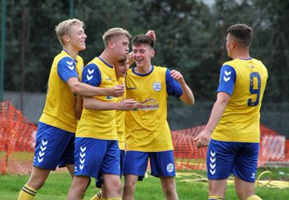
Premier Division: There is now only one unbeaten record remaining in the Premier Division after Shepton Mallet fell to a surprise 2-1 defeat at the hands of Torpoint Athletic. Having won eight from eight heading into this fixture, Mallet fell behind on the cusp of half-time when Curtis Damerell struck for the previously winless Torpoint. The sides then shared own goals to give the hosts a 2-1 lead heading into the final quarter, and despite squandering a late opportunity from the penalty spot, Torpoint managed to hold on to secure their first three-point haul of the campaign. There was never much doubt about the other unbeaten start remaining intact, with Bridgwater storming to a 6-1 win at home to Cadbury Heath. By the time Jack Taylor’s long-range free kick found the back of the net on the half-hour mark, United already led by two goals to nil thanks to early strikes from Tom Llewellyn and Jacob Spence. The second half started in much the same fashion with Taylor completing his brace prior to further goals from Jordan Greenwood and Llewellyn as the league leaders strolled to another victory. Another side to notch on Saturday afternoon were Buckland Athletic, with Ryan Bush grabbing a hat-trick of goals in their 6-2 triumph over Bitton. Following 33 goalless minutes, the hosts suddenly shot to life, with Bush scoring twice in the space of three minutes to help establish a two-goal lead at the interval. Finn Roberts then extended the hosts’ advantage early in the second half, with Bush not waiting too long before grabbing his third of the game. Jamal Chevolleau claimed a couple of consolation goals for the struggling Bitton, with Rob Farkins and Roberts scoring late on to round out the comprehensive victory. In what was their second meeting in the space of five weeks, Clevedon toppled Wellington once again to claim their fourth victory of the season (pictured celebrating, left). After going ahead through Ethan Feltham’s thumping header early in the second half, Town saw their lead disappear 17 minutes from time when Nathaniel Groom levelled for the hosts. Welly weren’t level for long however, and it was Clevedon who secured the early season double over their fellow Somerset outfit thanks to an outstanding curled finish from Freddie King. Incredibly, all 20 Premier Division teams got on the scoresheet on Saturday, including both Ilfracombe and Falmouth who battled out a 2-2 draw at Marlborough Park. Jack Bray-Evans and Olly Walker were each on target for the visitors, with the Bluebirds battling back to grab a share of the spoils thanks to goals from John Downing and Jack Langford. The points were also shared at Trungle Parc, where Barnstaple’s Callum Laird produced an excellent finish to level affairs early in the second half after Hayden Turner had given Mousehole a 41st minute lead. There was plenty of late drama up and down the division too, with Millbrook grabbing a stoppage time winner to see off Ashton & Backwell United by two goals to one. In a game where both sides finished with ten men, Sean Thomson had seen his early goal cancelled out, but Millbrook had the last laugh, with Josh Toulson executing an excellent run and finish to score with the final attack of the game. Saltash were another side to strike at the death, with Adam Carter’s 87th minute effort leading them past Street. Having taken the lead through Charlie Elkington, the Ashes were pegged back soon after when Harry Foster scored his seventh goal of the week. The Cobblers were hit with a sucker punch however, and with a point looking likely, Carter found enough time and space to hand the Cornish outfit maximum points. Welton Rovers came out on top in the battle between last season’s promoted duo, with Lewis Russell and Joe Ellis striking either side of the break in their 2-1 win over Sherborne at Raleigh Grove.
First Division: Wells City are showing no signs of slowing up, and have now won 37 points from a possible 39 after defeating Longwell Green Sports 3-1. A powerful header from Tom Ellis had put the league leaders in front towards the end of the first half, before the home side drew level 20 minutes from time. That left Wells plenty of time to go looking for more goals of their own, and after Craig Herrod’s wonder goal put them back ahead, Adam Wright then added the finishing touches to a counter attack to extend the visitors winning run. Oldland Abbotonians remain in second spot after Harry Pruett’s penalty and a second half strike from Owen McCallum led them to a 2-0 victory away at Bristol Telephones. Without doubt, the most entertaining encounter of the day saw Cheddar contribute six of the game’s nine goals in their big away win over Gillingham Town. The first half was a relatively quiet affair in the context of the entire game, with goals from Dean Chrisostomou and Kristian Bell putting the Cheesemen two goals to the good. The game then kicked into overdrive at the beginning of the second period, with Town halving the deficit, before Morgan Bacon’s effort was followed by a quick-fire brace from Lewis Chappell to hand Cheddar a 5-2 advantage. Kieran Burpitt and Jack Male scored soon after Chappell’s second to pull the bottom-side to within two, with Cheddar finally wrapping up the victory when Adam Davies struck the ninth and final goal of a wild game. Jennison Williams was a big difference maker for FC Bristol in their 3-2 comeback win over Bishops Lydeard. A fantastic start to the game for the Lyds saw both Mark Jones and skipper Conor Bryant score within the opening 11 minutes to hand the home side a strong foothold in the contest. Williams cut into the deficit midway through the first half, before Bristol drew level on the hour mark thanks to a strike from Daine O’Connor. It was then left to Williams to complete the turnaround, with his second of the afternoon coming 20 minutes from time to help secure all three points.
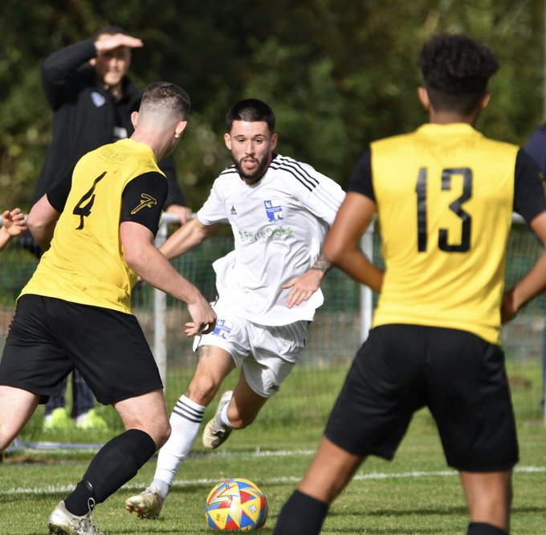
Dean Griffiths, Asa White and George Jones all claimed goals in Brislington’s 3-1 win away at Almondsbury, while Bishop Sutton moved back into the top half after winning 3-2 on their travels at AEK Boco. The other side in the division to claim an away victory over the weekend was Hallen, ending a four-match winless run in all competitions by beating Tytherington 2-0. After Mark Thuo put the visitors in front after 17 minutes, Hallen confirmed the result as the game headed into the final quarter thanks to a smart turn and finish from former Odd Down forward Adnan Hiroli. Speaking of the Bath outfit, they fell to a 2-0 loss at a fast-finishing Shirehampton, for whom Dan Morne and Scott Bamford each struck during the final 20 minutes. Jack Thorne’s double helped Nailsea & Tickenham come from behind to beat Wincanton 2-1 (pictured left), while Radstock remain without a win after they drew one-apiece away at Hengrove. After a tough start to the campaign which saw them wait until their ninth game before securing a win, Warminster now look to be in a better place and currently sit 12th following a 3-2 win over Portishead. It wasn’t easy going for the home side however, and they were forced to overturn a half-time deficit after goals from Caolan Pearce and Calum Townsend had given Posset a 2-1 lead at the end of 45 minutes. Max Wyatt has really found his shooting boots of late however, and after he levelled affairs, Derek Wheeler then produced a late cameo, scoring the winner within five minutes of coming off the bench.
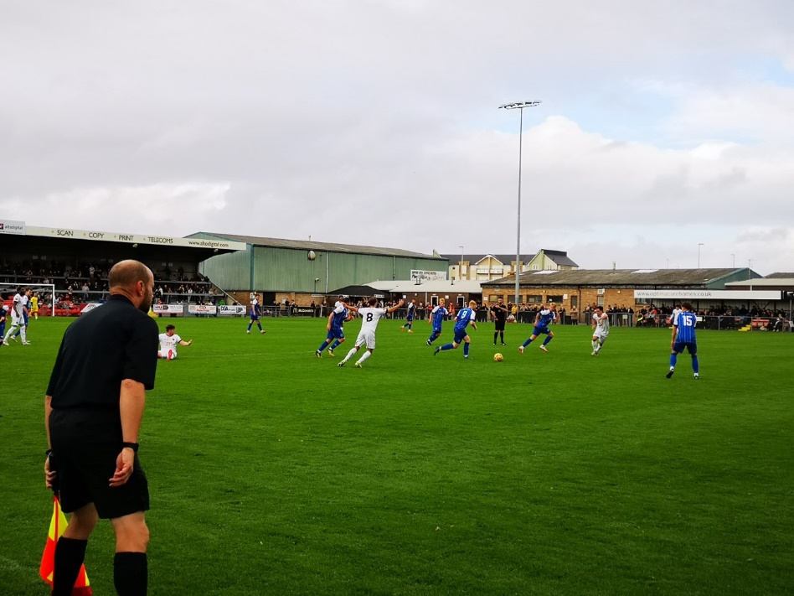
FA Cup: Helston’s momentous run in the FA Cup came to an end after they suffered a disappointing 7-2 defeat at the hands of Weston-Super-Mare. It was a tough afternoon for the Western League’s last side still standing in the competition, with Weston’s forward duo Reuben Reid and Marlon Jackson each punishing the visiting defence. An excellent Tom Payne effort early in the second half was followed later in the game by a Rubin Wilson strike to give Helston fans something to celebrate at the end of a terrific cup journey.
Action from Weston-Super-Mare vs Helston, courtesy of John Pool.
Recent Results
Tuesday 27th September
Premier Division
Bridgwater United 2-1 Saltash United
Helston Athletic 3-0 Millbrook
Shepton Mallet 2-0 Keynsham Town
First Division
Bishop Sutton 3-1 Wincanton Town
Hengrove Athletic 0-2 FC Bristol
Nailsea & Tickenham 5-0 Cheddar
Odd Down 5-0 Radstock Town

Wednesday 28th September
Premier Division
Cadbury Heath 2-4 Welton Rovers
Falmouth Town 0-2 Mousehole
Sherborne Town 3-1 Bitton
Street 3-2 Ilfracombe Town
First Division
Shirehampton 2-2 AEK Boco
Tytherington Rocks 0-0 Brislington
Warminster Town 2-1 Bristol Telephones

Saturday 1st October
FA Cup Third Qualifying Round
Weston-Super-Mare 7-2 Helston Athletic
Premier Division
Bridgwater United 6-1 Cadbury Heath
Buckland Athletic 6-2 Bitton
Ilfracombe Town 2-2 Falmouth Town
Millbrook 2-1 Ashton & Backwell United
Mousehole 1-1 Barnstaple Town
Sherborne Town 1-2 Welton Rovers
Street 1-2 Saltash United
Torpoint Athletic 2-1 Shepton Mallet
Wellington 1-2 Clevedon Town
First Division
AEK Boco 2-3 Bishop Sutton
Almondsbury 1-3 Brislington
Bishops Lydeard 2-3 FC Bristol
Bristol Telephones 0-2 Oldland Abbotonians
Gillingham Town 3-6 Cheddar
Hengrove Athletic 1-1 Radstock Town
Longwell Green Sports 1-3 Wells City
Nailsea & Tickenham 2-1 Wincanton Town
Shirehampton 2-0 Odd Down
Tytherington Rocks 0-2 Hallen
Warminster Town 3-2 Portishead Town

Upcoming Fixtures
Tuesday 4th October
Premier Division
Keynsham Town vs Cadbury Heath 19:45KO

Wednesday 5th October
First Division
Bristol Telephones vs Nailsea & Tickenham 19:30KO
FC Bristol vs Tytherington Rocks 19:30KO
Shirehampton vs Oldland Abbotonians 19:30KO

Saturday 8th October (3pm kick-off unless noted)
Premier Division
Bitton vs Wellington
Buckland Athletic vs Helston Athletic
Cadbury Heath vs Sherborne Town
Clevedon Town vs Street
Falmouth Town vs Shepton Mallet
Mousehole vs Ilfracombe Town
Saltash United vs Ashton & Backwell United
Torpoint Athletic vs Keynsham Town
Welton Rovers vs Millbrook
First Division
AEK Boco vs Hallen
Bishops Lydeard vs Almondsbury
Cheddar vs Hengrove Athletic
FC Bristol vs Nailsea & Tickenham
Gillingham Town vs Longwell Green Sports
Odd Down vs Bristol Telephones 14:00KO
Oldland Abbotonians vs Bishop Sutton
Portishead Town vs Wincanton Town 14:00KO
Radstock Town vs Brislington
Wells City vs Tytherington Rocks

On the latest podcast, Torpoint Athletic’s assistant manager Ryan Fice joins the show to talk about their start to the season, and what they are learning about life in the Western League. There is also a conversation with FC Bristol boss, Curtis Reid, who discusses the club’s evolution from Lebeq into a team that aspires to be successful on and off the pitch, with the prospect of promotion very much in their sights.
Season 2022/23 Podcast Episode 9 | Toolstation Western League (toolstationleague.com)

League Tables
 | PREMIER DIVISION | Played | Won | Drawn | Lost | GD | Points
1 | Bridgwater United | 15 | 13 | 2 | 0 | 42 | 41
2 | Saltash United | 13 | 9 | 3 | 1 | 16 | 30
3 | Shepton Mallet | 9 | 8 | 0 | 1 | 15 | 24
4 | Buckland Athletic | 12 | 7 | 0 | 5 | 6 | 21
5 | Barnstaple Town | 10 | 6 | 2 | 2 | 14 | 20
6 | Mousehole | 10 | 5 | 4 | 1 | 12 | 19
7 | Ashton & Backwell United | 10 | 5 | 1 | 4 | 3 | 16
8 | Helston Athletic | 9 | 4 | 4 | 1 | 2 | 16
9 | Welton Rovers | 13 | 4 | 3 | 6 | -7 | 15
10 | Street | 11 | 4 | 2 | 5 | -10 | 14
11 | Sherborne Town | 12 | 4 | 1 | 7 | 1 | 13
12 | Clevedon Town | 10 | 4 | 1 | 5 | -6 | 13
13 | Millbrook | 11 | 4 | 1 | 6 | -6 | 13
14 | Falmouth Town | 11 | 2 | 4 | 5 | 1 | 10
15 | Ilfracombe Town | 9 | 2 | 4 | 3 | -3 | 10
16 | Wellington | 10 | 2 | 2 | 6 | -7 | 8
17 | Keynsham Town | 12 | 2 | 2 | 8 | -25 | 8
18 | Torpoint Athletic | 9 | 1 | 3 | 5 | -10 | 6
19 | Cadbury Heath | 10 | 1 | 2 | 7 | -12 | 5
20 | Bitton | 10 | 0 | 1 | 9 | -24 | 1

 | FIRST DIVISION | Played | Won | Drawn | Lost | GD | Points
1 | Wells City | 15 | 12 | 1 | 2 | 28 | 37
2 | Oldland Abbotonians | 13 | 10 | 2 | 1 | 18 | 32
3 | Brislington | 13 | 9 | 2 | 2 | 19 | 29
4 | Nailsea & Tickenham | 13 | 9 | 1 | 3 | 23 | 28
5 | FC Bristol | 13 | 8 | 3 | 2 | 14 | 27
6 | AEK Boco | 13 | 7 | 1 | 5 | 3 | 22
7 | Portishead Town | 10 | 6 | 1 | 3 | 6 | 19
8 | Shirehampton | 13 | 5 | 4 | 4 | 4 | 19
9 | Hallen | 12 | 5 | 3 | 4 | 4 | 18
10 | Bishop Sutton | 13 | 5 | 3 | 5 | 3 | 18
11 | Longwell Green Sports | 13 | 5 | 3 | 5 | 0 | 18
12 | Warminster Town | 14 | 5 | 3 | 6 | -4 | 18
13 | Odd Down | 13 | 4 | 5 | 4 | 7 | 17
14 | Wincanton Town | 10 | 5 | 1 | 4 | 9 | 16
15 | Hengrove Athletic | 15 | 4 | 4 | 7 | -1 | 16
16 | Tytherington Rocks | 13 | 3 | 4 | 6 | -9 | 13
17 | Cheddar | 15 | 3 | 4 | 8 | -13 | 13
18 | Almondsbury | 14 | 3 | 3 | 8 | -32 | 12
19 | Bishops Lydeard | 11 | 3 | 1 | 7 | -14 | 10
20 | Bristol Telephones | 14 | 2 | 3 | 9 | -17 | 9
21 | Radstock Town | 14 | 0 | 5 | 9 | -22 | 5
22 | Gillingham Town | 12 | 0 | 3 | 9 | -26 | 3

