Latest Round-ups:
#6
Season 2022/23
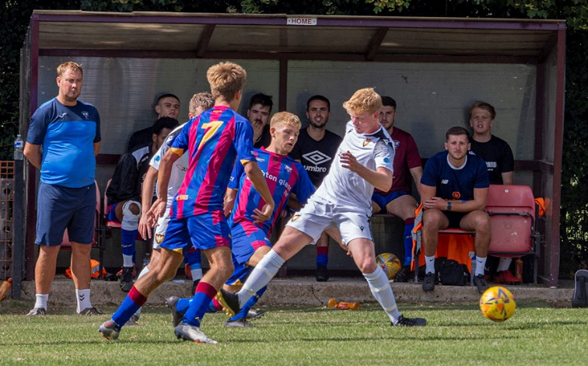
Bank Holiday Action: Bridgwater extended their winning start in the Premier Division on Monday, coming from behind to beat Buckland 3-1 at Homers Heath. Having won seven on the bounce coming into the game, Bridgwater found themselves on the back foot after half an hour when Sam Morcom fired Buckland in front. The visitors then got a lifeline on the stroke of half time, with Jake Llewellyn tucking home a spot after Jack Taylor had been felled in the box. Buckland’s Harry Hodges was then dismissed after receiving his second yellow, and from that moment, Bridgwater were in the ascendancy, eventually running out winners thanks to a couple of strong finishes in the final quarter hour from Taylor and Morgan Williams. Saltash United are another side who will be pleased with how the first month has gone, and that continued in their home clash with Bitton which they won by four goals to nil. Mike Smith scored in either half for the Ashes, with Callum Merrin and Sam Hughes joining him on the scoresheet to help maintain their unbeaten start. At the opposite end of the table, Keynsham grabbed their first league win of the season in stunning circumstances, putting four past Wellington inside the opening 45 minutes. Jemar Thomas was the star during the early stages, with his early double putting the hosts into a strong position. A pair of spot kicks then helped decide the game’s outcome, with Wellington’s Nat Groom denied from 12 yards, before Owen Brain converted his penalty a couple of minutes later to extend the hosts advantage. Keynsham continued to push forward, and their fourth goal came with a touch of class as Henry Sady produced a beautiful chipped finish to cap an excellent opening half. Dean Preddie’s 68th minute strike handed Ashton & Backwell a 1-0 win over Falmouth (pictured right, courtesy of Mike West), while Shepton Mallet beat Millbrook by the same scoreline thanks to a goal less than 60 seconds after the restart from Aaron Seviour.
Things were much simpler for Mousehole who strolled to a 5-1 win at home to Street. There were five different goalscorers for the hosts, with Moussa Diallo, Callam McOnie, Jack Symons, Hayden Turner and Jack Calver all finding the back of the net in a dominant home win. A brace from Tor Swann, plus another goal for the in-form Callum Laird saw Barnstaple Town beat Cadbury Heath 3-0 in a battle of two of the weekend’s cup heroes.
Welton Rovers managed to hold on to claim a 2-2 draw away at Torpoint despite suffering three red cards during the final 20 minutes. First half goals from Lewis Russell and Cam Allen put the Green Army in a position of dominance, before Torpoint reduced the arrears when John Heveran converted from a corner. It all started to unravel for Welton soon after, with two players dismissed after picking up their second yellow cards, and Heveran then struck again to make it two apiece in the closing stages. With Welton then suffering a third red card, the home side ploughed forwards, but despite hitting the woodwork on more than five occasions, they were unable to find the elusive winner and were forced to settle for a point. There was more late drama in the clash at Ilfracombe, where the home side struck in the third minute of stoppage time to secure a 2-2 draw with Clevedon. Having taken the lead through John Downing after just ten minutes, Ilfracombe found themselves 2-1 down as the game headed into the closing stages after Henry Westlake and Syd Camper had struck for the Seasiders. Then, with their final attack, Jack Langford’s pinpoint cross was met with a bullet header by Toby Johnson who rescued a point for the Devon side. The points were also shared in sunny Cornwall, where Aaron White’s goal two minutes into the second half helped Sherborne secure a 1-1 draw away at Helston.
In the First Division, Matt Garner inspired Wincanton Town’s fightback away at Brislington, scoring twice, and assisting the other goal in their dramatic 3-3 draw. The home side were excellent in the early stages, and after Ash Kington fired a free kick into the back of the net, they then doubled their lead through Dean Griffiths on the stroke of half time. Lewis Dunn’s corner was then back-heeled into the net by Griffiths to make it 3-0, before Garner struck to kick-start Town’s comeback. With seven minutes remaining, Garner headed home to draw Wincanton closer, and then with the game entering the final stages, Garner set up Cameron Vere who finished well to grab a share of the spoils. Wells City were another side who produced a comeback, scoring twice in the second half to beat Gillingham Town 2-1. With the home side leading at the interval thanks to James Boyland, Wells got back on level terms towards the start of the second period thanks to a bullet header from Ali Sen. It was then left to Harry Horton to hit the winner, with his sweetly struck finish in the final ten minutes giving City their sixth victory. In a battle between two of the other fast starters this season, first half goals from early sub Drew Thomas and then Josh Jenkins led AEK Boco to an impressive 2-0 win at home to Nailsea & Tickenham at the Greenbank Recreation Ground. The standout individual performance of the day belonged to Odd Down’s prolific forward Luke Bryan who scored four of his sides’ goals in their thumping 6-0 win away at Almondsbury. Bryan struck once in the first half, sandwiched by goals from Jake Thomas and Josh Clark, as the Bath side moved into a three-goal lead at the interval. The second half then belonged exclusively to Bryan, with last season’s top scorer adding three more goals to his tally as the Almonds crumbled to their second 6-0 defeat in the space of 48 hours. There was also a big win for Hengrove Athletic, with plenty of late goals adding some gloss to their 5-0 win at home to Tytherington. Following 35 goalless minutes, Luke Crewe finished expertly to put the Grove ahead, with an own goal then extending the hosts’ advantage on the cusp of half-time. With the Rocks unable to find a route back into the contest, Hengrove flexed their muscles in the final ten minutes, with Sam Jackson, Jack Jones and Jack Cousins all find the back of the net late on. Second half substitute Oscar Collins made an instant impact, scoring with one of his first touches to give Cheddar a 1-0 win over Bristol Telephones, while Oldland defeated Bishop Sutton by the same scoreline thanks to a Stefan Lee strike.
An equaliser from Corey Rawlings on the hour mark handed Radstock a 1-1 draw away at Shirehampton, with Longwell Green Sports and FC Bristol also sharing the points after their encounter finished two apiece. Goals from Kris Miller and Fabian McCarthy gave the visitors a 2-1 lead early in the second half, but Longwell Green battled back, with Andrew Nash scoring 18 minutes from time to deny Bristol a third consecutive win. In Somerset, Hallen struck twice in the final quarter to secure a come-from-behind win at Bishops Lydeard. Adam Willis’ left-footed finish midway through the opening half put the Lyds in front, but Hallen finished the stronger, and after Aaron Blakemore drew them level, he then turned provider two minutes later, crossing for Elliot Gardner who grabbed the crucial third and final goal of the contest.
FA Cup: Helston will take their place in the second qualifying round of the FA Cup after overcoming Torpoint on Saturday afternoon. In what was a repeat of the result when these sides met in league action seven days previously, Helston prevailed by two goals to one at the Mill. Both of Helston’s goals came inside the opening quarter of the contest, with Tom Payne wrong-footing the keeper for 1-0, before Rikki Sheppard doubled their advantage a couple of minutes later after beating the offside trap. The home side got themselves back into the game at the end of the first half thanks to a Curtis Damerell header, but they were unable to force home an equaliser during a goalless second half. As the lowest ranked side remaining in the competition, Wincanton Town had done a terrific job in qualifying for this round, but their cup run has now come to an end following a heavy 9-2 defeat at home to AFC Totton. The other Western League side who remain in the competition are Shepton Mallet, who will face a midweek replay at home to Blackfield & Langley after their tie ended goalless.
Premier Division: Bridgwater’s perfect start to the campaign finally came to an end on Saturday after they were held to a goalless draw at Fairfax Park by Wellington. Having scored 33 goals from their opening nine fixtures, United would have expected to defeat the struggling Tangerines, but they drew their first blank of the season on a tough afternoon for the league leaders. Barnstaple Town now sit in third spot after they secured an impressive 2-0 win away at Buckland. The visitors did their damage inside the opening 25 minutes at Homers Heath, with the in-form Stu Bowker, and Joe Grigg each finding the back of the net. There was also an away win for Welton, who defeated Bitton 2-1 despite playing the last 25 minutes without a recognised keeper. After Jacob Watson broke the deadlock for the visitors midway through the first half, Bitton drew level on the hour mark thanks to a smart finish from Lucas Vowles. It was then left to Joe Garland to score the winner 13 minutes from time, with the resolute Rovers playing this period with defender Will Hunter stepping in between the sticks following an injury to young keeper Alfie Kelsey. An incredible second half from Ilfracombe Town saw them storm to a 5-3 win at home to Millbrook. After falling behind for the second time ten minutes after the restart, Ilfracombe took over during the final half hour of the contest, with both Liam Short and Harry Stevens each scoring twice to end their four-match winless run in grand fashion.
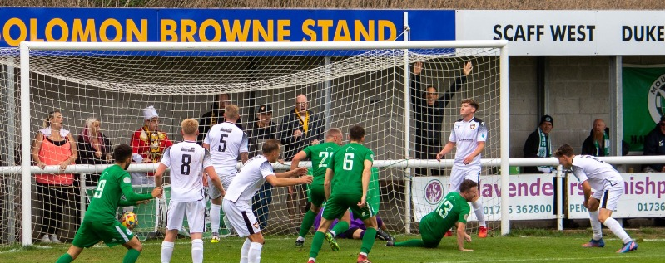
The late drama of the day took place at Mousehole, where the hosts struck an injury time winner to beat Falmouth Town by three goals to two. The opening half ended with Falmouth in the ascendancy, after Tim Nixon struck twice in the space of five minutes to overturn Moussa Diallo’s early opener. The impressive Diallo then struck again ten minutes into the second half to draw the side’s level, with Mousehole then grabbing all three points thanks to Andy Watkins winning goal just as the game reached the ninety minute mark.
Andy Watkins scores a dramatic injury time winner for Mousehole against Falmouth. Image courtesy of Robin Chiffers.
Keynsham were the other side to record three points on Saturday, beating Sherborne 1-0 to record back-to-back wins after they had begun the season on a seven-game winless streak. There was a tight affair at the Tannery Ground, where Street and Cadbury Heath battled out an entertaining 2-2 draw. The visitors surged ahead after just 11 minutes through Ali Boyer, before Street hit back to lead 2-1 at the interval thanks to Kyle Strange and Toby Davey. It was then left to Josh Haynes to score the Heath’s equalising goal, heading home midway through the second half.
First Division: Ever since losing their opening two games of the season, Wells City haven’t looked back since and have now collected 22 points from a possible 24 to move up into second spot. The Somerset side’s latest victory saw them hand Shirehampton a 2-0 loss, with Adam Wright’s penalty early in the second half adding to a third minute header from Harry Horton who scored for the third consecutive match. Third spot belongs to Nailsea & Tickenham who thumped struggling Almondsbury by seven goals to nil at Fryth Way. Jack Thorne was the standout performer for the home side, scoring five times during a one-sided contest, with the Almonds now having conceded 19 goals in the space of just seven days. The other top sides are still chasing unbeaten Oldland atop the division, after Owen McCallum scored the only goal of the game in their 1-0 win away at Portishead.

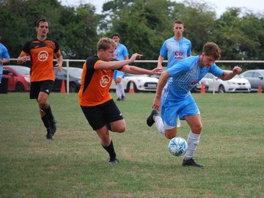
Brislington’s unpredictable start to the season continued away at Cheddar on Saturday afternoon, where the visitors eventually ran out 3-0 winners. Bris have suffered some heavy defeats during the first month of the campaign, but they have also hit their straps in some other fixtures and that was the case at Bowdens Park from the moment George Jones swept them ahead with his left-foot after 33 minutes. Dean Griffiths then grabbed a second for the visitors just prior to half time, with Harry Tobin scoring his first of the season to wrap up the win late on. A second half double from Bailey Croome helped lead Tytherington Rocks to a 2-0 victory over Radstock (pictured right), with Warminster beating Hengrove by the same margin thanks to a pair of goals after half time from Jamal Chevolleau and James Vincent at Weymouth Street. There was also a tight victory for AEK Boco, who have won three on the bounce after seeing off Gillingham Town by a goal to nil. Longwell Green Sports left it until the final possible moment before grabbing a share of the spoils in their home tie with Odd Down. The Bath side made a lightning start to the game and went ahead after just four minutes with the ever-reliable Luke Bryan finding the back of the net once again. That early Bryan strike looked like it would be the only goal of the afternoon, however Longwell Green kept pushing into the final moments and it paid off in stoppage time, with Liam Oswin rounding the keeper before rolling the ball into the empty net. The points were also shared in the clash between Bristol Telephones and Bishop Sutton, with the home side drawing level during the second half after Craig Wilson had put Sutton in position to secure back-to-back 1-0 wins.

On the podcast this week, Tony Beecham of Ashton & Backwell looks forward to the bright future he believes the Stags have. There is also a conversation with Wincanton boss Chris Wise, and he touches on their impressive FA Cup exploits, while also explaining how supporters & sponsors have moved heaven and earth to get the Wasps back to Wincanton Sports Ground.
Season 2022/23 Podcast Episode 6 | Toolstation Western League (toolstationleague.com)

Recent Results
Monday 29th August
Premier Division
Ashton & Backwell United 1-0 Falmouth Town
Barnstaple Town 3-0 Cadbury Heath
Buckland Athletic 1-3 Bridgwater United
Helston Athletic 1-1 Sherborne Town
Ilfracombe Town 2-2 Clevedon Town
Keynsham Town 4-0 Wellington
Millbrook 0-1 Shepton Mallet
Mousehole 5-1 Street
Saltash United 4-0 Bitton
Torpoint Athletic 2-2 Welton Rovers
First Division
AEK Boco 2-0 Nailsea & Tickenham
Almondsbury 0-6 Odd Down
Bishop Sutton 0-1 Oldland Abbotonians
Bishops Lydeard 1-2 Hallen
Brislington 3-3 Wincanton Town
Cheddar 1-0 Bristol Telephones
Gillingham Town 1-2 Wells City
Hengrove Athletic 5-0 Tytherington Rocks
Longwell Green Sports 2-2 FC Bristol
Shirehampton 1-1 Radstock Town

Saturday 3rd September
FA Cup First Qualifying Round
Blackfield & Langley 0-0 Shepton Mallet
Torpoint Athletic 1-2 Helston Athletic
Wincanton Town 2-9 AFC Totton
Premier Division
Bitton 1-2 Welton Rovers
Bridgwater United 0-0 Wellington
Buckland Athletic 0-2 Barnstaple Town
Ilfracombe Town 5-3 Millbrook
Mousehole 3-2 Falmouth Town
Sherborne Town 0-1 Keynsham Town
Street 2-2 Cadbury Heath
First Division
AEK Boco 1-0 Gillingham Town
Bristol Telephones 1-1 Bishop Sutton
Cheddar 0-3 Brislington
Longwell Green Sports 1-1 Odd Down
Nailsea & Tickenham 7-0 Almondsbury
Portishead Town 0-1 Oldland Abbotonians
Shirehampton 0-2 Wells City
Tytherington Rocks 2-0 Radstock Town
Warminster Town 2-0 Hengrove Athletic

Upcoming Fixtures
Tuesday 6th September
FA Cup First Qualifying Round Replay
Shepton Mallet vs Blackfield & Langley 19:30KO
Premier Division
Bitton vs Clevedon Town 19:30KO
Bridgwater United vs Welton Rovers 19:45KO
Torpoint Athletic vs Saltash United 19:30KO
First Division
Bishop Sutton vs Warminster Town 19:30KO
Cheddar vs Gillingham Town 19:45KO
Hallen vs Portishead Town 19:30KO
Odd Down vs Brislington 19:45KO
Tytherington Rocks vs Longwell Green Sports 19:45KO
Wells City vs Bishops Lydeard 19:30KO
Wednesday 7th September
Premier Division
Falmouth Town vs Helston Athletic 19:45KO
First Division
Shirehampton vs Hengrove Athletic 19:30KO

Friday 9th September
Premier Division
Clevedon Town vs Keynsham Town 19:30KO
First Division
Brislington vs Portishead Town 19:30KO

Saturday 10th September (3pm kick-off unless noted)
Premier Division
Barnstaple Town vs Helston Athletic
Bitton vs Sherborne Town
Cadbury Heath vs Bridgwater United
Falmouth Town vs Millbrook
Mousehole vs Torpoint Athletic
Shepton Mallet vs Wellington
Street vs Buckland Athletic
Welton Rovers vs Ashton & Backwell United
First Division
Bishop Sutton vs Longwell Green Sports
FC Bristol vs Oldland Abbotonians
Hallen vs Warminster Town
Nailsea & Tickenham vs Radstock Town
Odd Down vs AEK Boco
Shirehampton vs Almondsbury
Tytherington Rocks vs Cheddar
Wells City vs Hengrove Athletic
Wincanton Town vs Bishops Lydeard
League Tables
 | PREMIER DIVISION | Played | Won | Drawn | Lost | GD | Points
1 | Bridgwater United | 9 | 8 | 1 | 0 | 29 | 25
2 | Saltash United | 7 | 5 | 2 | 0 | 12 | 17
3 | Barnstaple Town | 8 | 5 | 1 | 2 | 12 | 16
4 | Shepton Mallet | 5 | 5 | 0 | 0 | 10 | 15
5 | Ashton & Backwell United | 8 | 4 | 1 | 3 | 3 | 13
6 | Buckland Athletic | 8 | 4 | 0 | 4 | 0 | 12
7 | Mousehole | 6 | 3 | 2 | 1 | 8 | 11
8 | Helston Athletic | 6 | 3 | 2 | 1 | -1 | 11
9 | Sherborne Town | 7 | 3 | 1 | 3 | 5 | 10
10 | Millbrook | 8 | 3 | 1 | 4 | 0 | 10
11 | Welton Rovers | 8 | 2 | 3 | 3 | -6 | 9
12 | Ilfracombe Town | 5 | 2 | 2 | 1 | 0 | 8
13 | Street | 8 | 2 | 2 | 4 | -14 | 8
14 | Falmouth Town | 7 | 2 | 1 | 4 | 1 | 7
15 | Clevedon Town | 6 | 2 | 1 | 3 | -4 | 7
16 | Keynsham Town | 9 | 2 | 1 | 6 | -19 | 7
17 | Cadbury Heath | 6 | 1 | 2 | 3 | 0 | 5
18 | Wellington | 8 | 1 | 2 | 5 | -8 | 5
19 | Torpoint Athletic | 6 | 0 | 2 | 4 | -10 | 2
20 | Bitton | 7 | 0 | 1 | 6 | -17 | 1

 | FIRST DIVISION | Played | Won | Drawn | Lost | GD | Points
1 | Oldland Abbotonians | 10 | 8 | 2 | 0 | 17 | 26
2 | Wells City | 10 | 7 | 1 | 2 | 13 | 22
3 | Nailsea & Tickenham | 9 | 6 | 0 | 3 | 16 | 18
4 | AEK Boco | 9 | 6 | 0 | 3 | 5 | 18
5 | Brislington | 8 | 5 | 1 | 2 | 7 | 16
6 | Hallen | 8 | 4 | 2 | 2 | 4 | 14
7 | Odd Down | 8 | 3 | 4 | 1 | 9 | 13
8 | Portishead Town | 7 | 4 | 1 | 2 | 5 | 13
9 | Shirehampton | 9 | 4 | 1 | 4 | 2 | 13
10 | FC Bristol | 7 | 3 | 2 | 2 | 5 | 11
11 | Bishop Sutton | 8 | 3 | 2 | 3 | 3 | 11
12 | Longwell Green Sports | 8 | 3 | 2 | 3 | 1 | 11
13 | Wincanton Town | 5 | 3 | 1 | 1 | 8 | 10
14 | Hengrove Athletic | 9 | 3 | 1 | 5 | -1 | 10
15 | Bishops Lydeard | 8 | 3 | 1 | 4 | -4 | 10
16 | Almondsbury | 10 | 3 | 1 | 6 | -28 | 10
17 | Bristol Telephones | 9 | 2 | 2 | 5 | -7 | 8
18 | Cheddar | 9 | 2 | 2 | 5 | -9 | 8
19 | Tytherington Rocks | 6 | 2 | 0 | 4 | -7 | 6
20 | Warminster Town | 7 | 1 | 2 | 4 | -5 | 5
21 | Radstock Town | 10 | 0 | 3 | 7 | -14 | 3
22 | Gillingham Town | 8 | 0 | 1 | 7 | -20 | 1

