Latest Round-ups:
#5
Season 2022/23
Midweek Action: In the most impressive result of the week, Wincanton Town defeated Camberley 3-0 in their FA Cup replay to become the only step 6 club to remain the famous competition. The Wasps took no time at all in asserting themselves on Wednesday evening, with headers from Matt Garner and Tom Richardson putting them two goals to the good inside 20 minutes. Connor Williams then put the finishing touches on an excellent performance, firing home in the closing stages to book their spot in the next round. Unfortunately, Clevedon could not join Wincanton in progressing after they fell to a 2-1 defeat against Cirencester Town, with the tie decided extra time following Mitch Osmond’s late equaliser.
Elsewhere that evening, a 44th minute effort from Street’s Harry Foster proved to be the difference in his side’s 1-0 win at home to Ashton & Backwell United in the Premier Division. Higher up the league table, Saltash United claimed a crucial three points, with Alex Cairo’s first half goal leading them to a 1-0 victory away at Millbrook. There was also an away win for Barnstaple Town, with their encouraging start picking up pace thanks to a 3-0 triumph at Torpoint. Billy Tucker starred for the visitors, opening the scoring from the penalty spot, before adding a direct free kick early in the second half, with Tor Swann adding their third soon after. Three goals in the space of eight minutes from a rampant Shepton Mallet led them to a fourth consecutive win to start their campaign at home to Buckland. The in-form Jacob Sloggett followed up his cup heroics by scoring the opening goal once again, smashing the hosts in front after 28 minutes. Matthew Wood then struck from close range to make it 2-0 soon after, with Sloggett on hand again to head home to wrap up the scoring in the 36th minute. The other side to score three points on Tuesday evening were Helston Athletic who produced a repeat of their FA Cup victory over the same opponents, again beating Falmouth by two goals to one. Helston relied on some more late heroics to claim the win, after Alex Wharton looked to have done enough for the visitors to gain a point, when he levelled the scores eight minutes from time. However, Rubin Wilson responded instantly for the home side, scoring for the second time on the night to maintain Helston’s strong run of form.
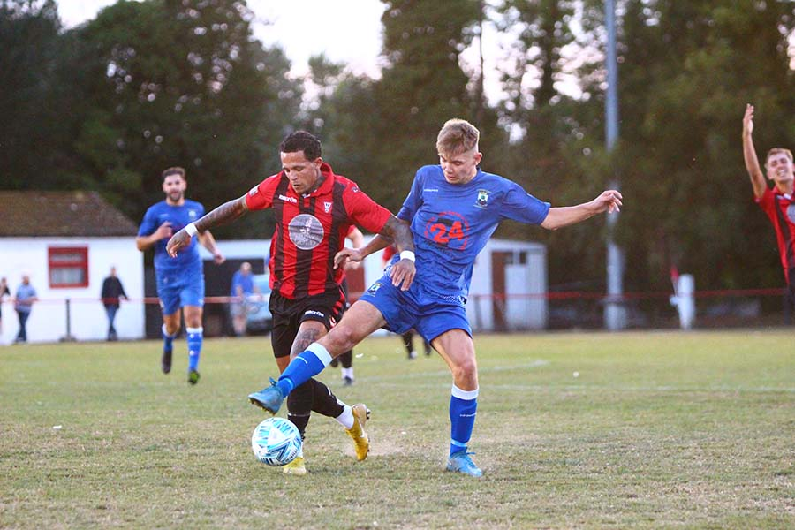
Nailsea & Tickenham are showing early signs of being the big entertainers in the First Division this season, with their 5-2 victory over Cheddar on Tuesday night adding to their increasing scoring tallies, both in the for and against columns! At the end of this game, there had been 22 goals in their previous three fixtures, but it was looking perilous early on for the visitors, after Archie Heywood and Ethan Reed had each struck to help the Cheddar go 2-1 up. The high-scoring Swags soon found their shooting boots however, and eventually ran out winners, with Luke Osgood’s brace, plus further efforts from Jacob O’Donnell, Dan Cook and Joe Berry leading them to another three points. AEK Boco have also showed signs of promise in the early weeks of the season, and they captured their fourth win of the month after coming from behind to beat Radstock 3-1. Josh Jenkins scored a crucial equaliser in the first half stoppage time, with the same man then striking again to complete the turnaround ten minutes from time, before sub Alfie Andrews wrapped up the victory. In the other game that evening, Almondsbury duo Luke Burman and Joe White each scored for the second consecutive fixture to hand Portishead their first defeat of the season. The following evening, Shirehampton were the big winners, putting six past Bishops Lydeard at Penpole Lane. Having actually fallen behind in the opening stages of the match, Shirehampton surged to victory behind goalscoring doubles from both Ryan Radford and Scott Bamford. There was also goals for George Brimson and Louis Snailham for the home side who grabbed their third win on the bounce. Warminster and Wells battled out a goalless draw (pictured left, courtesy of Jamie House), while Oldland survived a late red card in their 1-1 draw at home to Hallen. Jacob Reader’s successful penalty early in the second half had been cancelled out by a quick response from Elliot Gardener, but the Abbots were then forced to hold on during the closing stages following Stefan Lee’s dismissal 20 minutes from time.
Premier Division: In their second derby in the space of two weeks, Bridgwater again gained bragging rights over neighbours Street thanks to a 3-0 win on Friday evening. Having beaten the same opponent 7-0 just a fortnight ago, Bridgwater maintained their winning start to the campaign, with David Thorne opening the scoring after 14 minutes, before Jacob Spence and Oli Hebbard adding further goals after the interval. On Saturday, Clevedon produced an incredible comeback to defeat Wellington by four goals to three. Two goals from Nathaniel Groom gave the visitors a 2-1 lead at the interval, with Callum Eastwood having briefly put Clevedon on level terms thanks to a headed finish. Then, with five minutes left on the clock, Wellington looked to have wrapped up victory when the ball deflected into the home net to give them a late two-goal advantage. Clevedon gave themselves a little bit of hope when Freddie King rolled the ball into the back of the net, and then less than two minutes later, King turned provider, teeing up Henry Westlake who fired home to level the scores. With the away side reeling, Town sniffed blood and continued to push forward, somehow managing to score again in the first minute of stoppage time through Syd Camper to complete a remarkable turnaround.
Helston were victors by two goals to one for the third time in succession, grabbing a late winner to defeat Torpoint Athletic. Having taken the lead through Matty Bye, Helston were pegged back 15 minutes from time when Curtis Damerell levelled from the spot for the home side. It was then left to the in-form Rubin Wilson to secure the victory for Helston, with his 82nd minute strike helping to extend their six-match unbeaten run. Buckland Athletic were also successful away from home, with the Sam’s, Clifton and Stayt before scoring in the first half to help lead them to a 2-1 victory over Keynsham.
First Division: In Friday’s big clash between two of this season’s strong starters, Wells City came out on top at the Athletic Ground, beating Nailsea & Tickenham 2-1. It was a fast start to the contest which made the difference, with new man Michael Duffy and Harry Horton both scoring for the hosts inside the opening ten minutes. Nailsea claimed a late consolation, but were second best for much of the evening, with Wells now having grabbed 16 points from the last 18 available to them. Saturday’s contests saw a couple of big winners, with early table toppers Oldland Abbotonians strolling to a 6-0 victory at home to Almondsbury. The away side had won two on the bounce coming into the game, but they were no match for the Abbots, with Stefan Lee, Cash Vinall and Jai McLeod all scoring during a one-sided opening half. Aaron Mansfield then added a fourth early in the second period, with Jack Mills also getting his name on the scoresheet for the rampant hosts.
Another side to bag six on Saturday were FC Bristol, with Sacha Tong scoring four of those to put Gillingham Town to the sword. A penalty after just two minutes actually saw the hosts lead, but from there it was most one-way traffic, with James Hall equalising before the Tong show began. He struck twice towards the end of the first half to put his side 3-1 up, before completing his hat-trick ten minutes after the restart. Town showed a little bit of fight, trimming the deficit slightly, but Tong was soon back on target to make it 5-2, with Kinsly Murray then completing the scoring late on. Bishop Sutton ended a tough spell of results, overturning an early deficit to beat Shirehampton 3-2 at Lakeview. Ryan Radford give the visitors a dream start, finishing off a well-worked corner, before Sutton levelled from the spot after 33 minutes through Oaklan Buck. Michael Grist then produced two big moments in quick succession at the end of the first half to turn the game in his side’s favour. His first finish came from close range, tapping the loose ball home to put Sutton in front, before he then scored from much further out, with his long-ranger nestling in the top corner to put the hosts 3-1 up at the interval. Shirehampton hit back at the beginning of the second half thanks to a deflected effort from Dan Spicer, and despite going close on a couple of occasions they were unable to find the elusive equaliser. Bishops Lydeard’s strong home form continued against Hengrove, with a tenth minute effort from Mark Jones giving them a 1-0 win.
FA Vase: The knockout action got underway with a ten-goal thriller on Friday evening, with the luckless Wincanton eventually falling to a penalty shootout defeat at the hands of Fawley. In what was the highest score draw in the history of the competition, Winky let slip a two-goal lead eight minutes from time before eventually drawing 5-5. It was then Fawley who seemed to carry the momentum from normal time, prevailing 4-1 on penalties. Unfortunately, penalties didn’t seem to go the way of Western League sides on Saturday afternoon either, with three more teams knocked out despite drawing at the end of ninety minutes. Longwell Green and Warminster were each knocked out in this manor, as were Sherborne Town at the hands of Andover New Street. Anthony Herrin’s brace gave the Zebras a chance to progress, but they came up short on spot kicks and will have to turn their attention back to league matters.
It was better news for Portishead, with heroics from Dave Hewitt helping them beat Shrivenham following a dramatic afternoon. Although the game ended goalless at the end of normal time, Portishead keeper George Boon was unable to continue in the final few minutes and had to be replaced by Assistant player-manager Dave Hewitt between the sticks. Then, during the shootout, Hewitt pulled off a couple of smart saves before knocking home the winning penalty to help book Portishead’s spot in the next round. They will be joined in the draw by a number of Western League sides, including Ashton & Backwell who came from behind to beat Knaphill 2-1. Having seen the visitors take a tenth minute lead from the spot, Ashton drew level through Joe Banks, before Oscar Pearce’s effort midway through the second half turned the game in United’s favour. Another come-from-behind winner were Cadbury Heath, with Matt Huxley making an instant impact in their defeat of Woodley United. Making his first start of the season, Huxley took just 36 minutes to get amongst the goals, scoring an important equaliser soon after the Heath had fallen behind. Ali Boyer then struck soon after to complete the turnaround, before Huxley grabbed his second of the afternoon to give the away side an unassailable lead. Brislington were also winners away from home, with Dean Griffiths’ early double helping them beat Moreton 3-1, while Omari Sims goal on the hour mark giving Odd Down an impressive 1-0 win away at Bodmin. All of those victories were bettered significantly by Barnstaple Town however, with Callum Laird’s hat-trick playing a small part in their 10-0 thumping of Godolphin Atlantic. The contest was all-but decided from the 24th minute, with Joe Grigg, Stu Bowker and Tor Swann joining Laird on the scoresheet. Laird’s second of the contest extended the half-time lead to five, with substitute Charlie Wright then scoring with his first touch to kick-start the second half. Brodie Montague took the score to seven before Laird completed his treble, with Swann grabbing his second late on, before Billy Tucker took the scoreline into double figures on a memorable afternoon for Barum.
Another feel good story occurred in South Gloucestershire, where Bitton ended their winless start to the season by beating Wokingham & Emmbrook 4-1. The first 45 minutes passed without incident, but the hosts made a dream start to the second half with Jesse Howe slotting home a penalty within moments of the restart. Wokingham then drew level to pile pressure back onto Bitton, but they responded excellently, with two goals in the space of three minutes from Charlie Maddison and Jack Sheppard giving them a healthy two-goal advantage. It was then left to Alessandro Pelliccia to complete the win, with his stoppage time effort finally giving Bitton fans something to cheer following a tough start to their campaign.
Falmouth also navigated their way through to the next round after goals from Tom Annear, Tim Nixon and Charlie Edney saw them beat St Austell 3-1 at Bickland Park, while an early Aaron Blakemore effort led Hallen to a 1-0 win away at Stonehouse Town. It wasn’t such good news for the trio of Ilfracombe, Cheddar and Bristol Telephones who each went ahead before succumbing to defeats, with Tytherington Rocks falling to a 1-0 loss at Wantage, and Radstock coming out on the wrong side of an entertaining 4-2 result at home to Newton Abbot Spurs.
This week on the podcast, we hear from Shepton Mallet joint-manager, John Durbin, who reflects on their good run in the FA Cup, and what they hope to achieve in the league this season. There is also a conversation with Oldland Abbotonians boss, Darren Sealey, who talks about the ambitions of the club going forward, both on and off the pitch.
Season 2022/23 Podcast Episode 5 | Toolstation Western League (toolstationleague.com)
Recent Results
Tuesday 23rd August 2022
Premier Division
Helston Athletic 2-1 Falmouth Town
Millbrook 0-1 Saltash United
Shepton Mallet 3-0 Buckland Athletic
Torpoint Athletic 0-3 Barnstaple Town
First Division
Almondsbury 2-1 Portishead Town
Cheddar 2-5 Nailsea & Tickenham
Radstock Town 1-3 AEK Boco

Wednesday 24th August 2022
FA Cup Preliminary Round - Replay
Clevedon Town 1-2 AET Cirencester Town
Wincanton Town 3-0 Camberley
Premier Division
Street 1-0 Ashton & Backwell United
First Division
Oldland Abbotonians 1-1 Hallen
Shirehampton 6-2 Bishops Lydeard
Warminster Town 0-0 Wells City
Friday 26th August 2022
Premier Division
Bridgwater United 3-0 Street
First Division
Wells City 2-1 Nailsea & Tickenham
FA Vase First Qualifying Round
Fawley 5-5 (4-1 pens) Wincanton Town
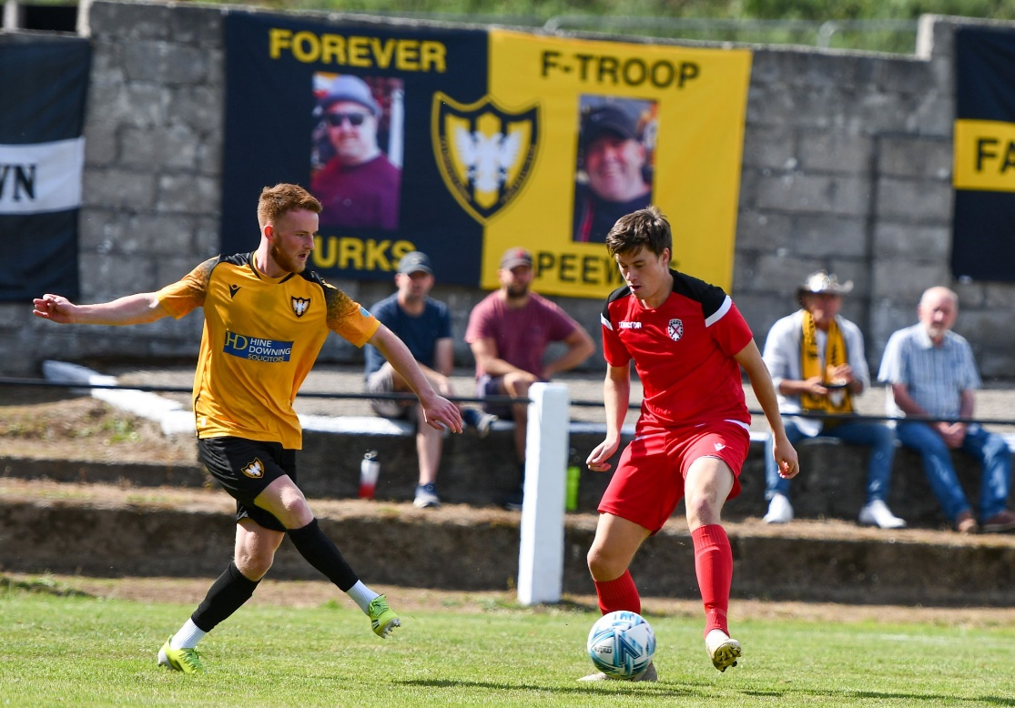

Saturday 27th August
Premier Division
Clevedon Town 4-3 Wellington
Keynsham Town 1-2 Buckland Athletic
Torpoint Athletic 1-2 Helston Athletic
First Division
Bishop Sutton 3-2 Shirehampton
Bishops Lydeard 1-0 Hengrove Athletic
Gillingham Town 2-6 FC Bristol
Oldland Abbotonians 6-0 Almondsbury
FA Vase First Qualifying Round
Ashton & Backwell United 2-1 Knaphill
Bitton 4-1 Wokingham & Emmbrook
Bodmin Town 0-1 Odd Down
Camelford 3-2 Ilfracombe Town
Cheddar 2-4 Crediton United
Clanfield 85 3-1 Bristol Telephones
Falmouth Town 3-1 St Austell
Godolphin Atlantic 0-10 (ten) Barnstaple Town
Milton United 2-2 (4-1 pens) Longwell Green Sports
Moreton FC 1-3 Brislington
Newport (IoW) 0-0 (4-2 pens) Warminster Town
Portishead Town 0-0 (4-3 pens) Shrivenham FC
Radstock Town 2-4 Newton Abbot Spurs
Sherborne Town 2-2 (2-3 pens) Andover New Street
Stonehouse Town 0-1 Hallen
Wantage 1-0 Tytherington Rocks
Woodley United FC 2-3 Cadbury Heath

Upcoming Fixtures
Monday 29th August (3pm kick-off unless noted)
Premier Division
Ashton & Backwell United vs Falmouth Town
Barnstaple Town vs Cadbury Heath
Buckland Athletic vs Bridgwater United
Helston Athletic vs Sherborne Town
Ilfracombe Town vs Clevedon Town
Keynsham Town vs Wellington
Millbrook vs Shepton Mallet
Mousehole vs Street
Saltash United vs Bitton
Torpoint Athletic vs Welton Rovers
First Division
AEK Boco vs Nailsea & Tickenham
Almondsbury vs Odd Down
Bishop Sutton vs Oldland Abbotonians
Bishops Lydeard vs Hallen
Brislington vs Wincanton Town
Cheddar vs Bristol Telephones
Gillingham Town vs Wells City
Hengrove Athletic vs Tytherington Rocks
Longwell Green Sports vs FC Bristol 13:30KO
Shirehampton vs Radstock Town

Saturday 3rd September (3pm kick-off unless noted)
FA Cup 1st Qualifying Round
Blackfield & Langley vs Shepton Mallet
Torpoint Athletic vs Helston Athletic
Wincanton Town vs AFC Totton
Premier Division
Bitton vs Welton Rovers
Bridgwater United vs Wellington
Buckland Athletic vs Barnstaple Town
Ilfracombe Town vs Millbrook
Mousehole vs Falmouth Town
Sherborne Town vs Keynsham Town
Street vs Cadbury Heath
First Division
AEK Boco vs Gillingham Town
Bristol Telephones vs Bishop Sutton
Cheddar vs Brislington
FC Bristol vs Bishops Lydeard
Longwell Green Sports vs Odd Down
Nailsea & Tickenham vs Almondsbury
Portishead Town vs Oldland Abbotonians
Shirehampton vs Wells City
Tytherington Rocks vs Radstock Town
Warminster Town vs Hengrove Athletic

