Latest Round-ups:
#4
Season 2022/23
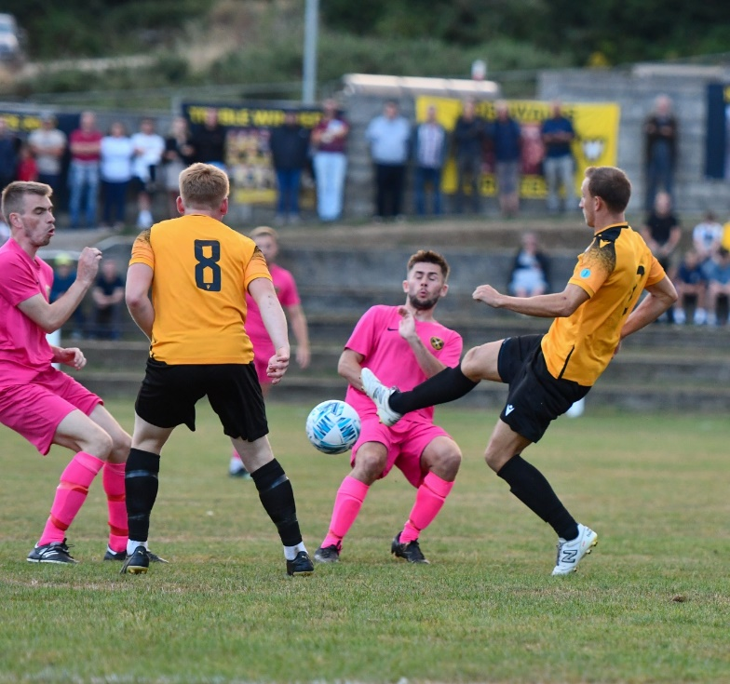
Midweek Action: On a busy Tuesday night of league action, Bridgwater secured their fifth consecutive victory in the Premier Division by beating Sherborne Town 2-1. First half goals from Troy Simpson and Jack Taylor proved to be enough for the home side who have laid down a strong marker over the opening rounds of action. In a clash between two Devon sides, Buckland claimed some early season bragging rights thanks to a 4-0 triumph over Ilfracombe. Josh Webber grabbed a brace of goals for the home side, with Ryan Bush and Owen Stockton also getting in on the scoring action. There was also a home win for Barnstaple Town over Wellington, with Brodie Montague, Stuart Bowker and Tommy Rogers each finding the back of the net at Mill Road. Late goals were very much in fashion on Tuesday, starting at Bitton, where visiting skipper Connor Saunders headed home in the seventh minute of stoppage time to lead Ashton & Backwell to a 2-1 victory. Another late winner handed Millbrook at 2-1 win at Trungle Parc, with a brilliant finish from Sean Thomson in the 82nd minute condemning Mousehole to a disappointing home defeat. Keynsham’s Jemar Thomas was also on hand to strike at the death, with his equaliser four minutes into added time giving the K’s a 2-2 draw at home to Welton, helping them become the 20th and final team to secure a point this season. The points were also shared between Saltash and Helston following the end of a feisty encounter in south Cornwall. Rubin Wilson’s strong start to the campaign continued, with his 30th minute opener put the away side in front, but the Ashes managed to hit back after the interval, with Sam Hughes levelling affairs around the hour mark. 24 hours later, Jake Mawford’s early headed goal led Street to a 1-0 win away at Cadbury Heath, while efforts from Tim Nixon, Charlie Edney and Luke Barner gave Falmouth a comfortable 3-1 victory over Torpoint (pictured right).
Hallen have enjoyed an encouraging start to the First Division season, and that continued on Tuesday after they claimed a 4-1 win away at Bishop Sutton. Both Saul Jarrett and Mark Thuo scored in either half for the visitors, with kickoff for the second half delayed slightly following a power cut in the local area which caused a brief floodlight failure.
Adam Wright also bagged a pair of goals, striking in either half of Wells’ 4-0 triumph away at Almondsbury, with Tom Ellis’ bullet header and Jake Curtis’ debut strike adding to the scoreline. On an evening where the goals flowed up and down the division, there was a rare stalemate between Cheddar and Warminster, but not so in Bath, where Odd Down thumped Gillingham by five goals to two. The game was two apiece at the interval, before the home side surged home during the second 45, with Luke Bryan completing his double, before Caelen Simpson and a late own goal confirmed back to back wins. Oldland continue to prosper during the month of August, after they managed to overturn a half time deficit to win 3-2 at Radstock. Kieran Cooper and Jack Farion each struck for the hosts during the first half, but Oldland managed to stay in touch thanks to the in-form Owen McCallum. The away side then got back on level terms in the opening stages of the second half thanks to a penalty from Harry Pruett, before McCallum helped complete the turnaround. In Wednesday’s standalone fixture, Mason Davis notched his second hat-trick of the season to give Bristol Telephones a 4-2 win at home to FC Bristol. Davis’ previous treble came in the Phones only other victory this season over Longwell Green, and he was it again on Wednesday, with Jason Thatcher adding a further goal to help secure maximum points.
Premier Division: Bridgwater United continue to set the pace atop the league, and have now won six on the bounce after defeating Bitton 4-0. The in-form hosts took just 17 minutes to go in front on Saturday afternoon, with Jack Taylor unexpectedly getting his name on the scoresheet. Ross Edwards then struck at the back post to double their advantage, with an own goal then making it 3-0 midway through the second half. Bridgy saved the best for last, with George King volleying home to put the finishing touches on a terrific team goal which completed the scoring. Saltash are another side who remain unbeaten over the first couple of weeks, and they were in excellent form against Keynsham, beating their visitors 6-1 at the Waterways Stadium. The contest was all-but over inside the opening 45 minutes, with the two Callum’s, Merrin and Martindale, giving the Ashes a promising start. An unfortunate own goal then made it 3-0 inside half an hour, before Callum O’Brien added a further effort just prior to the break to put the home side in command. Mike Smith continued the scoring, extending the lead to five after 51 minutes, with Jake Miller adding a late sixth to cap a dominant outing. Sherborne Town ended a four-match winless run in all competitions, with three second half efforts leading them to a 3-0 win over Wellington. Following 58 goalless minutes, the deadlock was finally broken by the home side, when Alex Murphy grabbed his first of the campaign. Just ten minutes later, Murphy managed to find enough space and time to slot home his second of the afternoon, before Brett Cotterill added a late third for the impressive Zebras.
Sherborne on the attack during their win over Wellington
On a good afternoon all round for the home sides, Ashton & Backwell United also ran out comfortable victors, beating Welton Rovers by four goals to nil. Goals from Miles Hardidge and Reece Hedges at either end of the opening half put Ashton in control, before a couple of efforts in the final ten minutes from Oscar Pearce and Dean Preddie wrapped up the one-sided victory. The points were shared in the other fixture at Jenkins Park, where Joe Edmonds’ first Barnstaple goal helped them come from behind to salvage a 1-1 draw against Millbrook, for whom Jake Foster had previously put them in front.
First Division: Shirehampton got the action underway on Friday evening, beating local rivals Hallen 2-1 in front of a healthy three-figure crowd. A first half double from Scott Bamford did the business for the Shire, with Aaron Blakemore scoring an injury time consolation for the hosts who missed out on the opportunity of moving briefly into top spot.
On Saturday afternoon, Cheddar finally grabbed their first victory of the season away at AEK Boco, with Morgan Bacon beating his man before slotting home in the closing stages. For early league leaders Oldland, goals from Courtney Charles and Jacob Reader proved to be enough for them in their 2-0 victory over the Tytherington Rocks. Slightly more impressive in victory were Wells City, with four different scorers helping them ease past the winless Radstock. Tom Ellis, Jake Curtis, Tom Hill and Adam Wright each found the back of the net at the Athletic Ground to extend Wells’ winning run to four matches, all of which have come without conceding. Another side to score four were Almondsbury, with the South Gloucestershire side picking up their first win since the opening day by beating Warminster. An excellent opening half was the catalyst for the away side’s victory, with Luke Burman and Joe White scoring inside the opening 25 minutes to put them two goals to the good. Lewis Hedges then fired low into the bottom corner to make it 3-0, before Aaron Langdon saved a penalty in first half stoppage time to preserve the Almonds three-goal lead. That save proved to be vitally important, with Warminster bounding into the second half through substitute Jamal Chevolleau who struck twice within five minutes of the restart to open up the contest. In the closing stages of the match, Burman tapped home his second goal of the afternoon to put the result beyond doubt, extending Warminster’s winless start to the campaign. The outcome was very similar in the clash between FC Bristol and Brislington, with the home side holding off an attempted fightback to prevail by four goals to two. Two Sacha Tong efforts put FC Bristol two goals ahead at the interval, and they then moved further in front on the hour mark thanks to Elan Plummer. Brislington have found form over the previous couple of weeks, and no sooner had Josh Egan tucked home his first penalty, he was then scoring from 12 yards once again following a foul on Asa White. With their advantage now in a more perilous position, it was left to Tong to complete his hat-trick, capping a fabulous individual performance from the front man. There was also a high scoring victory for Nailsea & Tickenham, with their goalscoring tally now sitting at 16 from their five fixtures after they beat Gillingham Town 5-3. Jacob O’Donnell, Callum Dunn, Jack Thorne, Gary Freeman and Joe Berry all struck for the victorious hosts, with Tom Jarvis at the double in defeat for Town who unfortunately remain winless. A second half winner from Luco Ponsillo led Hengrove past Bristol Telephones, while Bishops Lydeard also won 1-0, with a superb finish from Mark Jones in the 92nd minute helping them edge past Longwell Green Sports.

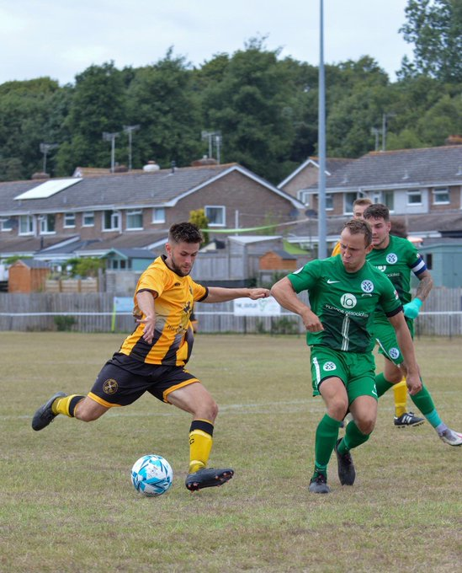
FA Cup: Shepton Mallet stormed into the qualifying rounds of the FA cup after claiming a 4-0 win at home to Brixham. After putting Liskeard to the sword in their previous tie, Mallet were at it again on Saturday, with Jacob Sloggett scoring for the second time this week to put them ahead in the early stages. A towering header from Nick Hewlett then doubled the home side’s advantage, with Joe Morgan making it 3-0 just prior to the half-time interval. Any chances of an unlikely comeback were put to bed in the 66th minute, when Morgan struck from close range to complete the scoring. Mallet will be joined in the next round by Helston after they produced a dramatic late turnaround against fellow Western League outfit Falmouth. The visitors had won three games on the bounce coming into this tie, and they led for much of the afternoon, with Tom Moxham’s attempted cross inadvertently ending up in the back of the net. Helston pushed for an equaliser, and they were duly rewarded five minutes from time, with Rikki Sheppard heading home to set up a likely midweek replay. However, with their next attack, Shepherd managed to get this head to another cross, and that too found its way past the visiting keeper to spark joyous scenes for the home supporters. There was also a late comeback in the other contest involving Premier Division sides, with Torpoint striking twice in the final 20 minutes to beat fellow Cornish outfit Mousehole by three goals to two. It was Mousehole who started the game fastest, taking the lead after just five minutes through Hayden Turner, with Torpoint drawing level thanks to skipper Darren Hicks. Callam McOnie then unleashed a mean strike from the edge of the area to put the visitors back ahead, bringing the curtain down on an entertaining opening 45 minutes. Torpoint managed to respond well again, equalising for the second time through John Heveran, and then with ten minutes remaining they scored what turned out to be the match-winner, with Curtis Damerell producing an unstoppable headed finish. Things didn’t go quite so well for Buckland and Cadbury Heath who suffered one-sided defeats, while a missed penalty 20 minutes from time costing Ilfracombe dearly in their 2-1 defeat at the hands of a fast-starting Willand Rovers. The cup runs of both Wincanton and Clevedon will continue, with both sides earning replays following creditable 1-1 draws on Saturday afternoon away at Camberley and Cirencester respectively.
Action from an entertaining cup tie between Torpoint Athletic and Mousehole at The Mill

Recent Results
Tuesday 16th August 2022
Premier Division
Barnstaple Town 3-1 Wellington
Bridgwater United 2-1 Sherborne Town
Bitton 1-2 Ashton & Backwell United
Buckland Athletic 4-0 Ilfracombe Town
Keynsham Town 2-2 Welton Rovers
Mousehole 1-2 Millbrook
Saltash United 1-1 Helston Athletic
First Division
Almondsbury 0-4 Wells City
Bishop Sutton 1-4 Hallen
Cheddar 0-0 Warminster Town
Odd Down 5-2 Gillingham Town
Radstock Town 2-3 Oldland Abbotonians

Wednesday 17th August 2022
Premier Division
Cadbury Heath 0-1 Street
Falmouth Town 3-1 Torpoint Athletic
First Division
Bristol Telephones 4-2 FC Bristol
Friday 19th August 2022
First Division
Hallen 1-2 Shirehampton

Saturday 20th August
Premier Division
Ashton & Backwell United 4-0 Welton Rovers
Bridgwater United 4-0 Bitton
Millbrook 1-1 Barnstaple Town
Saltash United 6-1 Keynsham Town
Sherborne Town 3-0 Wellington
First Division
AEK Boco 0-1 Cheddar
Bishops Lydeard 1-0 Longwell Green Sports
FC Bristol 4-2 Brislington
Hengrove Athletic 1-0 Bristol Telephones
Nailsea & Tickenham 5-3 Gillingham Town
Odd Down A-A Bishop Sutton
Oldland Abbotonians 2-0 Tytherington Rocks
Warminster Town 2-4 Almondsbury
Wells City 4-0 Radstock Town

FA Cup Preliminary Round
Buckland Athletic 0-3 Frome Town
Camberley 1-1 Wincanton Town
Cirencester Town 1-1 Clevedon Town
Didcot 4-0 Cadbury Heath
Helston Athletic 1-2 Falmouth Town
Shepton Mallet 4-0 Brixham
Torpoint Athletic 3-2 Mousehole
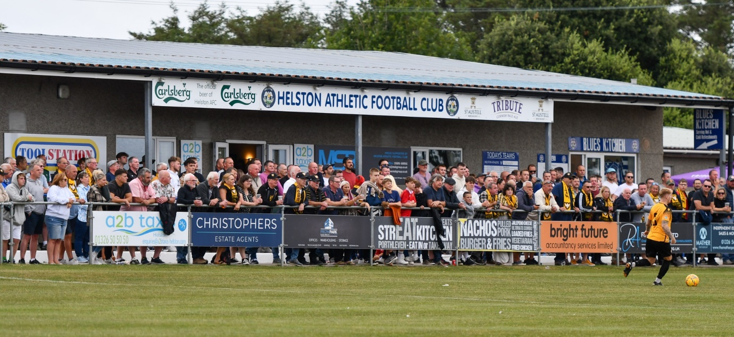
Willand Rovers 2-1 Ilfracombe Town

Upcoming Fixtures
Tuesday 23rd August 2022
Premier Division
Helston Athletic vs Falmouth Town 19:45KO
Millbrook vs Saltash United 19:45KO
Shepton Mallet vs Buckland Athletic 19:30KO
Torpoint Athletic vs Barnstaple Town 19:30KO
First Division
Almondsbury vs Portishead Town 19:45KO
Cheddar vs Nailsea & Tickenham 19:45KO
Radstock Town vs AEK Boco 19:45KO

Wednesday 24th August 2022
FA Cup Preliminary Round - Replay
Clevedon Town vs Cirencester Town 19:30KO
Wincanton Town vs Camberley 19:45KO
Premier Division
Street vs Ashton & Backwell United 19:30KO
First Division
Oldland Abbotonians vs Hallen 19:45KO
Shirehampton vs Bishops Lydeard 19:30KO
Warminster Town vs Wells City 19:45KO
Friday 26th August 2022
Premier Division
Bridgwater United vs Street 19:45KO
First Division
Wells City vs Nailsea & Tickenham 19:30KO
FA Vase First Qualifying Round
Fawley vs Wincanton Town 19:45KO

Saturday 27th August (3pm kick-off unless noted)
Premier Division
Clevedon Town vs Wellington
Keynsham Town vs Buckland Athletic
Millbrook vs Mousehole
Torpoint Athletic vs Helston Athletic
First Division
Bishop Sutton vs Shirehampton
Bishops Lydeard vs Hengrove Athletic
Gillingham Town vs FC Bristol
Oldland Abbotonians vs Almondsbury
FA Vase First Qualifying Round
Ashton & Backwell United vs Knaphill
Bitton vs Wokingham & Emmbrook
Bodmin Town vs Odd Down
Camelford vs Ilfracombe Town
Cheddar vs Crediton United
Clanfield 85 vs Bristol Telephones
Falmouth Town vs St Austell
Godolphin Atlantic vs Barnstaple Town
Milton United vs Longwell Green Sports
Moreton FC vs Brislington
Newport (IoW) vs Warminster Town
Portishead Town vs Shrivenham FC
Radstock Town vs Newton Abbot Spurs
Sherborne Town vs Andover New Street
Stonehouse Town vs Hallen
Wantage vs Tytherington Rocks
Woodley United FC vs Cadbury Heath
This week’s Podcast includes a conversation with Falmouth Town manager Andrew Westgarth who helps introduce his side to the Toolstation Western League. Portishead boss Eammon Daly reflects on his side’s excellent start to the campaign, while outlining their ambition to compete for promotion. There is also an important interview with Phil Hiscox from the South West Peninsula League and Western League Chairman, John Pool, providing an update on the merger between the two Leagues.
Season 2022/23 Podcast Episode 4 | Toolstation Western League (toolstationleague.com)

