Latest Round-ups:
Season 2022/23
#3
Midweek Action: There was a quick turnaround in the FA Cup replays, with four ties on Tuesday evening, just three days after the sides had originally met last weekend. A huge crowd of 312 took in the game of the night, where extra time was needed to decide the victor of the all-Western League clash between Mousehole and Barnstaple. Having drawn one apiece on Saturday, Mousehole made the better start at Trungle Parc, before a goal just after the hour mark from Callum Laird meant the tie could not be decided after 180 minutes of action. It was left to Louis Price to finally strike the final blow, with his goal five minutes into the second half of extra time helping Mousehole progress. Fellow Cornish outfit Torpoint also qualified for the next round after Ryan Richards’ goal helped them beat Millbrook 1-0, with Ilfracombe defeating Sherborne 2-0 in their replay following goals from Liam Short and Harry Stevens. After claiming a 2-2 draw at Springfield earlier in the week, Cadbury Heath booked a date with Didcot thanks to a storming 5-2 victory away at Mangotsfield United. A double from Josh Haynes was a major contribution towards the win, with Tom Withers, Callum Whooley and George Boon also getting in on the scoring for the gallant Heath.

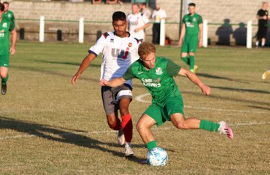
A trio of away teams all secured big victories in the midweek’s Premier Division fixtures, with Ashton & Backwell claiming local bragging rights thanks to their 3-2 win away at Clevedon on Wednesday. After Ethan Feltham had fired the home side in front, Ashton hit back and managed to forge ahead midway through the second half thanks to efforts from Will Solari and Miles Hardidge. Straight from the kickoff, Freddie King curled home to cancel out Hardidge’s strike, but it was Ashton who had the last word, with Joe Cattermole converting a 93rd minute penalty after Callum Eastwood had been adjudged to have handled the ball close to his line. 24 hours previously, Wellington skipper Sam Towler plundered a terrific hat-trick in his side’s 4-1 win away at Welton, while Jake Brown went one better, scoring half of Bridgwater’s goals in their thumping 8-1 triumph away at Keynsham.
Action from Wellington’s 4-1 victory away at Welton Rovers.
There was also some high scoring winners in the First Division, with Wincanton registering their fourth away win on the bounce, putting Longwell Green to the sword at Shellards Road. Matt Garner was another of the midweek hat-trick heroes, helping fire the Wasps to a 5-0 victory, with Connor Williams and Jamie Thompson also getting their names on the scoresheet. Robbie Cox, Matt Lloyd and Rob Latham each struck in Portishead’s 3-0 victory at home to Radstock, while AEK Boco defeated Hengrove 2-1 with substitute Gregory Yarde scoring the winner 20 minutes from time. There was a one-sided affair at Brislington, where the home side maintained their strong start to the campaign by scoring six unanswered goals against Bristol Telephones. Danny Dodimead struck a brace, adding to further goals from Dean Griffiths, Asa White, Josh Egan and Ashley Kington. Oldland Abbotonians were the heavy hitters on Wednesday, firing out of the blocks on their way to a 5-1 win at home to Gillingham Town. A trio of goals inside the opening 19 minutes from Jacob Reader, Aaron Mansfield and Owen McCallum set the Abbots on their way to victory, with McCallum making it 4-1 early in the second half, before Harry Pruett tucked home a penalty to complete the scoring. Another game with a fast start took place at Bishops Lydeard, where both they and Odd Down scored two goals apiece inside the opening half hour during an entertaining 2-2 draw. On Thursday evening, Hallen handed Radstock their second defeat in quick succession thanks to a 2-1 victory in Somerset. A Martin Stowell header was followed by an Adnan Hiroli penalty after the interval to help the visitors grab all three points.
Premier Division: On Friday evening, Bridgwater followed up their 8-1 victory at Keynsham earlier in the week by beating Street 7-0 to claim derby day bragging rights. After Jake Llewellyn put the visitors ahead from the spot in the tenth minute, a couple of headers from Troy Simpson and Jordan Greenwood extended their advantage. Man of the match Jack Taylor added a fourth prior to the interval, before a pair of quick-fire efforts early in the second half from Jacob Brown and captain Mark Armstrong added to Street’s woes. It was left to Taylor to add the finishing touches, with the frontman scoring Bridgwater’s seventh and final goal 13 minutes from time to extend their winning start to the campaign.
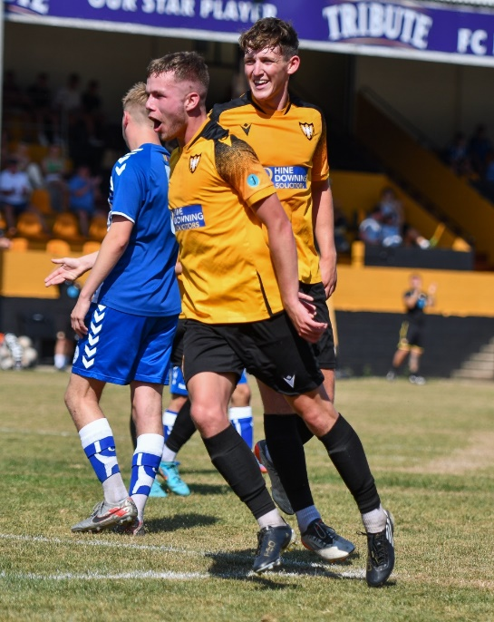
The following afternoon, Shepton Mallet joined Bridgwater in maintaining their 100% start thanks to a 2-0 victory at home to Barnstaple Town. The Somerset outfit have had a barnstorming start to the season, and they followed up last weekend’s cup heroics with a relatively comfortable home win thanks to goals either side of the interval from Jacob Sloggett and Joe Morgan. There was also a big home victory for Falmouth Town who dominated the opening half of their 4-0 win over Clevedon. Having taken the lead after 12 minutes thanks to James Swan’s long-ranger, Falmouth doubled their advantage midway through the half when Tim Nixon slammed the ball home. Alex Wharton was then on hand to stretch the lead further, with Nixon striking an excellent free-kick from the edge of the box to complete the scoring in first half stoppage-time. Fellow Cornish outfit Millbrook also enjoyed home comforts, with Dave Youlden and Sean Thomson both notching in their 2-0 win over Bitton, while Saltash left it late before beating Buckland, with United debutant Harry Jeffrey sliding home the crucial goal six minutes from time.
Falmouth players celebrate during their impressive win over Clevedon.
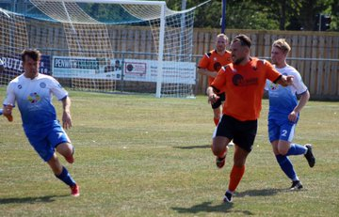
In the most dramatic game of the day, Helston Athletic eventually held on to beat Wellington by three goals to two at Kellaway Park. The opening half was a relatively quiet affair with Helston edging in front thanks to a penalty from Rubin Wilson, who dusted himself and converted from 12 yards after he had been tripped by the visiting keeper. Wellington then made a dream start to the second period, with Jake Quick breaking straight from the kick-off before teeing up his brother Miles who volleyed home within 60 seconds of the restart. Wilson then nodded home his second goal of the afternoon on the hour mark, before Rikki Sheppard made it 3-1 to the hosts after beating the offside trap. Welly pulled a goal back in the closing stages through Sully McKenna, but that was as close as they got in their late comeback attempt, with the visitors reduced to nine men following a couple of red cards which soured the ending to a fantastic contest. It also ended 3-2 at West Clewes, where Welton prevailed in the battle of the promoted sides, fighting off a late rally from Sherborne to grab their first win of the season. Rovers went ahead in the lead-up to half time, with Matty Morris scoring his first for the club, and they then doubled their lead on the hour mark through Cam Allen. Aaron White then pulled a goal back for Sherborne with ten minutes left on the clock, but Allen was on hand again to restore Welton’s two-goal advantage in the closing stages. The away side struck at the death through Duncan McCabe, but Welton managed to hang on to end their opponents winning start. Mousehole were held to a goalless draw away at Ashton & Backwell United, while the fixture at The Mill also finished level, with Curtis Damerell’s penalty securing a point for Torpoint after Will Obieng had put Cadbury Heath one-up with his first goal for the club. In an entertaining game at Marlborough Park, Ilfracombe claimed a 4-2 win over Keynsham to condemn their visitors to a fourth straight defeat. Goals from Owen Brain and debutant Sahr Nanoh twice levelled affairs for the K’s, but they were unable to hang on, with Harry Stevens’ double, plus further efforts from John Downing and sub Charlie Prentice leading Ilfracombe to victory.
Action from Saturday’s contest between Helston Athletic and Wellington at Kellaway Park.
First Division: Portishead remain one of only two unbeaten teams in the league after they came from behind to beat Bristol Telephones 2-1. Having conceded the opening goal after just ten minutes, the away side hit back instantly with Calum Townsend’s smart chipped finish drawing them level. Then, with 20 minutes remaining, the early pacesetters grabbed maximum points with left-back Josh Honey beating a couple of men before smashing home from outside the area. The other side who are still yet to suffer defeat after Oldland who came out on top of a seven-goal thriller away at Nailsea & Tickenham. With Oldland leading by a goal to nil thanks to Stefan Lee’s early opener, the game went into overdrive at the end of the first half from the moment Owen McCallum doubled the visitor’s advantage. Nailsea pulled a goal back in the 44th minute, and then despite McCallum scoring again just moments later, there was somehow still time for the hosts to strike once more in stoppage time to reduce the deficit to one at the interval. Nailsea continued to push forward, and despite drawing level midway through the second half, they were hit with a sucker-punch in the final few minutes, with Courtney Charles’ scissor kick leading Oldland to their third win on the bounce.
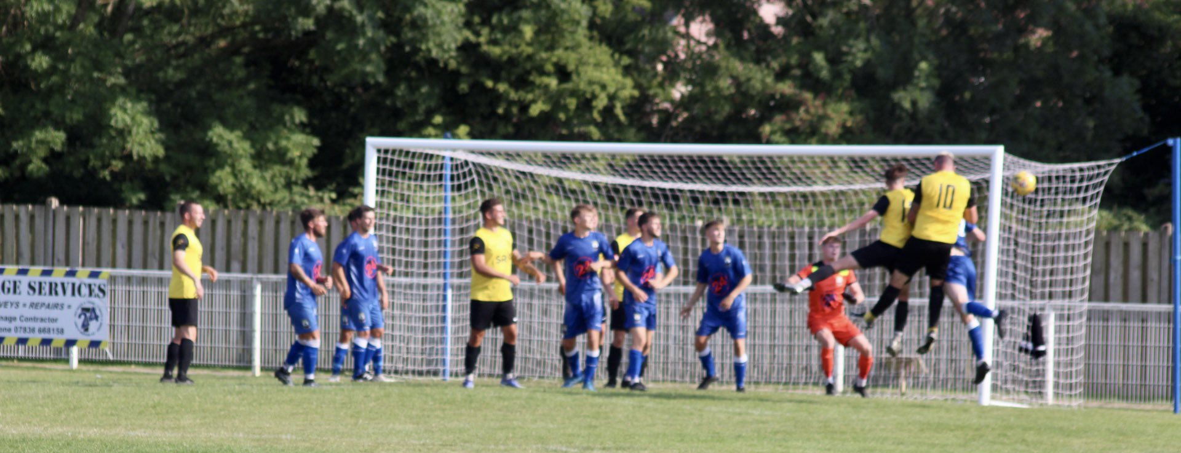
At the opposite end of the table, Warminster have made a surprisingly poor start, suffering a 2-1 defeat against Odd Down on Saturday afternoon. Goals from Luke Bryan and Jake Thomas put the Bath side in charge, and despite Ian Jeffery dispatching a late penalty, Warminster were unable to find an equaliser and remain without a point after three matches. Cheddar are another side who will have expected better things over the first couple of weeks, and they have just one point to show from their opening four fixtures after falling to a late 2-1 defeat at the hands of Shirehampton. The home side went ahead after just ten minutes through Ben Courtier, with Cheddar then getting back on level terms early in the second half thanks to a cool left-footed finish from Lewis Chappell. It was Shirehampton who managed to find the elusive late winner however, with Regan Lashenko firing home off the upright just as the game headed into injury time on a stiflingly hot afternoon. Brislington continue to look the business at this level, after they survived an early red card to defeat Bishop Sutton 1-0 at Ironmould Lane. Joe McLennan was given his marching orders inside the opening quarter of the contest, but the home side’s perseverance paid off when they scored the game’s elusive goal ten minutes from time thanks to a curled finish from Jordan Scadding. Wells City also secured a 1-0 victory, with Craig Herrod proving to be the difference in their close defeat of Wincanton, while a goal in either half from Zac Feltham, plus a late effort from substitute Mason Lewis helped Longwell Green Sports beat Hengrove 3-0. AEK Boco went one better than Longwell Green, backing up their win in midweek by beating Almondsbury 4-0 at the Greenbank Recreational Ground.
Goalmouth action from Wincanton’s clash with Wells City on Saturday afternoon.
On the latest episode of the podcast, we hear from Buckland Athletic manager Dan Hart who looks back on his sides’ victory in the FA Cup Extra Preliminary Round. There is also a conversation between Ian and Jake Edwards, boss of the Tytherington Rocks, who reflects on their first season in the Western League, while touching on what lesson he’s learnt going into the new campaign.
Season 2022/23 Podcast Episode 3 | Toolstation Western League (toolstationleague.com)

Recent Results
Tuesday 9th August 2022
Premier Division
Keynsham Town 1-8 Bridgwater United
Welton Rovers 1-4 Wellington
First Division
Brislington 6-0 Bristol Telephones
Hengrove Athletic 1-2 AEK Boco
Portishead Town 3-0 Radstock Town
Longwell Green Sports 0-5 Wincanton Town
FA Cup Extra Preliminary Round Replay
Ilfracombe Town 2-0 Sherborne Town
Mangotsfield United 2-5 Cadbury Heath
Millbrook 0-1 Torpoint Athletic
Mousehole 3-2 Barnstaple Town
Wednesday 10th August 2022
Premier Division
Clevedon Town 2-3 Ashton & Backwell United
First Division
Bishops Lydeard 2-2 Odd Down
Oldland Abbotonians 5-1 Gillingham Town
Thursday 11th August 2022
First Division
Radstock Town 1-2 Hallen
Friday 12th August 2022
Premier Division
Street 0-7 Bridgwater United

Saturday 13th August
Premier Division
Ashton & Backwell United 0-0 Mousehole
Buckland Athletic 0-1 Saltash United
Falmouth Town 4-0 Clevedon Town
Helston Athletic 3-2 Wellington
Ilfracombe Town 4-2 Keynsham Town
Millbrook 2-0 Bitton
Shepton Mallet 2-0 Barnstaple Town
Torpoint Athletic 1-1 Cadbury Heath
Welton Rovers 3-2 Sherborne Town
First Division
AEK Boco 4-0 Almondsbury
Brislington 1-0 Bishop Sutton
Bristol Telephones 1-2 Portishead Town
Gillingham Town P-P Bishops Lydeard
Longwell Green Sports 3-0 Hengrove Athletic
Nailsea & Tickenham 3-4 Oldland Abbotonians
Shirehampton 2-1 Cheddar
Warminster Town 1-2 Odd Down
Wells City 1-0 Wincanton Town
Upcoming Fixtures
Tuesday 16th August 2022
Premier Division
Barnstaple Town vs Wellington 19:45KO
Bridgwater United vs Sherborne Town 19:45KO
Bitton vs Ashton & Backwell United 19:30KO
Buckland Athletic vs Ilfracombe Town 19:30KO
Keynsham Town vs Welton Rovers 19:45KO
Mousehole vs Millbrook 19:45KO
Saltash United vs Helston Athletic 19:30KO
First Division
Almondsbury vs Wells City 19:45KO
Bishop Sutton vs Hallen 19:30KO
Cheddar vs Warminster Town 19:45KO
Odd Down vs Gillingham Town 19:45KO
Portishead Town vs Longwell Green Sports 19:25KO
Radstock Town vs Oldland Abbotonians 19:45KO

Wednesday 17th August 2022
Premier Division
Cadbury Heath vs Street 19:30KO
Falmouth Town vs Torpoint Athletic 19:45KO
First Division
Bristol Telephones vs FC Bristol 19:45KO
Friday 19th August 2022
First Division
Hallen vs Shirehampton 19:30KO

Saturday 20th August (3pm kick-off unless noted)
Premier Division
Ashton & Backwell United vs Welton Rovers
Bridgwater United vs Bitton
Millbrook vs Barnstaple Town
Saltash United vs Keynsham Town
Sherborne Town vs Wellington
First Division
AEK Boco vs Cheddar
Bishops Lydeard vs Longwell Green Sports
FC Bristol vs Brislington
Hengrove Athletic vs Bristol Telephones
Nailsea & Tickenham vs Gillingham Town
Odd Down vs Bishop Sutton
Oldland Abbotonians vs Tytherington Rocks
Warminster Town vs Almondsbury
Wells City vs Radstock Town

