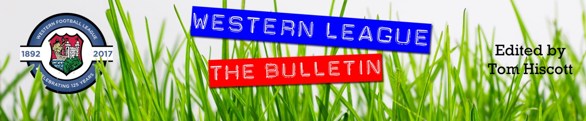
Latest Round-ups:
Season 2022/23
#2
Midweek Action: On Tuesday evening, Sherborne made it back-to-back wins to start their campaign thanks to a convincing 4-0 triumph away at Keynsham. Having gained promotion to the Premier Division just a couple of weeks ago, the Zebras made it six points from six following goals from Declan Cornish, Anthony Herrin, Josh Williams and Henry Lawrence-Napier. Shepton Mallet were another to maintain their winning start, after goals from Ieuan Crowe and Danny Constable led them to a 2-0 victory over Ashton & Backwell. Ryan Bush’s first-half header handed Buckland a slim 1-0 win at home to Welton, while a starring performance from Callum Kenny led Millbrook to a 3-1 victory over Falmouth at Jenkins Park. Kenny scored twice, while also providing an assist to hand the hosts their first win of the campaign. Bridgwater United joined the clubs on six points, after an own goal and a Conor Hartley effort inside the opening 14 minutes helped them defeat Barnstaple 2-1. Tuesday’s other contests both ended one apiece, with Harry Foster levelling for Street in their draw at Bitton, while Callum O’Brien struck 17 minutes from time to rescue a point for Saltash on their visit to Mousehole. On Wednesday, Callum Eastwood’s 14th minute effort was all that was needed for Clevedon to overcome Cadbury Heath by one goal to nil.

In the First Division, Dean Horseman’s Bishop Sutton side followed up their thumping win on the opening day with a high-scoring 4-2 win over Tytherington. With the game level at 2-2 heading into the final 20 minutes, Oaklan Buck was sent on from the bench and he made an immediate impact, scoring twice in the closing stages to help his side bag all three points. Another big winner were Longwell Green Sports who dominated the closing stages to claim a comfortable 6-1 win at home to Almondsbury. Leading 3-1 heading into the final 12 minutes, Longwell’s Matt Brown then took over the contest, scoring a quick-fire hat-trick to add some gloss to the scoreline. Nailsea & Tickenham made it two wins from two away at Brislington thanks to goals from Jacob O’Donnell, Andy Head & Callum Dunn, while Portishead defeated Wells City 3-1, with Matt Lloyd, Josh Honey and Jake Wakefield all notching for the away side. Jacob Grinnell’s opening goal inside ten seconds set Hengrove on their way to a 3-0 victory over Cheddar. Having lost their opening encounter, the Grove made amends against the Cheesemen, with second half efforts from Jude McCarthy and Joe Banks completing the scoring after Grinnell’s early opener. In Bath, the deadlock remained unbroken throughout, with Odd Down and Hallen maintaining their unbeaten starts thanks to a goalless draw.
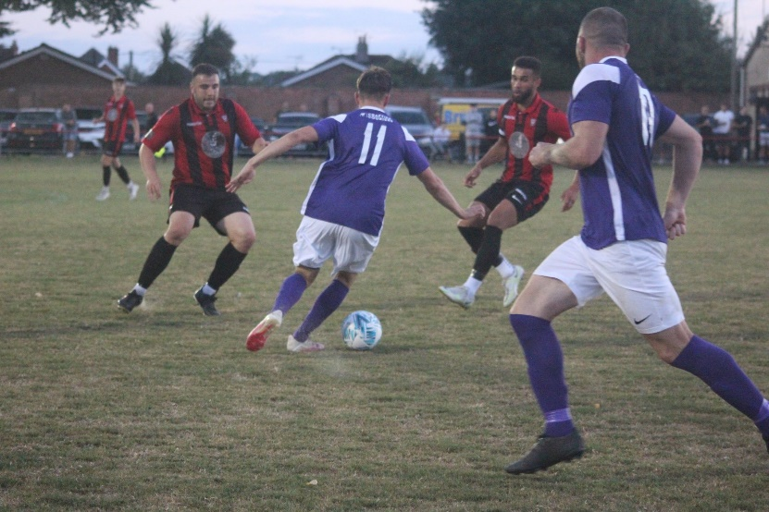
On Wednesday evening, Wincanton made it two from two, with a fine effort from Matt Garner helping give them a 1-0 win away at Warminster (pictured right, courtesy of Jess Harris). There was also an away victory for Shirehampton who overturned an early deficit to beat Bristol Telephones 3-1. Having fallen behind inside the opening 20 minutes, the visitors responded well and got back on level terms prior to the interval through Louis Snailham. Dan Spicer then converted a penalty early in the second half to put Shirehampton ahead for the first time, with Ryan Radford tapping home from close range to round out the victory. A terrific first-half treble from Sacha Tong gave FC Bristol a 3-1 victory at home to AEK Boco. Tong struck twice inside the opening quarter to put the hosts two ahead, and after Boco pulled one back from the spot, Tong then scored again seven minutes before the break to complete a stunning first half performance. Bishops Lydeard produced a stunning late salvo to defeat Radstock 3-2 at Cothelstone Road. After falling to a tight defeat on the opening day, the Lyds were staring at consecutive defeats to start their season when they fell two goals behind on the hour mark. Then, with 20 minutes left on the clock they were handed a lifeline into the contest thanks to a long range finish from Mason Raymond. The home side then levelled affairs in the 90th minute through substitute Adam Willis, and incredibly they then managed to push on in stoppage time, with Josh Lukins striking a dramatic winner.
First Division: Nailsea & Tickenham are the only team with nine points following the opening week of fixtures after they beat fellow new-boys Shirehampton 2-0 on Friday evening. Callum Dunn maintained his 100% hit rate, scoring for a third consecutive game, with James Seeley also bagging for the visitors who are still yet to concede in what has been a near perfect start to their campaign. Saturday saw a big away win for Wells City, with Adam Wright scoring a double in their 3-0 triumph in Bristol against AEK Boco. The highest scorers of the afternoon were Bristol Telephones who shot out of the blocks inside the early stages of their 4-2 victory at home to Longwell Green Sports. The Phones led by three goals inside half an hour, before scoring again late on to hold off a charge by the visitors. Mason Davis was the star of the show, scoring a hat-trick, with Archie Dark also on target for the hosts, while Alex Grimshaw and Rob Belcher each struck early in the second half for the defeated Longwell Green. There was also an impressive win for Tytherington Rocks away at Odd Down, with Ethan Johnson scoring twice for the victors. Having gone ahead through Joe Barnes, the Rocks were then pegged back towards the end of the first half following a well-taken set piece by Curtis Dunn. Johnson then struck twice at the beginning of the second half to give Tytherington a healthy advantage, which proved crucial when Jake Thomas headed home a late consolation for the hosts.
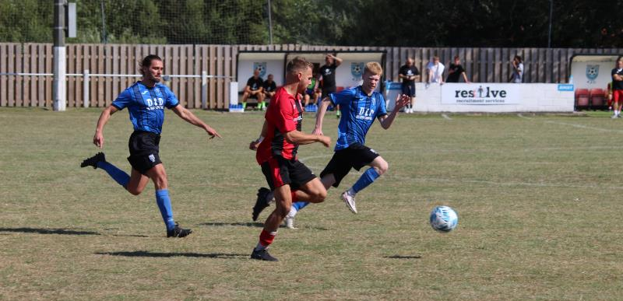
Another side to collect their first three points of the campaign were Oldland Abbotonians, with a late goal leading them to a 1-0 win at home to Bishops Lydeard. With the game seemingly headed towards a stalemate, debutant Courtney Charles played the ball across, where Stefan Lee was waiting to apply the finish to spark joyous scenes. Relegated Brislington earned their second victory of the season after overturning a late deficit to beat Hallen 2-1. After Aaron Blakemore had fired the home side in front just prior to the hour mark, Bris then drew level ten minutes from time through Jordan Scadding, before Josh Egan rolled the ball into an empty net to complete the turnaround soon after. Cheddar twice came from behind to secure a 2-2 draw in their home clash with Portishead. Having already cancelled out Josh Honey’s opener, the Cheesemen fell behind again at the beginning of the second half, but managed to claim a share of the points ten minutes from time thanks to a smart finish from Dean Chrisostomou. There was also a draw at Lakeview where Ethan Hardy equalised for Hengrove with three minutes left on the clock to deny Bishop Sutton their third win on the bounce. Ashley Knight and Louis Short were each on target for Almondsbury during their 2-2 draw at home to Gillingham Town, while 17-year-old Lewis Wheeler levelled affairs for Radstock during their 1-1 draw against FC Bristol after the visitors had gone in front through Josh Williams in first half stoppage time.
Action from Brislington’s last gasp 2-1 win away at Hallen.
FA Cup Action: Buckland Athletic produced an excellent comeback to knock out last season’s Western League runners-up Exmouth Town at Homers Heath. Having trailed to Ben Steer’s fourth minute opener, Buckland got back on level terms just prior to the half-hour mark when Ryan Bush headed home. It was then left to Sam Stayt to complete the turnaround, with his goal on the cusp of half-time proving to be enough for Buckland who recently celebrated the ten-year anniversary of their first Western League fixture. Shepton Mallet also overturned an early deficit to progress at the expense of Liskeard Athletic who led after only six minutes at Lux Park. The score remained 1-0 to the hosts for the entirety of the first half, but the second 45 minutes were a completely different story from the moment Aaron Seviour’s screamer hit the back of the Liskeard net. Joe Morgan struck soon after to make it 2-1 to Mallet, with Finn Haines and Seviour then both adding further goals in the final 15 minutes to wrap-up the victory. There was a dramatic late victory for Clevedon Town, with the Seasiders knocking out Buckinghamshire outfit Chalfont St Peter thanks to a 2-1 scoreline. After Alex Camm’s penalty had been answered by the away side, Clevedon avoided having to travel for a midweek replay when Freddie King slotted home an 89th minute winner.
There was not to be a late winner in the contest at Raleigh Grove where Premier Division sides Sherborne and Ilfracombe drew one apiece, while a wonder-goal from Taylor Love-Holmes helped Millbrook secure a 1-1 draw away at Torpoint. Those four sides will all face quick turnarounds, meeting in replays, with Barnstaple and Mousehole facing the same fate, along with Cadbury Heath who were held to a 2-2 draw at home to Mangotsfield United.
In another of the all-Western League affairs, Falmouth Town battled back to beat Saltash United by two goals to one. Having gone ahead five minutes before the break through Callum Merrin, the Ashes were pegged back on the hour mark following James Swan’s equaliser, with Falmouth then booking their spot in the next round thanks to a late winner from Alex Wharton. Helston Athletic responded well to their heavy opening day defeat in the league by beat Street 2-1 in their first cup tie of the campaign. Goals from Rubin Wilson and Rikki Sheppard either side of the interval put Helston two goals to the good, and they held on despite an injury time goal giving the hosts faint hope. Premier League duo Bitton and Keynsham both remain winless this season after suffering heavy cup defeats at the hands of Cinderford and Flackwell Heath respectively, while Bridgwater were dumped out by Bideford following a header early in the second half from Craig Duff. Warminster and Welton also each fell at the first hurdle after drawing blanks in their home losses, while a spirited effort from Wellington saw them fall just short away at Southern League outfit Willand Rovers. A 2-0 loss at home to Aylesbury condemned Ashton & Backwell to a third straight defeat, but there was much brighter news for Wincanton Town who produced a stunning performance to win by six goals to two away at Tadley Calleva. Saving the best till last, Wincanton were dominant for large periods of their clash in Hampshire, storming into a three-goal lead after just 26 minutes thanks to a brace of goals, plus an early assist from star man Connor Williams. The home side then scored twice in quick succession to set up an entertaining second half, but the Wasps found a second wind, and after Gary Chapman had put them 4-2 ahead they never looked back, with the immense Williams completing his treble, before substitute Louis Irwin added a late sixth to make it three wins on the spin.
In the second podcast of the season, Tom and Ian look back on the opening round of fixtures. There is then an interview with Cadbury Heath’s George Boon who talks about the motivation his side have this year following their Les Phillips Cup final defeat in May. Nic Steadman of Nailsea & Tickenham then joins Ian to introduce his side to the Western League fraternity.
Season 2022/23 Podcast Episode 2 | Toolstation Western League (toolstationleague.com)

Recent Results
Tuesday 2nd August 2022
Premier Division
Bitton 1-1 Street
Bridgwater United 2-1 Barnstaple Town
Buckland Athletic 1-0 Welton Rovers
Keynsham Town 0-4 Sherborne Town
Millbrook 3-1 Falmouth Town
Mousehole 1-1 Saltash United
Shepton Mallet 2-0 Ashton & Backwell United
First Division
Bishop Sutton 4-2 Tytherington Rocks
Brislington 0-3 Nailsea & Tickenham
Hengrove Athletic 3-0 Cheddar
Longwell Green Sports 6-1 Almondsbury
Odd Down 0-0 Hallen
Wells City 1-3 Portishead Town

Wednesday 3rd August 2022
Premier Division
Clevedon Town 1-0 Cadbury Heath
First Division
Bishops Lydeard 3-2 Radstock Town
Bristol Telephones 1-3 Shirehampton
FC Bristol 3-1 AEK Boco
Warminster Town 0-1 Wincanton Town

Friday 5th August 2022
First Division
Shirehampton 0-2 Nailsea & Tickenham

Saturday 6th August
First Division
AEK Boco 0-3 Wells City
Almondsbury 2-2 Gillingham Town
Bishop Sutton 1-1 Hengrove Athletic
Bristol Telephones 4-2 Longwell Green Sports
Cheddar 2-2 Portishead Town
Hallen 1-2 Brislington
Odd Down 2-3 Tytherington Rocks
Oldland Abbotonians 1-0 Bishops Lydeard
Radstock Town 1-1 FC Bristol

FA Cup Extra Preliminary Round
Ashton & Backwell United 0-2 Aylesbury United
Barnstaple Town 1-1 Mousehole
Bideford 1-0 Bridgwater United
Bitton 1-3 Cinderford Town
Buckland Athletic 2-1 Exmouth Town
Cadbury Heath 2-2 Mangotsfield United
Clevedon Town 2-1 Chalfont St Peter
Falmouth Town 2-1 Saltash United
Flackwell Heath 4-0 Keynsham Town
Liskeard Athletic 1-4 Shepton Mallet
Sherborne Town 1-1 Ilfracombe Town
Street 1-2 Helston Athletic
Tadley Calleva 2-6 Wincanton Town
Torpoint Athletic 1-1 Millbrook
Warminster Town 0-2 Andover New Street
Welton Rovers 0-1 United Services Portsmouth
Willand Rovers 2-1 Wellington

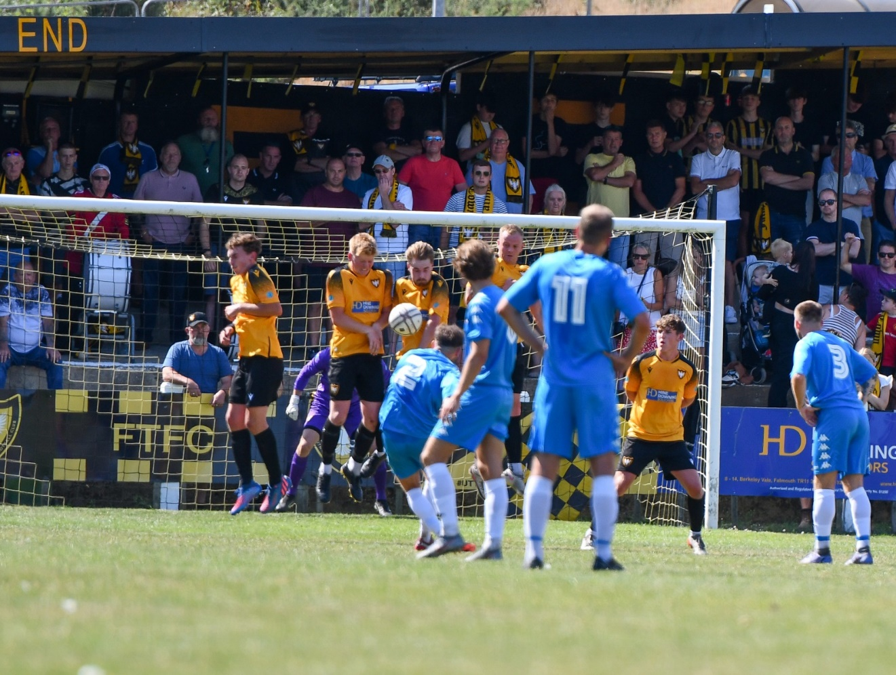

Upcoming Fixtures
Tuesday 9th August 2022
Premier Division
Keynsham Town vs Bridgwater United 19:45KO
Welton Rovers vs Wellington 19:45KO
First Division
Brislington vs Bristol Telephones 19:30KO
Hengrove Athletic vs AEK Boco 19:30KO
Portishead Town vs Radstock Town 19:30KO
Wincanton Town vs Longwell Green Sports 19:30KO
FA Cup Extra Preliminary Round Replay
Ilfracombe Town vs Sherborne Town 19:45KO
Mangotsfield United vs Cadbury Heath 19:45KO
Millbrook vs Torpoint Athletic 19:45KO
Mousehole vs Barnstaple Town 19:45KO
Wednesday 10th August 2022
Premier Division
Clevedon Town vs Ashton & Backwell United 19:30KO
First Division
Bishops Lydeard vs Odd Down 19:30KO
Oldland Abbotonians vs Gillingham Town 19:45KO
Thursday 11th August 2022
First Division
Radstock Town vs Hallen 19:45KO

Saturday 13th August (3pm kick-off unless noted)
Premier Division
Ashton & Backwell United vs Mousehole
Buckland Athletic vs Saltash United
Falmouth Town vs Clevedon Town
Helston Athletic vs Wellington
Ilfracombe Town vs Keynsham Town
Millbrook vs Bitton
Shepton Mallet vs Barnstaple Town
Street vs Bridgwater United
Torpoint Athletic vs Cadbury Heath
Welton Rovers vs Sherborne Town
First Division
AEK Boco vs Almondsbury
Brislington vs Bishop Sutton
Bristol Telephones vs Portishead Town
Gillingham Town vs Bishops Lydeard
Longwell Green Sports vs Hengrove Athletic
Nailsea & Tickenham vs Oldland Abbotonians
Shirehampton vs Cheddar
Warminster Town vs Odd Down
Wells City vs Wincanton Town

