Latest Round-ups:
Season 2022/23
#1
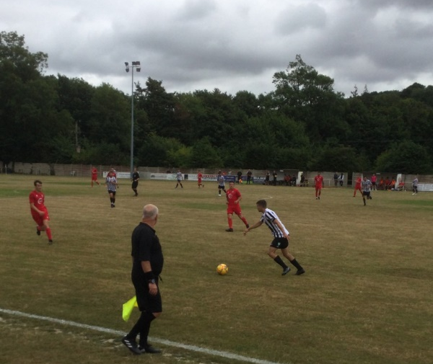
Premier Division: Barnstaple Town made an instant impact in the Western League’s top tier after defeating Bitton by five goals to nil. A relatively quiet opening half came to life just prior to the interval, with Tor Swann and Billy Tucker scoring in quick succession to give Town a two-goal advantage. The hosts then added a third on the hour mark through Ryan Turner, before Swann and Callum Davey wrapped up a five-star performance on the opening day. Cadbury Heath also posted a 5-0 victory of their own, putting Keynsham Town to the sword at Springfield. Josh Haynes struck a brace for the gallant hosts, with Dan Winstone, Ali Boyer and Callum Whooley also getting their names on the scoresheet. Shepton Mallet gained bragging rights early in the campaign, beating local rivals Street 3-1 thanks to an epic second half fightback. Having trailed to Callum Corbridge’s early smashed finish, Mallet got back on level terms after 64 minutes thanks to Joel Sisson. The away side then pushed on in the closing stages, and after Josh Williams was felled in the box, Nick Hewlett tucked home the resulting penalty to make it 2-1 ten minutes from time. There was plenty of drama in the closing stages, but it was Mallet who managed to find enough time and space to confirm their victory, with Joe Morgan wrapping things up in stoppage time. It was an excellent start in new surroundings for Sherborne, with last season’s First Division champs battling to a 1-0 win at home to Millbrook. George Mapletoft’s headed effort on the hour mark separated the sides, giving the Zebras three points to begin their campaign on a high. There was also a promising result for the other promoted outfit, with Toby Cole levelling early in the second half to help Welton secure a 1-1 draw at home to Ilfracombe Town.
Action from Sherborne’s opening day victory over Millbrook, courtesy of John Pool.
Bridgwater United laid down an early marker, with their excellent first half showing helping them to capture a 4-0 victory away at Helston. After Tom Llewellyn’s set piece had put the visitors in front, he then sent in another cross soon after which was deflected into his own net by Helston defender Reece Shanley. A third goal inside half an hour from Jacob Brown all but ended the contest, with Jake Llewellyn then firing home a penalty early in the second half to complete the scoring. Another successful away performance saw Mousehole overturn an early deficit on their way to a 5-1 win over Torpoint Athletic. Having seen the hosts power into a 12th minute lead, Louis Price then drew Mousehole level just prior to the interval. The second half belonged exclusively to the visitors however, and after Hayden Turner completed the turnaround, Tallan Mitchell’s double, along with another Price effort saw Mousehole run out comprehensive winners at The Mill.
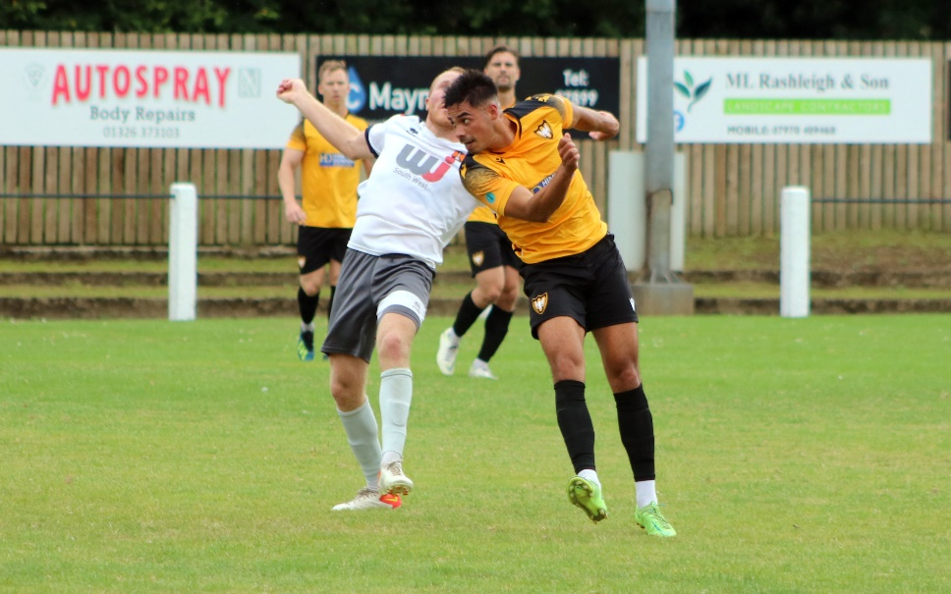
Elsewhere in Cornwall, there was success for Saltash who hung on to beat Clevedon Town by two goals to one. Having gone in front thanks to a long ranger from Harrison Davis, the Ashes saw their lead disappear when Freddie King responded early in the second half. It was then Charlie Elkington’s turn to fire Saltash back ahead, but they were forced to battle hard in the closing stages, especially after losing Dave Barker to a red card 15 minutes from time. Goals from Josh Webber and Ryan Bush inside the opening 20 minutes proved to be enough for Buckland who kept Ashton & Backwell at bay to open up their season with a 2-1 win. Having won a title last season, Falmouth proved their battling qualities, scoring a dramatic late equaliser to secure a 2-2 draw at home to Wellington. It was the Seasiders who enjoyed the better of the first half, and they moved in front after 20 minutes thanks to Tom Stone’s opener. Falmouth then claimed their first goal of the campaign after 65 minutes, with Tim Nixon’s cross headed home by Jack Bray-Evans. No sooner had they drawn level however, Falmouth then fell back behind when Miles Quick nipped in to restore Wellington’s advantage at the midway point of the second half. The game continued to excite for those in attendance, and with Eli Collins dismissed after receiving his second yellow of the afternoon, Wellington were then momentarily recued to nine men when Joe Chamberlain was sent to the sin bin. Falmouth saw that as their opportunity to come back into the game, and even with Chamberlain having returned, the hosts managed to draw level in the second minute of added time when Bray-Evans smashed home his second goal of the afternoon.
Action from the 2-2 draw between Wellington and Falmouth Town.
First Division: Bishop Sutton sit in top spot after the opening day of action, with a couple of long range efforts pushing them towards a 5-0 victory away at Gillingham Town. It took just ten minutes for Sutton to go ahead, with Craig Wilson’s 25-yard rocket giving the home keeper no chance whatsoever. Jacob Bird then followed that up with another goal from well outside the area, with Cody Vile stretching the lead to three. Sutton continued to push on in the closing stages, and after Mason Dagger had made it 4-0 in the 65th minute, it was then left to star man Bird, who volleyed home his second of the afternoon to complete the rout. Another standout result came from Wincanton, who struck three times in the final 20 minutes to secure a 4-1 win away at Hengrove. Having taken the lead through Connor Williams, the Wasps were forced to start again in the second half, after Joe Banks levelled for the hosts in the 42nd minute. Cameron Vere scored the crucial go-ahead goal midway through the second half, and from then on Wincanton were the better side, with a Jamie Irwin header followed in stoppage time by Williams’ second of the contest. There was a disappointing start for regular top-half finishers Warminster who fell to a 3-0 loss away at new-boys Nailsea & Tickenham. Goals from Jacob O’Donnell, Joe Berry and former-Clevedon forward Callum Dunn saw Nailsea ease to victory at Fryth Way.
Unfortunately for Shirehampton, they weren’t able to pick up three points on their debut in the league after falling to a 3-2 loss at home to Longwell Green Sports. Dan Morne had given the hosts a dream start, but they were soon pegged back when visiting skipper Ali Bamford struck from a corner. Ryan Radford managed to restore Shirehampton’s advantage, but it was soon turned on its head when Liam Oswin’s quick-fire double gave Longwell Green their first lead of the afternoon. The newbies were handed a dream opportunity to register a point, but Radford’s late spot kick cannoned back off the post and away to safety as Longwell Green hung on for maximum points.
3-2 results seemed to be the flavour of the day in the First Division, and Portishead were another side to come out on top in a five-goal thriller after they overcame FC Bristol. Having gone behind after just seven minutes, the Bristolians, formerly known as Lebeq, turned the game in their favour thanks to strikes from Jennison Williams and Sacha Tong. It was Portishead who came out on top however, and that came thanks to goals from Calum Townsend, Hamish Hurst and Rob Latham on an entertaining start to their season. Hallen were the third side to end up 3-2 victors, with Cory Thomas-Barker firing home a terrific hat-trick in their triumph over Cheddar. The home side were forced to come from behind to claim victory, with Morgan Bacon scoring after just two minutes for the confident Cheesemen. Thomas-Barker then struck twice towards the end of the first half to turn the game in Hallen’s favour, before George Fairchild smacked a penalty off the bar in what was a big blow for the away side. Hallen capitalised on that miss, with Thomas-Barker converting a fantastic set piece to complete his treble, before Bacon claimed a late consolation for the visitors. Goals from Asa White and Danny Dodimead proved to be enough for Brislington who hung on to beat Wells 2-1, while the contest between Radstock and Bristol Telephones ended goalless. AEK Boco defeated Tytherington 2-1 at Greenbank Road, and there was also a home victory for Almondsbury, with Stu Alexander’s 64th minute goal helping them beat Bishops Lydeard 1-0. Oldland Abbotonians twice came from behind to rescue a point at home to Odd Down in a topsy-turvy affair at the Aitchison Playing Field. Last season’s top scorer Luke Bryan picked up where he left off a couple of months ago, taking just seven minutes to open his scoring tally, giving the Bath side a fast start in the process. Owen McCallum then levelled for Oldland five minutes into the second half, before Bryan turned provider, laying on the assist for Josh Clark who restored Odd Down’s advantage. They were unable to hang on however, and the Abbots grabbed a share of the spoils thanks to a superb free kick in the closing stages from Cash Vinall.
On the first episode of the season, Ian is joined by a couple of local journalists to preview the upcoming campaign. Ross Reid from South West Sports News, and Josh Thomas from the North Somerset Times and Weston, Worle & Somerset Mercury, catch up with Ian to look ahead to the highly anticipated 2022/23 Toolstation Western League Season.

Opening Day Results
Saturday 30th July 2022
Premier Division
Ashton & Backwell United 1-2 Buckland Athletic
Barnstaple Town 5-0 Bitton
Cadbury Heath 5-0 Keynsham Town
Falmouth Town 2-2 Wellington
Helston Athletic 0-4 Bridgwater United
Saltash United 2-1 Clevedon Town
Sherborne Town 1-0 Millbrook
Street 1-3 Shepton Mallet
Torpoint Athletic 1-5 Mousehole
Welton Rovers 1-1 Ilfracombe Town
First Division
AEK Boco 2-1 Tytherington Rocks
Almondsbury 1-0 Bishops Lydeard
Brislington 2-1 Wells City
Gillingham Town 0-5 Bishop Sutton
Hallen 3-2 Cheddar
Hengrove Athletic 1-4 Wincanton Town
Nailsea & Tickenham 3-0 Warminster Town
Oldland Abbotonians 2-2 Odd Down
Portishead Town 3-2 FC Bristol
Radstock Town 0-0 Bristol Telephones
Shirehampton 2-3 Longwell Green Sports

Upcoming Fixtures
Tuesday 2nd August 2022
Premier Division
Bitton vs Street 19:30KO
Bridgwater United vs Barnstaple Town 19:45KO
Buckland Athletic vs Welton Rovers 19:30KO
Keynsham Town vs Sherborne Town 19:45KO
Millbrook vs Falmouth Town 19:45KO
Mousehole vs Saltash United 19:45KO
Shepton Mallet vs Ashton & Backwell United 19:30KO
First Division
Bishop Sutton vs Tytherington Rocks 19:30KO
Brislington vs Nailsea & Tickenham 19:30KO
Gillingham Town vs Oldland Abbotonians 19:30KO
Hengrove Athletic vs Cheddar 19:30KO
Longwell Green Sports vs Almondsbury 19:30KO
Odd Down vs Hallen 19:45KO
Wells City vs Portishead Town 19:30KO

Wednesday 3rd August 2022
Premier Division
Clevedon Town vs Cadbury Heath 19:30KO
First Division
Bishops Lydeard vs Radstock Town 19:30KO
Bristol Telephones vs Shirehampton 19:45KO
FC Bristol vs AEK Boco 19:30KO
Warminster Town vs Wincanton Town 19:45KO

Saturday 6th August (3pm kick-off unless noted)
First Division
AEK Boco vs Wells City
Almondsbury vs Gillingham Town
Bishop Sutton vs Hengrove Athletic
Bristol Telephones vs Longwell Green Sports
Cheddar vs Portishead Town
Hallen vs Brislington
Odd Down vs Tytherington Rocks
Oldland Abbotonians vs Bishops Lydeard
Radstock Town vs FC Bristol
Shirehampton vs Nailsea & Tickenham
FA Cup Extra Preliminary Round
Ashton & Backwell United vs Aylesbury United
Barnstaple Town vs Mousehole
Bideford vs Bridgwater United
Bitton vs Cinderford Town
Buckland Athletic vs Exmouth Town
Cadbury Heath vs Mangotsfield United
Clevedon Town vs Chalfont St Peter
Falmouth Town vs Saltash United
Flackwell Heath vs Keynsham Town
Liskeard Athletic vs Shepton Mallet
Sherborne Town vs Ilfracombe Town
Street vs Helston Athletic
Tadley Calleva vs Wincanton Town
Torpoint Athletic vs Millbrook
Warminster Town vs Andover New Street
Welton Rovers vs United Services Portsmouth
Willand Rovers vs Wellington
Fan Survey Highlights Warm Welcome as Key to Match Day Experience | Toolstation Western League (toolstationleague.com)

