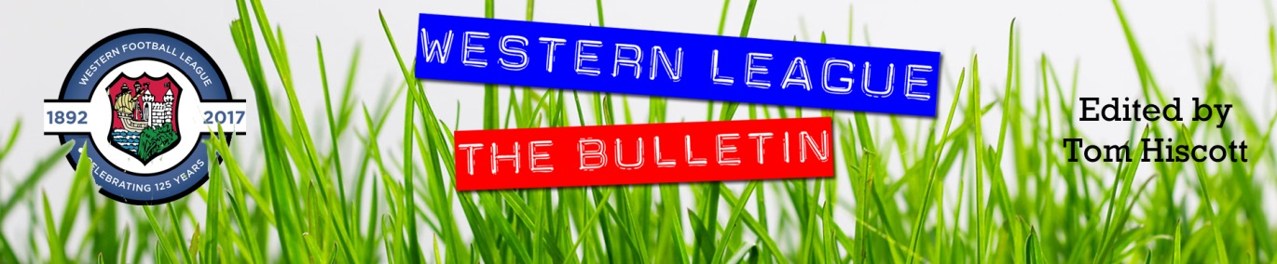
Latest Round-ups:
#39
Season 2021/22
Midweek Action: At the start of the final week of the regular season, Boco ended their season on a high, by beating Odd Down 4-2 in the First Division on Monday evening. In what was a frantic start to the contest, Jack Jenkins fired the visitors in front after less than a minute, before the league’s top scorer Luke Bryan responded a couple of moments later to get the Bath side back on level terms. It was Boco who found something extra after the break, and alongside Jenkins’ second of the contest, there were also goals from Ash McGrane and Freddy Taylor-Fox in a result which moved them up into the fourth and final playoff spot, piling the pressure on the other teams chasing a fifth-place finish. Radstock Town were able to regain fifth spot ahead of the final set of fixtures, but they came unstuck away at Almondsbury, falling to a 3-1 defeat on Tuesday night. Despite being level at the interval, Radstock eventually fell to defeat, setting up a dramatic final day in the chase for the play-offs.
In the first of the Les Phillips Cup Semi Finals, Cadbury Heath defeated Keynsham 2-1 at Springfield to reach the final for the first time in over a decade. Following a tense first half which ended goalless, the home side took control of the contest around the hour mark, with Will Boyer and Ewan McMillan scoring within the space of five minutes. Things soon started to go wrong for the Heath however, and they were forced to play the final 25 minutes with ten men following a red card to skipper Ashley Kendall. Unfortunately for the visitors, things were soon evened up on the numbers front, with Jack Dancey awarded his second yellow card of the evening just as the game headed into the final ten. Keynsham did set up a nervy finish for the home crowd when Will Hailston tucked home an 85th minute penalty, but the Heath did just enough to hang on and book their spot in the showpiece finale.
Weekend Action: In the second Les Phillips Cup semi-final, a hotly contested tie was decided at the death with Bridgwater’s late show helping them see off Helston at Fairfax Park. There was only goal during the 180 minutes of action between these sides in the league this season, and after 88 minutes this game was headed towards a goalless draw. The home side managed to find something in the final few minutes however, and after Ross Edwards headed them in front, they then added a second goal in the fourth minute of stoppage time through the ever-reliable Jack Taylor.
Millbrook brought the curtain down on the Premier Division season with a 1-0 win at home to Brislington. With the other sides having finished their campaigns last Saturday, Rikki Sheppard’s left-footed finish midway through the first half helped Millbrook finish on a high following a run of six defeats.

First Division: The four sides who qualified for the end of season play-offs all ended the regular season on a high with impressive home wins on the final day. Warminster Town clung on to second spot after scoring a late winner in their 2-1 triumph at home to Gillingham. Having gone in front after 18 minutes through Conner McKay, Warminster’s ownership of second place was under threat when their visitors drew level at the beginning of the second half. Then, with McKay in the sin bin, the ten-man hosts managed to find enough resolve to force a late winner, with Seth Wain’s cross diverted into his own net by a Gills defender. Third place belongs to Wincanton Town, who are now riding a 29-match unbeaten run in the league thanks to their 2-0 victory over Bishops Lydeard. The Wasps will be unable to host fixtures during their upcoming play-off campaign, but they will be a confident bunch, with Connor Williams scoring both goals in their final day win. Welton will be Wincanton’s opponents in the semi-finals after they stormed to a 6-1 win over Almondsbury at West Clewes. Cam Allen gave Rovers the perfect start, putting them ahead inside the opening minute, but Almondsbury were keen to spoil the show and threatened to do so when Joe White levelled affairs after quarter of an hour. That equaliser seemed to fire up the home team, and after Allen scored again to make it 2-1, further goals from Joe Ellis and Lewis Russell gave them a three-goal advantage at the interval. Courtney Charles then added a fifth for the rampant hosts, before Stuart James scored his first goal for the club from the penalty spot to bring an end to the scoring 15 minutes from time. The biggest question mark heading into the final day surrounded the battle for fifth spot, but Radstock were in dominant form and wrapped it up in no time at all. Knowing a victory would be enough for them to claim the final play-off spot, the Miners put Bristol Telephones to the sword at the Southfields Rec, securing a 5-0 win. James Rustell and Rico Sobers each scored twice for the home side who headed into their final day affair having won only one of their previous nine games in all competitions and looked to be wilting at exactly the wrong time.
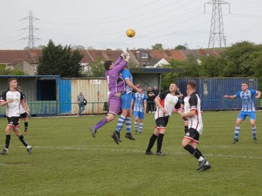
Elsewhere, Sacha Tong struck twice in Lebeq’s 2-2 draw with Devizes, for whom Bevan Cross claimed a double, while a brace of Ricky Bennett penalties helped Cheddar beat Odd Down 2-1 in Bath, despite yet another goal for the golden boot winner Luke Bryan. Oldland Abbotonians confirmed a top-half finish after coming from a goal down to beat Portishead 2-1 at the Aitchison Playing Fields. Having earlier scored Oldland’s equaliser, Cash Vinall was given the dream opportunity to score a late winner, only to see his spot kick finish wide of the mark. Fortunately for the Abbots, and Vinall in particular, they got another chance in the fourth minute of stoppage time which was finished well by Mitch Dann to help them finish their season on a high. The points were shared at Hengrove, where the home side scored an 88th minute equaliser to deny Wells at the death following a first half penalty from City’s top scorer Adam Wright.
Action from Oldland Abbotonians 2-1 win over Portishead, courtesy of @westcountryfb

Recent Results
Monday 25th April 2022
First Division
Odd Down 2-4 AEK Boco 70

Tuesday 26th April 2022
First Division
Almondsbury 3-1 Radstock Town 36

Wednesday 27th April 2022
Les Phillips Cup Semi Final
Cadbury Heath 2-1 Keynsham Town

Saturday 30th April 2022
Les Phillips Cup
Bridgwater United 2-0 Helston Athletic
Premier Division
Millbrook 1-0 Brislington 107
First Division
Hengrove Athletic 1-1 Wells City 72
Lebeq United 2-2 Devizes Town 20
Odd Down 1-2 Cheddar 75
Oldland Abbotonians 2-1 Portishead Town
Radstock Town 5-0 Bristol Telephones 64
Warminster Town 2-1 Gillingham Town 237
Welton Rovers 6-1 Almondsbury 135
Wincanton Town 2-0 Bishops Lydeard
Upcoming Fixtures
Tuesday 3rd May 2022
First Division Play-Off Semi Finals
Welton Rovers vs Wincanton Town 19:30KO
Warminster Town vs Radstock Town 19:45KO

Saturday 14th May 2022
Les Phillips Cup Final
Cadbury Heath vs Bridgwater United 15:00KO
The big-hitters join the podcast this week, with promoted duo Tavistock and Exmouth both represented to celebrate their excellent seasons. After claiming the title on a dramatic final day, Tavistock manager Stuart Henderson chats to Ian about what it took for his side to get over the line, while Exmouth’s Kevin Hill also joins the show to look back on Town’s phenomenal run of form towards the end of the season. AEK Boco’s Spencer Thomas reconnects with Ian to explain why he is chuffed to see how his charges have coped in the First Division, detailing how they are building on and off the pitch to be Western League force in the future.
http://toolstationleague.com/season-2021-22-podcast-episode-39/

Awards Update
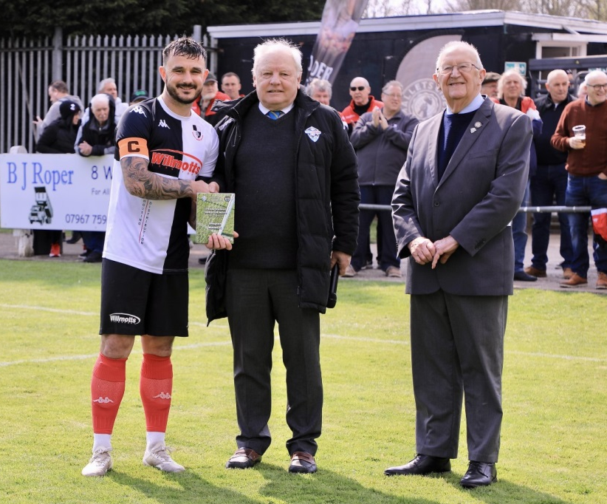

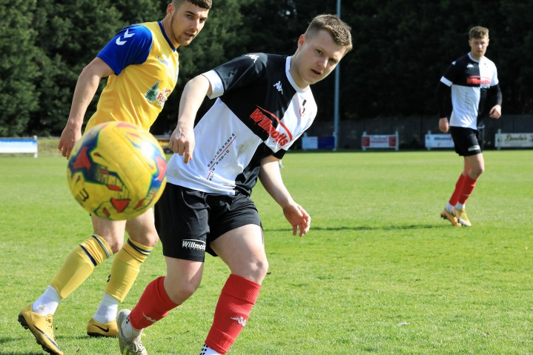
On the left, Shepton Mallet skipper Andy Martin receives the award for Toolstation Western League Team of the Month for March. In the action shot on the right is Shepton’s Jacob Sloggett who was voted as the league’s best player of the month for March. Images courtesy of Haydn Jones.

Leading Goalscorers (Stats courtesy of FA Fulltime Website)
All Competitions
Liam Prynn (Tavistock) – 41
Jack Taylor (Bridgwater) – 38
Luke Bryan (Odd Down) – 38
Will Hailston (Keynsham) – 35
Adam Wright (Wells) – 33
Jordan Harris (Exmouth) – 29
Oaklan Buck (Bishop Sutton) – 28

Premier Division
Liam Prynn (Tavistock) – 35
Jack Taylor (Bridgwater) – 29
Jordan Harris (Exmouth) – 27
Will Hailston (Keynsham) – 23
Dean Griffiths (Bitton) - 22
Sam Hughes (Saltash) – 20

First Division
Luke Bryan (Odd Down) -37
Adam Wright (Wells) – 33
Oaklan Buck (Bishop Sutton) -28
Alex Murphy (Sherborne) - 24

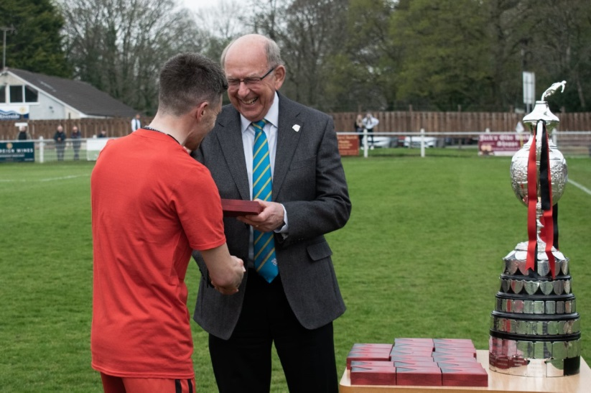

Tavistock players are awarded with their individual medals and Western League trophy by League Chairman after their tense final day victory. Images courtesy of ChillyPics.
League Tables
 | PREMIER DIVISION | Played | Won | Drawn | Lost | GD | Points
C | Tavistock | 36 | 24 | 7 | 5 | 63 | 79
P | Exmouth Town | 36 | 23 | 8 | 5 | 61 | 77
3 | Mousehole | 36 | 22 | 7 | 7 | 44 | 73
4 | Saltash United | 36 | 20 | 5 | 11 | 34 | 65
5 | Bridgwater United | 36 | 20 | 5 | 11 | 30 | 65
6 | Shepton Mallet | 36 | 17 | 9 | 10 | 41 | 60
7 | Clevedon Town | 36 | 16 | 11 | 9 | 22 | 59
8 | Ilfracombe Town | 36 | 16 | 8 | 12 | 6 | 56
9 | Helston Athletic | 36 | 14 | 12 | 9 | 19 | 55*
10 | Keynsham Town | 36 | 15 | 8 | 13 | 10 | 53
11 | Buckland Athletic | 36 | 14 | 8 | 13 | 14 | 51*
12 | Millbrook | 36 | 12 | 9 | 15 | -10 | 45
13 | Bitton | 36 | 13 | 6 | 17 | -11 | 45
14 | Wellington | 36 | 11 | 10 | 15 | -12 | 43
15 | Cadbury Heath | 36 | 10 | 5 | 21 | -33 | 35
16 | Street | 36 | 9 | 5 | 22 | -23 | 32
17 | Brislington | 36 | 9 | 5 | 22 | -53 | 32
18 | Ashton & Backwell United | 36 | 7 | 7 | 22 | -34 | 28
R | Bridport | 36 | 1 | 1 | 34 | -168 | 4

 | FIRST DIVISION | Played | Won | Drawn | Lost | GD | Points
C | Sherborne Town | 40 | 31 | 6 | 3 | 86 | 99
2 | Warminster Town | 40 | 28 | 5 | 7 | 51 | 89
3 | Wincanton Town | 40 | 27 | 7 | 6 | 77 | 88
4 | Welton Rovers | 40 | 27 | 7 | 6 | 51 | 88
5 | Radstock Town | 40 | 18 | 9 | 13 | 2 | 63
6 | Cheddar | 40 | 17 | 11 | 12 | 10 | 62
7 | Wells City | 40 | 16 | 12 | 12 | 13 | 60
8 | AEK Boco | 40 | 16 | 12 | 12 | 5 | 60
9 | Odd Down | 40 | 16 | 9 | 15 | 4 | 57
10 | Oldland Abbotonians | 40 | 17 | 4 | 19 | 0 | 55
11 | Bishop Sutton | 40 | 15 | 7 | 18 | 3 | 52
12 | Lebeq United | 40 | 13 | 12 | 15 | 2 | 51
13 | Tytherington Rocks | 40 | 13 | 10 | 17 | -17 | 49
14 | Portishead Town | 40 | 14 | 7 | 19 | -6 | 46*
15 | Gillingham Town | 40 | 12 | 10 | 18 | -14 | 46
16 | Hengrove Athletic | 40 | 12 | 9 | 19 | -19 | 45
17 | Longwell Green Sports | 40 | 11 | 9 | 20 | -24 | 42
18 | Almondsbury | 40 | 12 | 2 | 26 | -41 | 38
19 | Bristol Telephones | 40 | 10 | 5 | 25 | -59 | 35
20 | Bishops Lydeard | 40 | 6 | 6 | 28 | -48 | 24
21 | Devizes Town | 40 | 6 | 7 | 27 | -76 | 22*

