Latest Round-ups:
#38
Season 2021/22
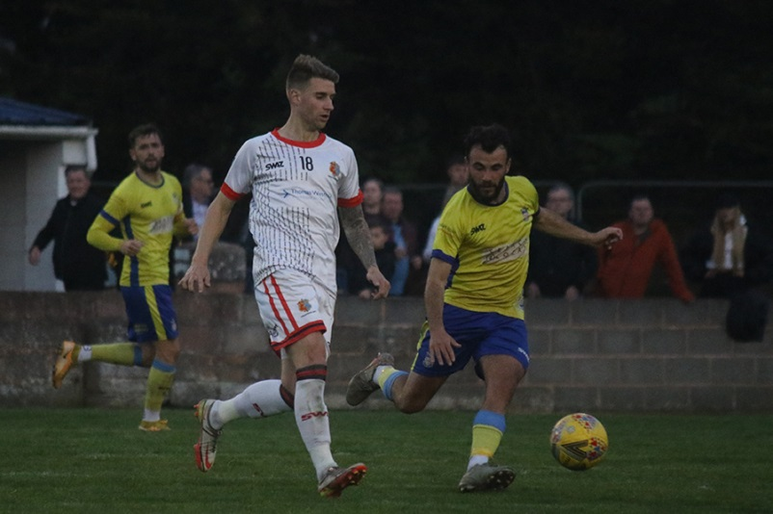
Midweek Action: In the highly anticipated top-of-the-table clash, Exmouth secured a 1-0 victory over Tavistock to set up a dramatic final day in the Premier Division. Going into the game three points behind their visitors, Exmouth claimed the much needed win thanks to Levi Landricombe, who struck for the third game in succession. A mammoth crowd of 728 were in attendance on Wednesday (pictured left, courtesy of Gerry Hunt) and it made for a terrific occasion which has given the league a thrilling finale.
The two First Division clashes on Wednesday saw a pair of away forwards notching hat-tricks in some high-scoring affairs. Promotion hopefuls Wincanton saw their long winning run brought to an end by Odd Down, with Josh Clark claiming a terrific treble for the Bath side in a 3-3 draw. After Clark had opened the scoring in the fifth minute, the Wasps responded well and led at the interval thanks to a brace from Matt Garner. Clark then levelled things 20 minutes from time, but Wincanton hit back once again, with Jamie Irwin setting them up for the win as the game headed towards the final ten. Odd Down had the last word however, and it was Clark again who popped up in stoppage time to deny Wincanton at the death, scoring the sixth and final goal of a thrilling contest. For AEK Boco, it was Josh Jenkins who went home with the match-ball after scoring three of his sides goals in their 5-0 win away at Bishops Lydeard. The away side flew out of the blocks, and after Jenkins and Nathan Hall had both struck in the opening stages, Jenkins then added another from the spot to make it 3-0 after just 32 minutes. After Freddy Taylor-Fox had increased the lead further in the closing stages, Jenkins then took over, completing the scoring in the 89th minute to cap an outstanding individual performance.
On the most recent podcast, Ian and Tom review a bumper Easter period, before catching up with Bridgwater United manager Dave Pearse who looks back on a good season which still has something to offer for his side. There is then a conversation with Sherborne Town Chairman, John Bowers, who celebrates his club’s First Division title win, and explaining why he’s relishing the challenges promotion will bring the ambitious Zebras outfit.
http://toolstationleague.com/season-2021-22-podcast-episode-38/

Premier Division: Following a thrilling title race which had been toing and froing, a stoppage time penalty finally decided the destination of this season’s champions. Only goal difference separated the top two going into the final day, and after a nervy day for all, it was a Liam Prynn spot kick which gave Tavistock the crucial 1-0 victory to confirm top spot. Hosting an Ashton & Backwell outfit battling for points at the other end of the table, it wasn’t an easy afternoon for the Lambs, but Prynn managed to hold his nerve to tuck home the late penalty, extending his lead atop the scoring charts in the process.
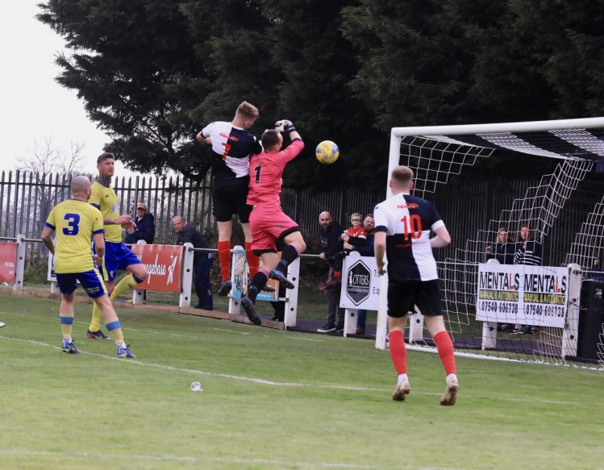
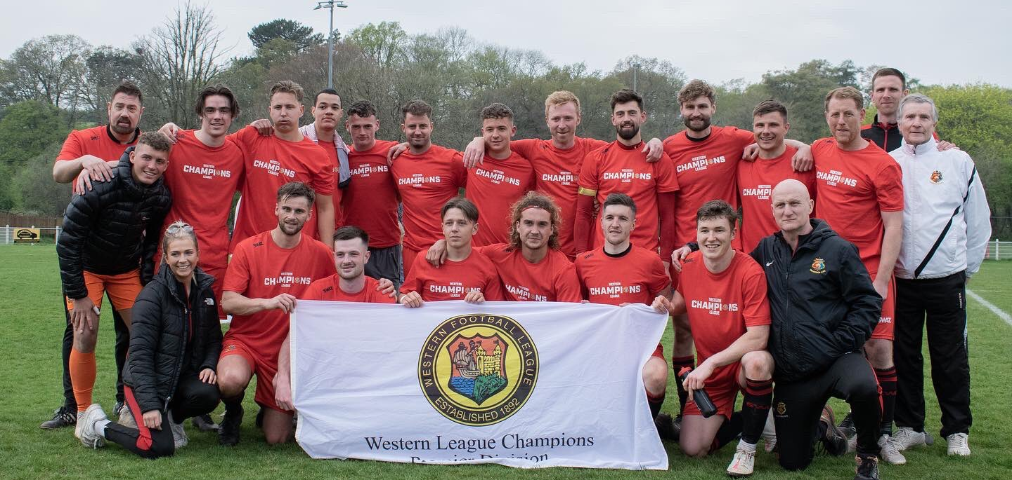
Exmouth were forced to settle for finishing in second spot after they were unable to force the issue in their goalless draw away at Shepton Mallet. Their midweek victory over Tavi had put them on level footing ahead of the final game of the campaign, but they drew a blank to fall just short in their title ambitions. Things looked to be swaying in their favour when Shepton skipper Andy Martin was sent off in first half stoppage time, but Town were unable to find the back of the net against a side who reached the sixty point mark thanks to Saturday’s stalemate. At the opposite end of the ladder, Street’s late season ascendancy continued with a 3-0 win at home to Millbrook. The Cobblers have ended their season by winning three of their final five fixtures, with goals from Callum Corbidge, Jakob Dickens and Dan Peach helping them see off their Cornish visitors, staving off the threat of relegation. Another side to end their campaign on the front foot were Clevedon Town, with their final day 3-0 triumph over Bridport giving them five wins from their final seven. Having been held goalless during the opening half, Alex Camm’s effort early in the second half loosened the visitors up, with Callum Eastwood and Josh Morgan adding further goals at St Mary’s Field.
Action from Shepton Mallet’s goalless draw with Exmouth Town, courtesy of Haydn Jones.
Tavistock celebrate after being crowned Western League Premier Division champions.
Image courtesy of Chris Chilcott (@ChillyPics).
The clash between Helston and Buckland was overshadowed by a neck injury to Stu Bowker forcing the abandonment at Kellaway Park. Fortunately the day ended on a positive note for all concerned, with Bowker confirming that he had been given the all-clear to head home following an afternoon at Truro Hospital. Elsewhere in Cornwall, a second half double from Scott Crocker followed an exquisite free kick from Sam Farrant to hand Saltash a 3-0 victory at home to Brislington. There was also a home victory for Keynsham over third-placed Mousehole, with Will Hailston scoring twice inside the opening ten minutes to hand Town a much-needed early buffer in their 2-1 win. Ilfracombe Town were also victors by two goals to one, with efforts from Joe Barker and Kyle Paine helping the North Devon outfit defeat ten-man Bitton.
First Division: Champions Sherborne ended their season on 99 points following a final day victory at home to Bishop Sutton. The Zebras campaign has seen them wrack up 31 wins, while notching 124 goals, and the last of those came in the form of an own goal at the beginning of the second half, helping lead them a 1-0 victory at Raleigh Grove. Wincanton have mirrored the champs in scoring 124 times this campaign, but they still have one game remaining and will hope to return to winning form after drawing 1-1 away at Portishead. Having seen their long-standing winning run come to an end in their previous fixture, Wincanton were in good position to hit back when Cameron Vere put them in front at Bristol Road, but the hosts managed to grab a share of the spoils thanks to Joe Fitzgerald’s leveller. Warminster have leapfrogged Wincanton up into second ahead of the final day after winning 2-0 away at Oldland. The in-form visitors went ahead on the half hour mark thanks to a volleyed finish from Conner McKay, before George Butler doubled their advantage ten minutes after the interval. Welton will also be a confident bunch heading into the play-offs, and they have now won two of their last three after beating Lebeq 3-1 at West Clewes. Lewis Russell’s penalty five minutes before the break looked to have put Rovers in control, but that was soon cancelled out when Sacha Tong hit back for the visitors in added time at the end of the first half. A strong finish from Toby Cole restored Welton’s advantage after the interval, with Cam Allen then assuring the destination of the points when he struck 13 minutes from time. The game of the day took place at the Athletic Ground, where Cheddar came from behind to beat fellow play-off hopefuls Wells City by three goals to two. Two goals from former Cheddar frontman Adam Wright had put Wells 2-1 up with the game headed towards the final whistle, but the visitors looked to have done enough to secure a point when second half sub Danny Griffiths headed home in the final minute of normal time. At the end of an emotional week for the club, popular player-manager Craig Mawford had announced that he would be leaving the club at the denouement of the season. Having entered the field for potentially the final time, Mawford produced a fairytale ending, with his stoppage time winner helping to complete the dramatic comeback. The fourth and final play-off spot is still very much up for grabs over the final seven days of the campaign, with ninth-placed AEK Boco still technically in contention following their 3-1 win away at local rivals Longwell Green. Another side who could pinch fifth spot are Odd Down, with the league’s leading marksman coming to the fore again in their 2-1 win over Almondsbury. Having fallen behind to Stuart Alexander’s 33rd minute opener, it took Luke Bryan just over an hour before his first impact when he slotted home the equaliser. With three points essential to remain in contention for a play-off spot, Bryan was in the right place at the right time yet again, scoring his 35th goal of the season to seal a come-from-behind victory. Bottom side Devizes enjoyed some late season cheer, with Ethan Witchell and an acrobatic effort from Dec McStravick handing them a 2-0 win over Hengrove, while Tytherington’s final game ended in a 2-1 win away at Bishops Lydeard thanks to Nathan Croot’s winner on what was his 100th appearance for the Rocks.
Recent Results
Wednesday 20th April 2022
Premier Division
Exmouth Town 1-0 Tavistock 728
First Division
Bishops Lydeard 0-5 AEK Boco 50
Wincanton Town 3-3 Odd Down 60

Saturday 23rd April 2022
Premier Division
Bridport 0-3 Clevedon Town 148
Helston Athletic A-A Buckland Athletic
Ilfracombe Town 2-1 Bitton
Keynsham Town 2-1 Mousehole 172
Saltash United 3-0 Brislington 106
Shepton Mallet 0-0 Exmouth Town 632
Street 3-0 Millbrook
Tavistock 1-0 Ashton & Backwell United
First Division
Bishops Lydeard 1-2 Tytherington Rocks 36
Devizes Town 2-0 Hengrove Athletic 98
Longwell Green Sports 1-3 AEK Boco
Odd Down 2-1 Almondsbury 23
Oldland Abbotonians 0-2 Warminster Town 75
Portishead Town 1-1 Wincanton Town 41
Sherborne Town 1-0 Bishop Sutton
Wells City 2-3 Cheddar 64
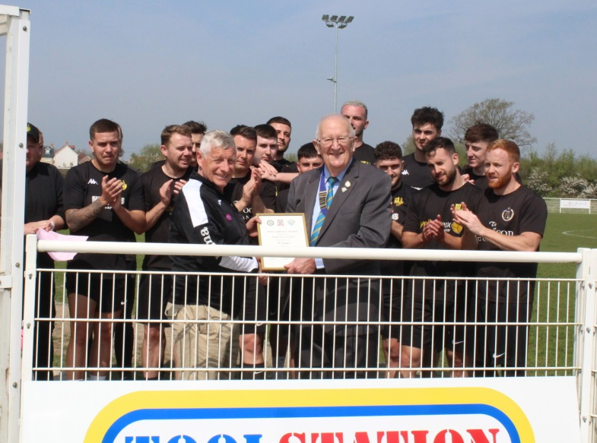
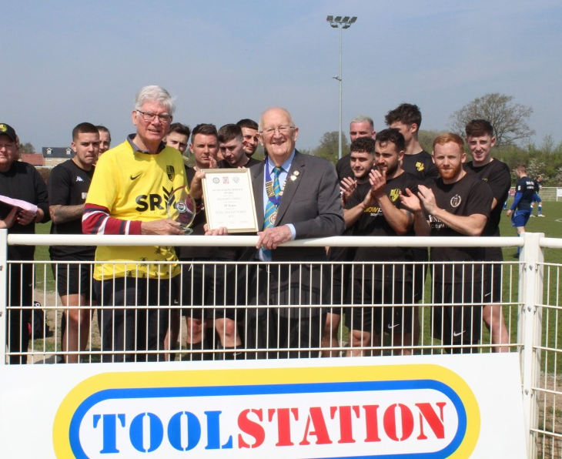
Welton Rovers 3-1 Lebeq United 121
There were more Long Service honours recognised last weekend, with Wincanton Town duo Richard D’Arcy (right) and Club President Mike Hatcher (left), presented with their awards by Toolstation Western League President, Brian Beer following 50 & 35 years at the club respectively.

Upcoming Fixtures
Monday 25th April 2022
First Division
Odd Down vs Tavistock 19:45KO

Tuesday 26th April 2022
First Division
Almondsbury vs Radstock Town 19:30KO

Wednesday 27th April 2022
Les Phillips Cup Semi Final
Cadbury Heath vs Keynsham Town 19:30KO

Saturday 30th April 2022 (3pm kick off unless noted)
Les Phillips Cup
Bridgwater United vs Helston Athletic
Premier Division
Millbrook vs Brislington
First Division
AEK Boco vs Tytherington Rocks
Hengrove Athletic vs Wells City
Lebeq United vs Devizes Town
Odd Down vs Cheddar
Oldland Abbotonians vs Portishead Town
Radstock Town vs Bristol Telephones
Warminster Town vs Gillingham Town
Welton Rovers vs Almondsbury
Wincanton Town vs Bishops Lydeard

Leading Goalscorers (Stats courtesy of FA Fulltime Website)
First Division
Luke Bryan (Odd Down) -35
Adam Wright (Wells) – 32
Oaklan Buck (Bishop Sutton) -28
Alex Murphy (Sherborne) - 24
Ian Jeffery (Warminster) - 24

All Competitions
Liam Prynn (Tavistock) – 41
Jack Taylor (Bridgwater) – 37
Luke Bryan (Odd Down) – 35
Will Hailston (Keynsham) – 34
Adam Wright (Wells) – 32
Jordan Harris (Exmouth) – 29
Oaklan Buck (Bishop Sutton) – 28

Premier Division
Liam Prynn (Tavistock) – 35
Jack Taylor (Bridgwater) – 29
Jordan Harris (Exmouth) – 27
Will Hailston (Keynsham) – 23
Dean Griffiths (Bitton) - 21
Sam Hughes (Saltash) – 20

League Tables
 | PREMIER DIVISION | Played | Won | Drawn | Lost | GD | Points
C | Tavistock | 36 | 24 | 7 | 5 | 63 | 79
2 | Exmouth Town | 36 | 23 | 8 | 5 | 61 | 77
3 | Mousehole | 36 | 22 | 7 | 7 | 44 | 73
4 | Saltash United | 36 | 20 | 5 | 11 | 34 | 65
5 | Bridgwater United | 36 | 20 | 5 | 11 | 30 | 65
6 | Shepton Mallet | 36 | 17 | 9 | 10 | 41 | 60
7 | Clevedon Town | 36 | 16 | 11 | 9 | 22 | 59
8 | Ilfracombe Town | 36 | 16 | 8 | 12 | 6 | 56
9 | Helston Athletic | 35 | 14 | 12 | 9 | 19 | 54
10 | Keynsham Town | 36 | 15 | 8 | 13 | 10 | 53
11 | Buckland Athletic | 35 | 14 | 8 | 13 | 14 | 50
12 | Bitton | 36 | 13 | 6 | 17 | -11 | 45
13 | Wellington | 36 | 11 | 10 | 15 | -12 | 43
14 | Millbrook | 35 | 11 | 9 | 15 | -11 | 42
15 | Cadbury Heath | 36 | 10 | 5 | 21 | -33 | 35
16 | Street | 36 | 9 | 5 | 22 | -23 | 32
17 | Brislington | 35 | 9 | 5 | 21 | -52 | 32
18 | Ashton & Backwell United | 36 | 7 | 7 | 22 | -34 | 28
R | Bridport | 36 | 1 | 1 | 34 | -168 | 4

 | FIRST DIVISION | Played | Won | Drawn | Lost | GD | Points
C | Sherborne Town | 40 | 31 | 6 | 3 | 86 | 99
2 | Warminster Town | 39 | 27 | 5 | 7 | 50 | 86
3 | Wincanton Town | 39 | 26 | 7 | 6 | 75 | 85
4 | Welton Rovers | 39 | 26 | 7 | 6 | 46 | 85
5 | Radstock Town | 38 | 17 | 9 | 12 | -1 | 60
6 | Wells City | 39 | 16 | 11 | 12 | 13 | 59
7 | Cheddar | 39 | 16 | 11 | 12 | 9 | 59
8 | Odd Down | 38 | 16 | 9 | 13 | 7 | 57
9 | AEK Boco | 39 | 15 | 12 | 12 | 3 | 57
10 | Bishop Sutton | 40 | 15 | 7 | 18 | 3 | 52
11 | Oldland Abbotonians | 39 | 16 | 4 | 19 | -1 | 52
12 | Lebeq United | 39 | 13 | 11 | 15 | 2 | 50
13 | Tytherington Rocks | 40 | 13 | 10 | 17 | -17 | 49
14 | Portishead Town | 39 | 14 | 7 | 18 | -5 | 46*
15 | Gillingham Town | 39 | 12 | 10 | 17 | -13 | 46
16 | Hengrove Athletic | 39 | 12 | 8 | 19 | -19 | 44
17 | Longwell Green Sports | 40 | 11 | 9 | 20 | -24 | 42
18 | Almondsbury | 38 | 11 | 2 | 25 | -38 | 35
19 | Bristol Telephones | 39 | 10 | 5 | 24 | -54 | 35
20 | Bishops Lydeard | 39 | 6 | 6 | 27 | -46 | 24
21 | Devizes Town | 39 | 6 | 6 | 27 | -76 | 21*

