Good Friday Round-up:
#37
Season 2021/22
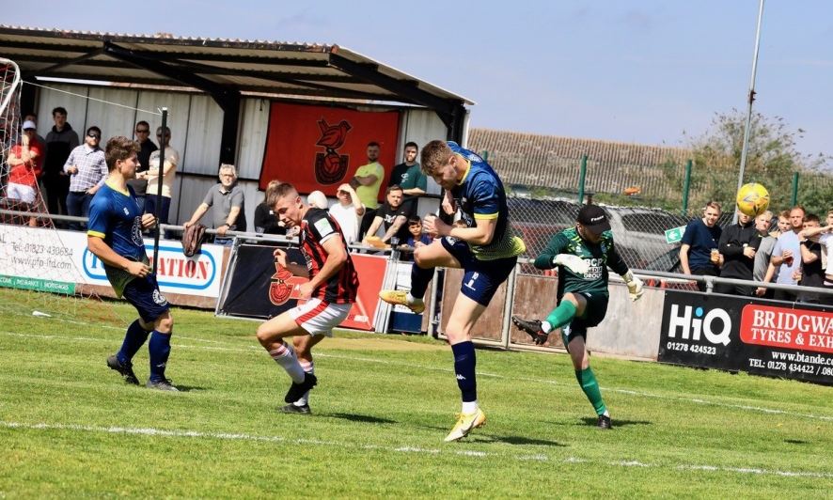
Premier Division: Bridgwater United ended their league season in dramatic circumstances on Good Friday with a tense 1-0 victory over Shepton Mallet. Both sides headed into the game in good form, and it was Bridgwater who took home all three points when Nick Woodrow scored in the fourth minute of injury time after Jack Taylor had seen his goal-bound effort blocked. Tavistock saw the five-point lead they carried into the Easter period trimmed after they were held to a goalless draw away at Buckland. Fellow Devon side Exmouth Town capitalised on Tavistock’s slip, eventually prevailing by four goals to one away at relegated Bridport. Incredibly, it was the basement dwellers who struck first at St Mary’s Field, with Florin Gusoi striking in the 25th minute to pile the pressure on their promotion-chasing visitors. Ace High managed to level affairs five minutes after Bridport’s opener, but the headlines from this match belong to Levi Landricombe who struck a 15 minute hat-trick during the second half to secure the victory for Exmouth. Mousehole also remain in the title race after they scored in the closing stages to secure a 3-1 win over Helston. Having taken a fourth minute lead through Callam McOnie, the hosts were pegged back just prior to half time by a Helston side they drew 0-0 with just three weeks previously. It was another tight tussle this time around at Trungle Parc too, however Mousehole found a second wind, with goals in the final 15 minutes from Max Hill and Mark Goldsworthy leading them to the crucial victory. Second half goals from Reece Thompson and Rubin Wilson led Saltash to a 2-0 win away at Millbrook, with United becoming just the fifth side to reach the 60-point mark this campaign. Another side to prevail on their travels was Cadbury Heath, with a dramatic late winner helping them come out on top in a seven-goal thriller against Bitton. In an entertaining clash, Matt Groves fired Bitton ahead after 15 minutes, before goals from George Boon and Ali Boyer turned the game in the visitors favour. Bitton’s top scorer Dean Griffiths then levelled towards the end of the first half, with Boon then scoring his second of the afternoon to give his side a 3-2 lead. It was then Ben Withey’s turn to equalise for Bitton, but the pattern of the game continued until the very end, with the Heath pushing in front once more through substitute Mo Jeng, and that was how it stayed as they ran out 4-3 winners. Wellington secured their tenth league victory of the season after storming to a 4-0 win away at Ilfracombe Town. After Mark Cornish headed them in front after 14 minutes, Welly powered home after the break, with Jordan Casey and Eli Collins adding to an own goal in the comprehensive victory.
Action from Bridgwater United’s victory over Shepton Mallet on Good Friday, courtesy of Haydn Jones.
Clevedon Town made it five wins from their previous seven in the league after they twice came from behind to beat Street 3-2. Goals from Kyle Strange and Harry Foster had put the Cobblers in front at different points in the first half, but Clevedon managed to hit back on each occasion through Archie Ferris and Freddie King. It was a terrific volley by Ferris at the beginning of the second half which ended up being the winning goal, helping Town secure the double over Street this season having beaten them 4-1 in December. Ashton & Backwell secured their second league win on the bounce, after first half goals from Reece Hedges and Henry Sady helped them defeat Brislington 2-1 at the Lancer Scott Stadium.
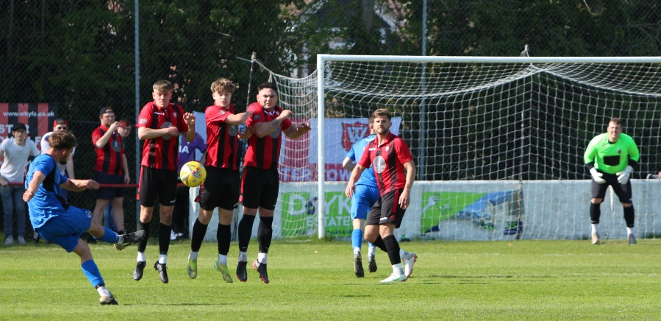
First Division: Sherborne were confirmed as champions on Friday following their 5-0 win away at local rivals Gillingham Town. Doing what they do best, the Zebras were deadly in front of goals, and settled any early nerves with a sixth minute opener from Anthony Herrin. Henry Lawrence-Napier then made it 2-0 midway through the first half, before a belting finish from Declan Cornish soon after put the result beyond doubt. Goals 121 and 122 of the season followed after the interval, with Cornish and Ashley Guppy completing the scoring for the newly-crowned champs. The Easter Weekend also started well for the other sides hoping to get promoted this season, with Welton impressing in the closing stages of their 4-1 win over local rivals Radstock. The big game at West Clewes started well for the hosts, with Courtney Charles putting them in front after eight minutes, before the Miners hit back ten minutes after the break through Morgan Skipp. That goal seemed to kick the Green Army back into life, and following a quickfire brace from Lewis Russell, there was a further late goal from Lewis Hunt to wrap up the victory. Warminster Town also picked up maximum points once again after beating bottom side Devizes 3-0. Ian Jeffery’s 30th minute penalty put the hosts in front, and they didn’t look back, with goals after the break from Eben Mortimer-Taylor and James Vincent making it back-to-back 3-0 triumphs. Almondsbury prevailed by the same scoreline away at Tytherington, with Theo Cox, Ashley Knight and Seb Scott all getting in on the act during their win at Hardwicke Field. The in-form Andy Nash and Josh Dempsey each got on the scoresheet during Oldland’s 4-0 thumping of Longwell Green Sports, while Lebeq reached the 50-point mark for the season following a 1-1 draw at home to Portishead. There was also a 1-1 draw in the fixture involving Boco and Bristol Telephones, and at Cothelstone Road, a second half strike from Kris Bell saw Cheddar beat Bishops Lydeard by a goal to nil. Bishop Sutton’s penultimate game of the season finished on a high note after they came from behind to beat Hengrove 2-1. Following a goalless first half, Danny Dodimead put Hengrove in front, before the away side turned the game in their favour with two goals in the space of five minutes from Luke Palmer and Mason Dagger. Wincanton’s remarkable run of form continued on Saturday afternoon, with Louis Irwin, and a penalty from Dan Wise handing them a 2-0 win at home to fellow top-six side Wells City.
Action from Friday’s Wiltshire derby at Weymouth Street between Warminster and Devizes, courtesy of Jamie House.
Easter Monday Round-up:
Premier Division: It was goals galore on Monday afternoon, with the top two setting themselves up for a huge final week in the league season by each winning 9-0. In the day’s early kick off, Exmouth put Millbrook to the sword at the King George V Ground to pile the pressure on their title rivals. After top scorer Jordan Harris struck a free kick to break the deadlock, the floodgates opened, with Ben Steer and Ace High each bagging braces. There was also another goal for Friday’s hero Levi Landricombe, but the plaudits on Monday will belong mainly to Nathan Cooper who grabbed a hat-trick to help improve his side’s goal difference. Hosting bottom-side Bridport, league leaders Tavistock maintained their three-point advantage heading into Wednesday’s mammoth clash by mirroring Exmouth’s nine-goal victory. Four different players got their name on the scoresheet before the interval, with Edd Harrison, Teigan Rosenquest, Josh Grant and Iestyn Harris each beating the visiting keeper. After the break it was all about two men, with Grant scoring twice more, while Warren Daw maintained his excellent goalscoring form with a terrific second half treble to join Grant in grabbing a hat-trick. Mousehole’s recent tendency to drop points looks to have cost them a title at becoming champions after they drew 2-2 with Ashton & Backwell United. The visitors are doing everything they can to avoid relegation at the moment, so their endeavour was on show throughout at Trungle Parc where they built a two-goal lead just prior to the hour mark. It looked like Ashton had done enough to secure all three points, but that was put in jeopardy when Jack Calver pulled one back for the hosts five minutes from time. Then, with their next attack, Mousehole grabbed a share of the spoils when Jack Symons struck to break Backwell hearts. Street leapfrogged Ashton & Backwell up into a 17th ahead of their final matches after securing a dramatic 3-2 win away at fifth-placed Saltash. Having gone ahead after four minutes thanks to Dan Peach, the Cobblers doubled their tally at the beginning of the second half when Alessandro Costanza fired home. The Ashes set up a thrilling finale when Tom Harris trimmed the deficit 20 minutes from time, and then with the game heading into stoppage time, it looked like Street’s hopes of a win had gone when Reece Thomson drew the hosts level. Incredibly, the relegation threatened side managed to produce one more attack, and with the final kick of the game, Harry Foster found the back of the net to secure maximum points. Keynsham earned late season bragging rights over local rivals Brislington after an own goal was followed by second half efforts from Callum Baker and Mat Long in their impressive 3-0 triumph. Wellington defeated Helston by the same 3-0 scoreline thanks to goals from Doug Camilo, Nathan Byrne and Mark Cornish, while Buckland went twice as well, putting six past a badly out of sorts Bitton at Homers Heath. Jake Evans struck twice for the Devonians, with Richard Groves, Ryan Bush, Luis Edmondson and Cieran Badger also getting in on the act for a side setting themselves up well ahead of next season. It was also a good afternoon for Ilfracombe Town who ended a four-match winless run by beating Cadbury Heath 4-1. Jon Invernizzi had scored for the Heath in the opening quarter, but that was as good as it got for them, with Town running out comfortable victors thanks to goals from Joe Barker, Jack Jenkins, Liam Short and Ollie Stevens.
First Division: Champions Sherborne grabbed their 30th league victory of the season after seeing off Welton by a goal to nil in the day’s lunchtime kickoff. Unfortunately the first half was overshadowed by bad injuries for either side, with home keeper Josh Attwood suffering a broken collarbone meaning that outfielder Haydn Hodges had to play the remainder of the game between the sticks. The winning moment came just prior to the interval, with Anthony Herrin firing home, and Sherborne’s victory was made simpler late on when Rovers forward Lewis Hunt picked up his second booking of the afternoon.
Warminster Town end the Easter period up in third spot after they overcame ten-man Cheddar. An early red card to Ryan Sandford put the home side on the back foot, and they were made to pay soon after when Corey Gardner scored to put Warminster in front. The Cheesemen got back on level terms pretty soon after thanks to a Sam Beresford rocket, giving the home fans something to cheer about in their final outing at Bowdens Park this season. The extra man finally paid off for Warminster, and after Gardner had struck again to restore their lead, top scorer Ian Jeffery then added another goal from the spot to confirm the destination of the points. Another side to win on their travels was Bishops Lydeard, with Cahal Robertson, Charlie Melvin-Sparks and skipper Ross Burford all striking in their 3-0 victory over Almondsbury in South Gloucestershire. There was a fantastic moment for Portishead Town’s stand-in keeper Alex Chapman, after he converted from the penalty spot in their 1-0 win away at Tytherington. There was late drama at Gillingham Town, where the hosts struck late on to complete their 2-1 comeback win over Oldland. Having fallen behind to Jacob Reader’s 27th minute header, the Gills levelled just prior to half time through Andrew Holmes. Reader was then given his marching orders, and the ten-man visitors were unable to hold on for a draw with James Boyland scoring two minutes from time to complete the turnaround. Sixth beat fifth at the Athletic Ground, with first half goals from Charlie Crook and Duncan McCabe helping Wells hold off a fightback from Radstock to move within a point of their visitors.
After suffering four consecutive defeats, Hengrove toppled Longwell Green Sports 4-2 behind a highly impressive first half performance. Two goals in quick succession at the end of the half from Mickey Parsons and Harry Lucas completed a standout 45 minutes for the Grove after top scorer Danny Dodimead had broken the deadlock. The visitors produced a better showing after the interval, but any hopes they had of securing a point were ended when Brandon Feehely added Hengrove’s fourth of the contest. The most dramatic game of the day took place at Nursteed Road, with a 90 minutes full of incident finally ending in a 4-4 draw between Devizes and Boco. A pair of headers from Matt Russell and Bevan Cross saw the bottom-side move into a two-goal lead, before Boco started their fightback. A major flashpoint which had a major bearing on the outcome of the game then took place, with three red cards handed out by the referee, with two of those awarded to the home side. Things then got even worse for Devizes when keeper George Bettles was sent to the sin bin, and Boco utilised that two-man advantage to draw level. The remainder of the game was difficult to comprehend, with impressive finishes from Declan McStravick and Logan Cassidy twice putting the nine-men in front, but Boco responded well on each occasion, with the eighth and final goal of the contest coming from the penalty spot during stoppage time.
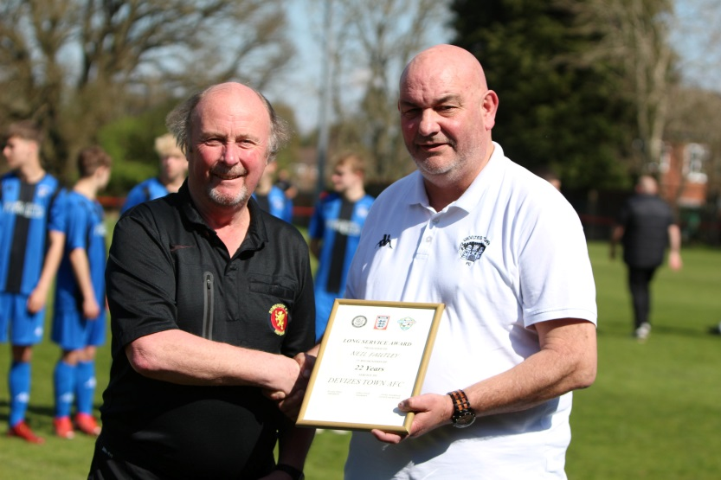
Long Service Awards
On the left, Neil Fautley of Devizes is presented with his Award following 22 years of service at Devizes Town.
In the image on the right, Radstock Town duo Simon and Dave Wilkinson are presented with their Awards from League President Brian Beer and Director Sue Merrill.
On the most recent podcast, Shepton Mallet joint manager Craig Loxton explains how he’d like to take his side to the next level following another impressive Premier Division campaign. Joint manager of Devizes, Alex Blake, then chats with Ian about the importance of the club’s under 18 players and the way his club goes about its approach to safeguarding.
http://toolstationleague.com/season-2021-22-podcast-episode-37/

Recent Results
Friday 15th April 2022
Premier Division
Ashton & Backwell United 2-1 Brislington 230
Bitton 3-4 Cadbury Heath 101
Bridgwater United 1-0 Shepton Mallet 376
Bridport 1-4 Exmouth Town 189
Buckland Athletic 0-0 Tavistock 340
Ilfracombe Town 0-4 Wellington 155
Millbrook 0-2 Saltash United
Mousehole 3-1 Helston Athletic 355
Street 2-3 Clevedon Town 190
First Division
AEK Boco 1-1 Bristol Telephones
Bishops Lydeard 0-1 Cheddar 65
Gillingham Town 0-5 Sherborne Town 249
Hengrove Athletic 1-2 Bishop Sutton 165
Lebeq United 1-1 Portishead Town 61
Oldland Abbotonians 4-0 Longwell Green Sports
Tytherington Rocks 0-3 Almondsbury
Warminster Town 3-0 Devizes Town 217
Welton Rovers 4-1 Radstock Town 407
Saturday 16th April 2022
First Division
Wincanton Town 2-0 Wells City 65

Easter Monday Results
Monday 18th 2022
Premier Division
Buckland Athletic 6-0 Bitton 138
Exmouth Town 9-0 Millbrook 301
Helston Athletic 0-3 Wellington 104
Ilfracombe Town 4-1 Cadbury Heath 127
Keynsham Town 3-0 Brislington 235
Mousehole 2-2 Ashton & Backwell United
Saltash United 2-3 Street 96
Tavistock 9-0 Bridport
First Division
Almondsbury 0-3 Bishops Lydeard 27
Cheddar 1-3 Warminster Town 88
Devizes Town 4-4 AEK Boco 123
Gillingham Town 2-1 Oldland Abbotonians 84
Hengrove Athletic 4-2 Longwell Green Sports 82
Sherborne Town 1-0 Welton Rovers 350
Tytherington Rocks 0-1 Portishead Town 41
Wells City 2-1 Radstock Town 95
Upcoming Fixtures
Wednesday 20th April 2022
Premier Division
Exmouth Town vs Tavistock 19:30KO
First Division
Bishops Lydeard vs AEK Boco 19:30KO
Wincanton Town vs Odd Down 19:30KO

Saturday 23rd April 2022 (3pm kick off unless noted)
Premier Division
Bridport vs Clevedon Town
Helston Athletic vs Buckland Athletic
Ilfracombe Town vs Bitton
Keynsham Town vs Mousehole
Saltash United vs Brislington
Shepton Mallet vs Exmouth Town
Street vs Millbrook
Tavistock vs Ashton & Backwell United
First Division
Bishops Lydeard vs Tytherington Rocks
Devizes Town vs Hengrove Athletic
Longwell Green Sports vs AEK Boco
Odd Down vs Almondsbury
Oldland Abbotonians vs Warminster Town
Portishead Town vs Wincanton Town
Sherborne Town vs Bishop Sutton
Wells City vs Cheddar
Welton Rovers vs Lebeq United
Action from Millbrook vs Saltash United, courtesy of John Pool.

Leading Goalscorers (Stats courtesy of FA Fulltime Website)
All Competitions
Liam Prynn (Tavistock) – 40
Jack Taylor (Bridgwater) – 37
Luke Bryan (Odd Down) – 34
Will Hailston (Keynsham) – 32
Adam Wright (Wells) – 30
Jordan Harris (Exmouth) – 29
Oaklan Buck (Bishop Sutton) – 28

Premier Division
Liam Prynn (Tavistock) – 34
Jack Taylor (Bridgwater) – 29
Jordan Harris (Exmouth) – 27
Will Hailston (Keynsham) – 21
Dean Griffiths (Bitton) - 21
Sam Hughes (Saltash) – 20

First Division
Luke Bryan (Odd Down) -33
Adam Wright (Wells) – 30
Oaklan Buck (Bishop Sutton) -28
Alex Murphy (Sherborne) - 24
Ian Jeffery (Warminster) - 22

League Tables
 | PREMIER DIVISION | Played | Won | Drawn | Lost | GD | Points
1 | Tavistock | 34 | 23 | 7 | 4 | 63 | 76
2 | Exmouth Town | 34 | 22 | 7 | 5 | 60 | 73
3 | Mousehole | 35 | 22 | 7 | 6 | 45 | 73
4 | Bridgwater United | 36 | 20 | 5 | 11 | 30 | 65
5 | Saltash United | 35 | 19 | 5 | 11 | 31 | 62
6 | Shepton Mallet | 35 | 17 | 8 | 10 | 41 | 59
7 | Clevedon Town | 35 | 15 | 11 | 9 | 19 | 56
8 | Helston Athletic | 35 | 14 | 12 | 9 | 19 | 54
9 | Ilfracombe Town | 35 | 15 | 8 | 12 | 5 | 53
10 | Buckland Athletic | 35 | 14 | 8 | 13 | 14 | 50
11 | Keynsham Town | 35 | 14 | 8 | 13 | 9 | 50
12 | Bitton | 35 | 13 | 6 | 16 | -10 | 45
13 | Wellington | 36 | 11 | 10 | 15 | -12 | 43
14 | Millbrook | 34 | 11 | 9 | 14 | -8 | 42
15 | Cadbury Heath | 36 | 10 | 5 | 21 | -33 | 35
16 | Brislington | 34 | 9 | 5 | 20 | -49 | 32
17 | Street | 35 | 8 | 5 | 22 | -26 | 29
18 | Ashton & Backwell United | 35 | 7 | 7 | 21 | -33 | 28
R | Bridport | 35 | 1 | 1 | 33 | -165 | 4

 | FIRST DIVISION | Played | Won | Drawn | Lost | GD | Points
C | Sherborne Town | 39 | 30 | 6 | 3 | 85 | 96
2 | Wincanton Town | 37 | 26 | 5 | 6 | 75 | 83
3 | Warminster Town | 38 | 26 | 5 | 7 | 48 | 83
4 | Welton Rovers | 38 | 25 | 7 | 6 | 44 | 82
5 | Radstock Town | 38 | 17 | 9 | 12 | -1 | 60
6 | Wells City | 38 | 16 | 11 | 11 | 14 | 59
7 | Cheddar | 38 | 15 | 11 | 12 | 8 | 56
8 | Odd Down | 36 | 15 | 8 | 13 | 6 | 53
9 | Bishop Sutton | 39 | 15 | 7 | 17 | 4 | 52
10 | Oldland Abbotonians | 38 | 16 | 4 | 18 | 1 | 52
11 | AEK Boco | 37 | 13 | 12 | 12 | -4 | 51
12 | Lebeq United | 38 | 13 | 11 | 14 | 4 | 50
13 | Gillingham Town | 39 | 12 | 10 | 17 | -13 | 46
14 | Tytherington Rocks | 38 | 12 | 10 | 16 | -17 | 46
15 | Hengrove Athletic | 38 | 12 | 8 | 18 | -17 | 44
16 | Portishead Town | 37 | 13 | 6 | 18 | -6 | 42*
17 | Longwell Green Sports | 39 | 11 | 9 | 19 | -22 | 42
18 | Almondsbury | 37 | 11 | 2 | 24 | -37 | 35
19 | Bristol Telephones | 39 | 10 | 5 | 24 | -54 | 35
20 | Bishops Lydeard | 37 | 6 | 6 | 25 | -40 | 24
21 | Devizes Town | 38 | 5 | 6 | 27 | -78 | 18*

