Latest Round-ups:
#36
Season 2021/22
Midweek Action: Wincanton Town kept up their terrific form in the First Division on Wednesday evening, winning by three goals to nil away at AEK Boco. Connor Williams and Matt Garner both got on the scoresheet once again for the Wasps, with an own goal rounding out the 3-0 victory. Radstock Town ended their four-match winless run by beating Oldland Abbotonians 2-1 at the Southfields Rec. A first half header from youngster Toby Vining set the Miners on their way, with Ali Sen then making it 2-0 before Oldland grabbed a goal back through Andy Nash 20 minutes from time. 24 hours earlier, Bristol Telephones scored twice inside the opening 12 minutes on their way to a 3-2 victory at home to Almondsbury. Goals from Billy Padfield, Archie Dark and the in-form Joe McLeod did the business for the Phones, with second half efforts from Greg Parr and Ashley Knight not quite enough for the away side in their comeback attempt. The other league fixture on Tuesday saw a pulsating 3-3 draw between Gillingham and Cheddar, with the hosts salvaging a point in the closing stages, Having fallen two goals behind at the break, a Robbi Maggs double, and a Ricky Bennett spot kick had turned the game in Cheddar’s favour, but their hard work was undone ten minutes from time when the home side fired home a penalty of their own to grab a share of the spoils.

Turning attention to the Les Phillips Cup, and there was instant revenge for Helston Athletic who defeated Exmouth 1-0 in the pick of the midweek ties. Having lost to the same opposition four days earlier in the league, Helston did enough to progress to the next round thanks to a solitary goal at the end of the first half by Kai Cornish. Cadbury Heath have joined Helston in reaching the last four of the competition after goals before the break from Will Boyer and Dan Winstone helped them defeat Ashton & Backwell 2-0. The third team to confirm their place in the semi-finals were Bridgwater, who survived a penalty shootout to knock out Shepton Mallet. Having gone in front after half an hour through the ever-dependable Jack Taylor, United saw their lead evaporate five minutes from time when Joe Morgan headed home a corner. With the game then decided from 12 yards, Mallet were only successful with two of their five penalties, as Mike Murphy stood firm in between the sticks to save the vital penalty and send his side through to the last four.

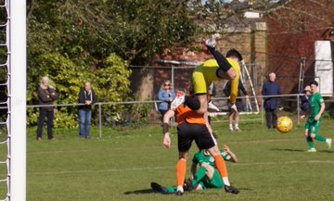
Premier Division: Tavistock hold a five-point lead with four games remaining atop the league after a second-half surge saw them win 4-0 away at Bitton. Following 45 goalless minutes, the Lambs went ahead in magnificent fashion soon after the interval when Warren Daw fired into the top corner from well outside the area. Daw then turned provider, crossing for teammate Dan Evans who added the finishing touches to double Tavistock’s advantage. It was then left to their leading marksman Liam Prynn to get in on the action, with two sublime finishes from him in the closing stages completing a fantastic half of football from the potential champions-in-waiting. There was late drama in the other two fixtures involving the title challengers, with Exmouth finishing the evening in second spot following a tense 1-0 win over Bridgwater. The Devonians have an exceedingly tough run-in on paper, so will gain great confidence from their 20th league victory of the campaign which was earned 13 minutes from time when Levi Landricombe rounded the Bridgwater keeper before tapping home. Mousehole have dropped back into third, six points off top spot, after they let slip a two-goal lead away at Wellington before drawing 2-2. A quickfire brace from Callam McOnie at the end of the first half put the visitors in command at the break against a side who they drew three-apiece with on the opening day of the season. Eventually, Wellington would fight back to grab a share of the spoils once again, with Jordan Casey pulling one back on the hour mark from long-range, before Jake Quick then levelled affairs with a poked finish just as the game headed into the final ten minutes. Shepton Mallet are finishing the season in fine form, and have now won six on the bounce after beating Saltash United 3-1 away from home. The victory saw Mallet move up into fifth at the expense of their hosts, and they wasted no time at all before surging ahead, with Josh Williams making no mistake from 20 yards out. Joe Morgan’s headed finish doubled the visitors lead, and they then put the result beyond doubt early in the second half when Jacob Sloggett beat a couple of defenders before slotting the ball into the back of the net. Another pair of top-half sides met at Kellaway Park, but the deadlock remained unbroken with Helston and Ilfracombe having to settle for a 0-0 draw. That stalemate was a rarity on a day of goals up and down the division, with Buckland putting four past Street at Homers Heath. Having gone in front after 20 minutes through Richard Groves, Buckland were pegged back soon after when a Harry Foster penalty helped the visitors draw level. An own goal at the beginning of the second half saw Buckland restore their lead, and Groves was at the forefront of the action again thereafter, with the frontman tucking home a penalty to make it 3-1 20 minutes from time. Then, given the perfect opportunity to bag his hat-trick, Groves squandered his chance, with his second spot kick deflecting back off the upright, before youngster Sam Stayt wrapped up the victory in stoppage time. 4-1 was also the result at Jenkins Park, where Henry Sady, Charlie Saunders and Conor Hartley all got on the scoresheet in a rare Ashton & Backwell victory away at Millbrook.
Goalmouth action from the 2-2 draw between Wellington and Mousehole, courtesy of @AroundWelly.

For Cadbury Heath, victories have been coming a bit more easily, and they racked up another three points on Saturday thanks to the impact of substitute Mohammed Jeng. After Matt Huxley’s early lobbed-finish had been cancelled out by an excellent Bridport strike, the game headed into the final few minutes with the game deadlocked at one apiece. Jeng then ran onto a long free kick from keeper Jordan Schofield before finishing well to put the Heath ahead, before he then crossed for Huxley who completed his brace in the 88th minute to condemn Bridport to another defeat. A strong fightback from Clevedon Town saw them beat Brislington 4-1 to extend their unbeaten run at the Hand Stadium which stretches back to December. After visiting skipper Scott Lewis had broken the deadlock after 17 minutes, Clevedon hit back to level affairs soon after when Ethan Feltham volleyed home. The hosts then took control of the contest at the end of the first half, with Mitch Osmond sliding the ball home to make it 2-1, before Archie Ferris then struck in stoppage time to put them two-up at the break. The second half was quieter in terms of goals, but Clevedon did enough to pick up their 14th victory of the league season with Alex Camm heading home to complete the scoring.
First Division: Sherborne Town took another step towards claiming the First Division title after securing a battling 3-2 win at home to Oldland Abbotonians. The Zebras haven’t suffered defeat in the league since early October, so it came as a surprise when they fell behind after 14 minutes with Andy Nash picking up where he left off in midweek with another goal. Sherborne weren’t behind for long however, and they responded instantly through Ollie Hebbard, before star man Aaron White then struck early in the second half to turn the game in their favour. The Abbots weren’t ready to lie down however, and they set up a tense final half hour when Owen McCallum drew them level on the hour mark. Sherborne are made of tough stuff however, and with their long winning run just ten minutes from being ended, they forged back ahead when Anthony Herrin struck home a late penalty to deny their visitors a deserved point.
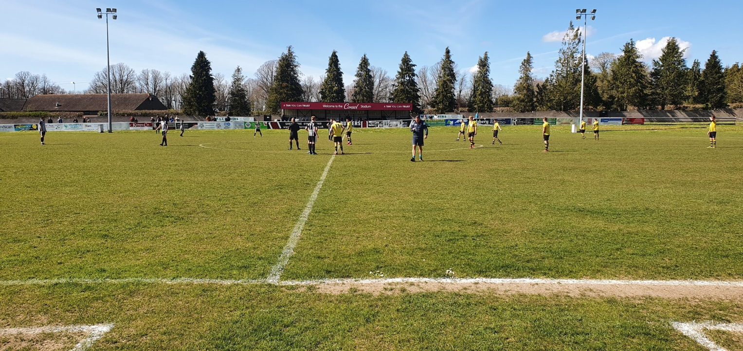
The pre-match scene at Raleigh Grove on Saturday afternoon, prior to Sherborne’s 3-2 win.

Wincanton Town continue to storm up the division, and they now sit in second spot after thumping Bristol Telephones by eight goals to nil. Louis Irwin, Connor Williams, Matt Garner, Dan Quirke and Dan Dix all found the back of the net, but the star performer of the afternoon was Tom Richardson who plundered a hat-trick in the one-sided victory. Wells City were the second highest scorers on Saturday afternoon, striking twice in either half to beat Almondsbury 4-2. Having gone ahead in the early stages through Charlie Crook, Wells doubled their tally midway through the first half when Craig Herrod fired home. A simple tap-in by Herrod extended City’s lead further, before Greg Parr pulled one back from the spot. Adam Wright’s excellent goalscoring campaign continued when he struck late on to make it 4-1, with Parr tucking home his second penalty in stoppage time to give the hosts some late joy at the end of a tough outing. Devizes kept alive their chances off finishing off the bottom of the table after winning 2-1 away at Longwell Green Sports. Having been without a win since December, the visitors will be eyeing a strong end to the season, after goals from Will Fowler and Jack Smith helped them topple a Longwell Green side who had beaten them 5-2 just a month previously. Another side who were victorious on their travels were Bishop Sutton, with a 3-0 win over Bishops Lydeard moving them into the top half. Mason Dagger got the ball rolling after less than a minute, and Sutton didn’t look back from there on, with Jacob Bird and Tom Francis adding further goals in an impressive win. The game at Cheddar played out similarly to the battle of the Bishop’s, with the home side scoring three unanswered goals in their victory over Hengrove. When Adam Jones stroked home a Rick Bennett corner to get on the scoresheet for the third successive game, the Cheesemen were on their way to victory. Joe Woodley then doubled the hosts advantage after just 20 minutes, with a super long-range effort from Bennett capping a strong performance. Having been playing away from home for the past three weeks, Warminster made a triumphant return to Weymouth Street, scoring three times after the break to overcome Tytherington. A goalless opening half included a penalty miss for the hosts, but they showed instant signs of improvement when Matty Morris scored five minutes after the restart. Morris then volleyed home from the edge of the area to make it 2-0 midway through the second half, with Seth Wain heading home a third soon after to remain in the fight for second place. That battle also includes Welton, who dropped two points in the closing stages away at Portishead. The win looked set to be headed in the Green Army’s direction, but Posset battled back to capture a point when Calum Townsend rolled home a late spot kick. Odd Down’s Luke Bryan has extended his lead atop the First Division goalscoring charts after notching another brace in their 2-2 draw away at Radstock. Having opened the scoring after 15 minutes, Bryan then saw his side fall behind, before claiming an equaliser five minutes from time in another standout performance for the Bath side. Gillingham Town produced an excellent comeback, overturning an early two-goal deficit to win 3-2 in their mid-table battle away at Lebeq United.
On the latest episode of the official podcast, we hear from Tavistock boss, Stuart Henderson, who discusses his sides promotion chances, and explains why games against teams lower down the division have proved to be among the tougher this season. Longwell Green Sports manager Chris Alway then catches up with Ian to talk about the development of his young side.
http://toolstationleague.com/season-2021-22-podcast-episode-36/

Recent Results
Tuesday 5th April 2022
Les Phillips Cup
Cadbury Heath 2-0 Ashton & Backwell United
Bridgwater United 1-1 (3-2 pens) Shepton Mallet
First Division
Bristol Telephones 3-2 Almondsbury 45
Gillingham Town 3-3 Cheddar 34

Wednesday 6th April 2022
Les Phillips Cup
Helston Athletic 1-0 Exmouth Town
First Division
AEK Boco 0-3 Wincanton Town 96
Radstock Town 2-1 Oldland Abbotonians 55

Saturday 9th April 2022
Premier Division
Bitton 0-4 Tavistock 63
Buckland Athletic 4-1 Street 101
Cadbury Heath 3-1 Bridport 42
Clevedon Town 4-1 Brislington 115
Exmouth Town 1-0 Bridgwater United 401
Helston Athletic 0-0 Ilfracombe Town
Millbrook 1-4 Ashton & Backwell United 87
Saltash United 1-3 Shepton Mallet 196
Wellington 2-2 Mousehole 105
First Division
Almondsbury 2-4 Wells City 26
Bishops Lydeard 0-3 Bishop Sutton 59
Cheddar 3-0 Hengrove Athletic 102
Lebeq United 2-3 Gillingham Town
Longwell Green Sports 1-2 Devizes Town 75
Portishead Town 1-1 Welton Rovers 53
Radstock Town 2-2 Odd Down 78
Sherborne Town 3-2 Oldland Abbotonians
Warminster Town 3-0 Tytherington Rocks
Wincanton Town 8-0 Bristol Telephones 45

Photo of the Season
- With the campaign heading towards a finale, the Toolstation Western League is welcoming the return of the Photo of the Season.
- The fantastic array of photographs which are received for the gallery on the website makes it an almost impossible task to choose a standout, so there is plenty to consider before submitting your images.
- Please head to www.toolstationleague.com/photo-of-the-season/ for full information on how to enter. The deadline for entries is Midday on Sunday 17th April 2022.
Easter Fixtures Part 1
Friday 15th April 2022 (3pm kick-off unless noted)
Premier Division
Ashton & Backwell United vs Brislington 13:00KO
Bitton vs Cadbury Heath 13:00KO
Bridgwater United vs Shepton Mallet 12:00KO
Bridport vs Exmouth Town 13:00KO
Buckland Athletic vs Tavistock
Ilfracombe Town vs Wellington 14:00KO
Millbrook vs Saltash United 12:00KO
Mousehole vs Helston Athletic 11:00KO
Street vs Clevedon Town
First Division
AEK Boco vs Bristol Telephones
Bishops Lydeard vs Cheddar
Gillingham Town vs Sherborne Town
Hengrove Athletic vs Bishop Sutton
Lebeq United vs Portishead Town
Oldland Abbotonians vs Longwell Green Sports
Tytherington Rocks vs Almondsbury
Warminster Town vs Devizes Town
Welton Rovers vs Radstock Town 13:00KO

Saturday 16th April 2022
First Division
Wincanton Town vs Wells City 13:00KO

A Message from Mike Blessing:
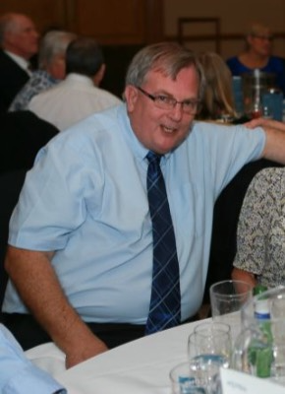
It is with great sadness to have to inform our footballing community the passing of Mr Doug Coles after a long illness* I’m sure all will agree, you could not have meet a kinder man and his extraordinary commitment to Almondsbury FC along with being a committed member of several local community groups in official roles. I’d personally, from all at Almondsbury send our condolences to Carol and family in this sad time. RIP Doug great friend. In respect to the family and understanding this great loss and more importantly with their wishes , being what Doug would like quietly and respectively we can inform all. Our great friend will be put to rest, on Friday 22nd April at 12:30 @ Westerleigh crematorium , Waterside chapel . All are welcome back to Patchway Sports and Social Club afterwards to celebrate his life and a great many tributes to be paid and the stories from family, work colleagues and his sporting families.

Easter Fixtures Part 2
Monday 18th 2022 (3pm kick-off unless noted)
Premier Division
Buckland Athletic vs Bitton
Exmouth Town vs Millbrook 12:00KO
Helston Athletic vs Wellington
Ilfracombe Town vs Cadbury Heath
Keynsham Town vs Brislington
Mousehole vs Ashton & Backwell United
Saltash United vs Street
Tavistock vs Bridport
First Division
Almondsbury vs Bishops Lydeard
Cheddar vs Warminster Town
Devizes Town vs AEK Boco
Gillingham Town vs Oldland Abbotonians
Hengrove Athletic vs Longwell Green Sports
Sherborne Town vs Welton Rovers 13:00KO
Tytherington Rocks vs Portishead Town
Wells City vs Radstock Town

Wednesday 20th April 2022
Premier Division
Exmouth Town vs Tavistock 19:30KO
First Division
Bishops Lydeard vs AEK Boco 19:30KO
Wincanton Town vs Odd Down 19:30KO

Leading Goalscorers (Stats courtesy of FA Fulltime Website)
First Division
Luke Bryan (Odd Down) -33
Adam Wright (Wells) – 30
Oaklan Buck (Bishop Sutton) -28
Alex Murphy (Sherborne) - 24
Bailey Croome (Tytherington) -20
Toby Cole (Wincanton/Welton) - 20

All Competitions
Liam Prynn (Tavistock) – 40
Jack Taylor (Bridgwater) – 37
Luke Bryan (Odd Down) – 33
Will Hailston (Keynsham) – 32
Adam Wright (Wells) – 30
Oaklan Buck (Bishop Sutton) – 28
Jordan Harris (Exmouth) – 28

Premier Division
Liam Prynn (Tavistock) – 34
Jack Taylor (Bridgwater) – 29
Jordan Harris (Exmouth) – 26
Will Hailston (Keynsham) – 21
Sam Hughes (Saltash) – 20

League Tables
 | PREMIER DIVISION | Played | Won | Drawn | Lost | GD | Points
1 | Tavistock | 32 | 22 | 6 | 4 | 54 | 72
2 | Exmouth Town | 32 | 20 | 7 | 5 | 48 | 67
3 | Mousehole | 32 | 20 | 6 | 6 | 43 | 66
4 | Bridgwater United | 35 | 19 | 5 | 11 | 29 | 62
5 | Shepton Mallet | 34 | 17 | 8 | 9 | 42 | 59
6 | Saltash United | 33 | 18 | 5 | 10 | 30 | 59
7 | Helston Athletic | 33 | 14 | 12 | 7 | 24 | 54
8 | Clevedon Town | 34 | 14 | 11 | 9 | 18 | 53
9 | Ilfracombe Town | 33 | 14 | 8 | 11 | 6 | 50
10 | Keynsham Town | 33 | 13 | 8 | 12 | 6 | 47
11 | Buckland Athletic | 33 | 13 | 7 | 13 | 8 | 46
12 | Bitton | 33 | 13 | 6 | 14 | -3 | 45
13 | Millbrook | 32 | 11 | 9 | 12 | 3 | 42
14 | Wellington | 34 | 9 | 10 | 15 | -19 | 37
15 | Cadbury Heath | 34 | 9 | 5 | 20 | -31 | 32
16 | Brislington | 32 | 9 | 5 | 18 | -45 | 32
17 | Street | 33 | 7 | 5 | 21 | -26 | 26
18 | Ashton & Backwell United | 33 | 6 | 6 | 21 | -34 | 24
19 | Bridport | 33 | 1 | 1 | 31 | -153 | 4

 | FIRST DIVISION | Played | Won | Drawn | Lost | GD | Points
1 | Sherborne Town | 37 | 28 | 6 | 3 | 79 | 90
2 | Wincanton Town | 36 | 25 | 5 | 6 | 73 | 80
3 | Welton Rovers | 36 | 24 | 7 | 5 | 42 | 79
4 | Warminster Town | 36 | 24 | 5 | 7 | 43 | 77
5 | Radstock Town | 36 | 17 | 9 | 10 | 3 | 60
6 | Wells City | 36 | 15 | 11 | 10 | 15 | 56
7 | Cheddar | 36 | 14 | 11 | 11 | 9 | 53
8 | Odd Down | 36 | 15 | 8 | 13 | 6 | 53
9 | Lebeq United | 37 | 13 | 10 | 14 | 4 | 49
10 | Bishop Sutton | 38 | 14 | 7 | 17 | 3 | 49
11 | Oldland Abbotonians | 36 | 15 | 4 | 17 | -2 | 49
12 | AEK Boco | 35 | 13 | 10 | 12 | -4 | 49
13 | Tytherington Rocks | 37 | 12 | 10 | 15 | -14 | 46
14 | Gillingham Town | 37 | 11 | 10 | 16 | -9 | 43
15 | Longwell Green Sports | 37 | 11 | 9 | 17 | -16 | 42
16 | Portishead Town | 36 | 13 | 5 | 18 | -6 | 41*
17 | Hengrove Athletic | 36 | 11 | 8 | 17 | -18 | 41
18 | Bristol Telephones | 38 | 10 | 4 | 24 | -54 | 34
19 | Almondsbury | 35 | 10 | 2 | 23 | -37 | 32
20 | Bishops Lydeard | 35 | 5 | 6 | 24 | -42 | 21
21 | Devizes Town | 36 | 5 | 5 | 26 | -75 | 17*

