Latest Round-ups:
#32
Season 2021/22
Midweek Action: In what was a busy midweek schedule, there was plenty of action for Western League sides, with both cup and league fixtures dishing up goals galore. Tuesday saw a trio of Les Phillips Cup ties, with Brislington claiming a 3-1 win to knock out one of the tournament favourites Bitton. A pair of outstanding finishes from Ash Kington in either half helped lead the home side to victory, with Bitton’s late attempted fightback falling short. There was also a 3-1 victory for Keynsham away at Hengrove thanks to a trio of second half strikes from Will Hailston, Jack Dancey and Jamie Noble, while Radstock required a 5-4 shootout victory to knock out Gillingham after their tie had finished 2-2 at the end of normal time. Penalties were also required in Wednesday’s Les Phillips offering, with Warminster keeper Sam Thompson pulling off a couple of saves to help his side knock out Lebeq after they had been held to a 1-1 draw at the end of 90 minutes.
The standout midweek fixture saw second meet third in the Premier Division, with Exmouth beating Mousehole 3-0 to move within a point of top spot. The home side made a strong start, and took the lead after just 11 minutes when Ace High powered home a header. It was then over to Exmouth’s leading scorer to complete the victory, with Jordan Harris adding a goal in either half to wrap up the crucial three points. In what was a big night at the top of the division, Saltash United moved up into fifth spot after surviving with ten-men to beat fourth-placed Bridgwater 2-1 down in Cornwall. Having moved ahead after 25 minutes through Reece Thompson, the Ashes hard-work looked to have been undone when Callum Martindale was given a red card towards the end of the first half. The hosts managed to find extra resolve after the interval, and the ten-men managed to stretch their advantage when Sam Hughes popped up to score in the 66th minute. Bridgwater finally made the extra man pay when Jacob Spence headed home a Jake Llewellyn corner 15 minutes from time, but they were unable to find the equaliser with Spence’s goalbound effort in stoppage time pushed away by Ryan Rickard to preserve the win for Saltash.
There was plenty of goals in the First Division clash on Wednesday, with Oldland Abbotonians coming from behind to beat Bristol Telephones 5-2. Having fallen behind in the opening stages, Oldland responded well and took a 2-1 lead to the break thanks to goals from Jack Mills and Jacob Reader. The away side managed to equalise on the hour mark after beating the offside trap, but Oldland managed to forge back ahead soon after thanks to a header from close range by Mitch Dann. Rather than enduring a nervous finish, the home side continued to push forward in the closing stages, and added to their advantage thanks to goals in the final ten minutes from Cash Vinall and Owen McCallum. 24 hours earlier, Longwell Green beat the bottom-side Devizes by the same scoreline, with Zac Cheetham, Rob Belcher, Liam Oswin, Ben Mitchell and Kyle Parsons all getting their names on the scoresheet thanks to the big win at Nursteed Road. A late blitz from Portishead saw them come from behind to beat Bishops Lydeard 3-1, with the visitors having led for much of the contest following a sweet strike from George Sinnott. Then, with 15 minutes left on the clock, Calum Townsend equalised from the spot for Portishead, and from there they didn’t look back, with Townsend scoring again soon after to turn the game on its head before youngster Billy Pring sealed the victory in the final few moments. In the game at Lakeview, Wincanton stretched their unbeaten run in all competitions to 20 matches after goals from Connor Williams and Louis Irwin helped them to secure a 2-1 win over Bishop Sutton.
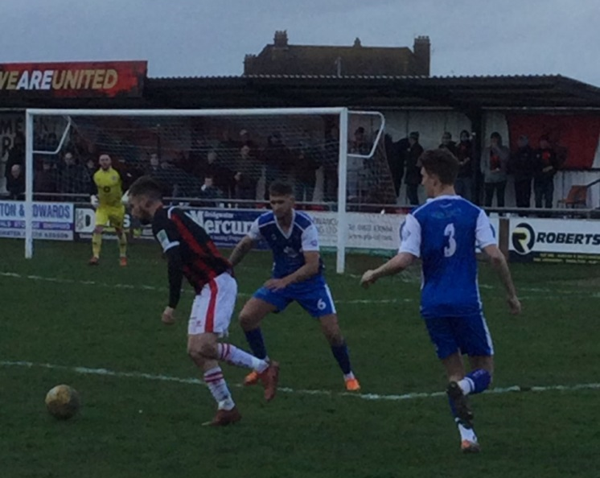
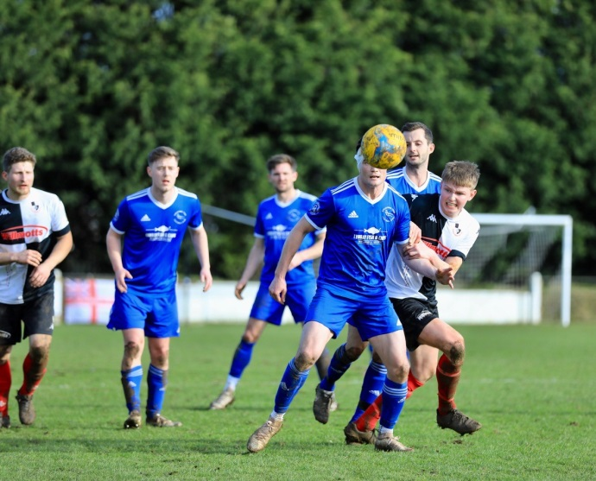
Premier Division: Shepton Mallet followed up their derby day victory last weekend with an impressive 5-1 win over Ilfracombe Town. Jacob Sloggett was the star performer for the hosts during the first half, opening the scoring after five minutes with a bullet header, before then providing assists for Joe Morgan and Aaron Seviour as the hosts powered into a three-goal lead. A penalty from Nick Hewlett then stretched the lead further, with Seviour adding a late fifth after the visitors had struck a consolation. Saltash United gained revenge over Keynsham, securing a 3-0 victory at the Crown Fields. Since losing to the K’s a fortnight ago, Saltash had claimed a couple of hard-fought wins, with their latest three points helping establish their spot in the top five. An excellent finish to the first half saw Reece Thompson and Sam Hughes score in the space of five minutes, with Callum Martindale wrapping up the victory from the spot on the hour mark. There was also a 3-0 triumph for Cadbury Heath at home to Buckland Athletic, with Matt Huxley scoring in either half for the Gloucestershire outfit. The Heath are becoming a really tough side to beat on their home patch, and that continued on Saturday afternoon, with Huxley’s brace putting them in control of the contest, before Harry Goldspink adding a third in the closing stages. Mousehole are now just three points off top spot after easing to an 8-1 thumping of bottom-side Bridport. Callam McOnie and Mark Goldsworthy both struck hat-tricks for the Cornish side, with Louis Price and Hayden Turner also getting their names on the scoresheet. There was late drama elsewhere in the county of Cornwall, with Wellington’s late salvo helping them grab a 2-2 draw away at Millbrook. With the hosts seemingly home and dry following goals from Sean Thompson and Ryan Knight, Wellington gave themselves a flicker of hope when Jordan Casey cut the deficit five minutes from time. The visitors then completed their late comeback with the final kick of the game, when Jake Quick slotted the ball home. 2-2 was also the score at Street, where the hosts grabbed a stoppage time equaliser to deny Ashton & Backwell at the death. Having gone in front through Fin Skiverton, the Cobblers were given another boost when the visitors were reduced to ten men. Incredibly, Ashton managed to score twice during the second half to go 2-1 up, but then with Street pushing for an equaliser they managed to restore parity when Elliot Hegarty found the back of the net. The points were also shared in the highly-anticipated clash between Bridgwater and Helston, with the game at Fairfax Park ending goalless (pictured above right, courtesy of John Pool).
Action from Shepton Mallet’s 5-1 win over Ilfracombe Town, courtesy of Haydn Jones.

First Division: A spirited fightback from Welton Rovers help them keep pace in the title race, coming from 2-0 down to prevail by three goals to two away at Devizes Town. A first half brace from Sam Hughes helped Devizes build a surprise two-goal lead at the interval, with Welton cutting into the deficit five minutes into the second half through Courtney Charles. Charles then struck again 15 minutes from time to draw the Green Army level, with Toby Cole heading home a dramatic winner to complete the turnaround. Sherborne Town have now won league games on the spin after beating Portishead 5-0 at Raleigh Grove. The contest was pretty much over by half-time, with Josh Williams and George Mapletoft making it 2-0, before Declan Cornish produced an excellent chipped finish to make it 3-0 after just 35 minutes. Aaron’s White long-ranger extended the lead to four, before the Zebras benefited from a late own-goal to complete the rout. Warminster Town relied on a late charge to remain in second spot, finally breaking down a gallant Bristol Telephones side at Weymouth Street. Following 70 goalless minutes, the hosts finally broke the deadlock when Lewis Graham fired home, with Seth Wain and Ian Jeffery then adding further goals in injury time to help Warminster return to winning ways. Wincanton’s long-running unbeaten run shows no signs of letting up, with a brace from Matt Garner, and another goal from Connor Williams handing them a 3-0 victory away at Longwell Green Sports. The comeback of the day belonged to Lebeq United, with the home side coming from two-down to beat Tytherington 3-2. The Rocks had been in decent form over the past couple of weeks, and they put themselves in position to grab another win when Ryan Sharpe and Max Wilding put them two goals to the good. Lebeq had other ideas however, and they forged an excellent fightback, led by Jennison Williams, with his double and a further goal from Elan Plummer handing them maximum points. Another player to score a crucial brace was Luke Bryan, with the league’s leading scorer notching two goals in the opening 25 minutes to help lead Odd Down to a 2-1 win over Bishop Sutton in Bath. Oldland Abbotonians finished with just nine-men, but survived to claim a 0-0 draw away at Boco, while Pete Sheppard struck in either half as Hengrove defeated Bishops Lydeard 3-0 at the AVB Stadium.

On the bumper 200th episode of the Official Western League Podcast, there are a plethora of interviews for listeners to enjoy. Ian catches up with Martin Cassidy from Ref Support UK, who gives an update on their bodycam campaign and the role our league have played in it. Saltash manager Dave Bunney also joins the show to talk about the importance of being able to grind out results, while Andy Crabtree, the boss at Warminster Town, explains how the top four in the First Division could have walked away with the title in any other season. There is also a chat with the Godfather of grassroots social media in the South West, Ross Reid, who looks back on the story of this season, and the incredible contribution our clubs have made in promoting Western League football via their social platforms.
http://toolstationleague.com/season-2021-22-podcast-episode-32/

Recent Results
Tuesday 8th March 2022
Les Phillips Cup
Brislington 3-1 Bitton
Hengrove Athletic 1-3 Keynsham Town
Radstock Town 2-2 (5-4 pens) Gillingham Town
First Division
Bishop Sutton 1-2 Wincanton Town 52
Devizes Town 2-5 Longwell Green Sports 65
Portishead Town 3-1 Bishops Lydeard

Wednesday 9th March 2022
Les Phillips Cup
Warminster Town 1-1 (5-3 pens) Lebeq United
Premier Division
Exmouth Town 3-0 Mousehole 183
Saltash United 2-1 Bridgwater United 86
First Division
Oldland Abbotonians 5-2 Bristol Telephones 40

Saturday 12th March 2022
Premier Division
Bridgwater United 0-0 Helston Athletic
Cadbury Heath 3-0 Buckland Athletic 35
Keynsham Town 0-3 Saltash United 150
Millbrook 2-2 Wellington
Mousehole 8-1 Bridport 103
Shepton Mallet 5-1 Ilfracombe Town 174
Street 2-2 Ashton & Backwell United
First Division
AEK Boco 0-0 Oldland Abbotonians 262
Devizes Town 2-3 Welton Rovers 102
Hengrove Athletic 3-0 Bishops Lydeard 57
Lebeq United 3-2 Tytherington Rocks
Longwell Green Sports 0-3 Wincanton Town 143
Odd Down 2-1 Bishop Sutton
Sherborne Town 5-0 Portishead Town 105
Warminster Town 3-0 Bristol Telephones

The Quarter-Final draw for the Les Phillips Cup was made on Tuesday evening, with the regionalised aspect helping to ensure fixtures are feasible over the final few months of the season.

· Tavistock or Helston Athletic vs Exmouth Town or Saltash United
· Bridgwater United or Radstock Town vs Wincanton Town or Shepton Mallet
· Cadbury Heath or Brislington vs Clevedon Town or Ashton & Backwell United
· Keynsham Town or Tytherington Rocks vs Almondsbury or Warminster Town

Upcoming Fixtures
Tuesday 15th March 2022
Les Phillips Cup
Almondsbury vs Warminster Town 19:30KO
Bridgwater United vs Radstock Town 19:45KO
Keynsham Town vs Tytherington Rocks 19:45KO
Tavistock vs Helston Athletic 19:45KO
Premier Division
Wellington vs Ilfracombe Town 19:45KO
First Division
Welton Rovers vs Bristol Telephones 19:30KO

Wednesday 16th March 2022
Les Phillips Cup
Cadbury Heath vs Brislington 19:30KO
Clevedon Town vs Ashton & Backwell United 19:30KO
First Division
Bishops Lydeard vs AEK Boco 19:30KO
Lebeq United vs Wells City 19:30KO

Saturday 19th March 2022 (3pm kick-off unless noted)
Les Phillips Cup
Shepton Mallet vs Wincanton Town
Premier Division
Bitton vs Clevedon Town
Buckland Athletic vs Mousehole
Exmouth Town vs Street
Helston Athletic vs Brislington
Ilfracombe Town vs Cadbury Heath
Millbrook vs Keynsham Town
Saltash United vs Wellington
First Division
Bishop Sutton vs Bristol Telephones
Bishops Lydeard vs Odd Down
Gillingham Town vs Almondsbury
Oldland Abbotonians vs Cheddar
Portishead Town vs AEK Boco
Sherborne Town vs Warminster Town
Tytherington Rocks vs Devizes Town

Leading Goalscorers (Stats courtesy of FA Fulltime Website)
Premier Division
Liam Prynn (Tavistock) – 30
Jack Taylor (Bridgwater) – 28
Jordan Harris (Exmouth) – 26
Will Hailston (Keynsham) – 20
Dean Griffiths (Bitton) – 19

First Division
Luke Bryan (Odd Down) -30
Oaklan Buck (Bishop Sutton) -27
Adam Wright (Wells) - 24
Alex Murphy (Sherborne) - 23
Bailey Croome (Tytherington) -20

All Competitions
Liam Prynn (Tavistock) – 36
Jack Taylor (Bridgwater) – 32
Luke Bryan (Odd Down) – 30
Oaklan Buck (Bishop Sutton) – 27
Jordan Harris (Exmouth) – 27
Will Hailston (Keynsham) – 26

League Tables
 | PREMIER DIVISION | Played | Won | Drawn | Lost | GD | Points
1 | Tavistock | 28 | 18 | 6 | 4 | 43 | 60
2 | Exmouth Town | 28 | 18 | 5 | 5 | 46 | 59
3 | Mousehole | 27 | 18 | 3 | 6 | 38 | 57
4 | Bridgwater United | 30 | 16 | 4 | 10 | 27 | 52
5 | Saltash United | 28 | 15 | 5 | 8 | 30 | 50
6 | Shepton Mallet | 30 | 13 | 8 | 9 | 33 | 47
7 | Helston Athletic | 27 | 12 | 9 | 6 | 18 | 45
8 | Bitton | 28 | 13 | 6 | 9 | 10 | 45
9 | Clevedon Town | 29 | 11 | 11 | 7 | 14 | 44
10 | Keynsham Town | 30 | 12 | 8 | 10 | 6 | 44
11 | Ilfracombe Town | 28 | 13 | 5 | 10 | 6 | 44
12 | Millbrook | 28 | 10 | 9 | 9 | 10 | 39
13 | Buckland Athletic | 28 | 11 | 6 | 11 | 8 | 39
14 | Wellington | 28 | 7 | 8 | 13 | -18 | 29
15 | Brislington | 27 | 8 | 4 | 15 | -39 | 28
16 | Cadbury Heath | 30 | 8 | 3 | 19 | -31 | 27
17 | Street | 27 | 6 | 4 | 17 | -25 | 22
18 | Ashton & Backwell United | 28 | 5 | 5 | 18 | -32 | 20
19 | Bridport | 31 | 1 | 1 | 29 | -144 | 4

 | FIRST DIVISION | Played | Won | Drawn | Lost | GD | Points
1 | Sherborne Town | 33 | 24 | 6 | 3 | 72 | 78
2 | Warminster Town | 31 | 21 | 5 | 5 | 39 | 68
3 | Welton Rovers | 30 | 20 | 6 | 4 | 36 | 66
4 | Wincanton Town | 30 | 19 | 5 | 6 | 49 | 62
5 | Radstock Town | 31 | 16 | 7 | 8 | 7 | 55
6 | Odd Down | 32 | 14 | 7 | 11 | 8 | 49
7 | Lebeq United | 32 | 12 | 9 | 11 | 5 | 45
8 | Oldland Abbotonians | 29 | 14 | 3 | 12 | 3 | 45
9 | Wells City | 31 | 11 | 10 | 10 | 8 | 43
10 | AEK Boco | 30 | 11 | 9 | 10 | -2 | 42
11 | Tytherington Rocks | 33 | 11 | 9 | 13 | -10 | 42
12 | Cheddar | 30 | 11 | 8 | 11 | 2 | 41
13 | Hengrove Athletic | 33 | 11 | 8 | 14 | -10 | 41
14 | Bishop Sutton | 34 | 11 | 7 | 16 | -2 | 40
15 | Longwell Green Sports | 34 | 10 | 9 | 15 | -13 | 39
16 | Portishead Town | 32 | 12 | 4 | 16 | -5 | 37*
17 | Gillingham Town | 33 | 9 | 9 | 15 | -13 | 36
18 | Almondsbury | 29 | 10 | 2 | 17 | -22 | 32
19 | Bristol Telephones | 32 | 7 | 4 | 21 | -44 | 25
20 | Bishops Lydeard | 31 | 5 | 6 | 20 | -34 | 21
21 | Devizes Town | 32 | 4 | 3 | 25 | -74 | 12*

