Latest Round-ups:
#31
Season 2021/22
Midweek Action: Wincanton extended their unbeaten run in all competitions to 18 matches with a come-from-behind 3-2 victory away at Welton in the Les Phillips Cup on Tuesday evening. Goals from Jake Slocombe and Joe Garland had twice put the home side in front during the first half, but the Wasps hit back after the interval, with Dan Dix levelling the scores, before Connor Williams swept home the winner with a well-taken free kick. Ashton & Backwell also progressed to the next round, with the Premier Division strugglers securing a confidence-boosting 3-0 win over Portishead at the Lancer Scott Stadium. In Tuesday’s First Division clash, Tytherington swept aside Bristol Telephones at Hardwicke Field, with goals from Mike Johnson and Ethan Johnson helping them register a 2-0 victory.

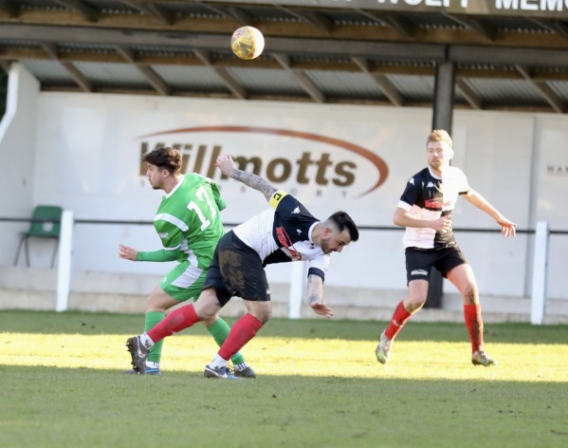
Premier Division: In one of the biggest shocks of the season so far, leaders Tavistock suffered their first defeat since early September, going down to a 2-1 loss away at 18th placed Ashton & Backwell. The home side started the game strongly, and deservedly took a lead to the interval thanks to Kye Simpson’s 20th minute strike. Tavistock responded in kind at the beginning of the second half, drawing level through Josh Parry, but they were soon back behind after 16-year-old Alfie Cummings rifled home a terrific free-kick for the hosts. That still left the Lambs plenty of time to mount another fightback, but it didn’t materialise and their afternoon got even worse in the closing stages when Teigan Rosenquest was given a red card. There was also positive news for another of the strugglers, with bottom side Bridport ending their long run of defeats after securing a 2-2 draw at home to Brislington. Having gone in front through Callum Arnold after 28 minutes, Bridport found themselves trailing on the hour mark after Joe McLennan struck in either half for the visitors. For once, the home fans will have gone home happy however, and after Arnold was felled in the box, substitute Dan Baggs held his nerve to tuck home the 89th minute penalty to secure the Bees first draw of the entire season. Local bragging rights remain with Shepton Mallet after they completed the double over Street. Having beaten the same opponent exactly one month previously, Shepton repeated the trick on Saturday afternoon, with goals either side of the interval from Finn Haines and Joe Morgan leading them to an impressive 2-0 victory.
Action from Shepton Mallet’s 2-0 win over Street, courtesy of Haydn Jones.
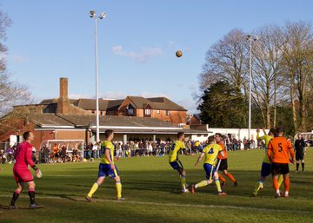
Exmouth Town now find themselves just four points off top spot after claiming a 3-0 win away at Wellington (see image below). Dan Cullen broke the deadlock for the visitors ten minutes before the interval, with Levi Landricombe then striking twice during the second half to help Exmouth take all three points back to Devon. Another player to hit a match-winning brace was Hayden Turner, with the Mousehole attacker adding to an earlier goal from teammate Jack Calver during their 3-0 triumph at home to Ilfracombe. There was also a 3-0 victory for Bridgwater, with man of the moment Jack Taylor starring in their defeat of Keynsham. Having struck twice in their most recent win, Taylor repeated the trick away at Keynsham, handing Town a rare home defeat. Substitute Adnan Hiroli also got in on the scoring, coming off the bench to extend Bridgwater’s advantage in the closing stages. Ten-man Clevedon managed to claw out a terrific 1-0 victory at home to Helston, joining their visitors and four other clubs locked on 44 points. There was only 30 minutes on the clock when Town’s Oli Babington was given his marching orders, but to their credit, Clevedon battled on and got their rewards in the final quarter of the game when Syd Camper’s set piece was met by a stooping header from Glen Hayer. Saltash United produced a late show of their own, scoring a late winner in their back-and-forth affair away at Buckland. Having fallen behind after 19 minutes to Owen Price’s free header, the Ashes drew level ten minutes before half-time when Neil Slateford fired low into the bottom corner. That set up a tense second half, and just after Ryan Bush had seen his 89th minute effort thwarted by the visiting keeper, Saltash broke up-field and claimed the 2-1 victory with Dave Barker slotting home the dramatic winner. Matt Huxley was another man to score a meaningful goal in the closing stages of his match, with the Cadbury Heath front-man cancelling out Dean Griffiths’ eighth-minute opener in their 1-1 draw at home to Bitton.
On the latest episode of the official Western League podcast, Keynsham’s manager John Allen joins Ian to reflect on Town’s first full season in the Premier Division, explaining why he feels they have found the perfect balance between attack and defence. We then catch up with Portishead’s Eamon Daly, who looks back on what might have been for his side against some of the top outfits in the First Division this season, while also casting an eye forward to the good times ahead for his young charges as they continue to build for the future.
Season 2021/22 Podcast Episode 31 | Toolstation Western League (toolstationleague.com)

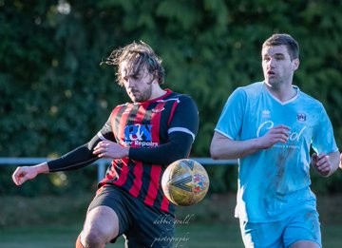
First Division: Sherborne Town have stretched their lead atop the division to ten points after claiming a 2-0 win away at Bishops Lydeard. The leading scorers in the league weren’t at their fluent best, but they still had enough to put away their hosts, with Alex Murphy scoring twice during the first half to help them capture maximum points. Sherborne’s title rivals Welton saw their match postponed on Saturday, while second-placed Warminster suffered a surprise defeat to 12th placed AEK Boco, with the home side scoring with the final kick of the game to grab the 1-0 win. There was also a 1-0 win for Gillingham Town over Bishop Sutton, with the free-scoring duo of Longwell Green and Lebeq both drawing rare blanks in their goalless draw at Shellards Road. Wincanton Town have gained ground on Warminster and Welton after beating Bristol Telephones by two goals to nil. Goals from Jamie Thompson and Cam Vere proved to be enough for the Wasps to extend their excellent unbeaten run to 19 matches in all competitions. Another side who have definitely showed improvements since the turn of the year are Wells City, and that continued on Saturday after they beat bottom-side Devizes 3-0. Adam Wright’s stellar form continued, with the former-Cheddar man opening the scoring towards the end of the first half, with Charlie Crook then striking either side of the interval to complete the win. Radstock Town have now won four of their past five fixtures after they toppled Portishead 2-1 at the Southfields Rec thanks to a pair of first half goals from Rico Sobers.
Action from Sherborne’s 2-0 victory over Bishops Lydeard, courtesy of Debbie Gould.
League supports ref Bodycam Pilot
The Toolstation Western League has thrown its support behind a national campaign by Ref Support UK, calling for the use of Bodycams by Match Officials.
The League’s Board have expressed concerns over abusive behaviour to match officials, and believe bodycams could “mitigate potential problems and improve the match day experience” for everyone.
Although it not currently allowed by the International Football Association Board (IFAB), the Western League have proposed taking part in a pilot for bodycam usage, with a trial period helping to consider their effectiveness in improving participant behaviour.
In a letter to Ref Support UK, the league recognised that “there are other considerations that need to be taken account of prior to commencing (a pilot), but in principle we are keen to support any initiative that enhances the enjoyment of football by players, spectators, club officials and match officials.”
Recent Results
Tuesday 1st March 2022
Les Phillips Cup
Ashton & Backwell United 3-0 Portishead Town
Welton Rovers 2-3 Wincanton Town
First Division
Tytherington Rocks 2-0 Bristol Telephones

Saturday 5th March 2022
Premier Division
Ashton & Backwell United 2-1 Tavistock 100
Bridport 2-2 Brislington 82
Buckland Athletic 1-2 Saltash United 135
Cadbury Heath 1-1 Bitton 62
Clevedon Town 1-0 Helston Athletic 101
Keynsham Town 0-3 Bridgwater United 172
Mousehole 3-0 Ilfracombe Town
Shepton Mallet 2-0 Street 213
Wellington 0-3 Exmouth Town 147
First Division
AEK Boco 1-0 Warminster Town
Bishops Lydeard 0-2 Sherborne Town 98
Bristol Telephones 0-2 Wincanton Town 37
Devizes Town 0-3 Wells City 88
Gillingham Town 1-0 Bishop Sutton 39
Longwell Green Sports 0-0 Lebeq United 130
Radstock Town 2-1 Portishead Town 67

Leading Goalscorers (Stats courtesy of FA Fulltime Website)

First Division
Luke Bryan (Odd Down) -28
Oaklan Buck (Bishop Sutton) -27
Adam Wright (Wells) - 23
Alex Murphy (Sherborne) - 21
Bailey Croome (Tytherington) -20

Premier Division
Liam Prynn (Tavistock) – 30
Jack Taylor (Bridgwater) – 28
Jordan Harris (Exmouth) – 24
Will Hailston (Keynsham) – 20
Dean Griffiths (Bitton) – 19

All Competitions
Liam Prynn (Tavistock) – 36
Jack Taylor (Bridgwater) – 32
Luke Bryan (Odd Down) – 28
Oaklan Buck (Bishop Sutton) – 27
Jordan Harris (Exmouth) – 25
Will Hailston (Keynsham) – 25

Upcoming Fixtures
Tuesday 8th March 2022
Les Phillips Cup
Brislington vs Bitton 19:30KO
Hengrove Athletic vs Keynsham Town 19:30KO
Radstock Town vs Gillingham Town 19:30KO
First Division
Bishop Sutton vs Wincanton Town 19:30KO
Devizes Town vs Longwell Green Sports 19:30KO
Portishead Town vs Bishops Lydeard 19:30KO

Wednesday 9th March 2022
Les Phillips Cup
Warminster Town vs Lebeq United 19:45KO
Premier Division
Exmouth Town vs Mousehole 19:45KO
Saltash United vs Bridgwater United 19:30KO
First Division
Oldland Abbotonians vs Bristol Telephones 19:45KO

Saturday 12th March 2022 (3pm kick-off unless noted)
Premier Division
Bridgwater United vs Helston Athletic
Cadbury Heath vs Buckland Athletic
Keynsham Town vs Saltash United
Millbrook vs Wellington
Mousehole vs Bridport
Shepton Mallet vs Ilfracombe Town
Street vs Ashton & Backwell United
Tavistock vs Clevedon Town
First Division
AEK Boco vs Oldland Abbotonians
Almondsbury vs Radstock Town
Devizes Town vs Welton Rovers
Gillingham Town vs Cheddar
Hengrove Athletic vs Bishops Lydeard
Lebeq United vs Tytherington Rocks
Longwell Green Sports vs Wincanton Town
Odd Down vs Bishop Sutton
Sherborne Town vs Portishead Town
Warminster Town vs Bristol Telephones

League Tables
 | PREMIER DIVISION | Played | Won | Drawn | Lost | GD | Points
1 | Tavistock | 28 | 18 | 6 | 4 | 43 | 60
2 | Exmouth Town | 27 | 17 | 5 | 5 | 43 | 56
3 | Mousehole | 25 | 17 | 3 | 5 | 34 | 54
4 | Bridgwater United | 28 | 16 | 3 | 9 | 28 | 51
5 | Bitton | 28 | 13 | 6 | 9 | 10 | 45
6 | Shepton Mallet | 29 | 12 | 8 | 9 | 29 | 44
7 | Saltash United | 26 | 13 | 5 | 8 | 26 | 44
8 | Helston Athletic | 26 | 12 | 8 | 6 | 18 | 44
9 | Clevedon Town | 29 | 11 | 11 | 7 | 14 | 44
10 | Ilfracombe Town | 27 | 13 | 5 | 9 | 10 | 44
11 | Keynsham Town | 29 | 12 | 8 | 9 | 9 | 44
12 | Buckland Athletic | 27 | 11 | 6 | 10 | 11 | 39
13 | Millbrook | 27 | 10 | 8 | 9 | 10 | 38
14 | Wellington | 27 | 7 | 7 | 13 | -18 | 28
15 | Brislington | 27 | 8 | 4 | 15 | -39 | 28
16 | Cadbury Heath | 29 | 7 | 3 | 19 | -34 | 24
17 | Street | 26 | 6 | 3 | 17 | -25 | 21
18 | Ashton & Backwell United | 27 | 5 | 4 | 18 | -32 | 19
19 | Bridport | 30 | 1 | 1 | 28 | -137 | 4

 | FIRST DIVISION | Played | Won | Drawn | Lost | GD | Points
1 | Sherborne Town | 32 | 23 | 6 | 3 | 67 | 75
2 | Warminster Town | 30 | 20 | 5 | 5 | 36 | 65
3 | Welton Rovers | 29 | 19 | 6 | 4 | 35 | 63
4 | Wincanton Town | 28 | 17 | 5 | 6 | 45 | 56
5 | Radstock Town | 31 | 16 | 7 | 8 | 7 | 55
6 | Odd Down | 31 | 13 | 7 | 11 | 7 | 46
7 | Wells City | 31 | 11 | 10 | 10 | 8 | 43
8 | Lebeq United | 31 | 11 | 9 | 11 | 4 | 42
9 | Tytherington Rocks | 32 | 11 | 9 | 12 | -9 | 42
10 | Cheddar | 30 | 11 | 8 | 11 | 2 | 41
11 | Oldland Abbotonians | 27 | 13 | 2 | 12 | 0 | 41
12 | AEK Boco | 29 | 11 | 8 | 10 | -2 | 41
13 | Bishop Sutton | 32 | 11 | 7 | 14 | 0 | 40
14 | Hengrove Athletic | 32 | 10 | 8 | 14 | -13 | 38
15 | Gillingham Town | 33 | 9 | 9 | 15 | -13 | 36
16 | Longwell Green Sports | 32 | 9 | 9 | 14 | -13 | 36
17 | Portishead Town | 30 | 11 | 4 | 15 | -2 | 34*
18 | Almondsbury | 29 | 10 | 2 | 17 | -22 | 32
19 | Bristol Telephones | 30 | 7 | 4 | 19 | -38 | 25
20 | Bishops Lydeard | 29 | 5 | 6 | 18 | -29 | 21
21 | Devizes Town | 30 | 4 | 3 | 23 | -70 | 12*

